Merhamdin Umbukan

Mumbukan.work@gmail.com

Flutter Mobile App Development

[Draw your reader in with an engaging abstract. It is typically a short summary of the document.   
When you’re ready to add your content, just click here and start typing.]

Meals App

Mer

I. INSTALLING FLUTTER

Reference: <https://docs.flutter.dev/get-started/install>

1. Set up VS Code for your IDE(**Integrated Development Environment).**
2. Go to extensions and install Flutter Extension.
3. Go to reference site and download flutter zip files.
4. Find a suitable file location and take note of the path
5. Go to environment variables via this setting. RIGHT CLICK – This PC – Properties – Advance System Settings – Environment Variables.
6. Go To Path and paste the path of flutter root folder.
7. Save.
8. You should be able to run flutter in command prompt, if not, kindly reboot and try.

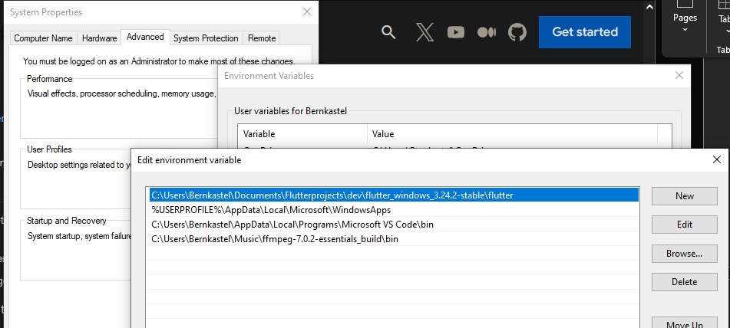

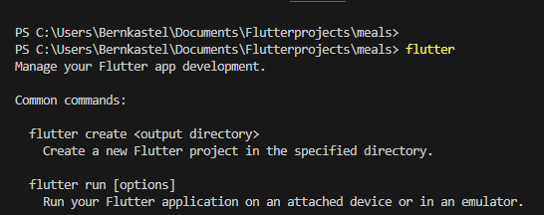

1. Set up working Android Emulator by downloading Android Studio.
2. Once Android Studio is set up, kindly check on the bottom right side of VSCode(along the terminal tab/output tab).
3. 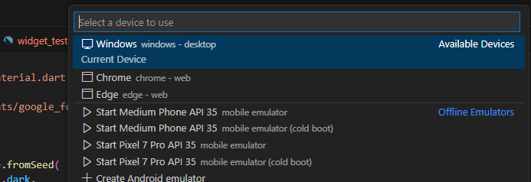 The choice to run your flutter apps using a device should show.(Windows is default).

II. RUN A NEW FLUTTER APP.

1. On the command prompt, run `flutter create app_name`
2. Flutter should build an app with the preferred name.
3. Once done, locate to the root of your folder. This can be done by going by inputting `cd app_name`
4. Run `flutter doctor` to ensure smoothness and no issues when we are going to use flutter.

Common Roadblocks

* cmdline-tools component is missing.

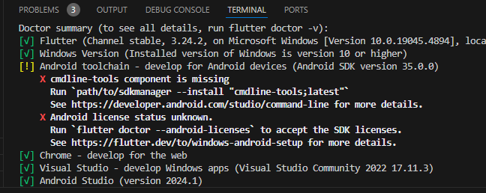

1. Go to Android Studio.
2. Go to Tools > SDK Manager > SDK Tools Tab > Check cmdline-Tools.
3. Wait for installation.

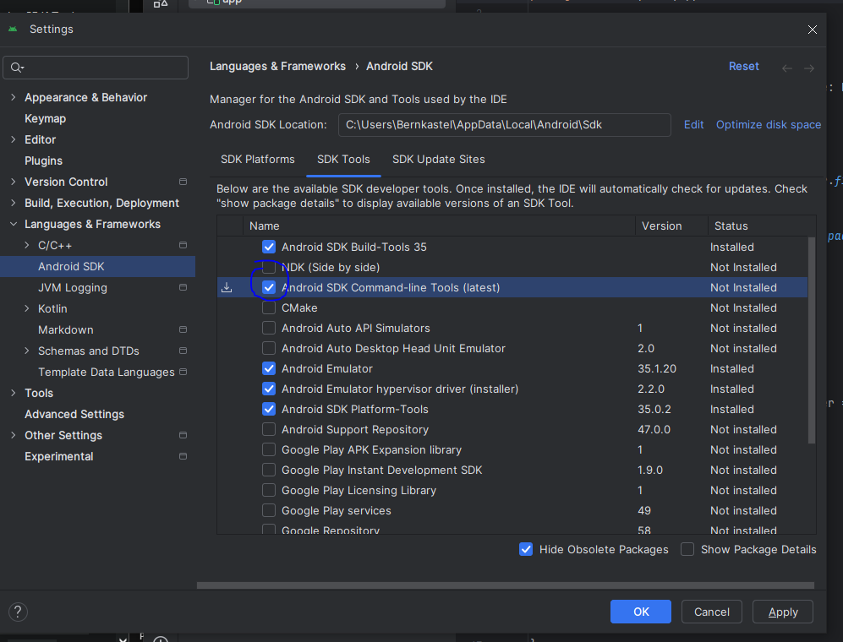

[ ERROR ]

-if you encounter this error, try to rerun Android Studio as Administrator.

