# Evaluating large-scale blood transfusion therapy for the current Ebola epidemic in Liberia

# DETAILED METHODS

**Alexander Gutfraind1 Ph.D.**

**and Lauren Ancel Meyers2 Ph.D.**

1 School of Public Health, University of Illinois at Chicago, Chicago, IL, USA

& Department of Medicine, Loyola University Medical Center, Maywood, IL, USA

2 Division of Statistics and Scientific Computation, University of Texas at Austin, Austin, TX, USA & Santa Fe Institute, Santa Fe, NM, USA

# A Model equations

Our model of transfusion therapy is described by a system of differential equations (Eqn. S1) and is illustrated schematically in Supplementary Figure 1.

ebola_equations.png

**Equations S1**: Dynamic system of the Ebola transfusion model. Time t is in days.

The model is a realization of the CDC model [1] as differential equations with an extension to consider the transfusion therapy, and updated to the latest available incidence data. Following exposure, susceptible persons *S* progress to the incubating compartment *E* and then into one of four infectious groups: hospitalized but not receiving transfusions *IH*, hospitalized and receiving transfusion therapy *IT*, non-hospitalized but isolated (*IQ*), and non-hospitalized and non-quarantined (*INQ*). Patients in the community either recover (*RC*) or die (*M*), while those recovering from hospital are labeled *RH* and some of these qualify as convalescent transfusion donors *C*. After a waiting period, a fraction *q*1 of the donors actually return and become available as donors (*DA*). Some of the donors make additional donations, and *DW* is the expected number of donors who are waiting for their next donation. We use *B* to denote the number of courses available (referred to as “blood”, which may be CWB or CP).

The treated group is analyzed similarly to other hospitalized patients in terms of risk to others and progression to recovery. We allow the donation to be split across multiple recipients. We assume that all available blood is utilized on any hospitalized patients which could be expressed by setting *u* = min(*B*, *IH*), but it is possible in general to consider other treatment policies that stockpile some blood. Rapid utilization is the best policy in the case of a growing epidemic, but in some situation one may consider building a stockpile, for example, when there is local surplus of donors.

The recruitment into *C* depends on recovery rates and probability of eligibility, and is given by *r* = *σCγ*(1 − *δC*)(*INI* + *IQ*) + *σHγ*(1 − *δH*)*IH* + *σHγ*(1 − *δT*)*IT*. Except where noted otherwise, convalescents which recovered in the community rather than hospital do not donate (*σC*=0). Only a fraction *q*1 of the convalescent return to donate make a donation, with an average time to donation of 1⁄*τ*. The average number of treatments prepared per donation is *ρ*, and the total available treatments is *B*. Only a fraction *q*2 of the donors return to make the donation, and the medically-safe mean time to the second donation is 1⁄*π*.

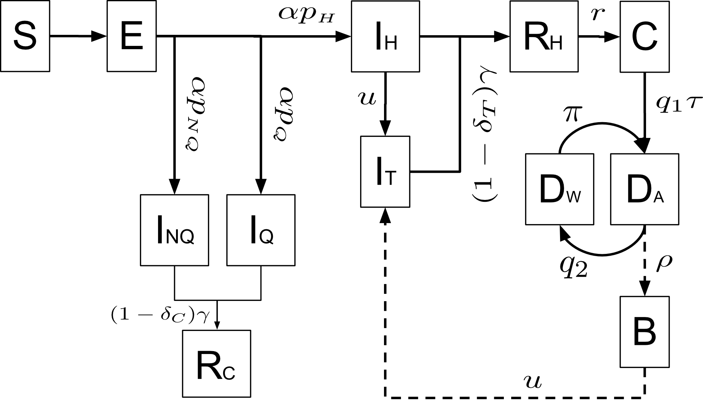

**Supplementary Figure 1** Structure of the model for Ebola infections and convalescent transfusion therapy. Individuals are initially susceptible (*S*) and become infected through contact with infectious persons (*IH*,*INI*,*IQ* or *IT*). *IT* and *B* compartments indicate the treatment group and number of available courses of transfusion treatment. Rates of transition between states are indicated in the diagram. All infectious individuals may die (*M*, transitions not shown).

We initialized the model on June 1, 2014 and calibrated the number of index cases and fatalities on June 1 so that to correctly match the estimated number of cases from June 1 to the latest available data as of November 3 (Supplementary Figure 2). In line with the evidence [1], [2], we assume that only 40% of the cases and deaths due to EVD are reported. The model matches the cases and fatalities quite well for most of the final five months. Fatalities, but not cases, appear to be overestimated in early November and may reflect disruptions in contact tracing work [3] or increasing hospitalization. While the fit is better to the 30% hospitalization scenario, we cannot reject the 10% scenario because of the high uncertainty in the mortality counts [1], [4] and model parameter uncertainty. In addition, the persistently high case fatality rate [5] suggests that many of the hospital facilities are unable to provide advanced supportive care, such as intravenous rehydration therapy, and hence are not equipped to perform transfusion therapy.

|  |
| --- |
| (A) figure figures/nov4/validation_2014-11-04__15-14-1812.png(B)figure figures/nov4/validation_2014-11-04__15-14-1812.png |

**Supplementary Figure 2** Comparison of the model predictions to cases and mortality data in Liberia over June-November, 2014 on a logarithmic scale. Official figures are multiplied by 2.5 based on typical estimates of underreporting [1], [2]. Ribbon indicates the interquartile range. (A) Peak hospitalization at 30% and (B) 10% rates.

# B Parameters

## Transfusion parameters

Donation rate: Generally, with convalescent whole blood (CWB) donation at most one unit is possible every 56 [6] to 84 days [7], where a standard unit = 450*mL* of blood. In the African region, very few facilities are able to perform blood fractionalization (<5%) [8], but this might be scaled up using imported equipment. Such donations of Convalescent Plasma (CP) are possible every two (2) weeks [7].

Fitness of donors: Over 96% Ebola convalescent patients have IgG antibodies [9], [10]. Patients develop IgG 5-18 days after symptoms [10], [11] but are often medically weak [12], [13] and may not be able to donate safely. We assume that donations are possible as soon as 28 days following recovery. However, generally many patients are not eligible for CWB donation because of low hemoglobin (Hg) levels and we assume eligibility of 0.5 [14], and no restriction for CP donation.

Blood suitability: Transfusion requires matching blood group (ABO/Rh) [7], [15] but finding donors does not appear to be a major barrier on the population level as the proportion of AB carriers (A1+/A2+B+) is low at approximately 4% [16]. An estimated 11% of the donors appear to carry major transfusion-transmittable infections [8].

Cost estimates: Cost of blood donation appears to be much lower in Africa than in Europe and the US, with an estimate of $12.5 in Tanzania [14] in 1999), $210 (US in 2011 [17]), 440 Euro (EU in 2011). Screening for TTI ranges from $5 (Tanzania [14] in 1999) to $15 per unit (Sub-Saharan Africa) [18]. Most of the region does not appear to have facilities for blood storage in a blood bank but cost of storage of blood has been estimated at $50 [17] (2011 in the US). Our cost estimate of $75 per donation appears to cover the majority of costs excluding fixed costs such as CP equipment (covered by international donors), training and staffing (small relative to the cost of hospitalization).

## Dynamic parameters

The following table summarizes the baseline parameter values and is taken from the estimates by the CDC [1] and the WHO [19]. The effectiveness of treatment with transfusion is estimated from Ref.[15], which applied the therapy in the phylogenetically-related 1995 virus [20].

**Table S1** Summary of parameters and their interpretation. All time rate constants are in units of day− 1.

|  |  |  |  |
| --- | --- | --- | --- |
| **Parameter** | **Interpretation** | **Value** | **Range and Sources, if available** |
| *α* | Inverse incubation time | 1⁄6 | CDC [1] 2.7 [19]- 16.1[19] |
| *βH* | Transmission rate for hospitalized | 0.02 | CDC [1] 0.015 − 0.025 |
| *βNQ* | Transmission rate for non-isolated | 0.3 | CDC [1] 0.25 − 0.35 |
| *βQ* | Transmission rate for isolated | 0.03 | CDC [1] 0.025 − 0.035 |
| *NQ*0 | Non-quarantined infections as of June 1, 2014 | 30 | 25 − 35 (Calibrated to match recent incidence) |
| *γ* | Inverse duration of infectiousness | 1⁄6 | CDC [1] 1⁄12.8[19]-1⁄4.5[19]\* |
| *δC* | Mortality rate in the community | 0.80 | [19]\*\* 0.76[19]-0.83[19] |
| *δH* | Mortality rate in hospital | 0.67 | [19] 0.62[19]-0.72[19] |
| *δT* | Mortality rate with treatment | 0.125 | [15] 0.075 − 0.175 |
| *N* | Population of Liberia | 4.20M | 4.09M[21]-4.29[1] |
| *ν* | Spoilage rate of blood donations | 1⁄38 | 1⁄40[22]-1⁄35[7] |
| *pH* | Probability of hospitalization before Sept 1 | 0.10 | CDC [1] 0.07-0.13 and increases to 0.4 0.35 − 0.45 by Dec. 1 |
| *pQ* | Probability of home care isolation | 0.08 | CDC [1] 0.06 − 0.10 |
| *pNQ* | Probability of non-isolation | 0.82 | *pNI* = 1 − *p* − *pQ* |
| *π* | Repeat donation rate (CWB) | 1⁄98 | 1⁄112[7]-1⁄84[7] |
|  | Repeat donation rate (CP) | 1⁄17.5 | [7]1⁄20-1⁄14 |
| *q*1 | Prob. first donation | 0.5 | 0.4 − 0.6 based on long wait |
| *q*2 | Prob. return for another donation (CWB) | 0.5 | 0.4 − 0.6 (typical of 2 donations in the US) |
|  | Prob. return for another donation (CP) | 0.67 | 0.5 − 0.8 (implied medical limit of 5 donations [7]) |
| *ρ* | Course of treatment available per donation | 1.2 | 1.0[7] -1.6[15] \*\*\* |
| *σH* | Recruitment per recovered in hospitals (CWB) | 0.43 | 0.4 − 0.5 (Calculated [8], [14]) |
|  | Recruitment per recovered in hospitals (CP) | 0.86 | 0.8 − 0.9 (Calculated [8], [14])) |
| *σC* | Recruitment per recovered in community | 0 | Explored in sensitivity analysis |
| *τ* | Donation readiness rate | 1⁄30 | 1⁄35[7]-1⁄28[7] |

# \*Bounds inferred from mean time from hospitalization until death or until hospital discharge. \*\*Based on reported cases before Aug 18. CWB=Convalescent Whole Blood, CP=Convalescent Plasma. Sensitivity analysis assigned a normal distribution with a SD equal to one quarter of the range.\*\*\*WHO recommendations also allows for up to two units of CP per therapy but we assume lower utilization of blood products more in line with past utilization [15].

**References**

[1] M. I. Meltzer, C. Y. Atkins, S. Santibanez, B. Knust, B. W. Petersen, E. D. Ervin, S. T. Nichol, I. K. Damon, and M. L. Washington, “Estimating the future number of cases in the Ebola epidemic - Liberia and Sierra Leone, 2014–2015,” *MMWR Surveill Summ*, vol. 63, no. suppl 3, pp. 1–14, 2014.

[2] A. Pandey, K. E. Atkins, J. Medlock, N. Wenzel, J. P. Townsend, J. E. Childs, T. G. Nyenswah, M. L. Ndeffo-Mbah, and A. P. Galvani, “Strategies for containing Ebola in West Africa,” *Science*, 2014.

[3] L. Garrett, “Liberia Is Stiffing Its Contact Tracers as Ebola Epidemic Continues,” *Foreign Policy*, 11-Nov-2014.

[4] A. P. Galvani, M. L. Ndeffo-Mbah, N. Wenzel, and J. E. Childs, “Ebola Vaccination: If Not Now, When?,” *Ann. Intern. Med.*, vol. 161, no. 10, 2014.

[5] “Ebola Response Roadmap Situation Report for January 7, 2015,” World Health Organization, 2015.

[6] “Blood Facts and Statistics,” American Red Cross, 2014.

[7] “Use of Convalescent Whole Blood or Plasma Collected from Patients Recovered from Ebola Virus Disease for Transfusion, as an Empirical Treatment during Outbreaks,” World Health Organization, 1.0, Sep. 2014.

[8] J. B. Tapko, B. Toure, and L. G. Sambo, “Status of Blood Safety in the WHO African Region: Report of the 2010 Survey,” World Health Organization, 2014.

[9] A. K. Rowe, J. Bertolli, A. S. Khan, R. Mukunu, J. Muyembe-Tamfum, D. Bressler, A. Williams, C. Peters, L. Rodriguez, H. Feldmann, and others, “Clinical, virologic, and immunologic follow-up of convalescent Ebola hemorrhagic fever patients and their household contacts, Kikwit, Democratic Republic of the Congo,” *J. Infect. Dis.*, vol. 179, no. Supplement 1, pp. S28–S35, 1999.

[10] N. Wauquier, P. Becquart, C. Gasquet, and E. M. Leroy, “Immunoglobulin G in Ebola outbreak survivors, Gabon,” *Emerg. Infect. Dis.*, vol. 15, no. 7, p. 1136, 2009.

[11] G. Wong, G. P. Kobinger, and X. Qiu, “Characterization of host immune responses in Ebola virus infections,” *Expert Rev. Clin. Immunol.*, vol. 10, no. 6, pp. 781–790, 2014.

[12] H. Feldmann and T. W. Geisbert, “Ebola haemorrhagic fever,” *The Lancet*, vol. 377, no. 9768, pp. 849–862, 2011.

[13] “Experimental therapies: growing interest in the use of whole blood or plasma from recovered Ebola patients (convalescent therapies),” World Health Organization, Sep. 2014.

[14] B. Jacobs and A. Mercer, “Feasibility of hospital-based blood banking: a Tanzanian case study,” *Health Policy Plan.*, vol. 14, no. 4, pp. 354–362, 1999.

[15] K. Mupapa, M. Massamba, K. Kibadi, K. Kuvula, A. Bwaka, M. Kipasa, R. Colebunders, and J. Muyembe-Tamfum, “Treatment of Ebola hemorrhagic fever with blood transfusions from convalescent patients,” *J. Infect. Dis.*, vol. 179, no. Supplement 1, pp. S18–S23, 1999.

[16] A. E. Mourant, *The Distribution of the Human Blood Groups.* Oxford: Blackwell Scientific Publications, 1954.

[17] R. Toner, L. Pizzi, B. Leas, S. Ballas, A. Quigley, and N. Goldfarb, “Costs to hospitals of acquiring and processing blood in the US,” *Appl. Health Econ. Health Policy.*, vol. 9, no. 1, pp. 29–37, 2011.

[18] M. van Hulst, C. T. S. Sibinga, and M. J. Postma, “Health economics of blood transfusion safety - focus on sub-Saharan Africa,” *Biologicals*, vol. 38, no. 1, pp. 53 – 58, 2010.

[19] WHO Ebola Response Team, “Ebola Virus Disease in West Africa - The First 9 Months of the Epidemic and Forward Projections,” *N. Engl. J. Med.*, vol. 371, no. 16, pp. 1481–1495, 2014.

[20] S. K. Gire, A. Goba, K. G. Andersen, R. S. Sealfon, D. J. Park, L. Kanneh, S. Jalloh, M. Momoh, M. Fullah, G. Dudas, and others, “Genomic surveillance elucidates Ebola virus origin and transmission during the 2014 outbreak,” *Science*, vol. 345, no. 6202, pp. 1369–1372, 2014.

[21] “World Fact Book: Liberia. Population estimate for 2014,” US Central Intelligence Agency, 2014.

[22] W. P. Pierskalla, “Supply chain management of blood banks,” in *Operations research and health care*, Springer, 2004, pp. 103–145.