

**POLYTECHNIC UNIVERSITY OF THE PHILIPPINES**

**COLLEGE OF ENGINEERING**

**COMPUTER ENGINEERING DEPARTMENT**

ELECTIVE 3: VISUAL BASIC

LIBRARY MANAGEMENT SYSTEM

PROJECT CHARTER DOCUMENT

Members:

PECIO, Rachel Dee S.

QUINTO, Mae Joyce Anne A.

REGINIO, Danica Mae P.

TANGQUE, John Paul M.

**PROBLEM STATEMENT**

In this era of Information Technology, one of the most important developments in recent years is that manual systems are being integrated into automated systems. Way back 3200 BC, the earliest known libraries called, “House of Writings” or “Place of the Records of the Palace of the King” were connected to Palaces and Temples. Their written language was Cuneiform, the world’s first written language.

A library is only as good as its indexing system. Without Dewey Decimal, the Library of Congress and some kind of volume catalogue, nobody could find the right book quickly or reliably enough. Until modern public libraries became the norm during the mid-19th century, professional librarians memorized the location of tomes in their care. Later, manual systems like card catalogues helped patrons look up the location of the books they wanted.

Over time, collection of books became enormous and complicated thus, vulnerability to errors, duplication of data entry for books and inconsistency of data cannot be disdain due a distracted, over-fatigue or exhausted admin of the library. Searching for a specific book in a catalogue- moving one index to another when searching from author to title of the book, consumes a lot of time and effort and that makes the admin less efficient.

Thus, the researchers came up with the Library Management System which will benefit students, librarians and as well as the management of the library itself for a more productive, trustworthy and better library experience.

**PROBLEM GOALS**

* To accomplish the Library Management System by March 24, 2018.
* To help lessen human errors
* To avoid inconsistency of data
* To avoid duplication of data
* To lessen the time of borrowing and returning of books
* To avoid complications while borrowing and returning books
* To have more accessible data for the students and the books
* To have admin authentication that promotes the security of the data

**SCOPE**

Library Management System is a system developed to perform the basic management functions of a library. The system is completed with the use of Visual Studio as an Integrated Development Environment (IDE) in C# language and MS Access, SQL is used for its database. This system can only be accessed using a desktop. It has login page to refrain anyone from using it without the respective admins who has accounts and has the full liability of the system. On the other hand, new admins can still sign up for an account and can also retrieve an account in case one has forgotten the password given that he can abide with the required security question. An admin can simply add book by clicking the New book button, same goes when adding new account for students, one can simply click the New Student button. To borrow a book, the admin must click the Borrow book button to record the book to be borrowed as well as the student’s name. On the contrary, Return book button is used when the student is about to return a book to delete his record and make the book available on the list again. The lists of books and students are displayed on the main page with their important details. The admin can then see whether the book is still available or already borrowed indicated the borrower’s name. There is a search button that allows the admin to simply look for a specific student or book. Delete button is also on the main page which enables the admin to easily delete a record of a student or book. Moreover, a refresh button is placed on the main page to allow the admin to refresh the page every time she deleted, added a book or account of a student. Lastly, data validation which restricts duplication of username, account and other data entry is implemented in the system.

**BENEFITS**

Integration of the library system would significantly reduce the workload of the library staffs in terms of cataloguing, circulations and acquisitions. This enable the staffs to provide better service to library patrons. They will become available to answer reference questions, help people with research work and find information on request. With this, finding materials such as books and reference journals becomes easier and less time consuming.

Finding books becomes easier because one can search for the book they wanted with just one click- one can know if the book is still available or all of the collection of that book has been borrowed. This allows the library to be more flexible when it comes to any increase in demand.

This also allows for an improvement in the variety, amount and quality of materials that are available in the library’s collection. Removing out old, outdated and irrelevant books and materials made easier because admins can delete it right away. It also helps to make the collection more streamlined.

Another evident benefit is that the costs from buying papers will also be saved.The amount that is used from buying papers every year is twice as much as the amount of maintenance that will be spent in a year.

Lastly, this is a good way of preparing the library management to become sustainable with ever-increasing shift to a technology- based society, information dissemination and allows to add features when they become available in the future.

**ORGANIZATIONAL CHART**



**Job Descriptions**

1. **Head of the Project-** Danica Mae P. Reginio

In charge of making sure everything is done effectively and efficiently. Responsible in checking recent updates on the status of the project. Makes the final decision for all aspect in the project making.

1. **Back- End Developer-** Rachel Dee S. Pecio

Responsible for the server-side applications: content, database and the integration of the front- end design.

1. **Front- End Developer-** Mae Joyce Anne A. Quinto

Responsible for implementing the environment for everything that users see: layout and interaction.

1. **Quality Assurance-** John Paul M. Tangque

Responsible for thorough software testing to detect possible errors in the system. Any errors or bugs must be reported immediately to the developers.

**TICKETS/ COMMITS**

|  |  |  |  |
| --- | --- | --- | --- |
| Tickets/ Commits | Resource | Tickets /Commits | Resource |
| SIGN IN FORM:  Form Design  Form Label/Textboxes  -Design  Login Button  -Button design  -Button function  -Database Authentication  New Admin Button  -Button design  -Button function  Forgot Password Button  -Button design  -Button Function  Testing of Sign in form  Checks/ Updates finished form | Mae  Mae  Mae  Mae  Rachel  Mae  Mae  Mae  Mae  JP  Danica | **ADD STUDENT FORM:**  **Form Design**  **Form Function**  **-** Database Connection  **Add Button**  **-** Button Design  - Button Function  **Cancel Button**  **-** Button Design  - Button Function  **Testing of Add Student form**  **Checks/ Updates finished form** | Mae  Rachel  Mae  Mae  Mae  Mae  JP  Danica |
| SIGN UP FORM:  Form Design  Form Label/Textboxes  - Design  Sign Up Button  - Button Design  - Button Function  - Database Connection  Back Button  - Button Design  - Button Function  Testing of Sign up form  Checks/ Updates finished form | Mae  Mae  Mae  Mae  Rachel  Mae  Rachel  JP  Danica | **ADD BOOK FORM:**  **Form Design**  **Form Function**  **-** Database Connection  **Add Button**  **-** Button Design  - Button Function  **Cancel Button**  **-** Button Design  - Button Function  **Testing of Add Book form**  **Checks/ Updates finished form** | Mae  Rachel  Mae  Mae  Mae  Mae  JP  Danica |
| FORGOT PASSWORD FORM:  Form Design  Form Label/Textboxes  - Design  - Search Database Connection  - Retrieve Database Connection  Sign Up Button  - Button Design  - Button Function  - Database Connection  Back Button  - Button Design  - Button Function  Testing of Forgot Password form  Checks/ Updates finished form | Mae  Mae  Rachel  Rachel  Mae  Mae  Rachel  Mae  Mae  JP  Danica | **BORROW FORM:**  **Form Design**  **Form Labels/Textboxes**  **-** Design  **Form Function**  **-** Database Connection  **Student Table**  **-** Database connection  - Table Design  - Row Select Function  **Borrow Button**  **-** Button Design  - Button Function  **Cancel Button**  **-** Button Design  - Button Function  **Testing of Borrow form**  **Checks/ Updates finished form** | Mae  Mae  Rachel  Rachel  Rachel  Rachel  Mae  Mae  Mae  JP  Danica |
| HOME FORM:  Form Design  Book Table  - Database Connection  - Table Design  - Select Row Function  Student Table  - Database Connection  - Table Design  - Select Row Function  Refresh Books Table Button  - Button Design  - Button Function  Delete Book Button  - Button Design  - Button Function  Refresh Students Table Button  - Button Design  - Button Function  Delete Student Button  - Button Design  - Button Function  Book Search  - Design  - Function  Student Search  - Design  - Function  Add Student Button  - Button Design  - Button Function  Add Book Button  - Button Design  - Button Function  Borrow Button  - Button Design  - Button Function  Return Button  - Button Design  - Button Function  About Us Button  - Button Design  - Button Function  Testing of Home form | Mae  Rachel  Rachel  Rachel  Rachel  Rachel  Rachel  Mae  Rachel  Mae  Rachel  Mae  Rachel  Mae  Rachel  Mae  Rachel  Mae  Rachel  Mae  Mae  Mae  Mae  Mae  Mae  Mae  Mae  Mae  Mae  JP | **RETURN FORM:**  **Form Design**  **Form Labels/Textboxes**  **-** Design  - Database Connection  **Form Function**  **-** Database Connection  **Borrow Button**  **-** Button Design  - Button Function  **Cancel Button**  **-** Button Design  - Button Function  **Testing of Return form**  **Checks/ Updates finished form**  **ABOUT FORM:**  Form Design  Form Labels  Back Button  **-** Design  - Function  **Testing of About form**  **Checks/ Updates finished form**  **DATABASE CONNECTION:**  Access Database Creation  Creation of Books Table  Creation of Students Table  Creation of Admin Table  Correlation of Tables  Access SQL Connection to Visual Studio C#  **Testing of Sign in form**  **Checks/ Updates finished form**  **Checks/ Updates finished form** | Mae  Mae  Rachel  Rachel  Mae  Mae  Mae  Mae  JP  Danica  Mae  Mae  Mae  Mae  JP  Danica  Rachel  Rachel  Rachel  Rachel  Rachel  Rachel  JP  Danica  Danica |

**TIMELINE**

|  |  |  |  |  |  |  |  |  |  |  |  |  |
| --- | --- | --- | --- | --- | --- | --- | --- | --- | --- | --- | --- | --- |
|  | Hours rendered  (hr:mns) | February | | | | March | | | | | | |
|  | 03-Feb | 10-Feb | 17-Feb | 24-Feb | 03-Mar | | 10-Mar | 16-Mar | 17-Mar | 23-Mar | 24-Mar |
| Planning | 3:00 |  |  |  |  |  | |  |  |  |  |  |
| Drafting of design | 3:00 |  |  |  |  |  | |  |  |  |  |  |
| **Sign in Form** |  |  |  |  |  |  | |  |  |  |  |  |
| Form design | 3:27 |  |  |  |  |  | |  |  |  |  |  |
| Form build | 3:27 |  |  |  |  |  | |  |  |  |  |  |
| Database Authentication | 1:45 |  |  |  |  |  | |  |  |  |  |  |
| Testing of Sign in form | 2:57 |  |  |  |  |  | |  |  |  |  |  |
| Update finished form | 1:20 |  |  |  |  |  | |  |  |  |  |  |
| **Sign up form** |  |  |  |  |  |  | |  |  |  |  |  |
| Form design | 3:27 |  |  |  |  |  | |  |  |  |  |  |
| Form build | 3:27 |  |  |  |  |  | |  |  |  |  |  |
| Database Connection | 1:45 |  |  |  |  |  | |  |  |  |  |  |
| Testing of Sign up form | 2:57 |  |  |  |  |  | |  |  |  |  |  |
| Update finished form | 1:20 |  |  |  |  |  | |  |  |  |  |  |
| **Forgot Password** |  |  |  |  |  |  | |  |  |  |  |  |
| Form design | 3:27 |  |  |  |  |  | |  |  |  |  |  |
| Form build | 3:27 |  |  |  |  |  | |  |  |  |  |  |
| Database Connection | 1:45 |  |  |  |  |  | |  |  |  |  |  |
| Testing of Forgot form | 2:57 |  |  |  |  |  | |  |  |  |  |  |
| Update finished form | 1:20 |  |  |  |  |  | |  |  |  |  |  |
| **Home form** |  |  |  |  |  |  | |  |  |  |  |  |
| Form design | 3:27 |  |  |  |  |  | |  |  |  |  |  |
| Form build | 3:27 |  |  |  |  |  | |  |  |  |  |  |
| Database Connection | 1:45 |  |  |  |  |  | |  |  |  |  |  |
| Testing of Home form | 2:57 |  |  |  |  |  | |  |  |  |  |  |
| Update finished form | 1:20 |  |  |  |  |  | |  |  |  |  |  |
| **Add Student form** |  |  |  |  |  |  | |  |  |  |  |  |
| Form design | 3:27 |  |  |  |  |  | |  |  |  |  |  |
| Form build | 3:27 |  |  |  |  |  | |  |  |  |  |  |
| Database Connection | 1:45 |  |  |  |  |  | |  |  |  |  |  |
| Testing of Student form | 2:57 |  |  |  |  |  | |  |  |  |  |  |
| Update finished form | 1:20 |  |  |  |  |  | |  |  |  |  |  |
| **Add book form** |  |  |  |  |  |  | |  |  |  |  |  |
| Form design | 3:45 |  |  |  |  |  | |  |  |  |  |  |
| Form build | 3:45 |  |  |  |  |  | |  |  |  |  |  |
| Database Connection | 1:45 |  |  |  |  |  | |  |  |  |  |  |
| Testing of Book form | 3:45 |  |  |  |  |  | |  |  |  |  |  |
| Update finished form | 1:50 |  |  |  |  |  | |  |  |  |  |  |
| **Borrow form** |  |  |  |  |  |  | |  |  |  |  |  |
| Form design | 3:45 |  |  |  |  |  | |  |  |  |  |  |
| Form build | 3:45 |  |  |  |  |  | |  |  |  |  |  |
| Database Connection | 1:45 |  |  |  |  |  | |  |  |  |  |  |
| Testing of Book form | 2:57 |  |  |  |  |  | |  |  |  |  |  |
| Update finished form | 1:50 |  |  |  |  |  | |  |  |  |  |  |
| **Return form** |  |  |  |  |  |  | |  |  |  |  |  |
| Form design | 3:45 |  |  |  |  |  | |  |  |  |  |  |
| Form build | 3:45 |  |  |  |  |  | |  |  |  |  |  |
| Database Connection | 2:30 |  |  |  |  |  | |  |  |  |  |  |
| Testing of Return form | 3:45 |  |  |  |  |  | |  |  |  |  |  |
| Update finished form | 1:50 |  |  |  |  |  | |  |  |  |  |  |
| **About form** |  |  |  |  |  |  | |  |  |  |  |  |
| Form design | 1:30 |  |  |  |  |  | |  |  |  |  |  |
| Form build | 1:30 |  |  |  |  |  | |  |  |  |  |  |
| Testing of About Us form | 2:00 |  |  |  |  |  | |  |  |  |  |  |
| Update finished form | 1:50 |  |  |  |  |  | |  |  |  |  |  |
| Access SQL Connection to Visual Studio C# | 3:00 |  |  |  |  |  | |  |  |  |  |  |
| Library Management System done | 123.62 |  |  |  |  |  | |  |  |  |  |  |
|  |  |  |  |  |  |  | |  |  |  |  |  |
|  | 123.62 | TOTAL |  |  |  |  | |  |  |  |  |  |
|  | 123 | HR TOTAL | |  |  | |  |  |  |  |  |  |
|  | 37 | MIN TOTAL | |  |  | |  |  |  |  |  |  |

**SCREENSHOTS OF THE SYSTEM**

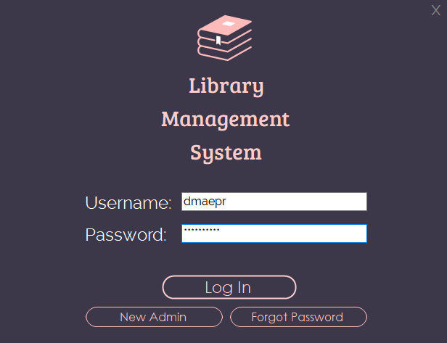

Figure 1: User Log-in

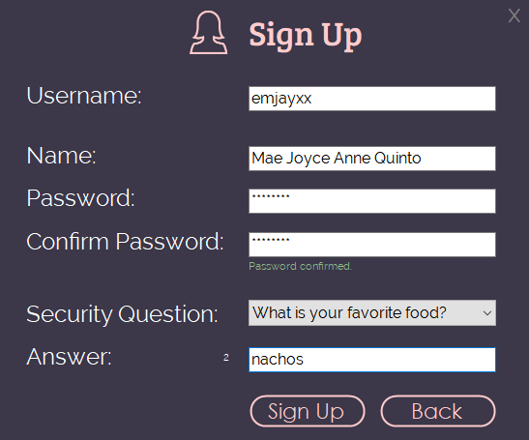

Figure 2: User Sign up

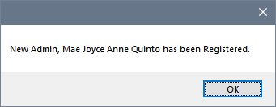

Figure 3: User message box

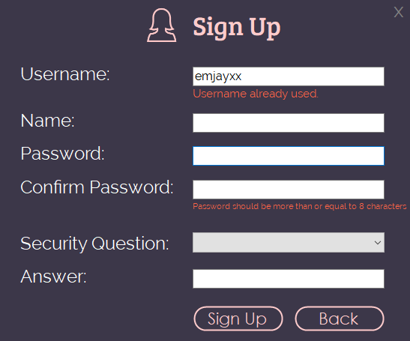

Figure 4: User verifications

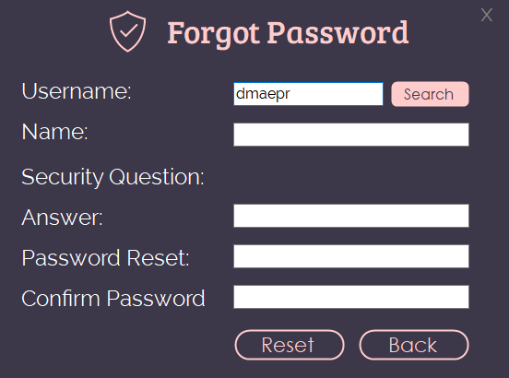

Figure 5: Forgot Password with reset

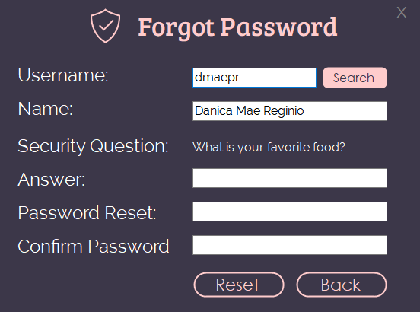

Figure 5: Forgot Password with searched username

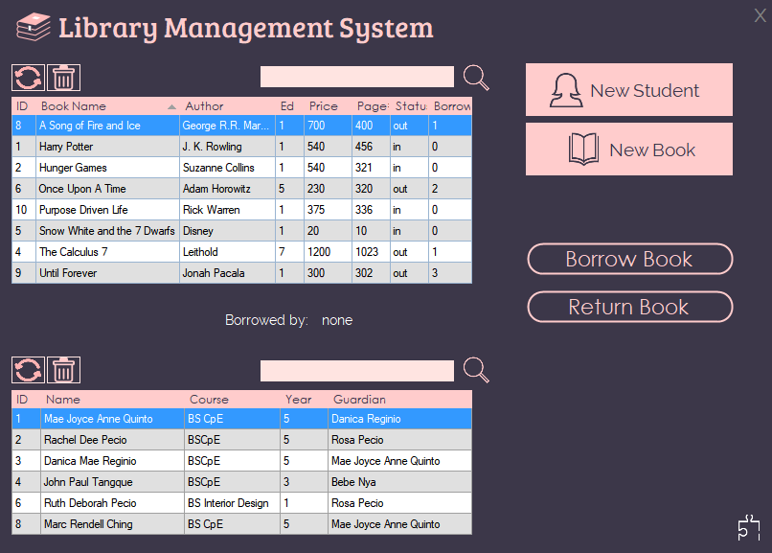

Figure 6: Home layout

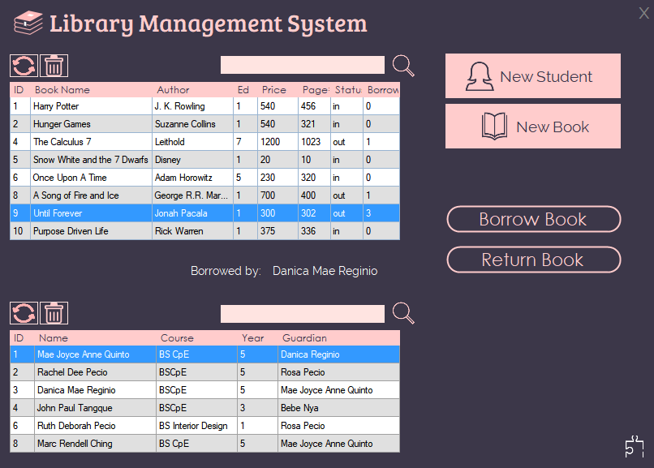

Figure 7: Home with Select Row and View Borrower

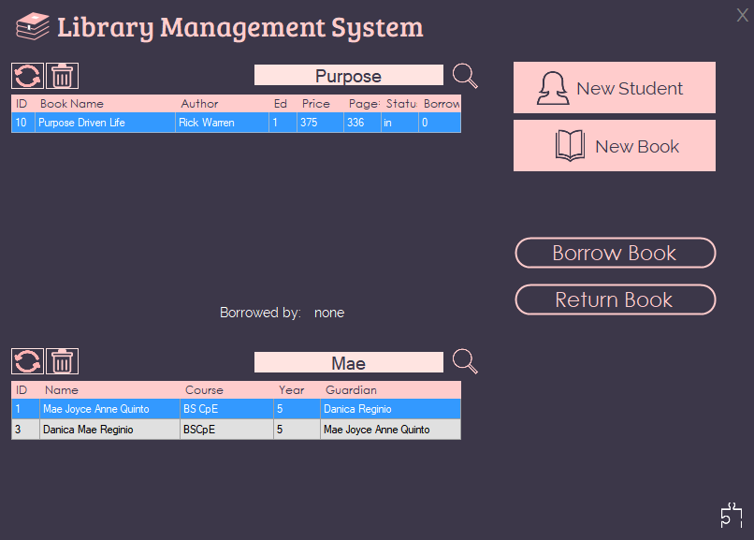

Figure 8: Home Layout + Search in Book and Student

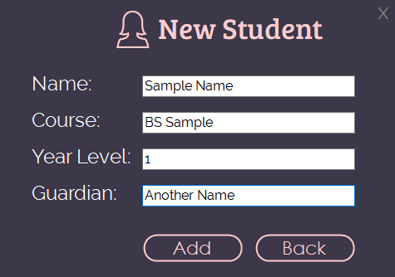

Figure 9: New Student

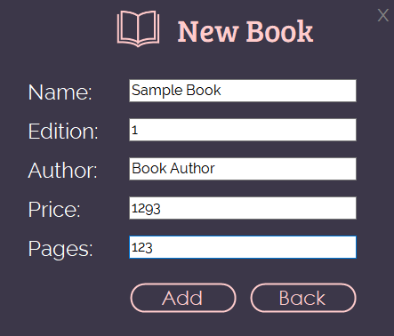

Figure 10: New Book

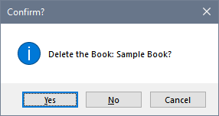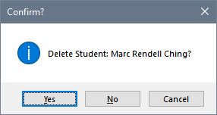

Figure 11: Delete Book/ Student Prompt

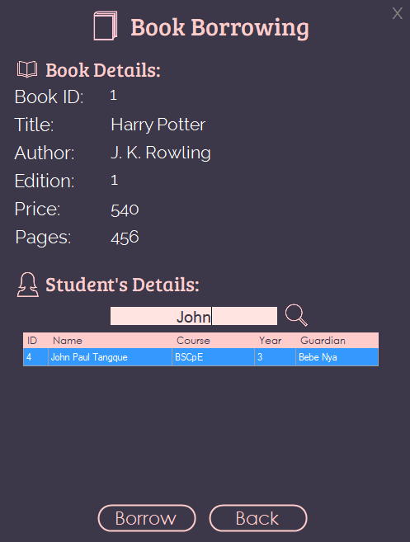

Figure 12: Book Borrowing with Student Search

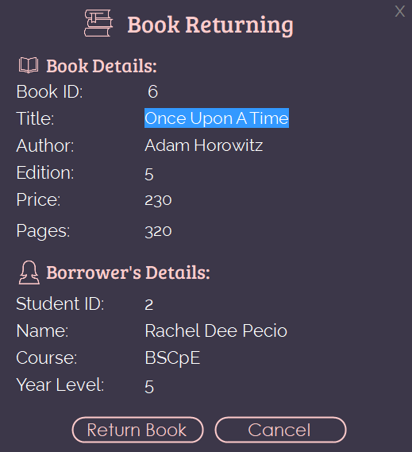

Figure 13: Book Returning

**SIGN OFF**

|  |  |  |  |
| --- | --- | --- | --- |
| Name | Position | Signature | Date Signed |
| Pecio, Rachel Dee | Back- End Developer |  |  |
| Quinto, Mae Joyce Anne | Front- End Developer |  |  |
| Reginio, Danica Mae | Project Manager |  |  |
| Tangque, John Paul | Quality Assurance |  |  |