1. Propensity Scores
   1. According to Clarke, Kenkel, & Rueda (2011), overadjusting for irrelevant covariates can create problems for interpreting propensity scores. Accordingly, I decided to use a stripped-down propensity model based on a subset of the variables. Output and a density plot of propensity estimates stratified by outcome are below.  
        
      Call:

glm(formula = qsmk ~ age + factor(sex) + factor(race), family = "binomial",

data = nhefs.final)

Deviance Residuals:

Min 1Q Median 3Q Max

-1.0824 -0.8079 -0.7051 1.3598 2.0738

Coefficients:

Estimate Std. Error z value Pr(>|z|)

(Intercept) -1.851517 0.226972 -8.157 3.42e-16 ***

age 0.022555 0.004698 4.801 1.58e-06 ***

factor(sex)1 -0.273412 0.112734 -2.425 0.0153 *

factor(race)1 -0.465416 0.182533 -2.550 0.0108 *

---

Signif. codes: 0 ‘***’ 0.001 ‘**’ 0.01 ‘*’ 0.05 ‘.’ 0.1 ‘ ’ 1

(Dispersion parameter for binomial family taken to be 1)

Null deviance: 1925.3 on 1678 degrees of freedom

Residual deviance: 1887.7 on 1675 degrees of freedom

AIC: 1895.7

Number of Fisher Scoring iterations: 4

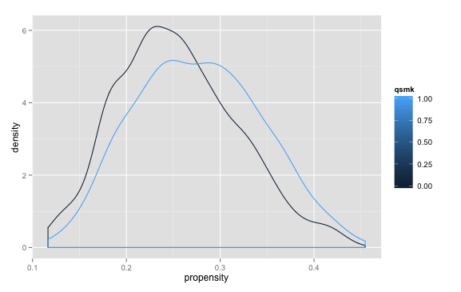

* 1. I classified propensity scores into quintiles and tertiles and regressed the primary outcome on the primary predictor and the propensity quantile of interest. Using propensity quintiles, the estimated average causal effect of quitting smoking is 2.837 kg of weight gained. Using propensity deciles, the estimate is 2.880 kg.  
       
     My R code is below.  
       
     ApplyQuantiles <- function(data,num) {

cut(data, breaks=c(quantile(data, probs = seq(0, 1, 1/num))),

labels=c(1:num),include.lowest=TRUE)

}

nhefs.final$rank5 <- with(nhefs.final,factor(ApplyQuantiles(propensity,5)))

nhefs.final$rank10 <-with(nhefs.final,factor(ApplyQuantiles(propensity,10)))

lm.rank5 <- lm(wt82_71~qsmk+rank5,data=nhefs.final)

lm.rank10 <- lm(wt82_71~qsmk+rank10,data=nhefs.final)

* 1. Propensity score estimates that predict the outcome “too perfectly” will have poor overlap, that is, the cells containing unusual outcomes for a particular set of predictors will be extremely small. Because of this, the estimates for the expected counterfactual given that set of covariates will be unreliable and misleading. (As you can see from the graph in 1a, this is not a problem for my analyses!)

1. Project idea