AutoRAG
Self-Improving RAG Platform with Autonomous Knowledge Compression
ENTERPRISE ARCHITECTURE DESIGN DOCUMENT
Version 1.0 · 15 May 2026 · Derived from PRD v2.3

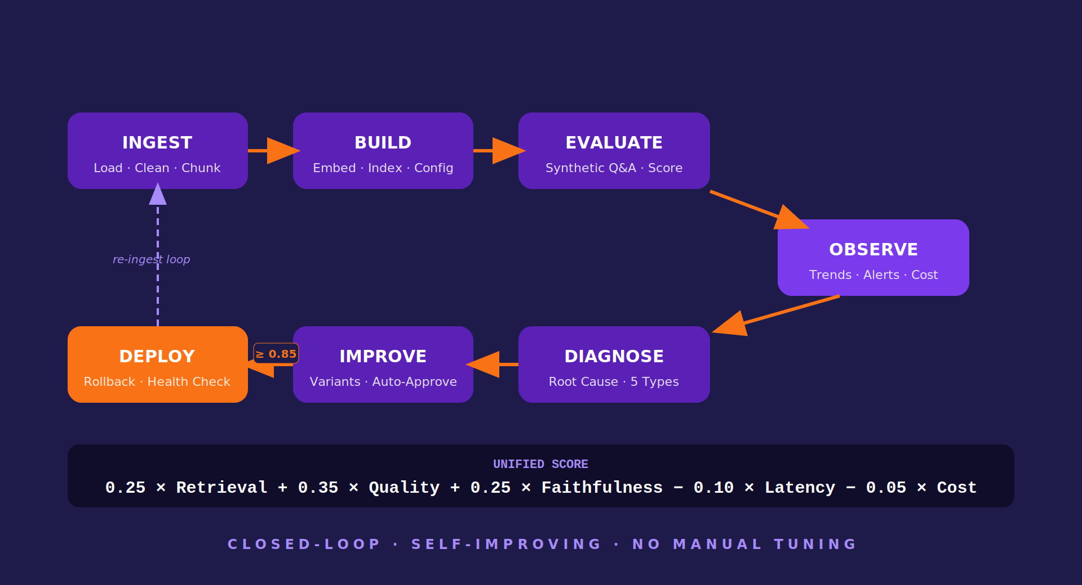
Version 1.0 | 15 May 2026 | CONFIDENTIAL

CONFIDENTIAL · © 2026 Euron AI Product Engineering · All Rights Reserved

Table of Contents
01. Executive Summary 3
02. Architecture Goals & Principles 4
03. High-Level Platform Architecture 5
04. Core Component Architecture 6
05. 7-Agent Autonomous Architecture 8
06. Data & Vector Architecture 10
07. AI / LLM Architecture 12
08. Workflow & Sequence Flows 13
09. Evaluation & Improvement Loop 14
10. Security & Governance Architecture 15
11. Deployment & Scalability Architecture 16
12. Observability & LLMOps 17
13. Resilience & Failover Design 18
14. Technology Stack 19
15. Architecture Decision Records 20
16. Future Architecture Roadmap 21
17. Conclusion 22

01 Executive Summary
AutoRAG establishes a new infrastructure category — Autonomous AI Quality Systems — by implementing a 7-agent closed loop that builds, evaluates, observes, diagnoses, improves, and deploys RAG pipelines without manual tuning or labeled data.
This document describes the complete technical architecture of AutoRAG v1.0. It is written for engineers who will build and operate the system, but deliberately uses plain language so that beginners can follow the design reasoning. Every architectural decision links back to a specific requirement in PRD v2.3.
Think of AutoRAG like a factory quality control system. A car factory doesn't have a human manually inspect every car — it has automated sensors, diagnostic tools, and improvement processes. AutoRAG does the same for AI pipelines: automated measurement (Evaluator), anomaly detection (Observer), root-cause analysis (Diagnoser), and automated improvement (Improver).

1.1 What This Document Covers
Table 1: Architecture Document Scope
Architecture Domain | What It Explains | Key Diagrams
Platform Architecture | How the 5 layers work together — what each layer does and why | Figure 1: 5-Layer Stack
Agent Architecture | How the 7 agents communicate and what each one is responsible for | Figure 2: Agent Workflow
Data Architecture | Where data lives, how it flows, how embeddings are stored | Figure 3: Retrieval Flow
AI/LLM Architecture | Which AI providers are used, how failover works | Figure 4: LLM Fallback
Evaluation Loop | How quality is measured and how improvement is triggered | Figure 5: Eval Loop
Security | Authentication, encryption, audit logging, trust boundaries | Figure 6: Trust Boundary
Deployment | Development, staging, production, on-premise environments | Figure 7: Deploy Topology
Observability | Monitoring, alerting, LLMOps loop | Figure 8: Monitoring Arch
Resilience | Retry logic, circuit breakers, provider failover | Embedded in §13
ADRs | Why each technology was chosen over alternatives | Tables in §15

02 Architecture Goals & Principles
Every architecture decision in AutoRAG traces back to one of six guiding principles. These are not abstract values — each maps to a concrete engineering constraint.
Table 2: Architecture Principles and Engineering Constraints
Principle | Plain English | Engineering Constraint
Measure First | You cannot improve what you cannot measure. Quality is quantified before anything else. | Evaluator Agent runs before Diagnoser or Improver. Score stored in PostgreSQL before next step.
Stateless Agents | Each agent is an independent, replaceable unit. One agent failing does not break others. | All agent state persisted to PostgreSQL or MinIO before hand-off. No in-memory cross-agent state.
Zero Cloud Lock-in | AutoRAG runs anywhere — on a laptop, a K8s cluster, or air-gapped server. | Docker Compose for dev. MinIO (not S3). Qdrant (not Pinecone). Local LLM via Ollama as fallback.
Immutable Audit Trail | Every decision the system makes is permanently recorded and cannot be changed. | audit_log table is INSERT-ONLY. No UPDATE or DELETE ever permitted. 11 event types logged.
Safe by Default | The system defaults to asking for human approval rather than acting autonomously on risky changes. | Faithfulness < 0.5 blocks deploy. Model swaps always require Mandatory Gate. PII halts ingestion.
Progressive Disclosure | A beginner can use it in 60 seconds. An expert can configure everything. | 5-question Configurator for beginners. Full YAML editable for experts. Same underlying engine.

2.1 Quality Targets from PRD v2.3
Table 3: Architecturally-Significant Performance Targets
SLO | Target | Architectural Implication
/query p95 latency | < 3 seconds | Qdrant HNSW search < 50ms + LLM < 2.5s. Embedding cached. Local fallback for latency spikes.
Evaluation cycle (50 Q&A) | < 5 minutes | Parallelised judge calls. Celery concurrency 2 per worker. LLM batching where supported.
Pipeline build time | < 5 minutes | Batch embeddings 100 chunks/call. Retry with backoff. MiniLM fallback if OpenAI rate-limited.
Configurator response | < 60 seconds | Rule-based engine (no LLM). Pure Python dict lookup. No external calls.
Unified Score accuracy | ≥ 90% classification | Validated against 200-failure test set. 3× averaging on borderline scores (0.40–0.60 range).

03 High-Level Platform Architecture
AutoRAG is organised as five horizontal layers. Think of these as the floors of a building — each floor has a clear job, and they communicate only through defined interfaces. This makes it easy to scale, debug, and replace any layer without affecting the others.
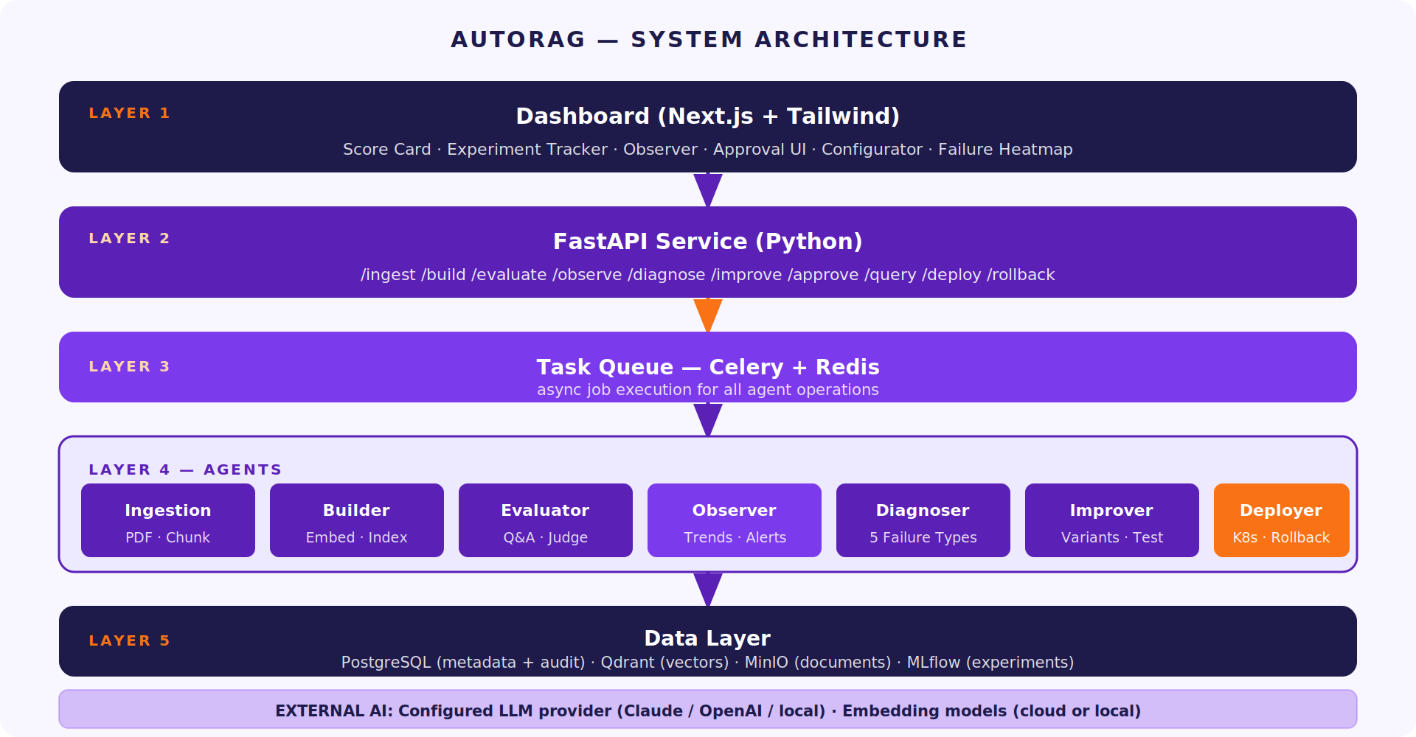
Figure 1: AutoRAG 5-Layer System Architecture — Dashboard to Data
Table 4: 5-Layer Architecture — Responsibility and Primary Components
Layer | Job | Primary Components | Talks To
Layer 1 — Dashboard | What users see. The face of the product. | Next.js 14, Tailwind CSS, shadcn/ui, Recharts | Layer 2 only (via REST API)
Layer 2 — API Service | Receives requests. Validates them. Dispatches work. | FastAPI, Pydantic, JWT/API-Key auth, OpenAPI | Layer 1 (responses) + Layer 3 (task dispatch)
Layer 3 — Task Queue | Runs long jobs asynchronously so API stays fast. | Celery, Redis broker, Flower monitoring | Layer 2 (receives tasks) + Layer 4 (runs agents)
Layer 4 — Agents | The intelligence layer. 7 specialised agents, each owning one stage. | 7 Python agent modules — stateless, independently scalable | Layer 3 (triggered by) + Layer 5 (read/write state)
Layer 5 — Data | Where everything is stored. Permanent record of all decisions. | PostgreSQL, Qdrant, MinIO, MLflow, Redis (session) | Layer 4 only (agents read and write)
Why layers? Imagine the Evaluator Agent suddenly needs more compute because you uploaded 10 large documents at once. With layers, you simply add more Celery workers (Layer 3) — you do not touch the API or the database. Each layer scales independently.

04 Core Component Architecture

4.1 Component Responsibilities
Table 5: Core Components — Responsibility, Technology, and Scaling Model
Component | Technology | Responsibility | Scaling Model
API Service | FastAPI (Python) | 14 REST endpoints; auth; request validation; async job dispatch | Horizontal — 3–10 replicas in production (HPA on CPU)
Task Queue | Celery + Redis | Async execution of all agent tasks; retry logic; job status tracking | Horizontal — 5–20 worker replicas (HPA on queue depth)
Ingestion Agent | Python + pypdf + Presidio | Load, clean, classify, chunk, PII-scan documents | Celery concurrency 4 per worker
Builder Agent | Python + OpenAI/MiniLM | Embed chunks; create Qdrant collection; store run record | Celery concurrency 2 (embedding API rate limit)
Evaluator Agent | Python + LLM judge | Generate 50 Q&A; score each; compute Unified Score | Celery concurrency 2; parallelised judge calls
Observer Agent | Python + PostgreSQL | Aggregate score trends; detect degradation; fire alerts | Runs as Celery beat scheduled task + on-demand
Diagnoser Agent | Python + LLM | Classify failures into 5 types; generate recommendations | Celery concurrency 4 (fast, low token usage)
Improver Agent | Python + Celery chain | Spawn 3–5 variant pipelines; compare scores; apply approval gate | Sequential — 1 per worker (expensive multi-step task)
Deployer Agent | Python + K8s API | Deploy best pipeline; run health check; trigger rollback if needed | Celery concurrency 1 (one deploy at a time)
Dashboard | Next.js 14 + Tailwind | 20-screen UI; real-time score cards; approval queue; audit log | Horizontal — 3–8 replicas; CDN for static assets
PostgreSQL | PostgreSQL 15 | All structured state — 9 core tables; append-only audit_log | Primary + 1 read replica in production; Patroni in P2
Qdrant | Qdrant (HNSW) | Vector store — 1 collection per pipeline run | Single node P1; multi-shard in P2 for >1M vectors
MinIO | MinIO (S3-compatible) | Raw documents + chunks — immutable object storage | Single node P1; distributed mode in P2
MLflow | MLflow OSS | Experiment artifact versioning; parameter and metric history | Single instance; shared across all pipeline runs
Redis | Redis 7 | Celery broker; short-term session state (TTL 24h) | Single node P1; Sentinel cluster in production

4.2 API Endpoint Summary
All endpoints use base path `/api/v1/`, JSON bodies, TLS 1.3, and JWT Bearer or X-API-Key authentication.
Table 6: 14 REST API Endpoints — Method, Path, Agent Triggered
Method | Endpoint | Triggers | Returns
POST | /ingest | Ingestion Agent (async) | job_id for status polling
POST | /pipelines | Builder Agent (async) | pipeline_run_id
POST | /pipelines/{id}/evaluate | Evaluator Agent (async) | job_id → Unified Score when done
GET | /observe | Observer Agent (sync) | Score trend, failure distribution, cost data
POST | /diagnose | Diagnoser Agent (async) | Failure type + remediation recommendation
POST | /improve | Improver Agent (async) | Best variant + approval status
POST | /approve | Approval gate | Deploy triggered or rejection logged
POST | /configurator | Rules engine (sync, no LLM) | YAML config + scoring profile
GET | /experiments | PostgreSQL query | List of all pipeline runs with scores
POST | /experiments/compare | PostgreSQL query | Side-by-side score + param diff
POST | /query | RAG Runtime (sync) | Answer + source chunks + latency_ms
POST | /deploy/{run_id} | Deployer Agent (async) | Deployment record + health check status
POST | /deploy/rollback | Deployer Agent (sync) | Previous version reinstated
GET | /jobs/{job_id} | Job tracker | {status: pending|running|done|failed, result}

05 7-Agent Autonomous Architecture
Each agent is a stateless Python module — it reads input from PostgreSQL or MinIO, does its job, writes output back, then exits. Agents do not communicate directly with each other. They communicate through shared state. This is like an assembly line — each station receives work, completes it, and passes the result to the next station via a shared conveyor belt (PostgreSQL).
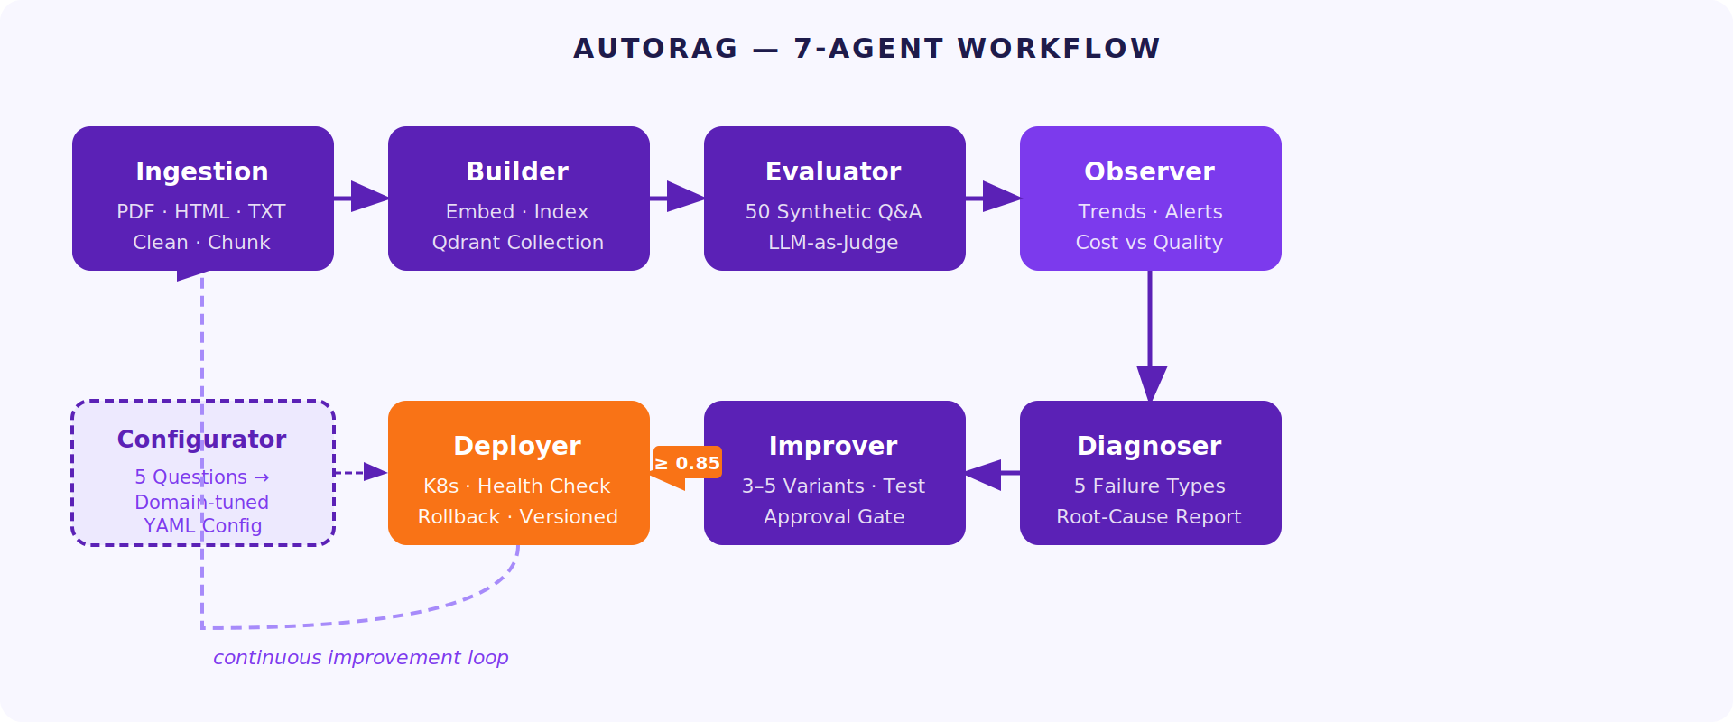
Figure 2: AutoRAG 7-Agent Closed-Loop Workflow with Configurator Entry Point

5.1 Agent Specification Table
Table 7: 7-Agent Architecture — Input, Output, Scaling, Key Integrations
Agent | Input | Output | Celery Concurrency | Key Integrations
Ingestion | Uploaded file path + config | Chunks in MinIO; metadata in PostgreSQL documents + chunks tables | 4 per worker | pypdf, BeautifulSoup, Presidio PII, Camelot (tables), Tesseract (OCR)
Builder | pipeline_run_id + YAML config | Qdrant collection created; pipeline_runs row written | 2 per worker (API rate limit) | OpenAI embeddings or MiniLM; Qdrant client; PostgreSQL
Evaluator | pipeline_run_id | evaluations rows (50); unified_score in pipeline_runs | 2 per worker; judge calls parallelised | LLM judge (Claude/GPT-4o/Ollama); Qdrant search; PostgreSQL
Observer | pipeline_run_id + time window | Score trend data; alert flags; cost vs quality metrics | Beat scheduled + on-demand | PostgreSQL aggregation queries; alert threshold checks
Diagnoser | evaluation_id (failed questions) | diagnoses row; failure type + remediation recommendation | 4 per worker | LLM classification call (low token); PostgreSQL; 200-case test set
Improver | diagnosis_id + current config | 3–5 variant pipeline_run rows; approval_log entry | 1 per worker (expensive) | Builder + Evaluator (spawned as sub-tasks); PostgreSQL; MLflow
Deployer | approved pipeline_run_id | deployments row; K8s config applied; health check result | 1 per worker (serial) | K8s API or Docker Compose; health check POST /query × 10; rollback trigger

5.2 Plugin Architecture (Extension Points)
AutoRAG defines three abstract interfaces for community and enterprise extensions. Any third-party implementation that satisfies the interface contract can be registered and used without modifying core agent code.
Table 8: Three Plugin Interfaces — Purpose and Validation Requirement
Interface | Abstract Method | Built-in Implementations | Validation Gate
RetrievalStrategy | retrieve(query, top_k) → List[Chunk] | DenseRetrieval (Qdrant), SparseRetrieval (BM25), HybridRetrieval | Must pass golden dataset; register via autorag.plugins registry
EmbeddingModel | embed(texts) → List[Vector] + dimension property | OpenAIEmbedding (1536-dim), MiniLMEmbedding (384-dim) | Collection naming must include dim suffix to prevent mismatch
LLMJudge | score(question, answer, context) → JudgeResult | ClaudeJudge, GPT4oJudge, OllamaJudge | ≥ 0.85 correlation with reference Claude judge on golden dataset

06 Data & Vector Architecture
Think of AutoRAG's data layer as four specialised filing systems, each optimised for a different kind of data. PostgreSQL is your structured records (spreadsheets). Qdrant is your similarity search engine (finds things that are semantically similar). MinIO is your file cabinet (stores the actual documents). MLflow is your lab notebook (tracks every experiment).
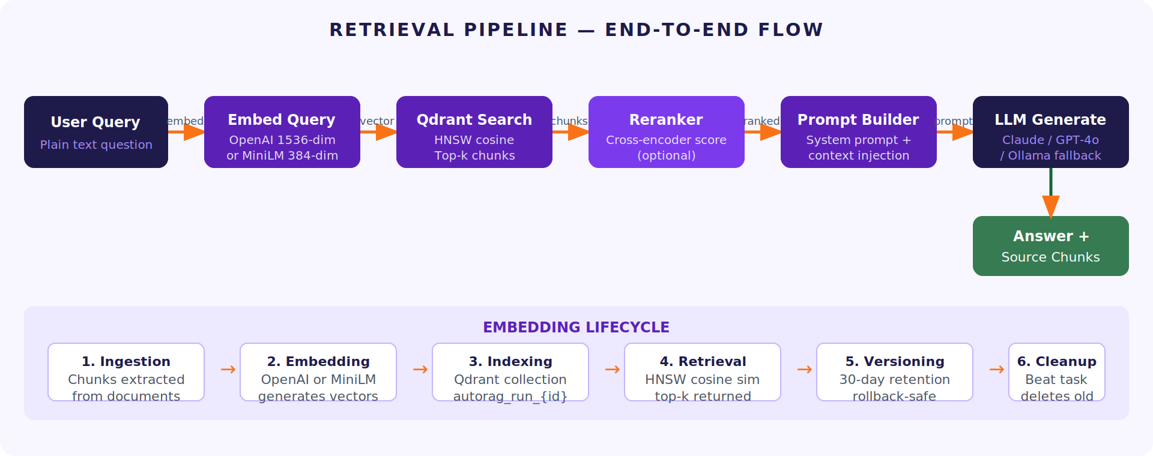
Figure 3: Retrieval Pipeline — User Query to Answer (with Embedding Lifecycle)

6.1 Storage Responsibility Matrix
Table 9: Four Stores — What Each Owns and Why
Store | Technology | What It Stores | Why This Store | Retention
Relational State | PostgreSQL 15 | Pipeline configs (JSONB), eval results, audit log, 9 core tables | ACID guarantees; JSONB for config snapshots; row-level security in P2 | Indefinite; daily backups; WAL archiving
Vector Embeddings | Qdrant (HNSW) | Chunk vectors — 1536-dim (OpenAI) or 384-dim (MiniLM); 1 collection per run | Purpose-built vector search; HNSW cosine; self-hostable; no cloud lock-in | 30 days non-active; permanent for production collection
Object Storage | MinIO (S3-compatible) | Raw PDFs, HTML, chunk text, ML artifacts | Full data residency; S3-compatible API; works offline; immutable by convention | Per policy; 7 years enterprise; 7 days for exports
Experiment Tracking | MLflow OSS | Parameter history, metric runs, artifact versioning | Version-controlled experiment reproducibility; self-hosted; Python-native | Indefinite production; 90 days experimental
Session State / Queue | Redis 7 | Celery task queue, active run session state | Sub-millisecond pub/sub; Celery native broker; TTL 24h auto-cleanup | TTL-based; 24h max for session; queue items consumed on completion

6.2 Qdrant Vector Store Design
Table 10: Qdrant Configuration Parameters
Parameter | Value | Why This Setting
Distance metric | Cosine similarity | Optimal for normalised text embeddings. Better than dot product for variable-length chunks.
Indexing algorithm | HNSW — m=16, ef_construct=200, ef_search=128 | Fast approximate nearest-neighbour. m=16 balances graph density vs memory. ef_search=128 for high recall.
Collection naming | autorag_{pipeline_id}_{version} | One collection per pipeline version. Rollback = switch collection. No data migration needed.
Payload fields | chunk_id, source_doc_id, page_number, chunk_text, embedding_model | Enables filtered search by document, page, or model without fetching from PostgreSQL.
Retention policy | 30 days (non-active); permanent (production) | Controlled by Celery beat cleanup task. Prevents unbounded storage growth during experiments.

6.3 Key Database Tables
Table 11: 9 PostgreSQL Core Tables — Purpose and Key Design Decisions
Table | Purpose | Key Design Decision
pipelines | YAML config snapshots; approval mode; scoring weights | JSONB for config — entire YAML stored as a single column. Never updated after creation.
pipeline_runs | One row per eval run — all 5 sub-scores + Unified Score | Immutable after creation. score fields are NOT NULL — evaluation always produces a score.
evaluations | Per-Q&A results — 50 rows per eval run | failure_type column set by Diagnoser; NULL until diagnosis runs.
experiments | Improvement variant history — links back to parent_run | variant_diff stored as JSONB. score_delta computed at insert time.
deployments | Active deployment record — one row per version | status field: active / superseded / rolled_back. Only one active per pipeline.
audit_log | Append-only event log — 11 event types | INSERT-ONLY enforced at database level. App user has no UPDATE or DELETE permission.
query_logs | Production /query traffic | Feeds Observer Agent trend analysis. Anonymised before LLM analysis.
agent_retries | Resilience log — every retry and circuit-breaker event | New in v2.3. Links to run_id for full traceability of provider failures.
doc_relationships | Cross-document citation graph | source→target with relationship_type (cites / supersedes / amends). CASCADE DELETE on pipeline deletion.

07 AI / LLM Architecture
AutoRAG never hard-codes a specific AI provider. The provider, model, and credentials are configured at deploy time via environment variables. This means an enterprise can run AutoRAG entirely with Claude, entirely on local Ollama models, or switch between providers without changing a single line of code.
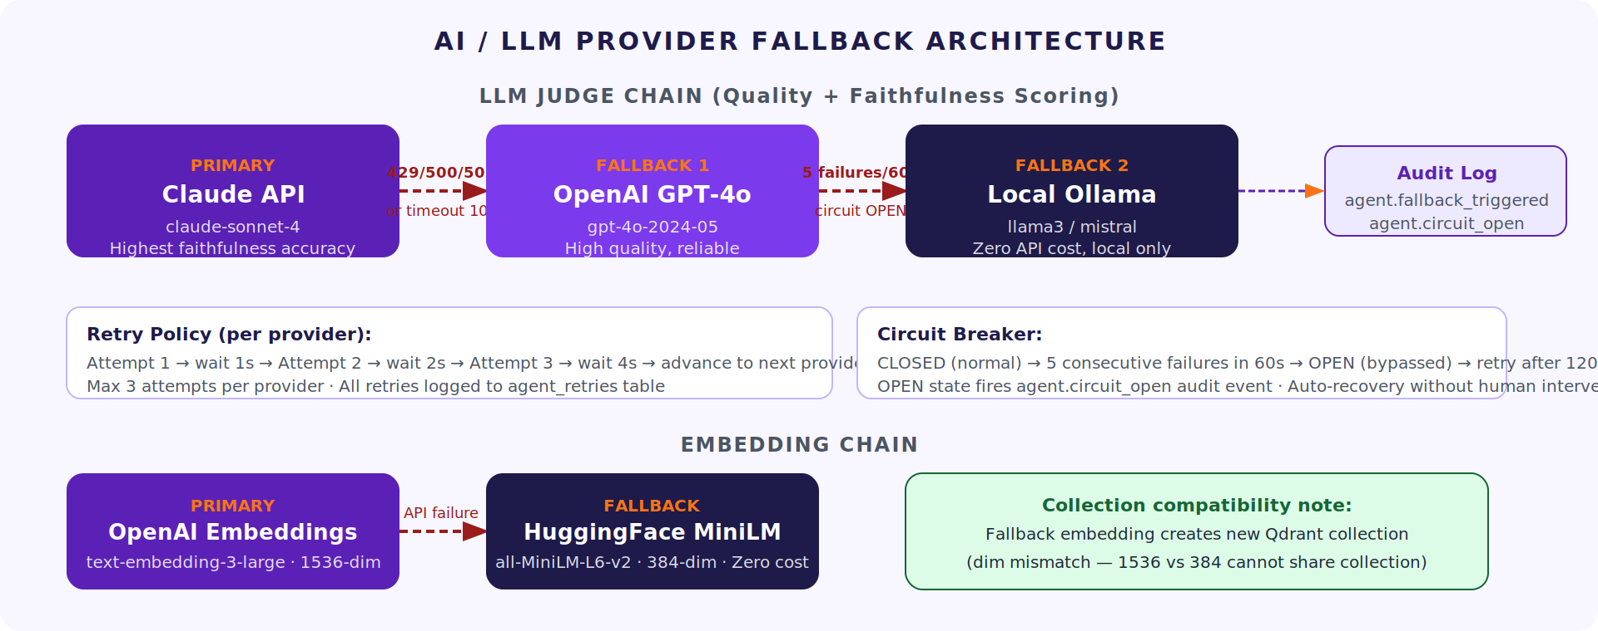
Figure 4: LLM Provider Fallback Chain — Primary, Fallback-1, Fallback-2 with Circuit Breaker

7.1 Provider Usage Matrix
Table 12: AI Provider Usage by Operation — Phase 1
Operation | Primary Provider | Fallback-1 | Fallback-2 | Est. Cost / 50-Q Eval
Q&A Generation | Claude Haiku | GPT-4o-mini | Local Ollama | ~$0.001
Quality Judge | Claude Sonnet | GPT-4o | Local Ollama | ~$0.09
Faithfulness Judge | Claude Sonnet | GPT-4o | Local Ollama | ~$0.09
Failure Classification | Claude Haiku | GPT-4o-mini | Local Ollama | ~$0.003
Cloud Embedding | OpenAI text-embedding-3-large (1536-dim) | — | HuggingFace MiniLM (384-dim) | ~$0.02/1K chunks
Local Embedding | MiniLM-L6-v2 (384-dim) | — | — | $0.00 (local compute)
RAG Generation | /query endpoint — configurable at deploy time | — | — | ~$0.001–0.005 per query

7.2 Domain Scoring Profiles
Table 13: 4 Built-in Domain Scoring Profiles — Weight Overrides
Profile | Domain | Retrieval | Quality | Faithfulness | Latency | Cost | Use When
Faithfulness-heavy | Legal, Medical | 0.20 | 0.30 | 0.45 | −0.03 | −0.02 | Hallucination is a compliance risk
Speed-heavy | Customer Support | 0.25 | 0.35 | 0.15 | −0.20 | −0.05 | Response time is primary UX concern
Completeness-heavy | Research, Internal KB | 0.35 | 0.35 | 0.20 | −0.05 | −0.05 | Comprehensive answers over speed
Balanced (default) | General purpose | 0.25 | 0.35 | 0.25 | −0.10 | −0.05 | No specific domain constraint

08 Workflow & Sequence Flows
These are the five key journeys through AutoRAG. Each is a sequence of steps — like a recipe. Read them left-to-right: what the user/system does, what happens next, where the result goes.

8.1 Document Ingestion Flow
Table 14: Ingestion Sequence — POST /ingest to Indexed Chunks
Step | Actor | Action | Output / State Change
1 | User | POST /ingest with file upload | FastAPI receives file; validates MIME type
2 | FastAPI | Dispatch ingest_document Celery task | Returns job_id immediately (async)
3 | Ingestion Agent | Classify document pages (text/table/image/mixed) | Page classification written to chunk metadata
4 | Ingestion Agent | Run Presidio PII scanner | PII detected → flagged in audit_log; processing paused for user decision
5 | Ingestion Agent | Chunk document (fixed-size or semantic based on config) | Chunks stored in MinIO; metadata in PostgreSQL chunks table
6 | Builder Agent | Embed chunks via OpenAI or MiniLM | Embedding vectors created (1536 or 384 dim)
7 | Builder Agent | Upsert vectors into Qdrant collection | Collection autorag_{pipeline_id}_{version} created and populated
8 | PostgreSQL | Write pipeline_runs row with config snapshot | Status: built; collection_name set; audit_log: pipeline.created

8.2 Query Lifecycle (POST /query)
Table 15: Query Sequence — Question to Answer with Source Chunks
Step | Latency Budget | Action | Notes
1. Embed query | < 100ms | OpenAI or MiniLM embeds user question | Same model as collection — dimension must match
2. Qdrant search | < 50ms | HNSW cosine similarity search; top-k chunks returned | Payload filter by doc_id if include_related_docs=true
3. Optional rerank | < 100ms | Cross-encoder reranks chunks if configured | Reduces context noise; increases faithfulness
4. Build prompt | < 5ms | System prompt + chunk context + user question assembled | Injection defence: chunks in delimited block
5. LLM generate | < 2,500ms | Configured provider generates answer | Fallback chain fires on timeout or 429/500/503
6. Log query | < 20ms (async) | query_logs row written; feeds Observer Agent | Non-blocking; does not add to user-perceived latency
7. Return | < 5ms | answer + source_chunks + latency_ms returned | related_docs appended if flag set
Total p95 | < 3,000ms | End-to-end p95 SLO from PRD v2.3 | Auto-rollback triggers if p95 > 5,000ms post-deploy

09 Evaluation & Improvement Loop
This is the heart of AutoRAG. Everything else exists to support this loop. The Evaluator measures quality, the Observer watches for degradation, the Diagnoser finds the root cause, and the Improver fixes it — automatically.
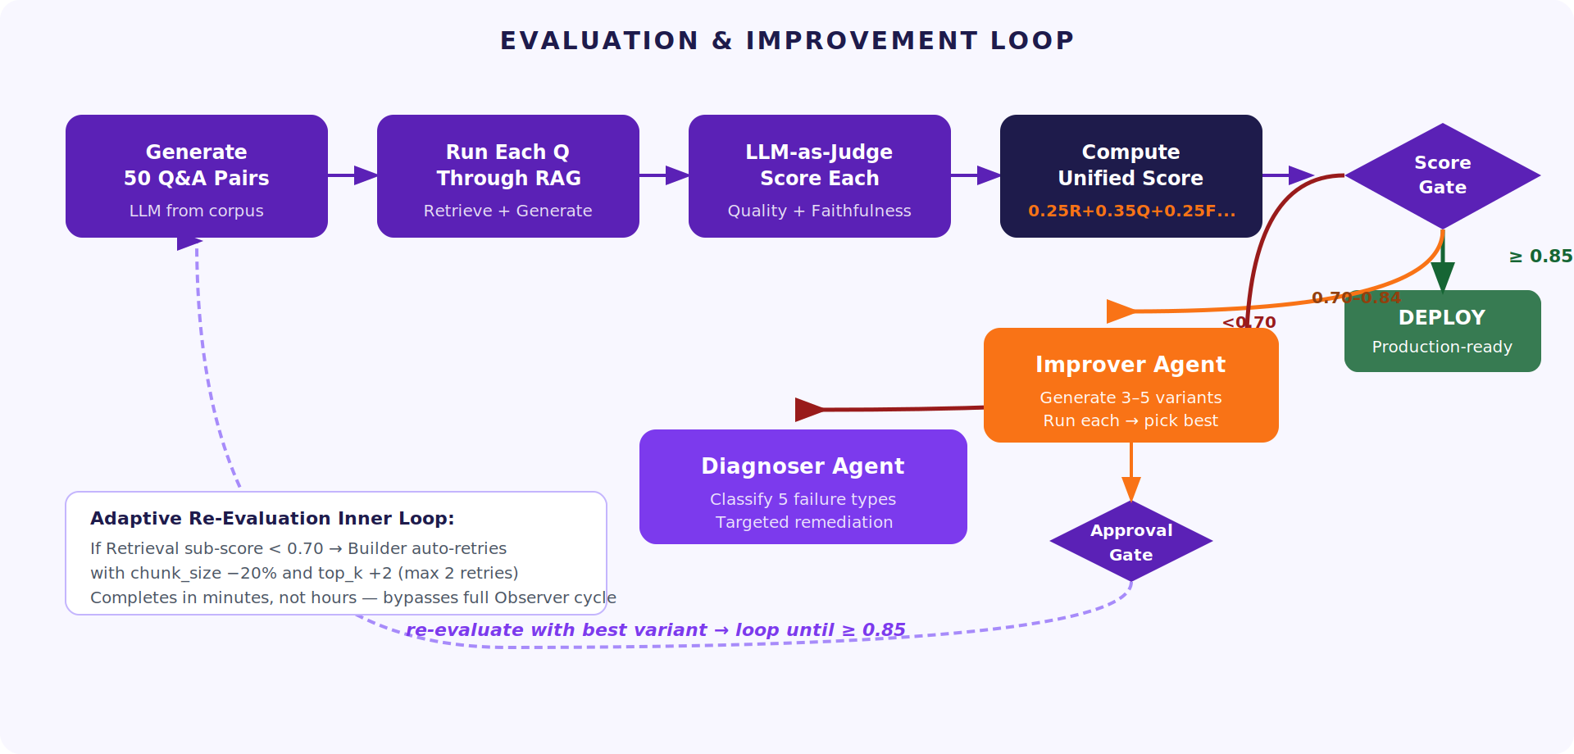
Figure 5: Evaluation & Improvement Loop — From Score to Approved Deployment

9.1 Unified Score Formula
Score = 0.25 × Retrieval + 0.35 × Quality + 0.25 × Faithfulness − 0.10 × Latency − 0.05 × Cost
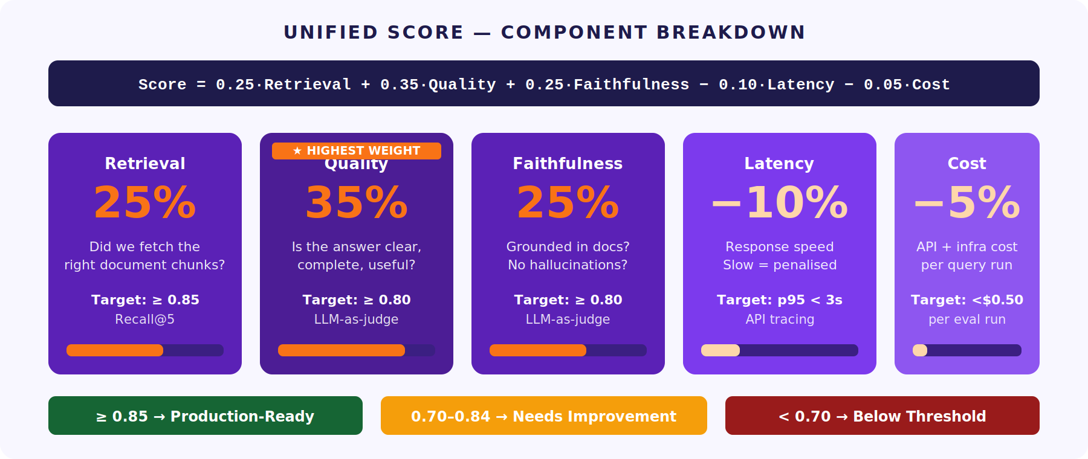
Figure 6: Unified Score Component Breakdown — Weights, Targets, Threshold Bands
Table 16: Score Thresholds and Automated System Actions
Score Range | Status | What Happens Automatically
≥ 0.85 | Production-ready | Deploy via safe-deploy protocol. Flag as best version. Continue Observer monitoring.
0.70 – 0.84 | Needs improvement | Trigger Improver Agent. Generate 3–5 variants. Test each. Submit best for approval.
< 0.70 | Below threshold | Block deployment. Run Diagnoser. Surface failure type + remediation to dashboard.

9.2 Improvement Approval Framework
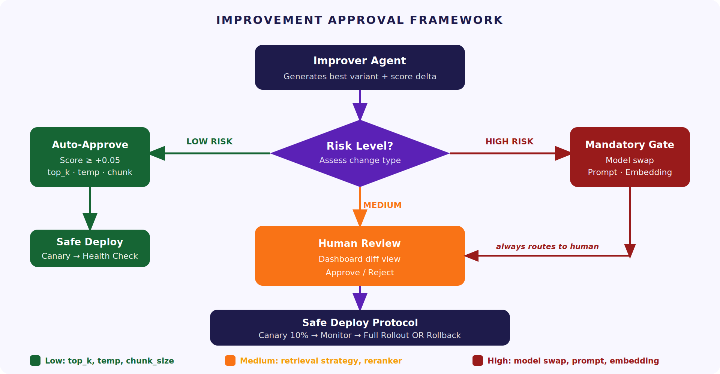
Figure 7: Improvement Approval Framework — Risk-Based Decision Tree
Table 17: Three Approval Modes — When Each Fires
Mode | Trigger Condition | What Happens | Can Be Bypassed?
Auto-Approve | Score improves ≥ 0.05 AND low-risk change (top_k, temp, chunk_size) | Safe deploy protocol executes automatically. audit_log: pipeline.approved. | Yes — enterprise setting can require human for all
Human-in-Loop | Enterprise governance mode OR medium-risk change (retrieval strategy swap) | Approval request surfaced in dashboard. Approver reviews diff + score delta. | No — must be resolved before deploy proceeds
Mandatory Gate | High-risk: model swap, system prompt change, embedding model change | Human approval always required. Cost ceiling check runs first. Data-residency rule enforced. | No — hard-coded guardrail in codebase

10 Security & Governance Architecture
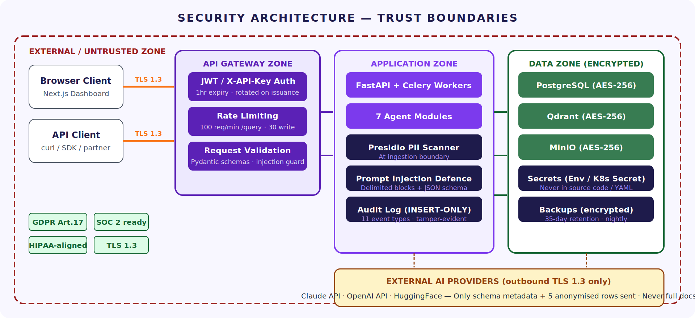
Figure 8: Security Architecture — Trust Boundaries and Data Protection Zones

10.1 Authentication & Authorisation
Table 18: Auth Controls by Component
Control | Mechanism | Detail
API Authentication | JWT Bearer (preferred) or X-API-Key | JWT: 1-hour expiry, 7-day refresh, RS256 in production; rotated on every issuance
Rate Limiting | Redis sliding window | 100 req/min per key for /query; 30/min for write ops; 200-req burst for first 30s
PII Detection | Presidio at ingestion boundary | Detected PII → flagged in audit_log; processing halted; never enters Qdrant vector store
Prompt Injection | Delimited context blocks + JSON schema validation | System prompt isolated from corpus content; all LLM outputs validated before storage
Secrets | Env vars (dev) / K8s Secrets (prod) | Never in source code, YAML, or logs; masked in all log outputs
Encryption at rest | AES-256 on all PVC volumes | PostgreSQL, Qdrant, MinIO; customer-managed keys in P2
Encryption in transit | TLS 1.3 mandatory | All API calls, internal service-to-service in production, LLM provider calls
Audit log | INSERT-ONLY PostgreSQL table | 11 event types; app user has no UPDATE or DELETE permission; tamper-evident

10.2 Governance Guardrails
- Faithfulness < 0.5 blocks deployment — hard-coded; cannot be disabled by config
- Model upgrades are always Mandatory Gate — Improver cannot auto-deploy a model switch
- Cost ceiling check before model recommendation — if projected cost > ceiling, recommendation blocked
- Local inference hard-block — if pipeline config has `inference_mode: local`, cloud model never recommended
- PII halts ingestion — detected PII pauses processing until human decision logged in audit_log

11 Deployment & Scalability Architecture
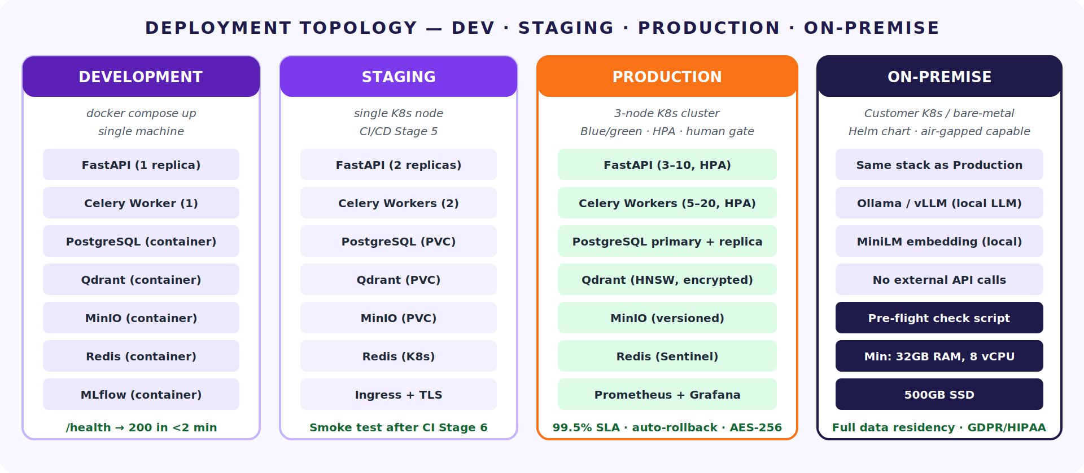
Figure 9: Deployment Topology — Development, Staging, Production, On-Premise

11.1 Environment Specifications
Table 19: Deployment Environments — Infrastructure and Purpose
Environment | Infrastructure | Min Spec | How to Start | Use Case
Development | Docker Compose — 7 containers on one machine | 8 GB RAM, 4 vCPU, SSD | docker compose up | Solo dev; fast iteration; zero config
Staging | Single Kubernetes node | 16 GB RAM, 4 vCPU | CI/CD Stage 5 (automated) | Integration testing; pilot demos; pre-release
Production | 3-node K8s cluster; HPA; blue/green | 3 × 32 GB RAM, 8 vCPU per node | CI/CD Stage 8 (post human approval) | Enterprise; HA; 99.5% SLO
On-Premise | Customer K8s / bare-metal; Helm chart; Ollama/vLLM for local LLM | 32 GB RAM, 8 vCPU, 500 GB SSD (min) | Helm install + pre-flight check | Air-gapped; full data residency; GDPR/HIPAA

11.2 CI/CD Gate Chain
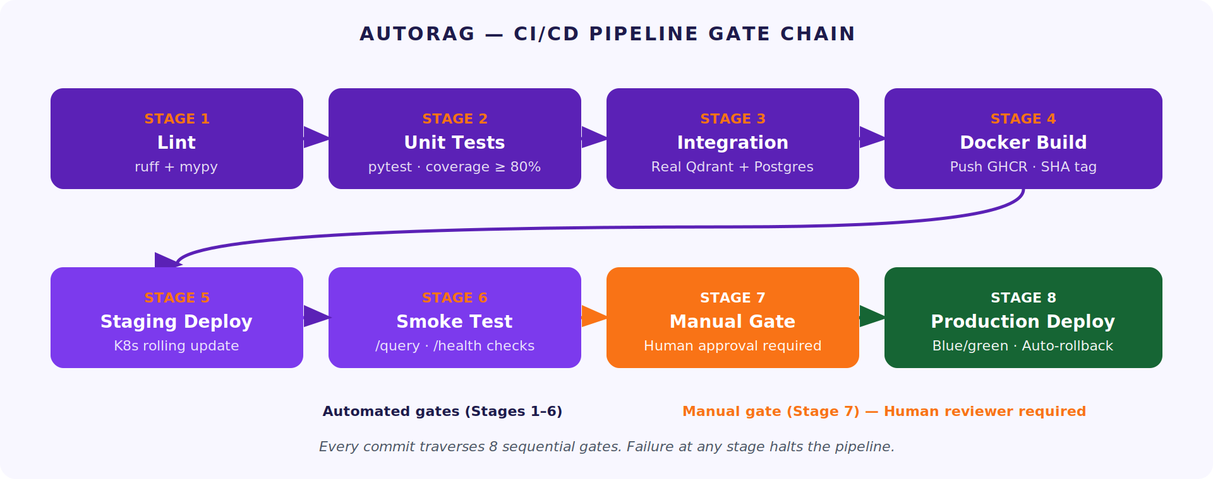
Figure 10: 8-Stage CI/CD Gate Chain — Automated Gates 1–6, Human Approval Gate 7
Table 20: CI/CD Stages — Tool, Action, Pass Criteria
Stage | Tool | Action | Pass Criteria
1 — Lint | ruff + mypy | Static analysis; type checking | Zero errors; no type violations
2 — Unit Tests | pytest | Module-level tests with coverage | Coverage ≥ 80%; all tests pass
3 — Integration | pytest + Docker Compose | Real Qdrant + PostgreSQL + Redis | All integration suites pass
4 — Docker Build | Docker + GHCR | Build API + worker + dashboard; SHA tag | Images build; size within threshold
5 — Staging Deploy | kubectl + Helm | Rolling deploy to staging | All pods Running; /health → healthy
6 — Smoke Test | pytest remote | POST /ingest → /build → /evaluate → /query | Unified Score ≥ 0.70; answer returned
7 — Manual Gate | GitHub Environments | Human reviewer approves prod deploy | Named reviewer explicit approval
8 — Prod Deploy | kubectl blue/green | Green deploy; traffic switch; blue 10-min standby | All pods healthy; p95 < 3s post-deploy

12 Observability & LLMOps
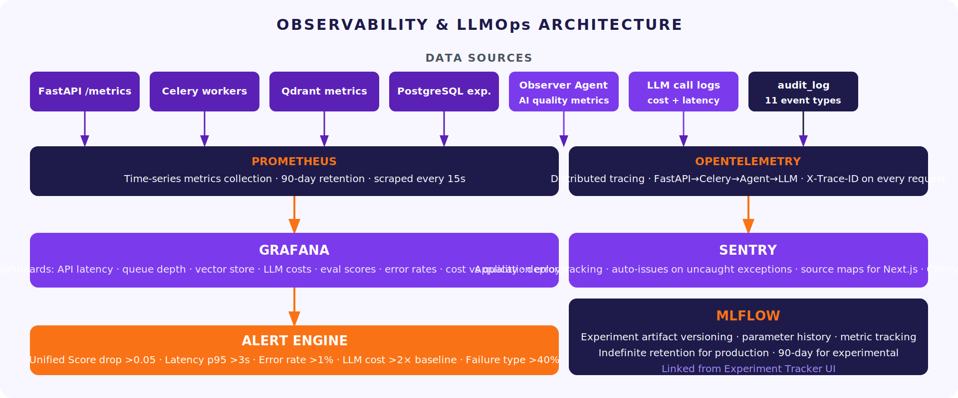
Figure 11: Observability Stack — Sources, Collection, Dashboards, Alerting, MLflow

12.1 AI-Specific Metrics Tracked by Observer Agent
Table 21: Observer Agent Alert Matrix
Metric | Source | Alert Threshold | Automatic Action
Unified Score trend (7-day) | Evaluator Agent | Drop > 0.05 vs baseline | Trigger Diagnoser → Improver chain
Query success rate | query_logs | < 0.95 over 1 hour | Alert + surface in Observer dashboard
Failure type concentration | Diagnoser Agent | Any type > 40% of failures | Surface dominant failure type prominently
LLM cost-per-query | Evaluator + query_logs | > 2× baseline for 4 hours | Alert; check if model upgrade was made
Latency p95 (rolling 15 min) | OpenTelemetry tracing | > 3 seconds | Alert; check Qdrant health and LLM provider
Faithfulness (production sample) | Periodic re-evaluation | < 0.70 | Trigger full evaluation cycle

12.2 LLMOps Continuous Loop
AutoRAG does not fine-tune models. Its LLMOps loop continuously improves pipeline configuration, not model weights. The loop has two paths — a slow path through the Observer (hours) and a fast inner loop through the Evaluator (minutes).
Table 22: LLMOps Two-Speed Improvement Architecture
Loop | Trigger | Path | Typical Duration
Outer Loop (standard) | Observer detects score drop > 0.05 | Observer → Diagnoser → Improver → Approval → Deploy | 4–6 hours end-to-end
Inner Loop (adaptive) | Retrieval sub-score < 0.70 on any eval | Evaluator → Builder (adjusted params: chunk_size −20%, top_k +2) → Re-evaluate | Minutes; max 2 retries
Scheduled Re-evaluation | Weekly Celery beat task | Evaluator runs full 50-Q cycle against production pipeline | 5 minutes; feeds Observer trend data

13 Resilience & Failover Design
AutoRAG is designed to keep working even when external services fail. Think of it like a car with a spare tyre and roadside assistance — the primary solution is preferred, but there are always fallbacks. Every failure event is logged so you can see exactly what happened and why.

13.1 Provider Resilience Envelope
Table 23: Resilience Controls — Retry, Circuit Breaker, Fallback
Control | Mechanism | Configuration | Logged To
Retry policy | Exponential backoff per provider | Attempts 1→2→3; waits 1s→2s→4s; max 3 per provider before advancing | agent_retries table: all attempts
Circuit breaker | Provider marked OPEN after 5 failures in 60s | Re-tests after 120s; auto-recovery; HALF-OPEN state for test | audit_log: agent.circuit_open
LLM failover | Claude → GPT-4o → Local Ollama | Triggers on HTTP 429, 500, 503 or timeout > 10s | audit_log: agent.fallback_triggered
Embedding failover | OpenAI → HuggingFace MiniLM | Automatic on API failure; new Qdrant collection created (different dim) | audit_log: agent.fallback_triggered
Retrieval fallback | Dense → Hybrid if Retrieval score < 0.70 | Max 2 auto-retries; surfaced as Retrieval Miss if both fail | agent_retries; then Diagnoser classifies
Pipeline rollback | Previous Qdrant collection + config reinstated | Auto: score drop >0.10, p95 >5s, error rate >1%; Manual: POST /deploy/rollback | audit_log: pipeline.rolled_back

13.2 Rollback Strategy
- Every pipeline version is preserved — Qdrant collection per version; PostgreSQL snapshot per run; 30-day retention
- Rollback is a config switch — route traffic to previous Qdrant collection; no data migration needed
- Three auto-rollback triggers — Unified Score drop > 0.10 post-deploy; p95 latency > 5s; API error rate > 1%
- Recovery time < 2 minutes — rollback is a single API call (POST /deploy/rollback) or one dashboard click
- Blue/green in production — new version deployed to green environment; traffic switched after health check; blue retained 10 min

14 Technology Stack
Table 24: Complete Technology Stack — Component, Version, Purpose, Layer
Component | Technology + Version | Purpose | Layer
API Framework | FastAPI (Python 3.11) | REST API; async; Pydantic validation; auto OpenAPI docs | API
Task Queue | Celery 5 + Redis 7 | Async agent execution; retry logic; job status | Task Queue
Relational DB | PostgreSQL 15 | All structured state; 9 core tables; audit log | Data
Vector Store | Qdrant (latest stable) | HNSW vector search; 1 collection per pipeline run | Data
Object Storage | MinIO (RELEASE.2024) | S3-compatible; raw docs + chunks; immutable | Data
Experiment Tracking | MLflow 2.x | Artifact versioning; parameter + metric history | Data
Cache / Broker | Redis 7 | Celery broker; session state TTL 24h | Task Queue / Data
Frontend | Next.js 14 + Tailwind CSS + shadcn/ui | 20-screen dashboard; SSR; real-time score cards | Dashboard
Charts | Recharts | Score trend charts; failure heatmaps; cost graphs | Dashboard
Cloud Embedding | OpenAI text-embedding-3-large | 1536-dim embeddings for maximum retrieval accuracy | Agents
Local Embedding | HuggingFace MiniLM-L6-v2 | 384-dim; zero cost; local fallback | Agents
LLM Primary | Claude Sonnet 4 (Anthropic) | Q&A judge; faithfulness judge; RAG generation | Agents
LLM Fallback-1 | OpenAI GPT-4o | LLM fallback when Claude unavailable | Agents
LLM Fallback-2 | Ollama (local) | Air-gapped / cost-zero LLM fallback | Agents
PII Detection | Microsoft Presidio | PII scan at ingestion boundary | Agents
Tracing | OpenTelemetry SDK | Distributed tracing across all layers | Observability
Metrics | Prometheus + Grafana | 8 dashboards; 90-day retention; alerting | Observability
Error Tracking | Sentry | Auto-issues on exceptions; source maps for Next.js | Observability
CI/CD | GitHub Actions | 8-stage gate chain; GHCR image push | Deployment
Container | Docker + Kubernetes | Dev: Compose; Staging: single node; Prod: 3-node cluster | Deployment
K8s Config | Helm charts | Templated K8s deployment; one-click installer in P2 | Deployment
Type Checking | mypy (strict) | Python type safety enforced in CI | Engineering
Linting | ruff | Fast Python linter; replaces flake8 + black | Engineering

15 Architecture Decision Records
An Architecture Decision Record (ADR) explains why a technology was chosen. Each one below follows the same format: Decision → Rationale → Alternative Considered. Read these if you ever wonder 'why did we use X instead of Y?'
Table 25: 7 Architecture Decision Records
# | Decision | Rationale | Alternative Considered
ADR-01 | FastAPI over Django REST | Async-native; Pydantic validation built-in; auto-generates OpenAPI docs; faster for high-concurrency agent dispatch | Django REST — more batteries included but sync-first; heavier for this use case
ADR-02 | Qdrant over pgvector or Pinecone | Self-hostable (no cloud lock-in); dedicated HNSW indexing; payload filtering without joining PostgreSQL; collection-per-run enables version-safe rollback | pgvector — simpler ops but no dedicated index tuning; Pinecone — SaaS lock-in, no data residency
ADR-03 | PostgreSQL over MongoDB | ACID guarantees for audit log; JSONB for flexible config snapshots without schema migration; RLS foundation for P2 multi-tenant | MongoDB — flexible but weaker ACID; audit log integrity not guaranteed
ADR-04 | Celery + Redis over Temporal | Python-native; simpler ops; no separate Temporal server; sufficient for AutoRAG's linear agent DAG; Redis already needed for session state | Temporal — more powerful state machine but adds operational complexity; overkill for P1
ADR-05 | MLflow over Weights & Biases | Fully self-hosted; no SaaS dependency; Python-native; sufficient for experiment tracking without LLM fine-tuning | Weights & Biases — better UI but requires external SaaS account; violates data-residency for enterprise
ADR-06 | Next.js over React SPA | Server-side rendering for faster initial load; file-based routing matches 20-screen inventory; Tailwind CSS + shadcn/ui for fast component development | React SPA (Vite) — simpler but slower initial load; no SSR; more bundler configuration
ADR-07 | 7-Agent design over monolith | Each agent is independently scalable, testable, and replaceable; failure isolation — Diagnoser failure does not affect /query; Plugin interfaces enable community extensions | Single service — simpler initially but becomes a bottleneck as evaluation and improvement tasks grow

16 Future Architecture Roadmap
Table 26: Phase 2 and Phase 3 Architecture Extensions
Phase | Feature | Architectural Change | Target Date
P2 | Multi-model support (Gemini, Mistral, Llama) | Add providers to LLM abstraction layer; update fallback chain; re-calibrate scoring benchmark | Sept 2026
P2 | Kubernetes one-click installer | Package Helm chart; add pre-flight check script; on-premise spec (32GB RAM, 8 vCPU, 500GB SSD) | Sept 2026
P2 | RBAC + SSO | Role-based access on FastAPI middleware; SAML 2.0 / OIDC in auth layer; user table in PostgreSQL | Sept 2026
P2 | Prometheus + Grafana managed | Add Prometheus operator to K8s Helm chart; 8 pre-built Grafana dashboards shipped with installer | Sept 2026
P2 | PostgreSQL read replica + Patroni HA | Primary/replica failover; connection pooling via PgBouncer in Helm chart | Sept 2026
P2 | Qdrant multi-shard | Horizontal Qdrant scaling for corpora > 1M vectors; collection routing layer in Builder Agent | Sept 2026
P3 | SaaS Cloud tier | Multi-tenant PostgreSQL (schema-per-tenant); tenant-scoped Qdrant namespaces; managed LLM cost budgeting | Dec 2026
P3 | SOC 2 Type II audit | Formalise audit log export; pen-test; access review automation; audit evidence collection tooling | Dec 2026
P3 | Adaptive scoring weights | Re-calibrate Unified Score weights after each pilot cohort using production query logs; weights versioned | Dec 2026
P3 | SharePoint + Confluence connectors | Ingestion Agent plugin for enterprise document sources; OAuth 2.0 auth; incremental sync | Dec 2026

17 Conclusion
AutoRAG's architecture is built around one idea: a RAG system that never stops improving itself. The 7-agent closed loop — Ingest, Build, Evaluate, Observe, Diagnose, Improve, Deploy — is the engine. The Unified Score is the fuel gauge. The approval framework is the safety net.
Every architecture decision in this document — from the choice of Qdrant over pgvector, to the use of Celery over Temporal, to the plugin interface design — traces back to three principles: zero cloud lock-in, immutable audit trail, and safe by default. These principles make AutoRAG deployable anywhere, trustworthy for regulated industries, and extensible by the open-source community.
For a beginner reading this document: start with Section 3 (the 5-layer architecture), then Section 5 (the 7 agents), then Section 9 (the evaluation loop). Those three sections contain the core ideas. Everything else is implementation detail that you will need when you build each component.
The architecture is designed to be built in 45 days by 1–2 engineers. It is not over-engineered for Phase 1 — the goal is a working, measurable, improvable RAG system. The complexity in Sections 11–13 is Phase 2 and Phase 3 work. Ship Phase 1 first.

AutoRAG | Enterprise Architecture Design Document v1.0 | Derived from PRD v2.3 | May 2026
CONFIDENTIAL — For Engineering & Product Review | Euron AI Product Engineering 2.0
Prepared by Euron Architecture Team | May 2026 | architecture@euron.one

