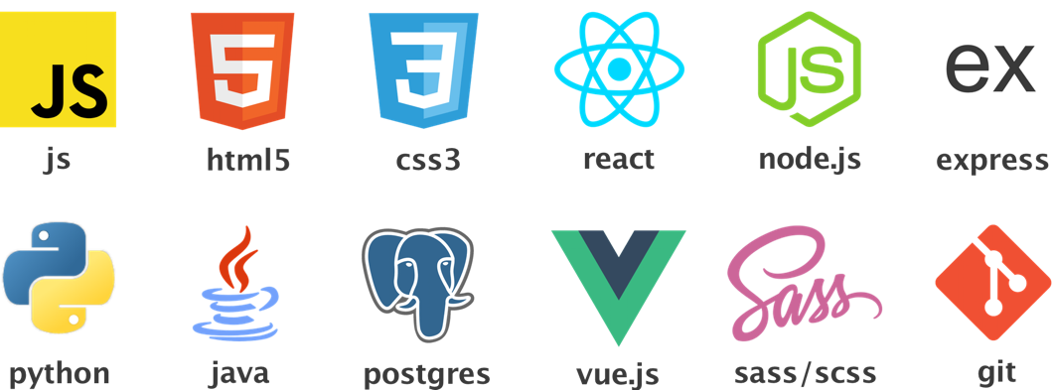

EMILY KEATOR

(904)-248-8155

[emkeator@gmail.com](mailto:emkeator@gmail.com)

[/in/emkeator](http://www.linkedin.com/in/emkeator)

[github.com/emkeator](https://github.com/emkeator)

[emkeator/personal-portfolio](https://emkeator.github.io/personal-portfolio/#/)

PROJECTS

[**On The Fly Travel App – Personally Developed Web App**](https://travel-showcase-app.herokuapp.com/#/login)

**React / Node.js / Express.js / PostgresSQL / Socket.io / AmazonS3 / Auth0 / Sass –** [**Video Tour**](https://youtu.be/eMnqAk2lCHM)

**Developed a full-stack web app for travel, with which a user can log in, plan & save trips, get flights & hotels, and chat with an “agent”.**

* **Used React to create components, including a chat component that connects to socket.io and allows image uploads.**
* **Integrated RESTful API calls to the server to get data, such as user data from database or external API data for airport codes.**
* **To try the app, use the email “testingtravelapp@gmail.com”, and the password “testingTravel”.**

[**Black Canary Safety – Group Developed Web App**](https://blackcanarysafetyapp.herokuapp.com/#/)

**React / GSAP / Sass / Google Maps API / Socket.io / PostgresSQL / Auth0 –** [**Video Tour**](https://youtu.be/cw8VR4JNrwk)

**Worked within a group of student developers to create a safety app that tracks the user’s location and allows them to send alerts, and their location, to their friends in a variety of locations.**

* **Created multiple interactive components for the frontend, including the geolocation and Google Maps API components.**
* **Designed and developed fully-responsive views using sass and photoshop, including animations.**
* **Collaborated with backend teammate in connecting the back and front-end data over socket.io, and with database logic.**

[**Ballet Salt Lake City – Personally Developed Web App**](http://balletslc.com/#/)

**React / Node.js / Express.js / PostgresSQL / GSAP / Stripe API / jQuery / Sass / Photoshop –** [**Video Tour**](https://youtu.be/K9R78UiJn-c)

**Designed & developed a full-stack web app for a (fake) ballet company; won “Best Overall” in DevMountain Cohort 26.**

* **Used React to create components viewed through different browser routes, animated with GSAP & fully responsive with Sass**
* **Integrated axios calls to backend server to load and update data from PostgresSQL database, including ticket data**
* **Custom-designed sass and GSAP for a 3D-interactive view of theatre seats so that user can select & purchase tickets with Stripe**

[**Summit Sotheby’s Website Clone/Redesign – Personally Developed Web App**](https://vue-sothebys-clone.herokuapp.com/#/)

**Vue.js / Node.js / Express.js / CSS / HTML5**

**Worked to redesign and clone aspects of the Summit Sotheby’s Realty Website. Mainly a front-end app, this project was for the purpose of learning Vue.js and exercising HTML/CSS/JS skills, with a basic Node.js backend.**

* **Intend to add more functionality to the backend, and continue building and learning Vue.js.**

EXPERIENCE & EDUCATION

**DevMountain – Provo, UT CURRENT**

**DevMountain Mentor – Emphasis on Full-Stack Development with React, Sass, Node, Express, Massive, SQL**

**Taught students and collaborated on development projects for DevMountain; acted as a project manager for students in full-stack app building simulations. Through teaching, further mastered skills learned as a student. Helped build curriculum as office admin assistant & dev.**

**DevMountain – Provo, UT JULY 2017 – OCT 2017**

**DevMountain Student Developer – Emphasis on Full-Stack Development with React, Sass, Node, Express, Massive, SQL**

**Developed web apps regularly, while improving skills with in-class demos and projects.**

**National Institutes of Health (NIMH) – Bethesda, MD JUNE 2016 - JUNE 2017**

**Post-baccalaureate IRTA Fellow**

**Received prestigious post-bac Intramural Training Research Award, for work in genetic/genomic engineering.**

**Udacity (Front-End Nanodegree, Deep Learning Foundations Certificate) – Online NOV 2016 – JULY 2017**

**Student Developer/Programmer – Emphasis on Front-End Development & Neural Networks with TensorFlow, respectively**

**Earned nanodegree in Front-End Web Dev & certificate in Deep Learning Foundations through online coursework with regular projects.**

**Davidson College – Davidson, NC AUG 2012 – MAY 2016**

**Student – B.S. in Biology, GPA 3.96 (Major GPA 3.98), successful tutor in Center for Teaching & Learning**

**Awarded John I. Smith Honor Scholarship and National Merit Scholarship; received Alumni Association Award for highest freshman GPA. Relevant coursework includes: Data Structures (Java, Algorithms & Object-Oriented Programming), Bioinformatics (Python), Statistics.**