# Instructions for Cloning Assignment

For this assignment, we will use GitHub to distribute the assignment and for you to submit your work. For this, you will clone the assignment to get your own working copy of the assignment on your computer (or university lab computer). Once you have completed the assignment, you will turn it in through GitHub by creating an issue stating that your assignment is ready for review.

## Create your GitHub account

First, create your GitHub account by following the “[Git_Introduction](https://github.com/emkiley/GettingStarted/blob/master/Git_Introduction.pdf)”.

## Follow the assignment link

Follow the link to the assignment that’s posted on Canvas (the first assignment link is: <https://classroom.github.com/a/Yyw6zYf_> , but future assignments will have their own links). This will then create a new private repository for you on GitHub. This repository has everything you need to complete this assignment. It is viewable by yourself and your course instructors.

## Clone this assignment

To clone the assignment to your local computer, you can either use PyCharm or the command line.

### PyCharm

1. Open PyCharm
   1. If opens to an already created project, choose File -> Close Project. That should bring you to the dialog below.
2. In the dialog below, choose “Check out from Version Control” and choose “GitHub.  
   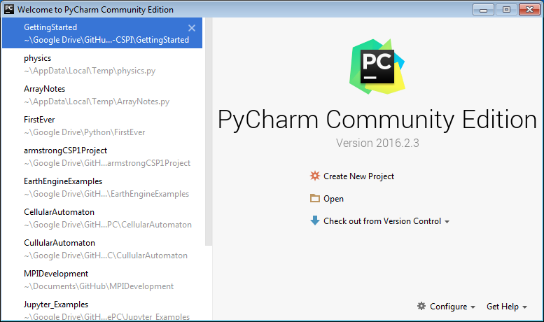
   1. PyCharm will ask for your GitHub username and password. If your password doesn’t work, then you’ll have to use a token for authentication. To create your token in GitHub, follow these instructions: <https://docs.github.com/en/authentication/keeping-your-account-and-data-secure/creating-a-personal-access-token> .
3. In the resulting dialog:
   1. Enter the url for YOUR GitHub assignment repository. This is the repository which was created when you followed the emailed link.
   2. Choose a “Parent Directory” location to store the local copy of the repository. This is where you will do your work.
   3. Choose a directory name. PyCharm will create this folder in the location specified by the “Parent Directory.”  
      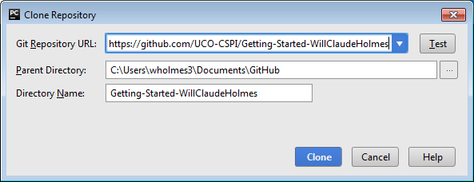
   4. Click “Clone”
4. PyCharm will download a local copy of your repository, and open with that project open. Note that you can access the files under the project.  
   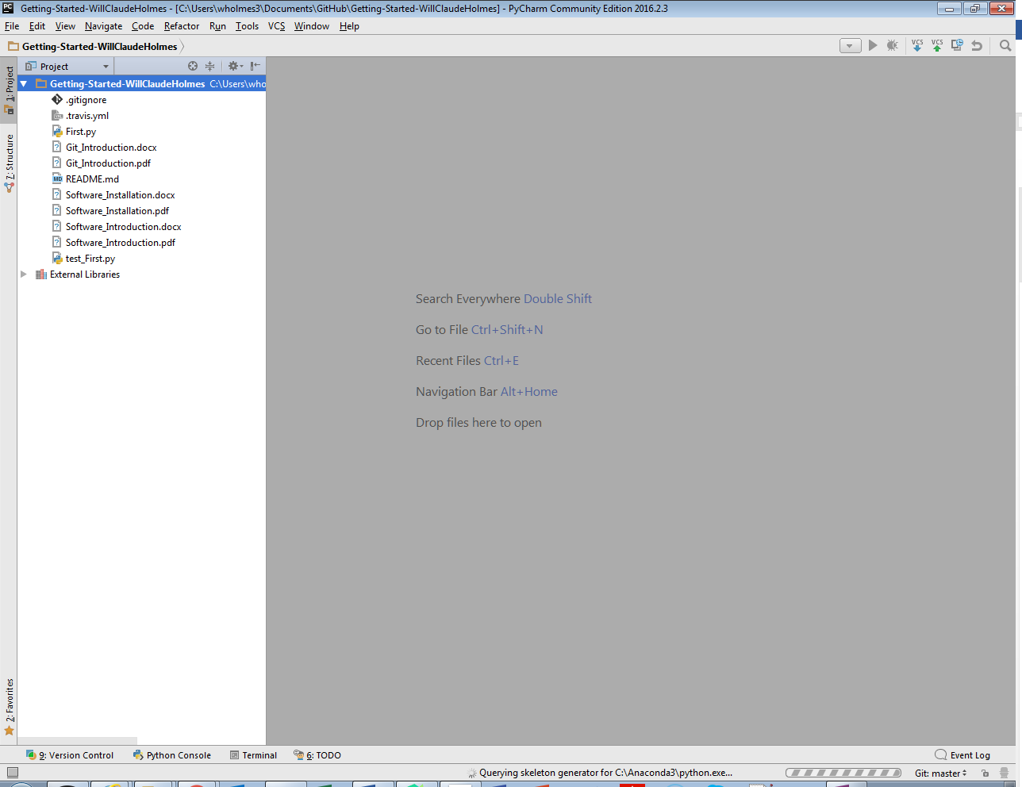
5. To change a file, simply click on the name of the file to edit it.
6. To add a new file, simply right-click on the directory name, and click “New File”.
7. To push changes back to the cloud, please follow these instructions: <https://www.jetbrains.com/help/pycharm/commit-and-push-changes.html#commit> .

### Command Line (Windows)

To use the command line to download the repository:

1. Open Windows PowerShell or Command Prompt
   1. For Windows PowerShell type PowerShell into the start menu search.
   2. For Windows Command Prompt, type cmd into the start menu search.
2. Browse to the folder in which you want the directory with your local copy of your repository.
   1. For me this is C:\users\emkiley\Documents\MATH365\
3. Clone the remote repository by typing ‘git clone’ and then the url of your remote repository. For me this would be:  
   git clone https://github.com/kileymcla/tools_git_tutorial-emkiley
4. Change directory into the newly created folder.
5. List the contents of the folder. It should contain the contents of the repository.
6. From here, you can open the project in PyCharm or edit First.py with your favorite text editor.

### Command Line (Mac OS or Linux)

1. Open your Terminal application (a bash or zsh shell).
2. Browse to the parent directory where you want to put the new directory with your local copy of your repository.
   1. For me, this is ~/Documents/MATH365/
3. Clone the remote repository by typing ‘git clone’ and then the url of your remote repository. For me this would be:  
   git clone https://github.com/kileymcla/tools_git_tutorial-emkiley
4. Change directory into the newly created folder.
5. List the contents of the folder. It should contain the contents of the repository.
6. From here, you can open the project in PyCharm or edit First.py with your favorite text editor.