**Project Plan**

***MedicomGo***

*Pharmapartners*

|  |
| --- |
| **Date : 08/10/2020** |
| **Version : 0.5** |
|  |
| **Authors : Bojidar, Mila, Emanuil, Vlad, Wondimu** |

#### Version history

|  |  |  |  |
| --- | --- | --- | --- |
| **Version** | **Date** | **Author(s)** | **Changes** |
| 0.1 | 05/09/2020 | Mila | First version |
| 0.2 | 08/09/2020 | Bojidar | Minor text changes, Communications updated, Strategy |
| 0.3 | 11/09/2020 | Bojidar | Removing repetitions, fixing spelling mistakes, remaking “Strategy” section |
| 0.4 | 20/10/2020 | Chao | Fill in testing environment and required resource |
| 1.0 | 17.01.2021 | Emanuil | Overall paragraph changes |

Contents

1. Project assignment 4

1.1 Context 4

1.2 Goal of the project 4

1.3 Scope and preconditions 5

1.4 Strategy 5

1.5 Research questions 5

1.6 Flowchart 6

2. Project organisation 8

2.1 Stakeholders and team members 8

2.2 Communication 8

3. Activities and time plan 9

3.1 Phases of the project 9

3.2 Time plan and milestones 9

4. Testing strategy and configuration management 12

4.1 Testing strategy 12

4.2 Test environment and required resources 12

# Project assignment

## Context

*PharmaPartners stands for enabling the best health care for the patients of their clients by implementing an application, which gives their clients the possibility to preview important data outside their workplace. Also, the company is hoping to find ICT solutions that can help in updating healthcare systems.*

*Currently, the company wants an application to be developed that is compatible with either mobile or small laptops so that  GP's can access the administration system, which contains the medical files, appointments of 10 million patients. In addition, the application can help the GP to see the information about the patients and his or her medical overview only by logging in to the mobile app, wherever they are.*

## Goal of the project

*In order to stimulate the innovation in the healthcare system, “Pharmapartners ” wants to improve the administration system for the general practioners by implementing a website portal that is accessable on mobile. By logging in, a general practitioner should have all the medical information he needs about the patient he/she is visiting.*

*This information includes: Name of the patient, address, medical history , medical overview, episodes, etc.*

* *Implement mobile application*
* *Improve the interaction between GP and their patients.*
* *Implement website portal with 10 million patients in the database.*
* *Improving the administration system*

## Scope and preconditions

|  |  |
| --- | --- |
| **Inside scope:** | **Outside scope:** |
| 1. Project plan | 1. Manual of the application |
| 1. Design document | 1. Dutch support for the application |
| 1. Application | 1. Dutch version of documentation |
| 1. Test document |

## Strategy

The methodology that we are going to use is Agile Scrum. It begins by a sprint planning phase, which is an event that has as purpose to define what can be delivered in the sprint and how that work will be achieved. Sprint planning is done in collaboration with the whole scrum team. In scrum, the sprint is a set period of time where all the work is done. However, before you can leap into action you have to set up the sprint. You need to decide on how long the time box is going to be, the sprint goal, and where you're going to start. The sprint planning session kicks off the sprint by setting the agenda and focus.

## Research questions

How to enhance the information management system of traditional doctors

Through ICT to improve work efficiency?

This question can be answered based on following sub questions:

* Compared with traditional information management methods, how to improve the efficiency of doctors going out through ICT ?

By observing the performance of doctors when they go out to work, they can obtain the information and tools they need to use when they go out, so as to know which aspects of these doctors spend unnecessary time when they are out of work. Create a simple user story based on the observed information, thereby simplifying the doctor’s out-of-work workflow. This makes it easier for developers to simplify unnecessary processes when designing mobile applications, thereby saving doctors’ time

* What data needs to be used in this new information management system?

Through a simple and efficient user story, you can get the patient data that the doctor needs to update or save while working out, so as to confirm what kind of data will be saved in the final database.

## Flowchart

The flowchart covers the functionalities, which the endproduct will cover and is being provided instead of a PBS.

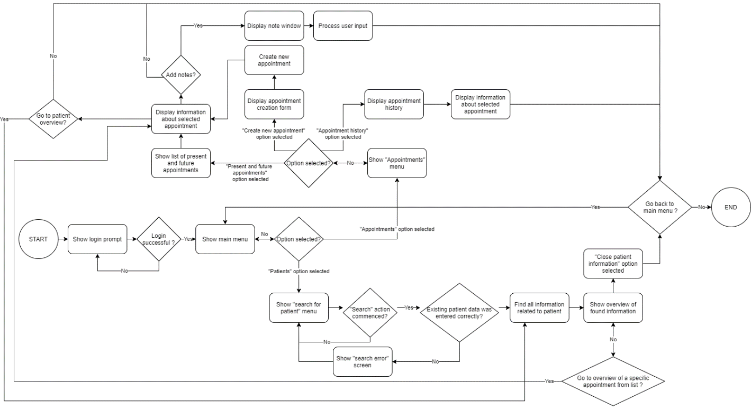

# Project organisation

## Stakeholders and team members

|  |  |  |
| --- | --- | --- |
| **Name** | **Role and functions** | **Availability** |
| Jeanne de Feber,  jeanne.de.feber@pharmapartners.nl | Project owner | Available only through email and for meetings on the end of each sprint. |
| Dennis de Wolf,  Dennis.de.Wolf@pharmapartners.nl | Project owner | Available only through email and for meetings on the end of each sprint. |
| Robbert Pas,  r.pas@fontys.nl | Mentor | Available during workdays. |
| Mila Marinova,  mila.marinova@student.fontys.nl  ,+359888087142 | Project developer | Available for the project on Monday,Tuesday,Wednesday,Friday,  Sunday and on these days I will working on the project the whole days. |
| Emanuil Karapachov,  e.karapachov@student.fontys.nl | Project leader, developer | Available during workdays. |
| Wondimu Gebre,  w.gebre@student.fontys.nl | Project developer | Available during workdays. |
| Bojidar Balabanov,  b.balabanov@student.fontys.nl | Project developer | Available every workday before 18:00. |
| Vlad Cojocariu,  v.cojocariu@student.fontys.nl | Project developer | Removed from group due to inactivity. |

## Communication

Currently due to the COVID-19 all meetings with the clients will be held online in Microsoft Teams, while group meetings will take place both at Fontys University and online in Microsoft Teams.

Meetings with the clients will be organized on the end of each sprint and group meetings will be held on Wednesdays and on Fridays, when needed also during other workdays.

Developer team is in constant contact on Microsoft Teams, if something happens help will be provided.

# Activities and time plan

## Phases of the project

*Sprint 0 – First draft of the project plan, user stories and setting up the management enviroment*

*Sprint 1 – Updating the project plan, implemeting backlog and updating it, making customer aware with out progress on,implementing back-end and front-end code.*

*Sprint 2 – Constantly updating internal documentation, Fixing bugs, implementing back-end and front-end code.*

*Sprint 3 - Constantly updating internal documentation,making customer aware with out progress on, deploying new functionality*

*Sprint 4- Final version of the internal documentation specifically project plan, deploying new functionalities and bugfixing.*

*Sprint 5- Doing some final touches on the project, updating documentation, testing the project, presenting the project to the Client.*

## Time plan and milestones

|  |  |  |
| --- | --- | --- |
| **Phasing** | **Start date** | **Finish date** |
| 1. Sprint 0 | 31-08-2020 | 18-09-2020 |
| 1. Sprint 1 | 19-09-2020 | 09-10-2020 |
| 1. Sprint 2 | 10-10-2020 | 06-11-2020 |
| 1. Sprint 3 | 07-11-2020 | 27-11-2020 |
| 1. Sprint 4 | 28-11-2020 | 16-12-2020 |
| 1. Sprint 5 | 17-12-2020 | 22-01-2021 |

**Sprint 0:**

* Acceptance criteria met for your architecture, e.g., you have discussed with the PO the architectural choices you made for your product
* First draft of the project plan complete and reviewed by semester coach
* Your online agile management environment is ready for sprint 1 and the proper stakeholders have access.
* Your backlog is mostly filled (80%) in, reviewed and accepted by your PO
* You have a proposal of us for sprint 1 based on the results from your discussions with the PO and your Planning poker session.

**Sprint 1:**

* Your test plan/report
* Updated architecture document (compliant to your shippable product)
* The project plan is updated with the research questions after following the [Research methods workshop](https://fhict.instructure.com/courses/10511/pages/research-methods-workshop)
* Proposal with US for the next sprint, any including research questions relevant for this stage in your project.

**Sprint 2:**

* Your test plan/report
* [A Technology Impact Cycle Tool report](https://fhict.instructure.com/courses/10511/pages/impact-on-society)
* Updated architecture document (compliant to your shippable product)
* When relevant, updated project plan
* Proposal with US for the next sprint, any including research questions relevant for this stage in your project.

**Sprint 3:**

* Your test plan/report
* Updated architecture document (compliant to your shippable product)
* The project plan is definitive and approved by PO
* A one page report on your [Cultural Awareness](https://fhict.instructure.com/courses/10511/pages/cultural-awareness?module_item_id=546043)
* Proposal with US for the next sprint, any including research questions relevant for this stage in your project.

**Sprint 4:**

* Your test plan/report
* [An updated version of your Technology Impact Cycle Tool report](https://fhict.instructure.com/courses/10511/pages/impact-on-society)
* Updated architecture document (compliant to your shippable product)
* The project plan is definitive and approved by PO
* Proposal with US for the next sprint, any including research questions relevant for this stage in your project.

**Sprint 5:**

* Your test plan/report
* Updated architecture document (compliant to your shippable product)
* The project plan is definitive and approved by PO
* All source code zipped
* Other relevant documents

# Testing strategy and configuration management

## 

## Testing strategy

In this project we are going to follow the metodology of unit testing. It is a type of software testing, where each individual unit or components of a software are tested. And in order to be sure that each unit of code performs according to the requirement, we are doing unit tests during the software development.

## Test environment and required resources

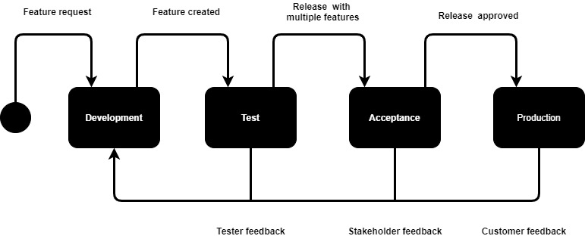

This is the DTAP environment that will be using in this project. Once functional requirements of the application are clear. The project will enter the testing phase. So, the following common steps will be implemented in this project. First, the program is developed in a development environment, which might have no testing capabilities. Secondly, once the software developer thinks it is ready, the product is copied to a test environment, to verify it works as expected. This test environment is supposedly standardized and in close alignment with the target environment. Moreover, if the test is successful, the product is copied to an acceptance test environment. During the acceptance test, the customer will test the product in this environment to verify whether it meets their expectations. Eventually, If the customer accepts the product, it is deployed to a production environment, making it available to all users of the system.