Car Rentals

Efrain Morales

Othman Kamel

Anthony Jackson

HONOR CODE   
I pledge, on my honor, to uphold UT Arlington's tradition of academic integrity, a tradition that values hard work and honest effort in the pursuit of academic excellence.   
I promise that I will submit only work that I personally create or that I contribute to group collaborations, and I will appropriately reference any work from other sources. I will follow the highest standards of integrity and uphold the spirit of the Honor Code.

Efrain Morales

Othman Kamel

Anthony Jackson

**Task 1.**

1.

ALTER TABLE RENTAL ADD COLUMN Returned INTEGER;

UPDATE RENTAL  
 ...> SET Returned = 1  
 ...> WHERE PaymentDate != 'NULL';

UPDATE RENTAL  
 ...> SET Returned = 0  
 ...> WHERE PaymentDate = 'NULL';

SELECT *

Action output response: 23 returned rows

2.

CREATE VIEW vRentalInfo AS

...>SELECT DISTINCT OrderDate, StartDate, ReturnDate, julianday(ReturnDate) - julianday(StartDate) AS TotalDays, VehicleID AS VIN, Description AS Vehicle, Type, VEHICLE.Category, CustID AS CustomerID, Name AS CustomerName, TotalAmount AS OrderAmount,

…>CASE

...>WHEN PaymentDate != "NULL" THEN 0

…>ELSE TotalAmount

…>END AS RentalBalance

…>FROM CUSTOMERS JOIN RENTAL USING (CustID) JOIN VEHICLE USING (VehicleID) JOIN RATE USING (Type)

…>ORDER BY StartDate Asc;

SELECT * FROM vRentalInfo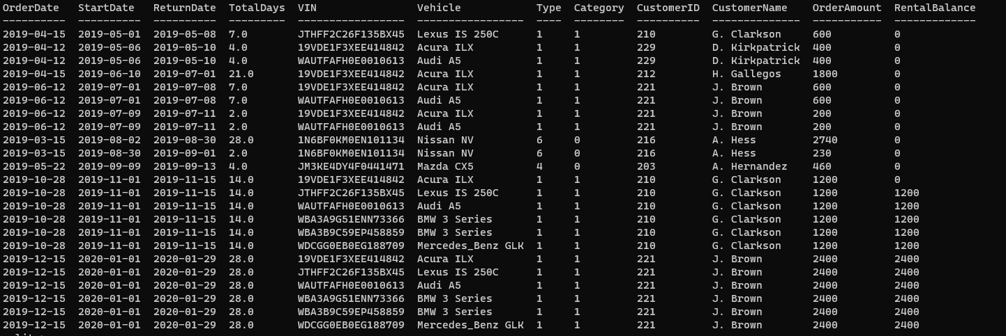

Action output response: 23 returned rows

**Task 2**

insert_cur.execute("INSERT INTO CUSTOMERS(Name, Phone) VALUES(:Name, :Phone)",

{

"Name": Name.get(),

"Phone": Phone.get()

})

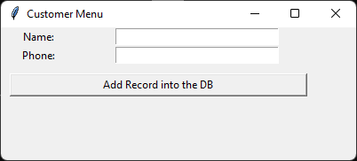

2.

insert_cur.execute("INSERT INTO VEHICLE VALUES(:VehicleID, :Description, :Year, :Type, :Category)

{

"VehicleID": VehicleID,

"Description": Description,

"Year": Year,

"Type": Type,

"Category": Category,

})

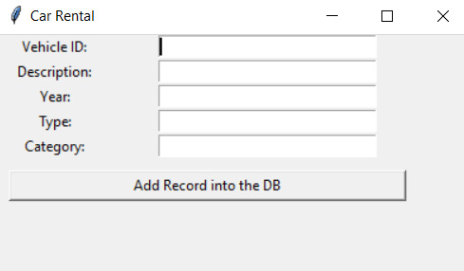

3.

insert_cur.execute("SELECT DISTINCT RENTAL.VehicleID FROM RENTAL WHERE Returned = 0 AND PaymentDate = 'NULL'")

insert_cur.execute("INSERT INTO RENTAL VALUES(:CustID, :VehicleID, :StartDate, :OrderDate, :RentalType, :Qty, :ReturnDate, :TotalAmount, :PaymentDate, :Returned)",

{

"CustID": CustID,

"VehicleID": VehicleID,

"StartDate": StartDate,

"OrderDate": OrderDate,

"RentalType": RentalType,

"Qty": Qty,

"ReturnDate": ReturnDate,

"TotalAmount": TotalAmount,

"PaymentDate": PaymentDate,

"Returned": Returned

})

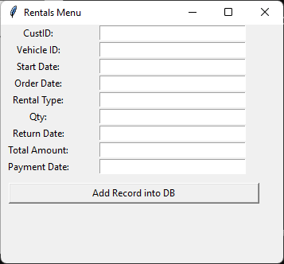

4.

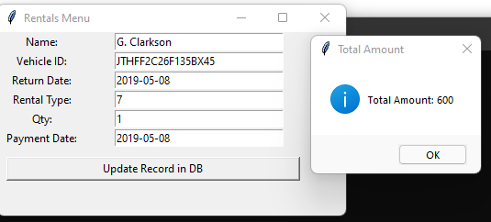

5A.

insert_cur.execute('''SELECT CustomerID AS 'Customer ID', CustomerName, SUM(RentalBalance) AS 'Remaining Balance'

FROM vRentalInfo

GROUP BY CustomerID

ORDER BY CustomerID Asc''')

insert_cur.execute('''SELECT CustomerID AS 'Customer ID', CustomerName, SUM(RentalBalance) AS 'Remaining Balance'

FROM vRentalInfo

WHERE CustomerID = ?

GROUP BY CustomerID

ORDER BY CustomerID Asc''',(CustID,))

insert_cur.execute('''SELECT CustomerID AS 'Customer ID', CustomerName, SUM(RentalBalance) AS 'Remaining Balance'

FROM vRentalInfo

GROUP BY CustomerID

ORDER BY CustomerID Asc''')

insert_cur.execute('''SELECT CustomerID AS 'Customer ID', CustomerName, SUM(RentalBalance) AS 'Remaining Balance'

FROM vRentalInfo

WHERE CustomerName = ?

GROUP BY CustomerID

ORDER BY CustomerID Asc''',(matching[0],))

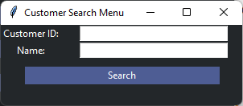

5B.

insert_cur.execute('''SELECT VIN, Vehicle AS Description, AVG(OrderAmount/TotalDays) AS 'Average Daily Price'

FROM vRentalInfo

GROUP BY VIN

ORDER BY "Average Daily Price" Asc''')

insert_cur.execute('''SELECT VehicleID, Description

FROM VEHICLE''')

insert_cur.execute(f'''SELECT VIN, Vehicle, AVG(OrderAmount/(TotalDays)) AS DailyPrice

FROM vRentalInfo

WHERE Vehicle

LIKE '%{Description}%' ''')

insert_cur.execute('''SELECT VIN, Vehicle, AVG(OrderAmount/(TotalDays)) AS DailyPrice

FROM vRentalInfo

WHERE VIN = ? ''', (VehicleID,))

insert_cur.execute('''SELECT VIN, Vehicle, AVG(OrderAmount/(TotalDays)) AS DailyPrice

FROM vRentalInfo

WHERE VIN = ? AND Vehicle = ?''',

(VehicleID, Description,))

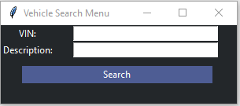

Team Contributions:

Anthony – Task 1, Task 2: 1, 5a, Created ReadMe.docx

Othman – Task 2: 2, 5b

Efrain – Task 2: 3, 4, Cleaned up Report file