Li-ion Transport Related to LiTFSA Cluster Size in Localized High-Concentration Electrolytes Using Molecular Dynamics Simulations

Yuki Ito¹, Taiki Shiba², Kaoru Dokko², Kazushi Fujimoto³
¹ Department of Chemistry and Materials Engineering, Graduate School of Science and Engineering,
Kansai University, 3-3-35 Yamate-cho, Suita, Osaka 564-8680, Japan.
²Department of Chemistry and Life Science, Yokohama National University, 79-5 Tokiwadai, Hodogaya-ku, Yokohama 240-8501, Japan.
³Department of Chemistry and Materials Engineering, Faculty of Chemistry, Materials and
Bioengineering, Kansai University, 3-3-35 Yamate-cho, Suita, Osaka 564-8680, Japan.
e-mail: k-fuji@kansai-u.ac.jp
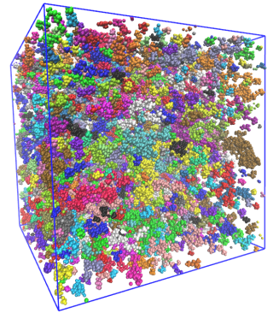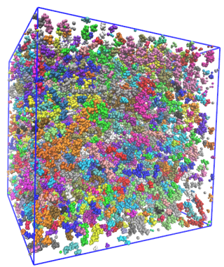
Efficient Li⁺ transport is essential for the performance of lithium batteries. Localized high-concentration electrolytes (LHCEs) exhibit heterogeneous salt-rich and diluent-rich regions. Therefore, clarifying how this heterogeneous structure affects Li⁺ diffusion is important for understanding Li⁺ transport in LHCEs.
Figure 1 Cluster-colored snapshots of the nBME system (left) and tBME system (right).
In our previous study, we investigated an LHCE composed of FEC (solvent), TTE (diluent), and LiTFSA (salt), and showed that Li⁺ species in diluent-rich regions significantly contribute to the overall Li⁺ transport [1]. In this study, we examined two LHCEs composed of FEC, LiTFSA, and either nBME or tBME as the diluents, focusing on how differences in LiTFSA cluster structures affect Li⁺ transport. The molar ratio was LiTFSA:FEC:BME = 1:6:3.7.
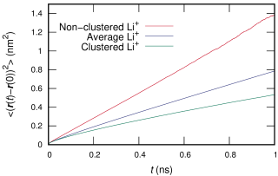
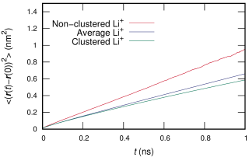
Cluster analysis revealed that the nBME and tBME systems formed different LiTFSA cluster structures (Figure 1). The cluster volume distribution showed that larger LiTFSA clusters were preferentially formed in the nBME system, whereas many smaller clusters were formed in the tBME system. This difference is likely related to the different coordination abilities of nBME and tBME toward Li⁺. tBME coordinates more readily with Li⁺ than nBME, which suppresses LiTFSA aggregation. As a result, the tBME system contains smaller LiTFSA clusters and more non-clustered Li⁺ species.
Figure 2 MSDs of non-clustered Li⁺, clustered Li⁺, and the average over all Li⁺. The upper and lower panels correspond to the nBME and tBME systems, respectively.
MSDs calculated separately for clustered and non-clustered Li⁺ showed that non-clustered Li⁺ diffused faster than clustered Li⁺ (Figure 2), indicating that Li⁺ species in diluent-rich regions enhance the overall Li⁺ transport. In addition, the center-of-mass MSD of LiTFSA clusters larger than 1 nm³ revealed that cluster translational motion also contributes to Li⁺ transport. By further analyzing the diffusion behavior for different cluster sizes, we discuss size-dependent Li⁺ transport involving non-clustered Li⁺ species, medium-sized LiTFSA clusters, and large LiTFSA clusters.
These results suggest that suppressing excessive LiTFSA aggregation and forming mobile small-to-medium-sized clusters are important for promoting Li⁺ diffusion in LHCEs.

References
[1] Y. Ito, Y. Yasuda, Y. Konishi, T. Shiba, K. Dokko, K. Fujimoto, J. Phys. Chem. C, 130, 1327-1337 (2026).

