Concentration-Dependent Dynamics in Solvate Ionic Liquids via NMR Relaxometry

L. Kruse¹, T. Winter¹, J. K. Philipp-Taube¹, A. Strate¹, D. Paschek¹, R. Ludwig^{1,2}
¹Physical and Theoretical Chemistry, University of Rostock, Albert-Einstein-Str. 27, 18059 Rostock/DE
²Department Life, Light & Matter, University of Rostock, Albert-Einstein-Str. 25, 18059 Rostock/DE
³Leibniz Institut für Katalyse an der Universität Rostock e.V., Albert-Einstein-Str. 29a, 18059 Rostock/DE
e-mail: lennart.kruse@uni-rostock.de

In contrast to conventional Ionic Liquids (ILs), which consist of organic and/or inorganic ions, the so-called Solvate Ionic Liquids (SILs) are being formed by mixing a salt and a solvent, which form stochiometric chelate complexes. These room-temperature liquids have been studied extensively regarding their electrolyte properties such as conductivity and self-diffusion.[1] To shed more light on the ion- and molecule specific dynamics, fast field cycling (FFC) NMR relaxometry is used to measure the frequency-dependent T₁ spin-lattice relaxation times (Fig. 1). By fitting the relaxation rates (R₁ = 1/T₁) to relaxation models the self-diffusion coefficients and rotational correlation times of different species are determined. This method has proven to be well suited to investigate neat ILs.[2] However, literature involving FFC studies on SILs systems is scarce. To address this shortcoming, we investigate the SIL consisting of lithium bis(trifluoromethylsulfonyl)imide (LiNTf₂) and triethylenglycoldimethylether (triglyme/G3). In this SIL, the triglyme coordinates the Li⁺ cation in a crown-ether like manner and thereby forms complexes like [Li(G3)₁]⁺, as it has been shown by MD simulations and far-infrared measurements.[3] However, the structure of these complexes highly depends on the concentration of the salt. To address the concentration effect on the dynamics we probed two different lithium salt/triglyme mixtures over a broad temperature range, with salt:solvent ratios of 1:1 and 1:2, yielding structures like [Li(G3)₁][NTf₂] and [Li(G3)₂][NTf₂]. By measuring the T₁ spin-lattice relaxation times of ¹H and ¹⁹F nuclei using FFC NMR, we obtain dynamic information of the G3 and NTf₂ anions, respectively. Finally, we find good agreement between experimentally obtained values of self-diffusion coefficients and rotational correlation with those derived from MD simulations.

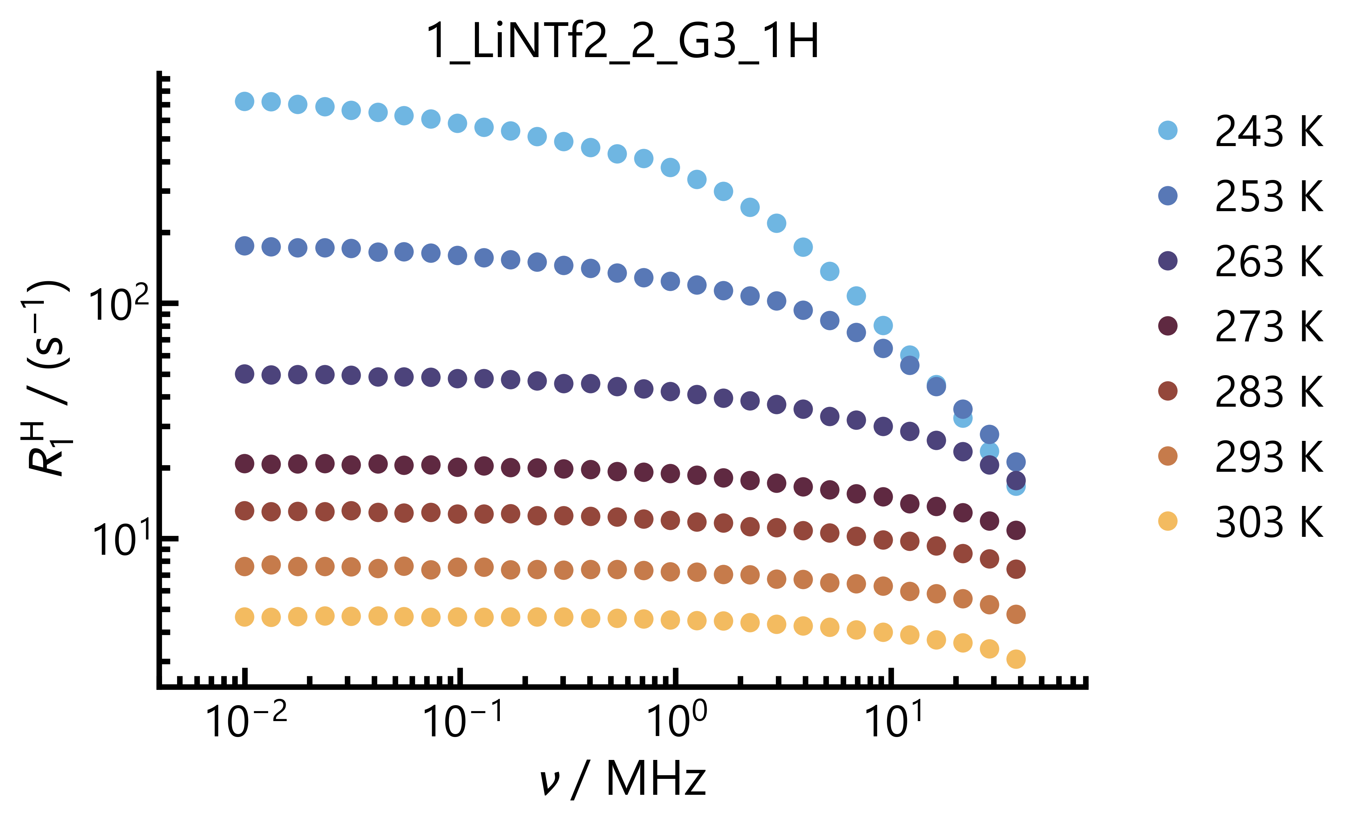
Figure 1 – Temperature-dependent ¹H NMR dispersion profiles of the SIL [Li(G3)₂][NTf₂]
obtained from fast field cycling NMR relaxometry.

References
[1] T. Tamura et al., Chemical Letters, 39, 753 (2010).
[2] L. Kruse et al., Journal of Physical Chemistry Letters, 15, 10410 (2024).
[3] J. K. Philipp et al., ChemPhysChem, 26, e202400991 (2025).

