Understanding the Nature of Hydration of Aqueous Alkali Metal Carbonates Employing Molecular Dynamics Simulations

Pujarini Mahapatra¹, P. Padma Kumar¹
¹ Department of Physics, Indian Institute of Technology Guwahati, 781039, Assam, India
e-mail: pujarini.mhapatra@iitg.ac.in

Aqueous alkali metal carbonates (M₂CO₃, where M = Li⁺, Na⁺, and K⁺) have attracted significant attention due to their critical role in CO₂ capture, energy storage, and various industrial processes. Despite extensive experimental progress in understanding their macroscopic properties, the molecular-level mechanisms governing solvation and ion-association behaviour in these systems with varying concentrations remain largely unexplored. To address this gap, we present a comprehensive molecular dynamics (MD) investigation of aqueous Li₂CO₃, Na₂CO₃, and K₂CO₃ using a refined force field model, validated against the experimental solubility limits of the respective salts. The study highlights how the local environment of carbonate ions (CO₃²⁻) evolves with solute concentration, providing fresh insights into the role of alkali metal cations in promoting the self-aggregation of carbonates. The trajectory analysis predicts that the mobility of all the solute and solvent species decreases with concentration, leading to the co-movement of cations and carbonate ions near their solubility limit. Notably, Li⁺ exhibits anomalously slow diffusion compared to the larger Na⁺ and K⁺ ions, owing to its stronger association with carbonate ions, which is consistent with the experimentally observed low solubility of Li₂CO₃ in water. This behaviour is attributed to the size-sensitive “hardness” of the hydration shells of cations, corroborated in terms of the water residence times in their first hydration shells. In addition, enhanced sampling via umbrella sampling is employed to compute the free energy profile of CO₂ transfer across the gas–liquid interface, revealing the thermodynamic preference and solubility of CO₂ in carbonate media. This provides molecular-level insight into the energetics governing CO₂ absorption in carbonate-based capture systems.

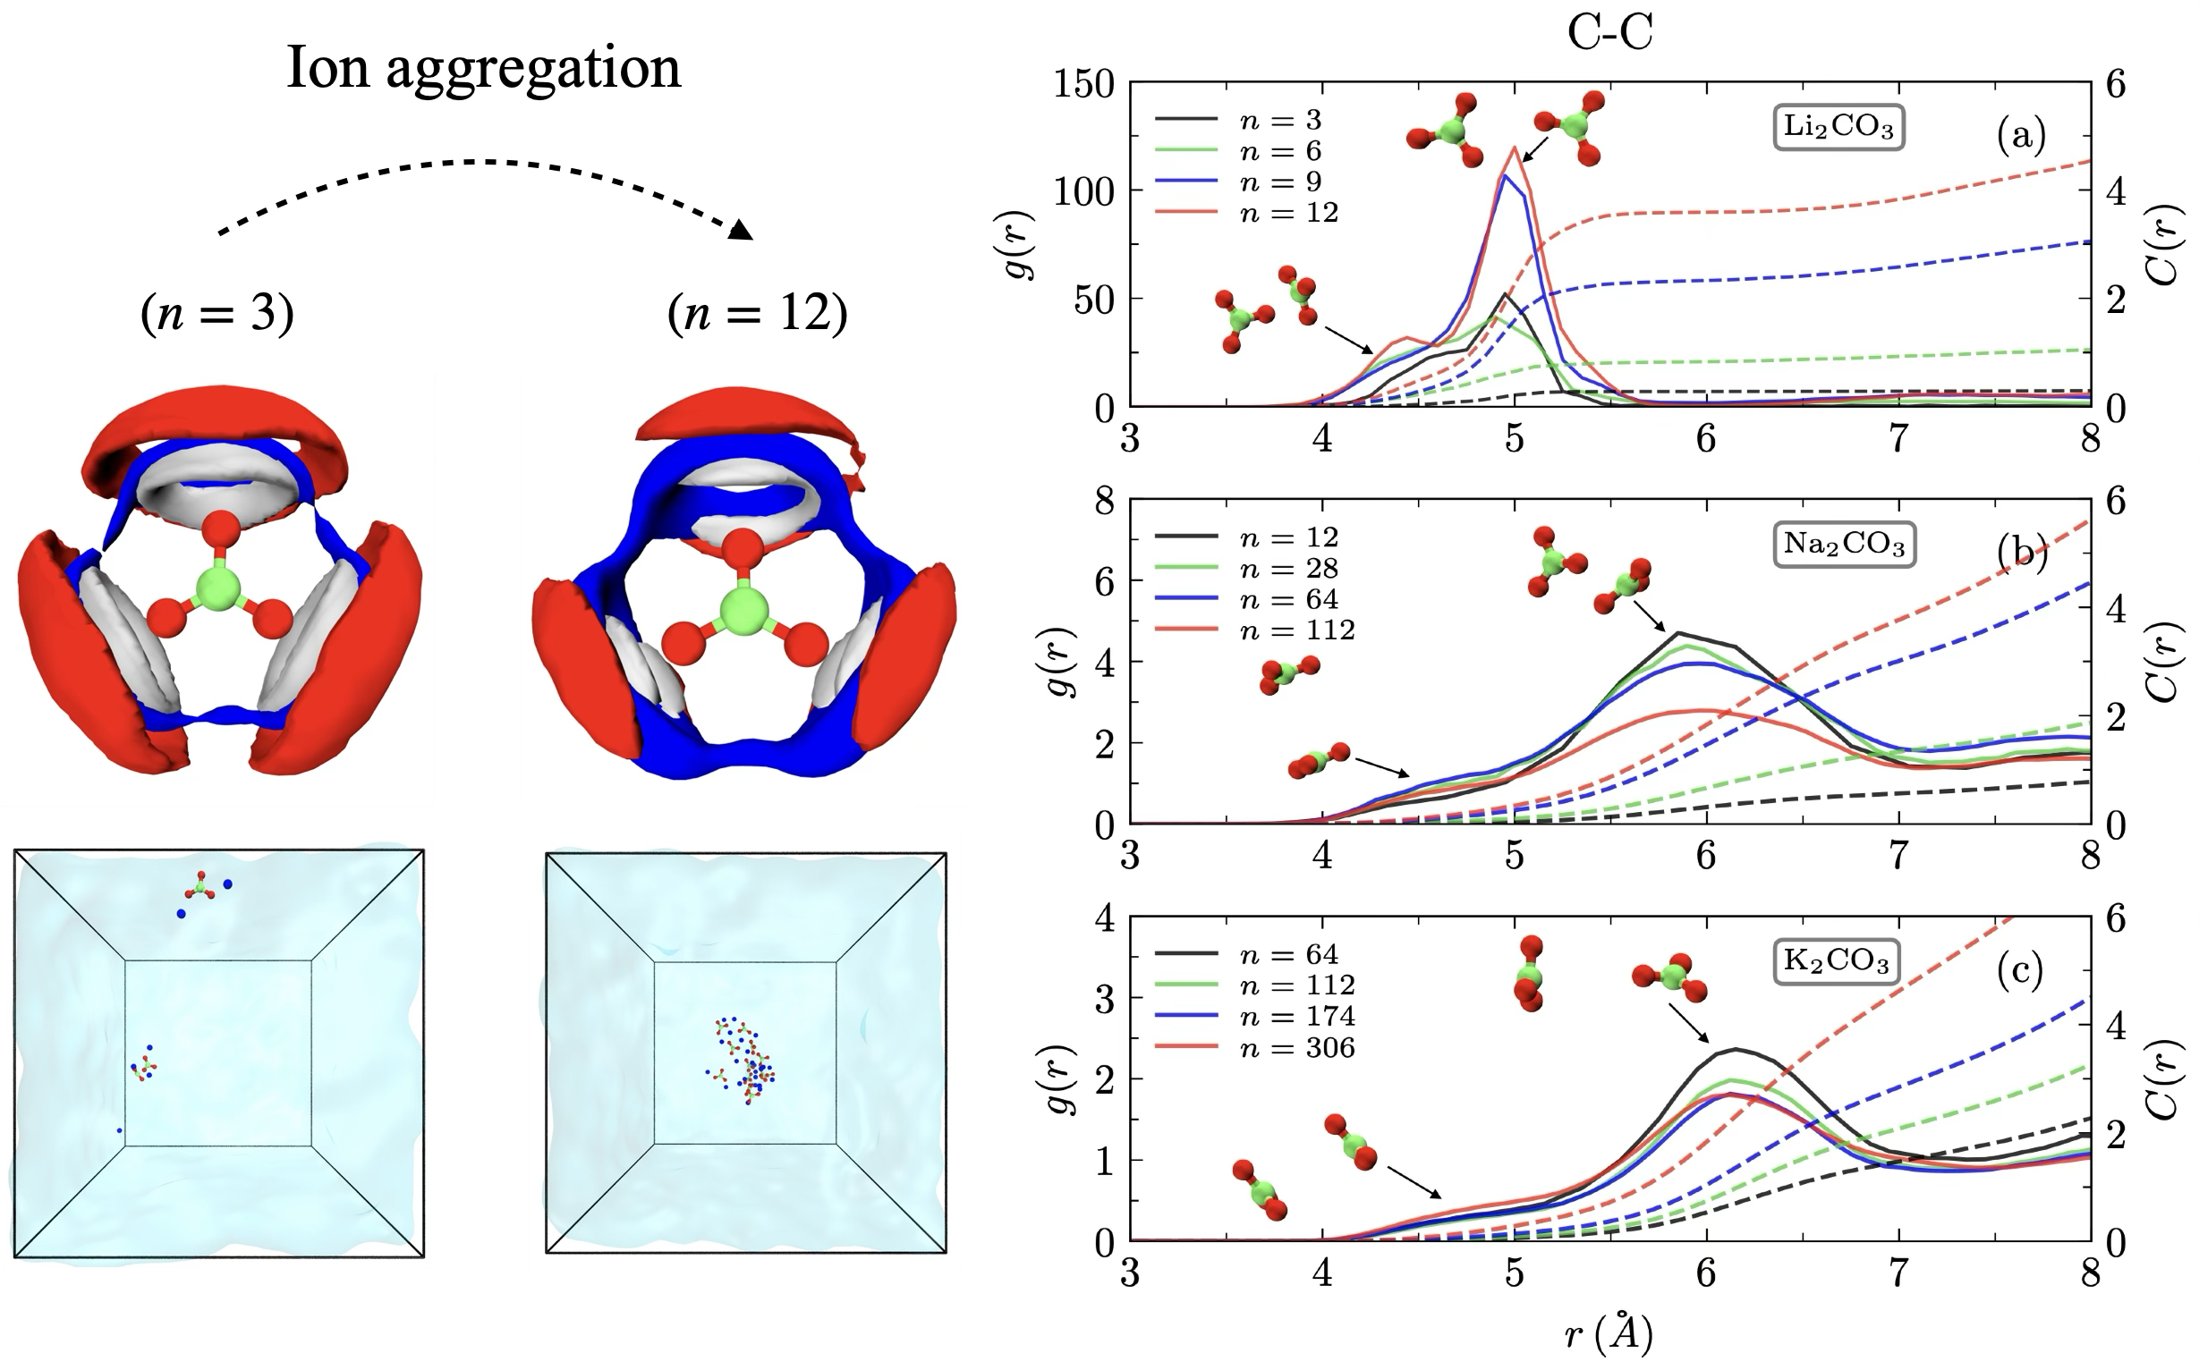
Figure 1 – Left: Hydration isosurfaces around CO₃²⁻ at low (dilute) and high (beyond solubility) concentrations with corresponding simulation snapshots showing the transition from dispersed ions to aggregates. Right: Carbonate–carbonate RDFs (solid lines) and coordination numbers, RCNs (dashed lines), for C···C correlations in aqueous Li₂CO₃, Na₂CO₃, and K₂CO₃, quantifying enhanced ion aggregation at higher concentrations.
References
[1] P. Mahapatra and P. P. Kumar, Chemical Engineering Science, 2026, 123914.
[2] P. P. Kumar, A. G. Kalinichev and R. J. Kirkpatrick, The Journal of Physical Chemistry B, 2009, 113, 794–802.

