Using the Zeno line to assess and refine molecular models

Thomas Paterson¹, Marcus N. Bannerman², Leo Lue¹
¹ Department of Chemical and Process Engineering, University of Strathclyde, James Weir Building, 75 Montrose Street, Glasgow G1 1XJ, United Kingdom
² School of Engineering, University of Aberdeen, Aberdeen AB24 3UE, United Kingdom
e-mail: thomaspaterson@strathclyde.ac.uk

The Zeno line is the locus of points on the temperature–density plane where the compressibility factor of the fluid is equal to one. It has been observed to be straight for a broad variety of real fluids, although the underlying reasons for this are still unclear. In this work, a detailed study of the Zeno line and its relation to the vapor–liquid coexistence curve is performed for two simple model pair-potential fluids: attractive square-well fluids with varying well-widths λ and Mie n-6 fluids with different repulsive exponents n. Interestingly, the Zeno lines of these fluids are curved, regardless of the value of λ or n. We find that for square-well fluids, λ ≈ 1.8 presents a Zeno line, which is the most linear over the largest temperature range. For Mie n-6 fluids, we find that the straightest Zeno line occurs for n between 8 and 10. Additionally, the square-well and Mie fluids with the straightest Zeno line showed the closest quantitative agreement with the vapor–liquid coexistence curve for experimental fluids that follow the principle of corresponding states (e.g., argon, xenon, krypton, methane, nitrogen, and oxygen). These results suggest that the Zeno line can provide a useful additional feature, in complement to other properties, such as the phase envelope, to evaluate molecular models [1].
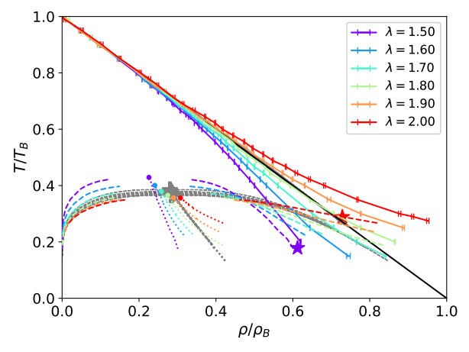
Figure 1 – The Zeno line (i.e. locus of points with Z = 1) for attractive square-well fluids of varying well width λ (coloured solid lines) and real/corresponding-states fluids (gray solid lines). T_{B} is the Boyle Temperature, and ρ_{B} is the Zeno density. The dashed lines denote the boundaries of the vapour-liquid coexistence regions, and the dotted lines are the rectilinear diameters. The filled circles are the critical points for the square-well fluids, while the gray plus is the critical point for the corresponding states fluids. The red star denotes the triple point for the square-well system with λ = 2.

Acknowledgements
The authors gratefully acknowledge financial support from CCP5.

References
[1] Thomas Paterson, Marcus N. Bannerman, Leo Lue; Using the Zeno line to assess and refine molecular models. J. Chem. Phys. 21 April 2024; 160 (15): 154503. https://doi.org/10.1063/5.0192770

