Solution-Phase Co-Oligomer Analysis as a Predictive Tool for Co-Crystal and Co-Amorphous Forms
Zhiyu Liao,¹ Immacolata Abate,² Rebecca Beveridge,² and Klaas Wynne¹
¹School of Chemistry, University of Glasgow, G12 8QQ, UK
²Dept. of Pure and Applied Chemistry, University of Strathclyde, Glasgow G1 1XL, UK
e-mail: klaas.wynne@glasgow.ac.uk

Multicomponent molecular solids underpin technologies ranging from pharmaceuticals to functional materials, including co-amorphous drug delivery systems (CAMS). However, there is no general method to predict whether a mixture of small molecules will form a cocrystal, a homogeneous glass, or separate crystalline phases. Here we show that solution-phase noncovalent oligomers, detected by nanoelectrospray ionization mass spectrometry (nESI-MS), enable direct prediction of the solid-state forms obtained from multicomponent mixtures.¹ By analysing the distribution and stoichiometry of mixed oligomers formed in dilute solution, we find that well-defined complexes with a fixed molar ratio reliably precede the formation of stoichiometric cocrystals, whereas disordered ensembles of mixed aggregates with variable composition lead instead to single-phase amorphous solids. In contrast, the absence of detectable mixed oligomers correlates with macroscopic phase separation into the individual crystalline components. This solution-phase oligomer analysis operates on microliter sample volumes, requires no prior structural information and is compatible with a wide range of molecular systems. Our results establish a mechanistic link between pre-nucleation aggregation in solution and the emergent structure of multicomponent molecular solids, enabling rapid, physically grounded screening of co-formers and co-assemblies across fields from pharmaceutical formulation to materials science.

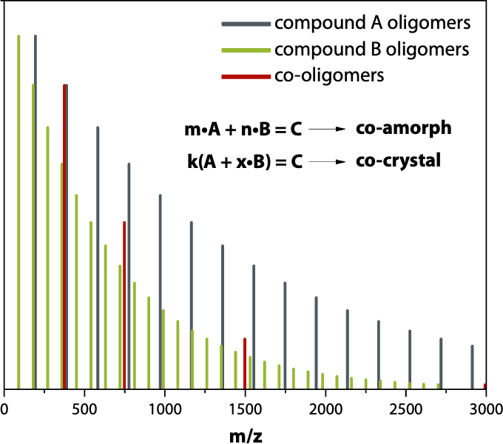
Figure 1 – Schematic representation of a predictive workflow for co-structure formation in drug formulations using solution-phase oligomer analysis. nESI-MS reveals the detailed distribution and stoichiometry of oligomers and co-oligomers formed in solution. These molecular signatures serve as precursors that indicate the propensity of forming either co-crystals or co-amorphous solids.

References
(1) Liao, Z.; Abate, I.; Beveridge, R.; Wynne, K. Solution-Phase Co-Oligomer Analysis as a Predictive Tool for Co-Crystal and Co-Amorphous Forms. ChemRxiv 2026. https://doi.org/10.26434/chemrxiv.10001669/v1.

