Structural and Spectroscopic Evidence of Hydrogen Bonded Anionic Wires in Protic Ionic Liquids

Maham Azhar¹, Loai Al-Sheakh¹, Lasse Hunger¹, Andreas Appelhagen¹, Lennart Kruse¹ and Ralf Ludwig^{1,2}*

¹Institut für Chemie, Abteilung Physikalische Chemie Universität Rostock, Albert-Einstein-Straße 27, 18059 Rostock, Germany
²Leibniz Institut für Katalyse an der Universität Rostock e.V. Albert-Einstein-Straße 29a, 18059 Rostock, Germany
ralf.ludwig@uni-rostock.de

Hydrogen Bonding between ions of like charge challenges the fundamental principle of electrostatics that opposite charges attract and like charges repel. We used triethylamine ((CH₃CH₂)₃N) and two different alkanedicarboxylic acids (HOOC(CH₂)_{n}COOH) with n = 0,1, namely ethanedionic (oxalic) and propanedionic (malonic) acid in equal ratio.

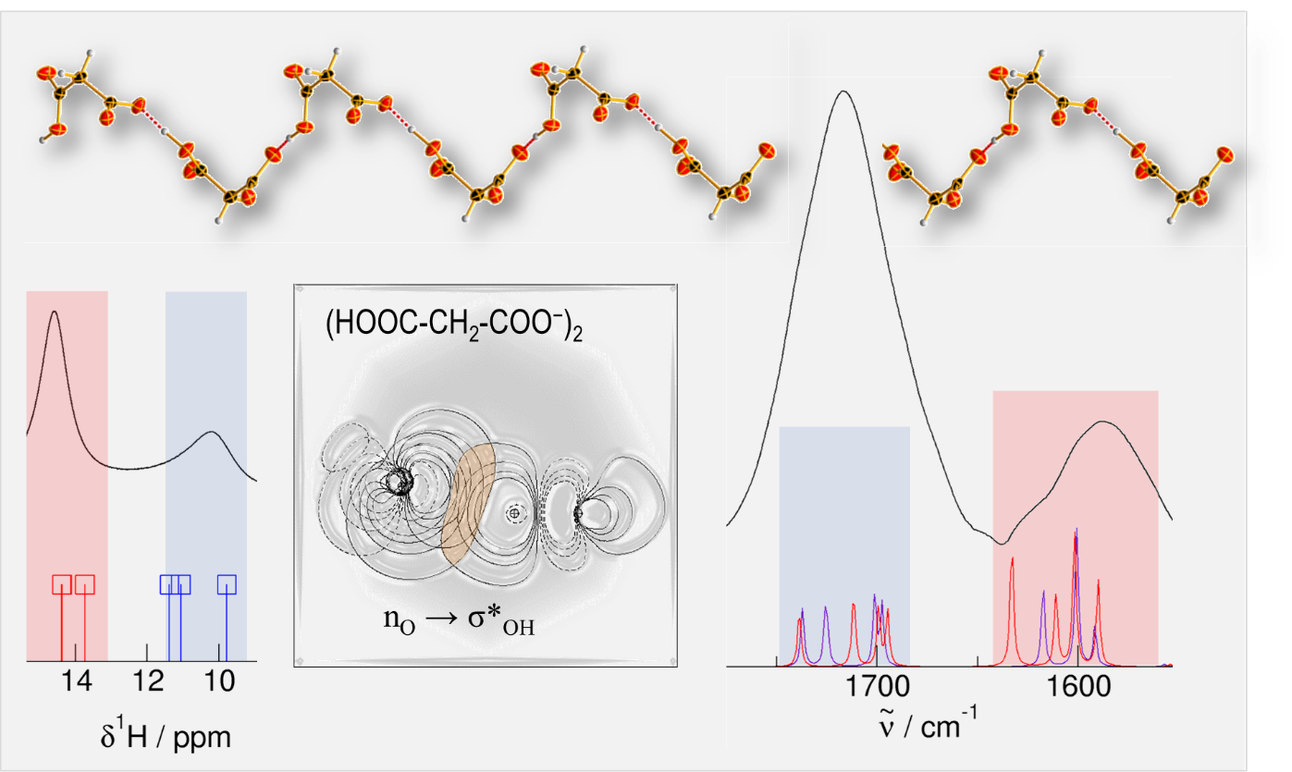

Figure 1: Graphical summary of IR, NMR, NBO and anionic wires structure

H-bonds between cations have been observed in hydroxy-functionalized ionic liquids.[1] More recently, we replaced the hydroxy- by carboxy-functionalized cations in similar ILs. We observed doubly H-bonded cationic dimers in the solid, the liquid and the gas phase.[2]
In this work, we have shown similar structural motifs for anionic clusters in PILs. The anionic wires were identified by X-ray crystallography in the solid state, wherein the anions are linked by the –OH···O– type H-bonds. The H-bonds within the anionic wire are significantly stronger than those between cation and anion despite repulsive Coulomb interaction in the first and attractive ones in the latter case. Analysis by NMR and IR spectroscopy suggests that the binding motifs of the solid structure are mainly preserved in the liquid state of the supercooled PILs.
This conclusion is drawn from density functional theory (DFT) calculations of the same structural motifs as observed in the solid state. The calculated ¹H NMR chemical shifts and IR C=O frequencies for these H-bond structures correspond well with the measured spectroscopic signatures. The anionic chains remain intact even when gradually removing the counterions. A fourfold negatively charged chain tetramer still exhibits strong H-bonds that are hardly weaker than those in the neutral species. These findings highlight the fundamental role of hydrogen bonding for the unusual attractive interaction between ions of like charge.

References
[1] A. Knorr, P. Stange, and K. Fumino et al., ChemPhysChem, 17, 458 (2016).
[2] L. Hunger, L. Al-Sheakh and D. H. Zaitsau et al., Chemistry – A European Journal 28, e202200949 (2022).

