Characterizing the electrolyte/graphene interface: an integrated approach with modelling and experiments

P. Carbone¹
¹Department of Chemistry, University of Manchester, Oxford Road, M13 9PL, Manchester (U.K.)
e-mail: paola.carbone@manchester.ac.uk

The physical-chemistry of the graphene/aqueous–electrolyte interface underpins the operational conditions of a wide range of devices. Despite its importance, this interface is poorly understood due to the challenges faced in its experimental characterization and the difficulty of developing models that encompass its full physics. [1]
In this talk I’ll show how combining molecular simulations with experiments, it is possible to investigate the relationship between wetting, double layer structure, friction coefficient and interfacial dynamics and understand how these properties are related to the capacitive properties of the interface. I’ll initially introduce the new multiscale modelling techniques we developed to capture the ions-induced polarization of graphite modelling simultaneously the coupled motion of the surface electrons and ions in the solution.[2, 3] Then I’ll show some applications of the methods to electrified bulk interfaces and under confinement [4, 5] and show how the simulation results can be an invaluable tool to understand experimental data.[6, 7, 8]

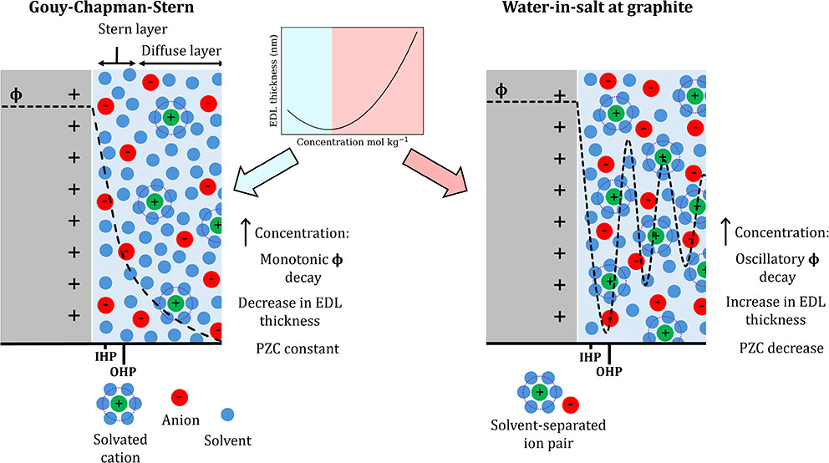
Figure 1 – Sketch of the structure of the double layer in dilute and water-in-salt electrolytes [1]

References
[1] J. D. Elliott, et al., J. Mater. Chem. C, 10, 15225 (2022).
[2] J. D. Elliott, A. Troisi, P. Carbone, J. Comp. Theory Sim., 16, (2020), 5253.
[3] N. DiPasquale, et al., J. Comp. Theory Sim., 17, (2021), 4477.
[4] Z. Wei, et al., Carbon, 198, (2022), 132.
[5] L. Smith et al., ACS Appl. Mater. Interface, 16, (2024), 56316.
[6] J. D. Elliott, et al., Carbon, 292 (2023), 292.
[7] Z. Wei, et al., J. Am. Chem. Soc., 146, (2023), 760.
[8] H. O. Wood, et al. J. Phys. Chem. C, 130, (2026). 5965.

