Computer simulations of complex self-assembly – and obstinate agglomeration

A. Dastan¹, J. Earnshaw¹ and D.J. Cleaver¹

¹Materials and Engineering Research Institute, Sheffield Hallam University
e-mail: d.j.cleaver@shu.ac.uk

Most of the twisted fibres and threads found in natural systems are formed through spontaneous self-assembly of small molecules, such as peptides, and stabilised by hydrogen bonds rather than covalent cross-links [1]. This can lead to amazing structures, since the inherent flexibility of hydrogen bonds allows for morphological change within a self-assembly pathway. However, it also imposes a considerable restriction - for a given object type to exist it needs not only to
be stable (to changes in mechanical environment, temperature, pH, ... ), but also to be a reproducible end-point of a full aggregation process [2]. This requires it to have a complete, kinetically accessible pathway, potentially involving several generations of aggregate [3].

Here, we use molecular dynamics simulation to examine bipartite particle-based systems which combine the thread-packing of chromonics and the frustrations of amphiphilicity to yield a range of self-assembled structures with emergent supramolecular chirality. Through this, we find a veritable zoo of hierarchical, chiral self-assembled structures, the supramolecular morphologies of which emerge from choices of particle-level parameters [3]. As well as directly observing how structures such as fibres, bundles and tubules nucleate and grow, often via intermediate states
with super-extensive growth modes.

We then contrast this with the behaviour of functionalised Polyhedral Oligomeric Silsesquioxanes (POSS) systems which, for most choices of ligand, lock into disordered, immobile glasses at high temperatures. When appropriately blended within an organic matrix material, however, even these POSS systems can be effectively dispersed to achieve target composite behaviours [4].

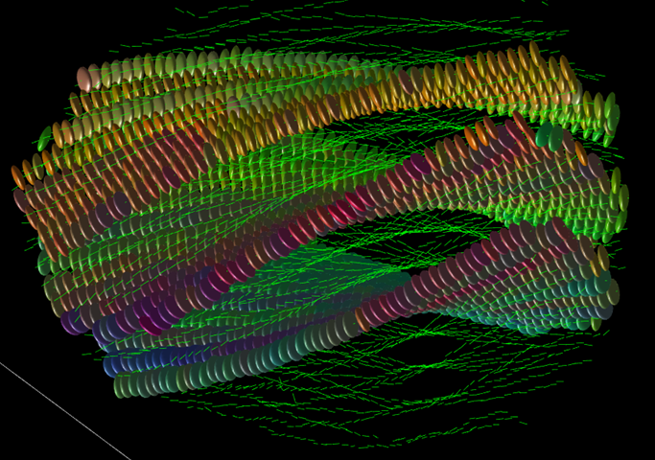

Figure 1 – Side view of a twisted, multi-sheet bundle self-assembled by a mixture of discotic and spherical particles. For clarity, the spheres are not shown, and the discs are shown in full for three layers but as short, axial lines for all others.

References
[1] I.W. Hamley, Chemie Angew, 46, 8128 (2007).
[2] A. Dastan, W.J. Frith and D.J. Cleaver, J Phys Chem B, 121, 9920 (2017).
[3] A. Dastan, E.A. Matsumoto, W.J. Frith and D.J. Cleaver, Mol Phys, 116, 2823 (2018).
[4] J. Earnshaw, Molecular Dynamics simulation of polyhedral oligomeric silsesquioxanes (POSS) and their polymeric nanocomposites, PhD Thesis, Sheffield Hallam University (2022).

