On The Aggregation of Amphiphiles in Water: Hydrotropy as the missing link between salts and surfactants

Dinis O. Abranches¹, João A. P. Coutinho¹
¹CICECO – Aveiro Institute of Materials, Department of Chemistry, University of Aveiro, 3810-193, Aveiro, Portugal
e-mail: jcoutinho@ua.pt

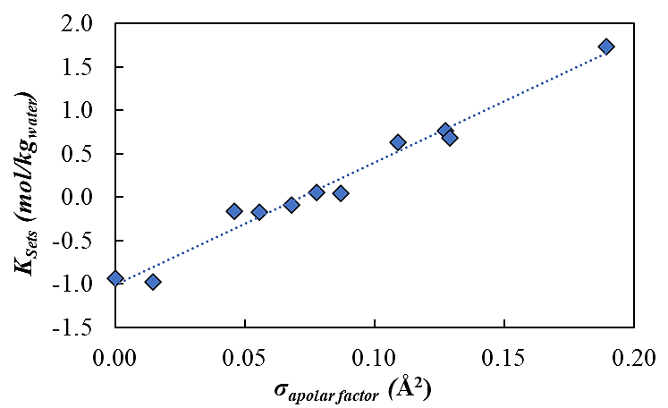
Hydrotropes and surfactants are commonly employed to enhance the aqueous solubility of hydrophobic compounds, and they are traditionally regarded as distinct classes based on the assumption that surfactants solubilize via micelle formation whereas hydrotropes do not. In the first part of this communication this distinction is critically examined by systematically investigating the solubilization of carbamazepine in aqueous solutions of two homologous families: sodium sulfates and sodium sulfonates, spanning species from inorganic salts to classical surfactants. Across these families, solubility enhancement increases monotonically with the apolar volume of the anion,[1] as shown in Figure 1, with densely charged ions inducing salting-out and amphiphilic compounds promoting salting-in. Analysis of the dilute concentration regime using Setschenow constants reveals a continuous trend encompassing hydrotropes and surfactants, with no separation between them.
Figure 1 – Correlation between apolar factor and Setschenow constants for the sodium alkyl sulfate salts.

At higher amphiphile concentrations, deviations from linear behavior define critical aggregation concentrations that correlate systematically with anion apolarity among hydrotropes and surfactants, and align closely with reported critical micelle concentrations. These results establish a unified framework in which hydrotropes and surfactants follow the same structural and thermodynamic principles, supporting a continuum view of solubilizing agents rather than two fundamentally distinct classes.

The mechanisms of enhanced solubility on these systems are highlighted by molecular dynamic simulations, and, in the final part of this communication, it will be shown how other phenomena, apparently unrelated, such as the impact of dissolved gases on the transport properties of electrolytes, [2] or the solubility of gases in aqueous solutions of ionic liquids, can be understood under the light of the aggregation of amphiphiles in water around an apolar compound.

Acknowledgment: The authors are grateful to FCT, Portugal, for financial support through national funds FCT/MCTES (PIDDAC) to CICECO from projects UID/50011/2025 and LA/P/0006/2020.

References
[1] B. P. Soares, D. O. Abranches, T. E. Sintra, A. Leal-Duaso, J. I. García, E. Pires, S. Shimizu, S. P. Pinho, and J. A. P. Coutinho, ACS Sustain. Chem. Eng., 8, 5742 (2020)
[2] E. E. Fileti, D. O. Abranches, J. A. P. Coutinho, J. Phys Chem B, 130, 5059 (2026)

