Protein sequestration into biomolecular condensates and hydration water.

G. Franzese^{1,2}
Please underline the presenting author
¹Departament de Física de la Matèria Condensada, Facutat de Física, Universitat de Barcelona, Martí i Franquès 1, Barcelona 08028, Spain
²Institut de Nanociencia i Nanotecnologia de la Universitat de Barcelona (IN2UB)
e-mail: gfranzese@ub.edu

Biological processes such as the sequestration of superoxide dismutase 1 (SOD1) into biomolecular condensates, including fused in sarcoma (FUS) and stress granules, are vital for understanding disease mechanisms, including amyotrophic lateral sclerosis (ALS). Moreover, protein–crowder interactions within these condensates are recognized as fundamental to cellular phase separation and disease-related processes. However, the specific role of the hydration environment in governing SOD1’s behavior and transition dynamics within these condensates remains poorly understood, limiting our ability to accurately model these critical biological systems [1]. We incorporate explicit water into an implicit solvent model (OPEP) to investigate how water influences SOD1’s behavior, residence times, and transition rates among associative states. We employ the advanced CVF water model, which accurately captures hydrogen-bond networks at the molecular level [3, 4]. While the OPEP model indicates that bovine serum albumin (BSA) crowders reduce SOD1’s partition coefficient (PC) into FUS condensates primarily through non-specific interactions, our explicit-water approach points to hydration entropy in BSA as a key contributor to the observed PC reduction (Fig. 1). This result offers a new perspective on the system’s free-energy landscape, complementing those obtained from OPEP alone. Our research supports the notion that explicitly modeling water can enhance our understanding of protein–crowder interactions and their biological implications, further emphasizing the potential role of water in cellular phase separation and disease-related processes [5].

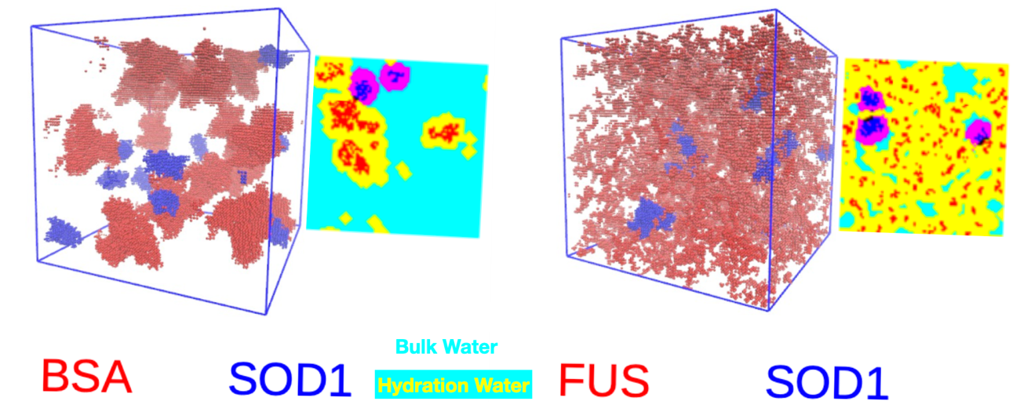

Figure 1 – Simulation snapshots of SOD1 in contact with BSA (left) and FUS (right) are shown in their 3D implicit-water representation (with SOD1 in blue and the other protein in red) or as 2D sections with water (turquoise for bulk and yellow or purple for hydration water).

References
[1] N. Samanta, S. S. Ribeiro, M. Becker, E. Laborie, R. Pollak, S. Timr, F. Sterpone, and S. Ebbinghaus, J. Am. Chem. Soc. 143, 19909 (2021).
[3] L. E. Coronas and G. Franzese, J. Chem. Phys. 161, 164502 (2024).
[4] L. E. Coronas, O. Vilanova, and G. Franzese, J. Mol. Liq. 434, 128032 (2025).
[5] L. E. Coronas, S. Timr, F. Sterpone, and G. Franzese, J. Chem. Phys. 164, 094910 (2026).

