A Graph-based approach for the structural characterization of macromolecules and their interactions with the environment

K. Jonas (née Drysch)¹, Y. Dawer¹, P. Zaby¹, K. Buchmüller¹, L. Dick¹, B. Szabó²,
O. Hollóczki², B. Kirchner¹
¹Mulliken Center for Theoretical Chemistry, University of Bonn, Beringstraße 4, 53115 Bonn, Germany
²Department of Physical Chemistry, Faculty of Science and Technology, University of Debrecen, H-4032 Debrecen, Hungary
e-mail: kdrysch@uni-bonn.de

The use of molecular dynamics (MD) simulations to gain molecular-level insights into macromolecular interactions with environmental and physiological systems has become increasingly important. Yet, efforts have remained focused on naturally occurring biomolecules that rely on known monomer motifs. This has raised the need for robust, generalised tools to study chemically relevant macromolecular systems.
In this contribution, we introduce MakroLyzer [1], an open-source program that uses a graph-based representation of macromolecules to determine structural descriptors such as the asphericity parameter, the anisotropy factor, the radius of gyration, the order parameter, and local conformational features. We demonstrate the utility of MakroLyzer by examining the aggregation behaviour of nanoplastics such as polyethylene (PE) and nylon 66 (N66) under different simulation protocols [2, 3].
In addition, we present studies on the interactions between nanoplastic particles and their environment, including the adsorption of drug molecules onto nanoplastic surfaces [4].
Finally, we discuss recent projects examining the behaviour of chemically functionalised nanoplastics in complex liquid environments. Particular emphasis is placed on analysing the interaction between the particle surface and the surrounding solvent molecules. One example of this is the detection of hydrogen bonds between the particles and the surrounding solvent molecules, as illustrated in Fig. 1.

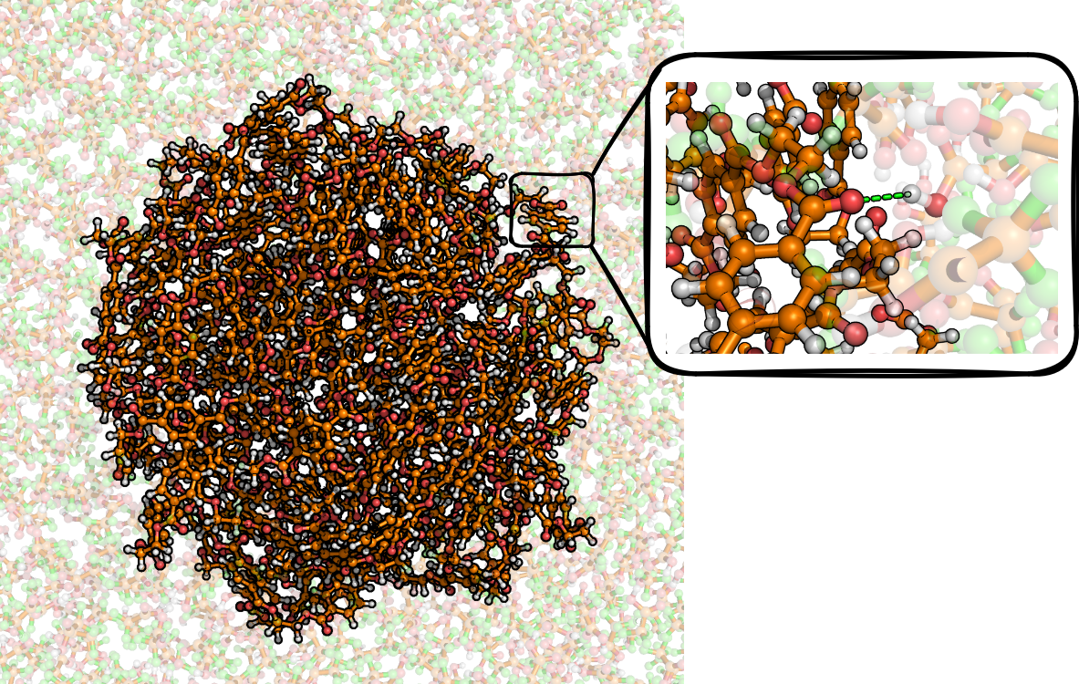

Figure 1 – Hydrogen bond analysis between a nanoplastic particle and the surrounding solvent.

References
[1] K. Drysch, Y. Dawer, P. Zaby, K. Buchmüller, L. Dick, P. Mutzel, O. Hollóczki and B. Kirchner J. Phys. Chem. B, 129, 12997–13008 (2025).
[2] B. Szabó, P. Zaby, L. Dick, K. Drysch, Y. Dawer, W. Reckien, A. Udvardy, F. Neese, B. Kirchner and O. Hollóczki, J. Phys. Chem. B, 130, 881-893 (2026)
[3] K. Drysch, B. Kirchner, O. Hollóczki and L. Dick, ChemRxiv (preprint) (2026)
[4] L. Dick, P. R. Batista, P. Zaby, G. Manhart, V. Kopatz, L. Kogler, V. Pichler, F. Grebien, V. Bakos, B G. Plósz, N. Zlatkov Kolev, L. Kenner, B. Kirchner and O. Hollóczki, Sci. Rep., 14, 25853 (2024)

