Relationship between ion pair formation in aqueous solutions and anomalous decrease in NMR signal intensity of solvent

H. Maki¹, R. Matsuda², Y. KOH¹

¹ Graduate School of Engineering, Kobe University, 1-1 Rokkodai-cho, Nada-ku, Kobe, Japan
² Faculty of Engineering, Kobe University, 1-1 Rokkodai-cho, Nada-ku, Kobe, Japan
e-mail: maki@kobe-u.ac.jp

The formation behavior of various ion pairs in high-concentration electrolyte aqueous solutions was analyzed using quantitative ¹H NMR for water molecule and multinuclear NMR for ions. While the signal intensity of multinuclear NMR showed a linear relationship with electrolyte concentration, the quantitative ¹H NMR showed a significantly lower signal intensity than expected due to the reduced physical properties of the solution resulting from the low mobility of water molecules in the hydration structure, and the decrease in the activity of water molecules due to reduced mobility. Furthermore, it was confirmed that the undetectable amount of water by quantitative ¹H NMR tended to decrease due to the release of hydrated water into free water as a result of the destabilization of the ionic hydration structure by ion pair formation. The electrolyte concentration dependence of the chemical shifts of ¹H NMR and multinuclear NMR, and the undetectable amount of water by quantitative ¹H NMR, both changed characteristically at the electrolyte concentrations at which SSIP and CIP formation began.
The electrolytes XCl, XBr, XNO₃, XClO₄, and X₂SO₄ (X=Li, Na) were dissolved in pure water to near-saturation concentrations. Based on these stock solutions, 25 solutions of different concentrations were prepared. Ion pair formation behavior and solvation structure were estimated by performing ¹H, ⁷Li, and ²³Na qNMR measurements on the prepared solvents. The amount of H₂O determined by ¹H qNMR was determined based on the signal area of ​​the ¹H qNMR of pure water.
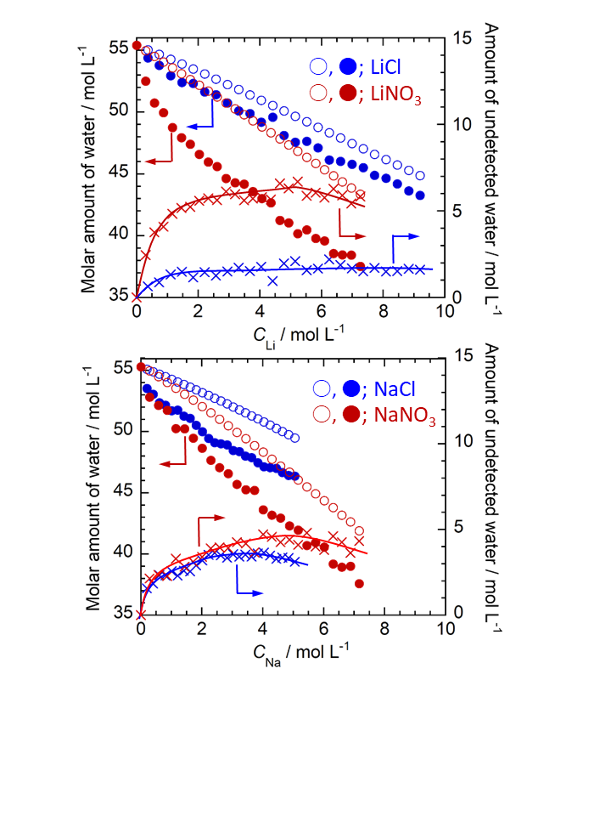
Fig. 1 shows the electrolyte concentration dependence of the detected water molecules by ¹H qNMR measurement of concentrated aqueous solutions. The × marks in the figure represent the
difference between the actual amount of H₂O present (○) calculated from density measurement of the sample solution and the amount of H₂O detected by ¹H qNMR (●) (= amount of undetected water, A_{un}). The A_{un} initially increases with increasing ion concentration due to the formation of hydration structures, but this increasing trend slows down. This is due to dehydration occurring due to the formation of solvent-separated ion pairs (SSIP), which increases the amount of detected water. At even higher concentrations, except for LiCl aqueous solutions, dehydration becomes more pronounced due to the formation of contact ion pairs (CIP), further increasing the amount of detected water and causing A_{un} to decrease. In both Li-based and Na-based solutions, the amount of A_{un} is greater when the anion is NO₃⁻ (×) than when it is Cl⁻ (×). This is because the ionic interaction between NO₃⁻, which has a large ionic radius, and the cation is small, making it difficult to form an ion pair. Furthermore, in both the Li and Na systems, when the anion was ClO₄⁻ or especially SO₄²⁻, the A_{un} value was small. This suggests that these anions have extremely weak electrostatic interactions with cations, do not form ion pairs such as SSIP, and that the structural disruption of the hydrogen bond network by the anions does not significantly reduce the mobility or activity of water molecules near the cations.
Fig. 1 Detected H₂O ratios by ¹H qNMR in XCl and XNO₃ aq. Open symbols; calculated H₂O amount from the sample solution density (y axis). Close symbols; detected H₂O amount by ¹H qNMR (y axis). Cross symbols; differential value between and (i.e., A_{un}. y2 axis).

