Water self-dissociation in slit pores
displays non-monotonic behavior as a function of water filling

S. Ruiz-Barragan¹,D. Muñoz-Santiburcio², S. Körning³, D. Marx³
¹Universitat Politécnica de Catalunya, Departament de Física, Terrassa 08222, Spain
² Instituto Andaluz de Ciencias de la Tierra, Spanish Research Council, Armilla, 18100, Spain
³ Lehrstuhl für Theoretische Chemie, Ruhr-Universität Bochum, Bochum, 44780, Germany
e-mail: sergio.ruiz.barragan@upc.edu

Although nanofluidics and chemistry in nanoconfined liquids has emerged as an exciting field, the quantitative impact of confinement on fundamental properties remains often unclear [1,2]. Currently, there is not yet consensus on the impact of slit pore confinement on water selfdissociation [1,2] , namely if this ubiquitous elementary reaction is enhanced, unaltered or suppressed by nanoconfinement. We address this question for well-defined water/graphene slit pore systems that allow us to carefully establish the appropriate thermodynamic conditions for different pore fillings, specifically pressure [3,4]. Anticipating our key results, we show that the energetics of the self-dissociation reaction is very sensitive to even subtle changes of the confinement conditions, leading even to non-monotonic behavior depending on water filling.

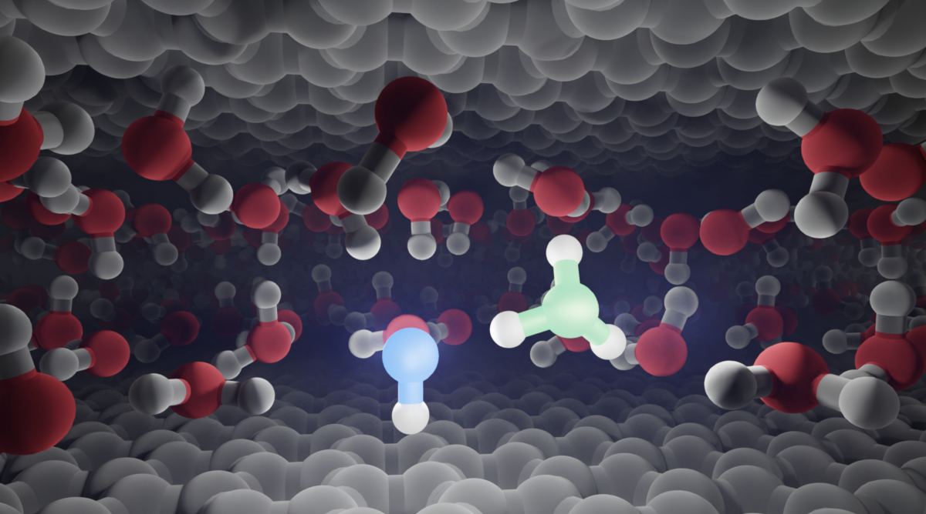
Figure 1 – Solvated hydronium-hydroxide contact ion pair in nanoconfined water in a graphene slit pore.

References
[1] D. Muñoz Santiburcio and D. Marx, Phys. Rev. Lett., 119, 056002 (2017)
[2] S. Di Pino, Y. A. Perez Sirkin, U. N. Morzan, V. M. Sanchez, A. Hassanali and D. A. Scherlis, Angew. Chem. Int. Ed., 62, e202306526 (2023)
[3] S. Ruiz-Barragan, D. Muñoz-Santiburcio, S. Körning and D. Marx, Phys. Chem. Chem. Phys., 22,10833 (2020)
[4] S. Ruiz-Barragan, H. Forbert and D. Marx, Phys. Chem. Chem. Phys., 25, 28119 (2023)

