Comprehensive Theoretical Approaches to the Self-Assembly Process
at the Molecular Level

H. Sato^{1,2}
¹Department of Molecular Engineering, Kyoto University
²Fukui Institute for Fundamental Chemistry, Kyoto University
e-mail: hirofumi@moleng.kyoto-u.ac.jp

Self-assembly, in which highly ordered structures form spontaneously, has attracted the attention of many researchers. Whilst it is often described as a quantitative conversion that yields a unique product from a macroscopic perspective, the process involves many intermediates that connect to form a complex network of numerous elementary steps at the molecular level. To gain insight into the process, a comprehensive approach is vital, and we have been developing a variety of theoretical approaches, including statistical mechanics for liquids, quantum chemistry, dynamical theory and so on. Prof Hiraoka (U Tokyo) developed an experimental protocol utilising NMR, called QASAP. As the theoretical counterpart, we developed NASAP (numerical analysis of the self-assembly process), providing more detailed information. In this treatment, the process is simulated on the network of possible intermediates using the Gillespie algorithm to be consistent with QASAP. The analysis has been successfully applied to various systems [1], especially in drawing a new perspective on a chemical reaction network [2]. Figure 1 illustrates an example of NASAP, in which a caged dinuclear palladium complex [Pd₂L₄]⁴⁺ is analysed as a time evolution of the self-assembly [3].
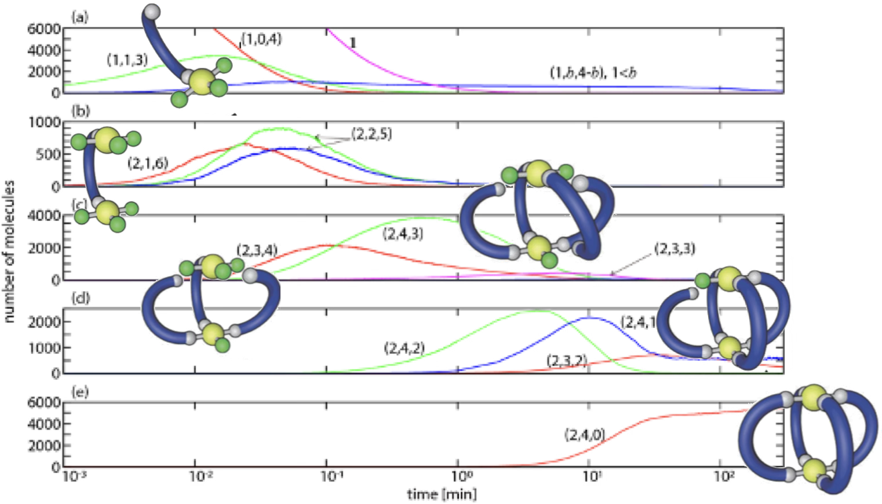
Figure 1 – Analysis by NASAP allows the long-term changes in all intermediates to be tracked. Reproduced from [3] with permission from the Royal Society of Chemistry.

In addition, a coarse-grained analysis is proposed for this cage-formation system to extract interactions among constituent units during assembly [4]. Recent developments in a quantum-statistical mechanical hybrid theory for solvated molecules, RISM-SCF-cSED, will be addressed if time permits [5].

Acknowledgements
The author thanks Prof Shuichi Hiraoka, Dr Satoshi Takahashi, Dr Satoru Iuchi and all the collaborators, including the students.

References
[1] S. Takahashi, S. Iuchi, S. Hiraoka, and H. Sato, Phys. Chem. Chem. Phys., 25, 14659 (2023).
[2] S. Takahashi, T. Abe, H. Sato, and S. Hiraoka, Chem., 9, 2971 (2023). T. Abe, K. Takeuchi, M. Higashi, H. Sato, and S. Hiraoka, Nature Chem., 15, 7630 (2024).
[3] S. Takahashi, Y. Sasaki, S. Hiraoka, and H. Sato, Phys. Chem. Chem. Phys., 21, 6341 (2019).
[4] Y. Ichikawa, K. Sugiyama, M. Higashi, S. Hiraoka, and H. Sato, Chem. Lett., 53, upae099 (2024).
[5] K. Imamura, D. Yokogawa, and H. Sato, J. Chem. Phys., 160, 050901 (2024).

