Integral Equations and Density Functional Theory for the cluster fluid phase of fluids with competing interactions

Martin B. Sweatman

School of Engineering, University of Edinburgh, Mayfield Road, Edinburgh, EH9 3FB.
e-mail: martin.sweatman@ed.ac.uk

Fluids with short-ranged attractive (SA) interactions and long-ranged repulsive (LR) interactions, often called SALR fluids, are known to form clusters of particles at low concentrations for suitable combinations of SALR parameters. These clusters can appear to behave like a stable dispersion of liquid-like droplets. SALR fluids are, therefore, often considered a reasonable model for some biological molecules, such as proteins, and other large molecules that are also known to form large stable clusters in solution.

Due to their strong concentration fluctuations over multiple length scales, these cluster fluids have proved quite challenging to model theoretically using standard methods, such as integral equations and density functional theory. Here, some recent progress in this area towards obtaining an accurate density functional theory (DFT) for the cluster fluid phase is presented [1,2].

In the first part of this presentation, some issues with published DFT approaches are described and a weighted DFT that can potentially overcome these issues is suggested [1]. A key input into this weighted DFT is accurate knowledge of the pair direct correlation function at a specific density for the cluster fluid. This can be generated using integral equation methods, although standard integral equation closures and/or Picard iteration solution methods for these clustered states often fail. However, ChatGPT 5 has been used to help design a suitable algorithm that can overcome such “stiffness” problems for some closures [2]. This progress is described in the second part of this presentation, although more work is needed to fully demonstrate the utility of this approach.

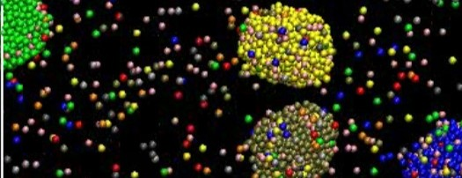

Figure 1 – Example of the cluster fluid phase of the hard sphere double Yukawa SALR fluid

Acknowledgements: I am grateful for insightful conversations with Leo Lue and the hard work of Jiazheng Tan on aspects of this study.

References
[1] M.B. Sweatman, submitted to Molecular Physics, 2026.
[2] M.B. Sweatman and J. Tan, submitted to Molecular Physics, 2026.

