Week 7: Network Psychometrics
Umar Toseeb

1. Introduction
 Learning objectives
By the end of this practical, you should be able to:
- Explain the core concepts of network modelling, including nodes, edges, network structure, and common network types used in social and behavioural research.
- Interpret key network metrics (e.g., degree, strength) and describe what they reveal about the structure and dynamics of a system.
- Construct and visualise basic networks using R.
- Apply introductory network‑analytic techniques to real data, evaluate emerging patterns, and communicate findings using appropriate visual and statistical summaries.
In the lecture, we saw how network models represent psychological variables as nodes, and their conditional dependencies as edges. We also introduced regularisation to estimate sparse, interpretable networks, and bootstrapping to evaluate the stability of estimated edges.
Today, we will apply these ideas to two short questionnaires from a study of parents of children with special educational needs during the COVID‑19 pandemic:
- Part A: Six items from the Kessler Psychological Distress Scale
- Part B: Six items from the Warwick–Edinburgh Mental Wellbeing Scale
- Part C: Combining the 12 items and figuring out the overall structure of Mental Health

2. Setting up

2.1 Packages
Install and load the following packages:
library(haven) # import Stata data
library(tidyverse) # data wrangling
library(psych) # polychoric correlations
library(bootnet) # network estimation + bootstrapping
library(qgraph) # network visualisation
library(igraph) # graph tools
library(NetworkComparisonTest) #network comparison test

3. Part A: Core Example

3.1 Introduction to the dataset
We begin with six distress items,these are taken from the Kessler Psychological Distress Scale
- nervous
- hopeless
- restless
- nothing_cheer
- everything_effort
- worthless
These are ordinal (1–5). Clear your workspace, set your working directory, and load the data - note that you’ll need to use the read_dta() function to import this file.
Next, extract the distress items from the dataset:
distress <- c("nervous", "hopeless", "restless",
"nothing_cheer", "everything_effort", "worthless")
items <- data[distress]
nrow(items)
summary(items)
colMeans(items, na.rm = TRUE)
- How many observations are in the dataset?
Use nrow(items).
- How many missing values does each item have?
Use summary(items).
- Which item has the highest mean?
Use colMeans(items, na.rm = TRUE).

3.2 Preparing the data
Convert labelled variables to numeric to be sure:
items <- data.frame(lapply(items, function(x) as.numeric(as.character(x))))
str(items)
'data.frame': 517 obs. of 6 variables:
$ nervous : num NA 3 2 3 3 4 NA NA 5 NA ...
$ hopeless : num NA 3 2 3 5 4 NA NA 2 NA ...
$ restless : num NA 4 2 3 4 5 NA NA 3 NA ...
$ nothing_cheer : num NA 2 5 4 5 5 NA NA 1 NA ...
$ everything_effort: num NA 2 4 3 4 4 NA NA 1 NA ...
$ worthless : num NA 4 5 5 5 5 NA NA 2 NA ...
summary(items)
nervous hopeless restless nothing_cheer
Min. :1.000 Min. :1.000 Min. :1.000 Min. :1.000
1st Qu.:2.000 1st Qu.:3.000 1st Qu.:2.000 1st Qu.:3.000
Median :3.000 Median :4.000 Median :3.000 Median :4.000
Mean :3.072 Mean :3.551 Mean :3.251 Mean :4.105
3rd Qu.:4.000 3rd Qu.:5.000 3rd Qu.:4.000 3rd Qu.:5.000
Max. :5.000 Max. :5.000 Max. :5.000 Max. :5.000
NA's :211 NA's :212 NA's :214 NA's :213
everything_effort worthless
Min. :1.000 Min. :1.000
1st Qu.:3.000 1st Qu.:3.000
Median :3.000 Median :4.000
Mean :3.326 Mean :4.057
3rd Qu.:4.000 3rd Qu.:5.000
Max. :5.000 Max. :5.000
NA's :216 NA's :221
- Are all variables now numeric?
- Have the descriptive statistics changed?

3.3 Polychoric correlations
Compute polychoric correlations:
poly_corr <- polychoric(items)$rho
poly_corr
nervous hopeless restless nothing_cheer everything_effort
nervous 1.0000000 0.4757092 0.4773222 0.3630860 0.2526908
hopeless 0.4757092 1.0000000 0.4255863 0.6428647 0.5692128
restless 0.4773222 0.4255863 1.0000000 0.3832485 0.2842738
nothing_cheer 0.3630860 0.6428647 0.3832485 1.0000000 0.6790467
everything_effort 0.2526908 0.5692128 0.2842738 0.6790467 1.0000000
worthless 0.3996348 0.6874185 0.3870143 0.7040625 0.6546725
worthless
nervous 0.3996348
hopeless 0.6874185
restless 0.3870143
nothing_cheer 0.7040625
everything_effort 0.6546725
worthless 1.0000000
- Which pair shows the strongest correlation?
- Which pair shows the weakest?
- Do these patterns make psychological sense?

3.4 Estimating a partial correlation network
net <- estimateNetwork(
items,
default = "EBICglasso",
corMethod = "cor_auto"
)
Estimating Network. Using package::function:
- qgraph::EBICglasso for EBIC model selection
- using glasso::glasso
- qgraph::cor_auto for correlation computation
- using lavaan::lavCor
Variables detected as ordinal: nervous; hopeless; restless; nothing_cheer; everything_effort; worthless
Warning in EBICglassoCore(S = S, n = n, gamma = gamma, penalize.diagonal =
penalize.diagonal, : A dense regularized network was selected (lambda < 0.1 *
lambda.max). Recent work indicates a possible drop in specificity. Interpret
the presence of the smallest edges with care. Setting threshold = TRUE will
enforce higher specificity, at the cost of sensitivity.
- Why is cor_auto appropriate?
- What does the sparsity warning imply?
- What is EBICglasso, and why is it used to estimate the network?

3.5 Inspecting the partial correlation matrix
partial_cor_matrix <- net$graph
partial_cor_matrix
nervous hopeless restless nothing_cheer
nervous 0.000000000 0.2156853 0.31556873 0.005394736
hopeless 0.215685300 0.0000000 0.10652941 0.214032491
restless 0.315568732 0.1065294 0.00000000 0.087621946
nothing_cheer 0.005394736 0.2140325 0.08762195 0.000000000
everything_effort 0.000000000 0.1077785 0.00000000 0.350987468
worthless 0.060110434 0.3260112 0.05424997 0.305585527
everything_effort worthless
nervous 0.0000000 0.06011043
hopeless 0.1077785 0.32601116
restless 0.0000000 0.05424997
nothing_cheer 0.3509875 0.30558553
everything_effort 0.0000000 0.26408804
worthless 0.2640880 0.00000000
- Which edges are non‑zero?
- Which strong marginal correlations disappear?
- What does this tell you?

3.6 Plotting the network
qgraph(
net$graph,
labels = colnames(items),
layout = "spring",
edge.labels = TRUE,
edge.label.cex = 0.8
)
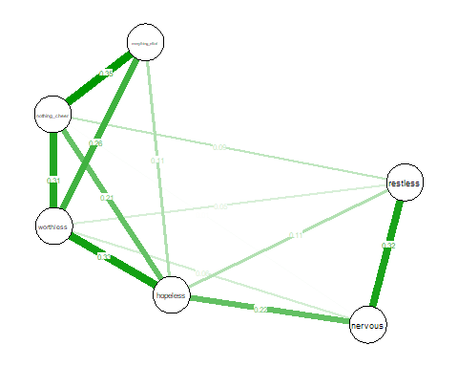
- Which symptoms are most strongly connected?
- Are there clusters?
- Does the visual structure match the matrix?

3.7 Bootstrapping edge accuracy
boot_edges <- bootnet(
net,
nBoots = 100,
type = "nonparametric"
)
Note: bootnet will store only the following statistics: edge, strength, outStrength, inStrength
Bootstrapping...
|
| | 0%
|
|= | 1%
|
|= | 2%
|
|== | 3%
|
|=== | 4%
|
|==== | 5%
Note: Network with lowest lambda selected as best network: assumption of sparsity might be violated.
|
|==== | 6%
|
|===== | 7%
|
|====== | 8%
Note: Network with lowest lambda selected as best network: assumption of sparsity might be violated.
|
|====== | 9%
Note: Network with lowest lambda selected as best network: assumption of sparsity might be violated.
|
|======= | 10%
|
|======== | 11%
Note: Network with lowest lambda selected as best network: assumption of sparsity might be violated.
|
|======== | 12%
|
|========= | 13%
|
|========== | 14%
|
|========== | 15%
Note: Network with lowest lambda selected as best network: assumption of sparsity might be violated.
|
|=========== | 16%
|
|============ | 17%
|
|============= | 18%
|
|============= | 19%
Note: Network with lowest lambda selected as best network: assumption of sparsity might be violated.
|
|============== | 20%
|
|=============== | 21%
|
|=============== | 22%
|
|================ | 23%
|
|================= | 24%
|
|================== | 25%
|
|================== | 26%
|
|=================== | 27%
|
|==================== | 28%
|
|==================== | 29%
|
|===================== | 30%
|
|====================== | 31%
Note: Network with lowest lambda selected as best network: assumption of sparsity might be violated.
|
|====================== | 32%
|
|======================= | 33%
Note: Network with lowest lambda selected as best network: assumption of sparsity might be violated.
|
|======================== | 34%
Note: Network with lowest lambda selected as best network: assumption of sparsity might be violated.
|
|======================== | 35%
Note: Network with lowest lambda selected as best network: assumption of sparsity might be violated.
|
|========================= | 36%
|
|========================== | 37%
Note: Network with lowest lambda selected as best network: assumption of sparsity might be violated.
|
|=========================== | 38%
|
|=========================== | 39%
|
|============================ | 40%
|
|============================= | 41%
|
|============================= | 42%
Note: Network with lowest lambda selected as best network: assumption of sparsity might be violated.
|
|============================== | 43%
|
|=============================== | 44%
|
|================================ | 45%
|
|================================ | 46%
|
|================================= | 47%
|
|================================== | 48%
|
|================================== | 49%
Note: Network with lowest lambda selected as best network: assumption of sparsity might be violated.
|
|=================================== | 50%
|
|==================================== | 51%
|
|==================================== | 52%
Note: Network with lowest lambda selected as best network: assumption of sparsity might be violated.
|
|===================================== | 53%
|
|====================================== | 54%
|
|====================================== | 55%
|
|======================================= | 56%
|
|======================================== | 57%
|
|========================================= | 58%
|
|========================================= | 59%
|
|========================================== | 60%
Note: Network with lowest lambda selected as best network: assumption of sparsity might be violated.
|
|=========================================== | 61%
|
|=========================================== | 62%
|
|============================================ | 63%
|
|============================================= | 64%
|
|============================================== | 65%
|
|============================================== | 66%
|
|=============================================== | 67%
|
|================================================ | 68%
|
|================================================ | 69%
|
|================================================= | 70%
|
|================================================== | 71%
|
|================================================== | 72%
|
|=================================================== | 73%
|
|==================================================== | 74%
|
|==================================================== | 75%
Note: Network with lowest lambda selected as best network: assumption of sparsity might be violated.
|
|===================================================== | 76%
|
|====================================================== | 77%
|
|======================================================= | 78%
|
|======================================================= | 79%
Note: Network with lowest lambda selected as best network: assumption of sparsity might be violated.
|
|======================================================== | 80%
|
|========================================================= | 81%
Note: Network with lowest lambda selected as best network: assumption of sparsity might be violated.
|
|========================================================= | 82%
Note: Network with lowest lambda selected as best network: assumption of sparsity might be violated.
|
|========================================================== | 83%
|
|=========================================================== | 84%
|
|============================================================ | 85%
|
|============================================================ | 86%
|
|============================================================= | 87%
|
|============================================================== | 88%
|
|============================================================== | 89%
Note: Network with lowest lambda selected as best network: assumption of sparsity might be violated.
|
|=============================================================== | 90%
|
|================================================================ | 91%
|
|================================================================ | 92%
|
|================================================================= | 93%
|
|================================================================== | 94%
|
|================================================================== | 95%
|
|=================================================================== | 96%
|
|==================================================================== | 97%
Note: Network with lowest lambda selected as best network: assumption of sparsity might be violated.
|
|===================================================================== | 98%
|
|===================================================================== | 99%
|
|======================================================================| 100%
Computing statistics...
|
| | 0%
|
|= | 1%
|
|= | 2%
|
|== | 3%
|
|=== | 4%
|
|==== | 5%
|
|==== | 6%
|
|===== | 7%
|
|====== | 8%
|
|====== | 9%
|
|======= | 10%
|
|======== | 11%
|
|======== | 12%
|
|========= | 13%
|
|========== | 14%
|
|========== | 15%
|
|=========== | 16%
|
|============ | 17%
|
|============= | 18%
|
|============= | 19%
|
|============== | 20%
|
|=============== | 21%
|
|=============== | 22%
|
|================ | 23%
|
|================= | 24%
|
|================== | 25%
|
|================== | 26%
|
|=================== | 27%
|
|==================== | 28%
|
|==================== | 29%
|
|===================== | 30%
|
|====================== | 31%
|
|====================== | 32%
|
|======================= | 33%
|
|======================== | 34%
|
|======================== | 35%
|
|========================= | 36%
|
|========================== | 37%
|
|=========================== | 38%
|
|=========================== | 39%
|
|============================ | 40%
|
|============================= | 41%
|
|============================= | 42%
|
|============================== | 43%
|
|=============================== | 44%
|
|================================ | 45%
|
|================================ | 46%
|
|================================= | 47%
|
|================================== | 48%
|
|================================== | 49%
|
|=================================== | 50%
|
|==================================== | 51%
|
|==================================== | 52%
|
|===================================== | 53%
|
|====================================== | 54%
|
|====================================== | 55%
|
|======================================= | 56%
|
|======================================== | 57%
|
|========================================= | 58%
|
|========================================= | 59%
|
|========================================== | 60%
|
|=========================================== | 61%
|
|=========================================== | 62%
|
|============================================ | 63%
|
|============================================= | 64%
|
|============================================== | 65%
|
|============================================== | 66%
|
|=============================================== | 67%
|
|================================================ | 68%
|
|================================================ | 69%
|
|================================================= | 70%
|
|================================================== | 71%
|
|================================================== | 72%
|
|=================================================== | 73%
|
|==================================================== | 74%
|
|==================================================== | 75%
|
|===================================================== | 76%
|
|====================================================== | 77%
|
|======================================================= | 78%
|
|======================================================= | 79%
|
|======================================================== | 80%
|
|========================================================= | 81%
|
|========================================================= | 82%
|
|========================================================== | 83%
|
|=========================================================== | 84%
|
|============================================================ | 85%
|
|============================================================ | 86%
|
|============================================================= | 87%
|
|============================================================== | 88%
|
|============================================================== | 89%
|
|=============================================================== | 90%
|
|================================================================ | 91%
|
|================================================================ | 92%
|
|================================================================= | 93%
|
|================================================================== | 94%
|
|================================================================== | 95%
|
|=================================================================== | 96%
|
|==================================================================== | 97%
|
|===================================================================== | 98%
|
|===================================================================== | 99%
|
|======================================================================| 100%
plot(boot_edges, "edge", plot = "interval")
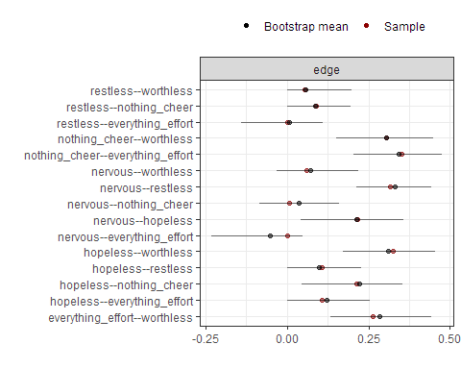
- Which edges have narrow CIs?
- Which are unstable?
- How does this affect interpretation?

3.8 Node centrality - Degree & Centrality
# Node degree = number of non-zero edges per node
degree <- apply(net$graph != 0, 1, sum)
sort(degree, decreasing = TRUE)
hopeless nothing_cheer worthless nervous
5 5 5 4
restless everything_effort
4 3
# Node strength centrality
cent <- centrality(net)
sort(cent$strength, decreasing = TRUE)
NULL
centralityPlot(net)
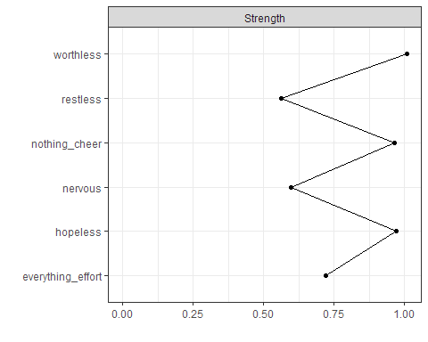
- Which symptom has highest degree?
- Which has highest strength?
- Do degree and strength tell a similar story?
- How does this relate to edges?
- Which symptoms might be leverage points to improve psychological distress?

3.9 Stability of centrality
# Case-dropping bootstrap for centrality stability
boot_cent <- bootnet(
net,
nBoots = 100,
type = "case"
)
Note: bootnet will store only the following statistics: edge, strength, outStrength, inStrength
Bootstrapping...
|
| | 0%
|
|= | 1%
Note: Network with lowest lambda selected as best network: assumption of sparsity might be violated.
|
|= | 2%
|
|== | 3%
|
|=== | 4%
|
|==== | 5%
|
|==== | 6%
|
|===== | 7%
|
|====== | 8%
|
|====== | 9%
|
|======= | 10%
|
|======== | 11%
|
|======== | 12%
|
|========= | 13%
|
|========== | 14%
Note: Network with lowest lambda selected as best network: assumption of sparsity might be violated.
|
|========== | 15%
|
|=========== | 16%
|
|============ | 17%
Note: Network with lowest lambda selected as best network: assumption of sparsity might be violated.
|
|============= | 18%
Note: Network with lowest lambda selected as best network: assumption of sparsity might be violated.
|
|============= | 19%
|
|============== | 20%
|
|=============== | 21%
|
|=============== | 22%
Note: Network with lowest lambda selected as best network: assumption of sparsity might be violated.
|
|================ | 23%
|
|================= | 24%
|
|================== | 25%
|
|================== | 26%
|
|=================== | 27%
|
|==================== | 28%
|
|==================== | 29%
|
|===================== | 30%
|
|====================== | 31%
|
|====================== | 32%
Note: Network with lowest lambda selected as best network: assumption of sparsity might be violated.
|
|======================= | 33%
Note: Network with lowest lambda selected as best network: assumption of sparsity might be violated.
|
|======================== | 34%
|
|======================== | 35%
|
|========================= | 36%
|
|========================== | 37%
|
|=========================== | 38%
|
|=========================== | 39%
Note: Network with lowest lambda selected as best network: assumption of sparsity might be violated.
|
|============================ | 40%
|
|============================= | 41%
|
|============================= | 42%
|
|============================== | 43%
|
|=============================== | 44%
Note: Network with lowest lambda selected as best network: assumption of sparsity might be violated.
|
|================================ | 45%
|
|================================ | 46%
|
|================================= | 47%
|
|================================== | 48%
|
|================================== | 49%
|
|=================================== | 50%
|
|==================================== | 51%
|
|==================================== | 52%
|
|===================================== | 53%
|
|====================================== | 54%
|
|====================================== | 55%
|
|======================================= | 56%
|
|======================================== | 57%
Note: Network with lowest lambda selected as best network: assumption of sparsity might be violated.
|
|========================================= | 58%
|
|========================================= | 59%
|
|========================================== | 60%
|
|=========================================== | 61%
|
|=========================================== | 62%
|
|============================================ | 63%
|
|============================================= | 64%
|
|============================================== | 65%
|
|============================================== | 66%
|
|=============================================== | 67%
|
|================================================ | 68%
|
|================================================ | 69%
|
|================================================= | 70%
|
|================================================== | 71%
|
|================================================== | 72%
|
|=================================================== | 73%
|
|==================================================== | 74%
|
|==================================================== | 75%
|
|===================================================== | 76%
|
|====================================================== | 77%
|
|======================================================= | 78%
|
|======================================================= | 79%
|
|======================================================== | 80%
|
|========================================================= | 81%
|
|========================================================= | 82%
|
|========================================================== | 83%
|
|=========================================================== | 84%
|
|============================================================ | 85%
|
|============================================================ | 86%
|
|============================================================= | 87%
Note: Network with lowest lambda selected as best network: assumption of sparsity might be violated.
|
|============================================================== | 88%
|
|============================================================== | 89%
|
|=============================================================== | 90%
|
|================================================================ | 91%
|
|================================================================ | 92%
|
|================================================================= | 93%
|
|================================================================== | 94%
Note: Network with lowest lambda selected as best network: assumption of sparsity might be violated.
|
|================================================================== | 95%
|
|=================================================================== | 96%
Note: Network with lowest lambda selected as best network: assumption of sparsity might be violated.
|
|==================================================================== | 97%
|
|===================================================================== | 98%
|
|===================================================================== | 99%
|
|======================================================================| 100%
Computing statistics...
|
| | 0%
|
|= | 1%
|
|= | 2%
|
|== | 3%
|
|=== | 4%
|
|==== | 5%
|
|==== | 6%
|
|===== | 7%
|
|====== | 8%
|
|====== | 9%
|
|======= | 10%
|
|======== | 11%
|
|======== | 12%
|
|========= | 13%
|
|========== | 14%
|
|========== | 15%
|
|=========== | 16%
|
|============ | 17%
|
|============= | 18%
|
|============= | 19%
|
|============== | 20%
|
|=============== | 21%
|
|=============== | 22%
|
|================ | 23%
|
|================= | 24%
|
|================== | 25%
|
|================== | 26%
|
|=================== | 27%
|
|==================== | 28%
|
|==================== | 29%
|
|===================== | 30%
|
|====================== | 31%
|
|====================== | 32%
|
|======================= | 33%
|
|======================== | 34%
|
|======================== | 35%
|
|========================= | 36%
|
|========================== | 37%
|
|=========================== | 38%
|
|=========================== | 39%
|
|============================ | 40%
|
|============================= | 41%
|
|============================= | 42%
|
|============================== | 43%
|
|=============================== | 44%
|
|================================ | 45%
|
|================================ | 46%
|
|================================= | 47%
|
|================================== | 48%
|
|================================== | 49%
|
|=================================== | 50%
|
|==================================== | 51%
|
|==================================== | 52%
|
|===================================== | 53%
|
|====================================== | 54%
|
|====================================== | 55%
|
|======================================= | 56%
|
|======================================== | 57%
|
|========================================= | 58%
|
|========================================= | 59%
|
|========================================== | 60%
|
|=========================================== | 61%
|
|=========================================== | 62%
|
|============================================ | 63%
|
|============================================= | 64%
|
|============================================== | 65%
|
|============================================== | 66%
|
|=============================================== | 67%
|
|================================================ | 68%
|
|================================================ | 69%
|
|================================================= | 70%
|
|================================================== | 71%
|
|================================================== | 72%
|
|=================================================== | 73%
|
|==================================================== | 74%
|
|==================================================== | 75%
|
|===================================================== | 76%
|
|====================================================== | 77%
|
|======================================================= | 78%
|
|======================================================= | 79%
|
|======================================================== | 80%
|
|========================================================= | 81%
|
|========================================================= | 82%
|
|========================================================== | 83%
|
|=========================================================== | 84%
|
|============================================================ | 85%
|
|============================================================ | 86%
|
|============================================================= | 87%
|
|============================================================== | 88%
|
|============================================================== | 89%
|
|=============================================================== | 90%
|
|================================================================ | 91%
|
|================================================================ | 92%
|
|================================================================= | 93%
|
|================================================================== | 94%
|
|================================================================== | 95%
|
|=================================================================== | 96%
|
|==================================================================== | 97%
|
|===================================================================== | 98%
|
|===================================================================== | 99%
|
|======================================================================| 100%
# Plot centrality stability
plot(boot_cent, "strength")
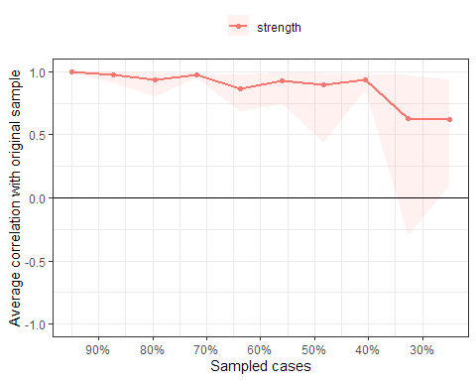
plot(boot_cent, "edge")
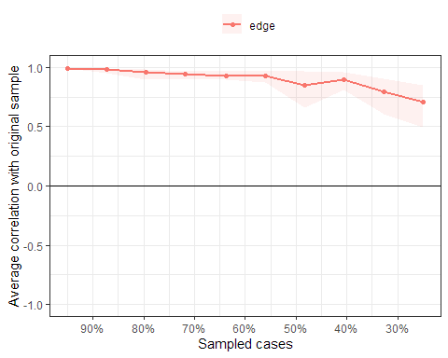
corStability(boot_cent)
=== Correlation Stability Analysis ===
Sampling levels tested:
nPerson Drop% n
1 129 75.0 20
2 169 67.3 9
3 210 59.4 9
4 250 51.6 10
5 290 43.9 9
6 330 36.2 9
7 371 28.2 4
8 411 20.5 16
9 451 12.8 8
10 491 5.0 6
Maximum drop proportions to retain correlation of 0.7 in at least 95% of the samples:
edge: 0.594
- For more accuracy, run bootnet(..., caseMin = 0.516, caseMax = 0.673)
strength: 0.594
- For more accuracy, run bootnet(..., caseMin = 0.516, caseMax = 0.673)
Accuracy can also be increased by increasing both 'nBoots' and 'caseN'.
- Does node strength remain consistent?
- Do strongest edges stay stable?
- Are edge weights and strength stable enough?
- Is CS > .25?
- What does this imply?

3.10 Network Comparison Test: High vs Low Income
We now test whether the psychological distress network during COVID-10 differs between those from low income households and those from low income households:
- High‑income (low_income = 0)
- Low‑income (low_income = 1)
The NCT compares:
- Global strength
- Network structure
- Edge differences
# Distress items - prepare the groups
distress <- c("nervous", "hopeless", "restless",
"nothing_cheer", "everything_effort", "worthless")
# High-income group
items_high <- data[data$low_income == 0, distress]
# Low-income group
items_low <- data[data$low_income == 1, distress]
#clean the data
items_high_clean <- na.omit(items_high)
items_low_clean <- na.omit(items_low)
#run the NCT
nct <- NCT(
data1 = items_high_clean,
data2 = items_low_clean,
test.edges = TRUE,
test.centrality = FALSE,
it = 1000
)
|
| | 0%
|
| | 1%
|
|= | 1%
|
|= | 2%
|
|== | 2%
|
|== | 3%
|
|== | 4%
|
|=== | 4%
|
|=== | 5%
|
|==== | 5%
|
|==== | 6%
|
|===== | 6%
|
|===== | 7%
|
|===== | 8%
|
|====== | 8%
|
|====== | 9%
|
|======= | 9%
|
|======= | 10%
|
|======= | 11%
|
|======== | 11%
|
|======== | 12%
|
|========= | 12%
|
|========= | 13%
|
|========= | 14%
|
|========== | 14%
|
|========== | 15%
|
|=========== | 15%
|
|=========== | 16%
|
|============ | 16%
|
|============ | 17%
|
|============ | 18%
|
|============= | 18%
|
|============= | 19%
|
|============== | 19%
|
|============== | 20%
|
|============== | 21%
|
|=============== | 21%
|
|=============== | 22%
|
|================ | 22%
|
|================ | 23%
|
|================ | 24%
|
|================= | 24%
|
|================= | 25%
|
|================== | 25%
|
|================== | 26%
|
|=================== | 26%
|
|=================== | 27%
|
|=================== | 28%
|
|==================== | 28%
|
|==================== | 29%
|
|===================== | 29%
|
|===================== | 30%
|
|===================== | 31%
|
|====================== | 31%
|
|====================== | 32%
|
|======================= | 32%
|
|======================= | 33%
|
|======================= | 34%
|
|======================== | 34%
|
|======================== | 35%
|
|========================= | 35%
|
|========================= | 36%
|
|========================== | 36%
|
|========================== | 37%
|
|========================== | 38%
|
|=========================== | 38%
|
|=========================== | 39%
|
|============================ | 39%
|
|============================ | 40%
|
|============================ | 41%
|
|============================= | 41%
|
|============================= | 42%
|
|============================== | 42%
|
|============================== | 43%
|
|============================== | 44%
|
|=============================== | 44%
|
|=============================== | 45%
|
|================================ | 45%
|
|================================ | 46%
|
|================================= | 46%
|
|================================= | 47%
|
|================================= | 48%
|
|================================== | 48%
|
|================================== | 49%
|
|=================================== | 49%
|
|=================================== | 50%
|
|=================================== | 51%
|
|==================================== | 51%
|
|==================================== | 52%
|
|===================================== | 52%
|
|===================================== | 53%
|
|===================================== | 54%
|
|====================================== | 54%
|
|====================================== | 55%
|
|======================================= | 55%
|
|======================================= | 56%
|
|======================================== | 56%
|
|======================================== | 57%
|
|======================================== | 58%
|
|========================================= | 58%
|
|========================================= | 59%
|
|========================================== | 59%
|
|========================================== | 60%
|
|========================================== | 61%
|
|=========================================== | 61%
|
|=========================================== | 62%
|
|============================================ | 62%
|
|============================================ | 63%
|
|============================================ | 64%
|
|============================================= | 64%
|
|============================================= | 65%
|
|============================================== | 65%
|
|============================================== | 66%
|
|=============================================== | 66%
|
|=============================================== | 67%
|
|=============================================== | 68%
|
|================================================ | 68%
|
|================================================ | 69%
|
|================================================= | 69%
|
|================================================= | 70%
|
|================================================= | 71%
|
|================================================== | 71%
|
|================================================== | 72%
|
|=================================================== | 72%
|
|=================================================== | 73%
|
|=================================================== | 74%
|
|==================================================== | 74%
|
|==================================================== | 75%
|
|===================================================== | 75%
|
|===================================================== | 76%
|
|====================================================== | 76%
|
|====================================================== | 77%
|
|====================================================== | 78%
|
|======================================================= | 78%
|
|======================================================= | 79%
|
|======================================================== | 79%
|
|======================================================== | 80%
|
|======================================================== | 81%
|
|========================================================= | 81%
|
|========================================================= | 82%
|
|========================================================== | 82%
|
|========================================================== | 83%
|
|========================================================== | 84%
|
|=========================================================== | 84%
|
|=========================================================== | 85%
|
|============================================================ | 85%
|
|============================================================ | 86%
|
|============================================================= | 86%
|
|============================================================= | 87%
|
|============================================================= | 88%
|
|============================================================== | 88%
|
|============================================================== | 89%
|
|=============================================================== | 89%
|
|=============================================================== | 90%
|
|=============================================================== | 91%
|
|================================================================ | 91%
|
|================================================================ | 92%
|
|================================================================= | 92%
|
|================================================================= | 93%
|
|================================================================= | 94%
|
|================================================================== | 94%
|
|================================================================== | 95%
|
|=================================================================== | 95%
|
|=================================================================== | 96%
|
|==================================================================== | 96%
|
|==================================================================== | 97%
|
|==================================================================== | 98%
|
|===================================================================== | 98%
|
|===================================================================== | 99%
|
|======================================================================| 99%
|
|======================================================================| 100%
summary(nct)
INDEPENDENT GROUPS GAUSSIAN NETWORK COMPARISON TEST
P-VALUE CORRECTION: none
NETWORK INVARIANCE TEST
Test statistic M: 0.2692764
p-value 0.1688312
GLOBAL STRENGTH INVARIANCE TEST
Global strength per group: 2.302893 2.233734
Test statistic S: 0.06915881
p-value 0.7122877
EDGE INVARIANCE TEST
Var1 Var2 p-value Test statistic E
7 nervous hopeless 0.17382617 0.15131636
13 nervous restless 0.39060939 0.10387309
14 hopeless restless 0.22977023 0.13803481
19 nervous nothing_cheer 0.29770230 0.07460678
20 hopeless nothing_cheer 0.84915085 0.02292007
21 restless nothing_cheer 0.21178821 0.12355624
25 nervous everything_effort 1.00000000 0.00000000
26 hopeless everything_effort 0.30869131 0.11986385
27 restless everything_effort 0.34465534 0.03184012
28 nothing_cheer everything_effort 0.01698302 0.26927637
31 nervous worthless 0.63536464 0.04931521
32 hopeless worthless 0.87412587 0.01870152
33 restless worthless 0.35964036 0.09146354
34 nothing_cheer worthless 0.08791209 0.20234389
35 everything_effort worthless 0.10489510 0.15688239
- Is there a significant difference in global strength?
- Is there a difference in overall network structure?
- Are any edges significantly different?
- What does this suggest?
 Take a break!
If you haven’t already taken a break today, we suggest you do so before you start the next section.


4. Part B: Apply Your Knowledge

4.1 Introduction to the dataset
You now need to repeat the same workflow using six wellbeing items from the Warwick–Edinburgh Mental Wellbeing Scale:
- optimistic
- useful
- deal_problems
- think_clearly
- feeling_close
- make_up_mind

5. Part C: Challenge Yourself — Combined Network
In the earlier sections, you estimated separate networks for six distress items and six wellbeing items. In this challenge, you will combine all 12 items into a single dataset and estimate a joint network model. This allows you to explore how distress and wellbeing processes interrelate within the same system.
You will then use igraph to identify clusters (communities) in the combined network.

5.1 Prepare data
# Vector of variable names
mental_health <- c("nervous", "hopeless", "restless",
"nothing_cheer", "everything_effort", "worthless",
"optimistic", "useful", "deal_problems", "think_clearly",
"feeling_close", "make_up_mind")
# Subset the actual data from your dataset
items <- data[mental_health]
str(items)
tibble [517 × 12] (S3: tbl_df/tbl/data.frame)
$ nervous : dbl+lbl [1:517] NA, 3, 2, 3, 3, 4, NA, NA, 5, NA, NA, 4, NA, 2...
..@ label : chr "During the past 30 days, about how often did you feel... - nervous?"
..@ format.stata: chr "%40.0f"
..@ labels : Named num [1:5] 1 2 3 4 5
.. ..- attr(*, "names")= chr [1:5] "All of the time" "Most of the time" "Some of the time" "A little of the time" ...
$ hopeless : dbl+lbl [1:517] NA, 3, 2, 3, 5, 4, NA, NA, 2, NA, NA, 4, NA, 2...
..@ label : chr "During the past 30 days, about how often did you feel... - hopeless?"
..@ format.stata: chr "%40.0f"
..@ labels : Named num [1:5] 1 2 3 4 5
.. ..- attr(*, "names")= chr [1:5] "All of the time" "Most of the time" "Some of the time" "A little of the time" ...
$ restless : dbl+lbl [1:517] NA, 4, 2, 3, 4, 5, NA, NA, 3, NA, NA, 5, NA, 2...
..@ label : chr "During the past 30 days, about how often did you feel... - restless or fidgety?"
..@ format.stata: chr "%40.0f"
..@ labels : Named num [1:5] 1 2 3 4 5
.. ..- attr(*, "names")= chr [1:5] "All of the time" "Most of the time" "Some of the time" "A little of the time" ...
$ nothing_cheer : dbl+lbl [1:517] NA, 2, 5, 4, 5, 5, NA, NA, 1, NA, NA, 5, NA, 4...
..@ label : chr "During the past 30 days, about how often did you feel... - so depressed that not"
..@ format.stata: chr "%40.0f"
..@ labels : Named num [1:5] 1 2 3 4 5
.. ..- attr(*, "names")= chr [1:5] "All of the time" "Most of the time" "Some of the time" "A little of the time" ...
$ everything_effort: dbl+lbl [1:517] NA, 2, 4, 3, 4, 4, NA, NA, 1, NA, NA, 2, NA, 3...
..@ label : chr "During the past 30 days, about how often did you feel... - that everything was a"
..@ format.stata: chr "%40.0f"
..@ labels : Named num [1:5] 1 2 3 4 5
.. ..- attr(*, "names")= chr [1:5] "All of the time" "Most of the time" "Some of the time" "A little of the time" ...
$ worthless : dbl+lbl [1:517] NA, 4, 5, 5, 5, 5, NA, NA, 2, NA, NA, 3, NA, 3...
..@ label : chr "During the past 30 days, about how often did you feel... - worthless?"
..@ format.stata: chr "%40.0f"
..@ labels : Named num [1:5] 1 2 3 4 5
.. ..- attr(*, "names")= chr [1:5] "All of the time" "Most of the time" "Some of the time" "A little of the time" ...
$ optimistic : dbl+lbl [1:517] NA, 3, 3, 2, 4, 4, NA, NA, 2, NA, NA, 3, NA, 3...
..@ label : chr "I've been feeling optimistic about the future"
..@ format.stata: chr "%40.0f"
..@ labels : Named num [1:5] 1 2 3 4 5
.. ..- attr(*, "names")= chr [1:5] "None of the time" "Rarely" "Some of the time" "Often" ...
$ useful : dbl+lbl [1:517] NA, 3, 3, 2, 4, 3, NA, NA, 1, NA, NA, 3, NA, 3...
..@ label : chr "I've been feeling useful"
..@ format.stata: chr "%40.0f"
..@ labels : Named num [1:5] 1 2 3 4 5
.. ..- attr(*, "names")= chr [1:5] "None of the time" "Rarely" "Some of the time" "Often" ...
$ deal_problems : dbl+lbl [1:517] NA, 2, 4, 3, 4, 4, NA, NA, 2, NA, NA, 4, NA, 4...
..@ label : chr "I've been dealing with problems well"
..@ format.stata: chr "%40.0f"
..@ labels : Named num [1:5] 1 2 3 4 5
.. ..- attr(*, "names")= chr [1:5] "None of the time" "Rarely" "Some of the time" "Often" ...
$ think_clearly : dbl+lbl [1:517] NA, 2, 5, 2, 4, 4, NA, NA, 1, NA, NA, 4, NA, 3...
..@ label : chr "I've been thinking clearly"
..@ format.stata: chr "%40.0f"
..@ labels : Named num [1:5] 1 2 3 4 5
.. ..- attr(*, "names")= chr [1:5] "None of the time" "Rarely" "Some of the time" "Often" ...
$ feeling_close : dbl+lbl [1:517] NA, 3, 5, 1, 5, 4, NA, NA, 2, NA, NA, 4, NA, 3...
..@ label : chr "I've been feeling close to other people"
..@ format.stata: chr "%40.0f"
..@ labels : Named num [1:5] 1 2 3 4 5
.. ..- attr(*, "names")= chr [1:5] "None of the time" "Rarely" "Some of the time" "Often" ...
$ make_up_mind : dbl+lbl [1:517] NA, 3, 4, 3, 4, 4, NA, NA, 3, NA, NA, 3, NA, 4...
..@ label : chr "I've been able to make up my mind about things"
..@ format.stata: chr "%40.0f"
..@ labels : Named num [1:5] 1 2 3 4 5
.. ..- attr(*, "names")= chr [1:5] "None of the time" "Rarely" "Some of the time" "Often" ...
summary(items)
nervous hopeless restless nothing_cheer
Min. :1.000 Min. :1.000 Min. :1.000 Min. :1.000
1st Qu.:2.000 1st Qu.:3.000 1st Qu.:2.000 1st Qu.:3.000
Median :3.000 Median :4.000 Median :3.000 Median :4.000
Mean :3.072 Mean :3.551 Mean :3.251 Mean :4.105
3rd Qu.:4.000 3rd Qu.:5.000 3rd Qu.:4.000 3rd Qu.:5.000
Max. :5.000 Max. :5.000 Max. :5.000 Max. :5.000
NA's :211 NA's :212 NA's :214 NA's :213
everything_effort worthless optimistic useful
Min. :1.000 Min. :1.000 Min. :1.00 Min. :1.000
1st Qu.:3.000 1st Qu.:3.000 1st Qu.:2.00 1st Qu.:3.000
Median :3.000 Median :4.000 Median :3.00 Median :3.000
Mean :3.326 Mean :4.057 Mean :2.88 Mean :3.156
3rd Qu.:4.000 3rd Qu.:5.000 3rd Qu.:3.00 3rd Qu.:4.000
Max. :5.000 Max. :5.000 Max. :5.00 Max. :5.000
NA's :216 NA's :221 NA's :208 NA's :209
deal_problems think_clearly feeling_close make_up_mind
Min. :1.00 Min. :1.00 Min. :1.000 Min. :1.00
1st Qu.:3.00 1st Qu.:3.00 1st Qu.:2.000 1st Qu.:3.00
Median :3.00 Median :3.00 Median :3.000 Median :4.00
Mean :3.33 Mean :3.33 Mean :3.104 Mean :3.54
3rd Qu.:4.00 3rd Qu.:4.00 3rd Qu.:4.000 3rd Qu.:4.00
Max. :5.00 Max. :5.00 Max. :5.000 Max. :5.00
NA's :208 NA's :208 NA's :208 NA's :208
# Ensure numeric type
items <- data.frame(lapply(items, function(x) as.numeric(as.character(x))))

5.2 Estimate the 12‑item network and Plot it
net <- estimateNetwork(items,
default = "EBICglasso",
corMethod = "cor_auto"
)
Estimating Network. Using package::function:
- qgraph::EBICglasso for EBIC model selection
- using glasso::glasso
- qgraph::cor_auto for correlation computation
- using lavaan::lavCor
Variables detected as ordinal: nervous; hopeless; restless; nothing_cheer; everything_effort; worthless; optimistic; useful; deal_problems; think_clearly; feeling_close; make_up_mind
Warning in EBICglassoCore(S = S, n = n, gamma = gamma, penalize.diagonal =
penalize.diagonal, : A dense regularized network was selected (lambda < 0.1 *
lambda.max). Recent work indicates a possible drop in specificity. Interpret
the presence of the smallest edges with care. Setting threshold = TRUE will
enforce higher specificity, at the cost of sensitivity.
qgraph(
net$graph,
labels = colnames(items),
layout = "spring",
edge.labels = TRUE, # <-- this adds the numbers
edge.label.cex = 0.8 # <-- adjust text size (optional)
)
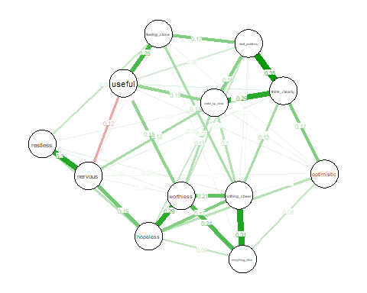

5.3 Convert to igraph and detect clusters using various different algorithms
W <- net$graph # <-- convert to absolute values to get rid of negative values
W_abs <- abs(W) # <-- convert to absolute values to get rid of negative values
g <- graph_from_adjacency_matrix(W_abs, mode = "undirected", weighted = TRUE, diag = FALSE)
wc <- cluster_walktrap(g, weights = E(g)$weight)
lv <- cluster_louvain(g, weights = E(g)$weight)
fg <- cluster_fast_greedy(g, weights = E(g)$weight)
im <- cluster_infomap(g, e.weights = E(g)$weight)
le <- cluster_leading_eigen(g, weights = E(g)$weight)

5.4 Inspect Clusters
membership(wc)
nervous hopeless restless nothing_cheer
3 2 3 2
everything_effort worthless optimistic useful
2 2 1 1
deal_problems think_clearly feeling_close make_up_mind
1 1 1 1
membership(lv)
nervous hopeless restless nothing_cheer
1 2 1 2
everything_effort worthless optimistic useful
2 2 3 1
deal_problems think_clearly feeling_close make_up_mind
3 3 1 3
membership(fg)
nervous hopeless restless nothing_cheer
1 3 1 3
everything_effort worthless optimistic useful
3 3 2 1
deal_problems think_clearly feeling_close make_up_mind
2 2 1 2
membership(im)
nervous hopeless restless nothing_cheer
1 1 1 1
everything_effort worthless optimistic useful
1 1 1 1
deal_problems think_clearly feeling_close make_up_mind
1 1 1 1
membership(le)
nervous hopeless restless nothing_cheer
1 1 1 3
everything_effort worthless optimistic useful
3 3 2 2
deal_problems think_clearly feeling_close make_up_mind
2 2 2 2

5.5 Plot each solution
plot(wc, g)
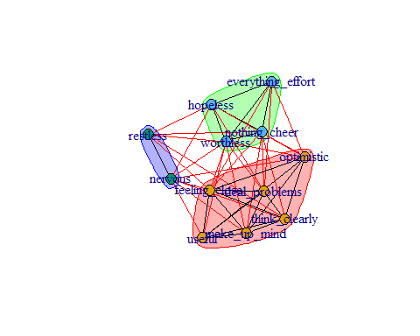
plot(lv, g)
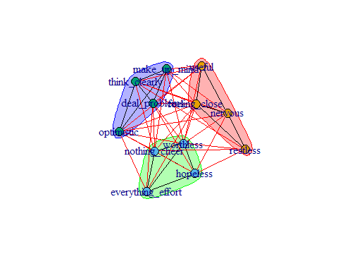
plot(fg, g)
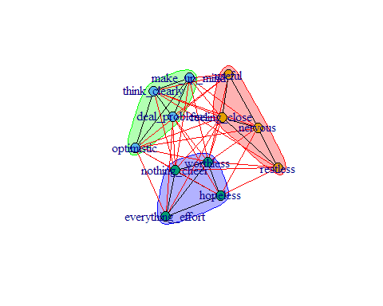
plot(im, g)
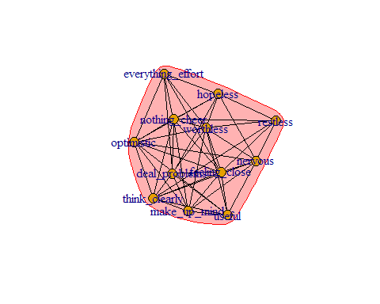

5.6 Compare the number of clusters
length(unique(membership(wc)))
[1] 3
length(unique(membership(lv)))
[1] 3
length(unique(membership(fg)))
[1] 3
length(unique(membership(im)))
[1] 1
length(unique(membership(le)))
[1] 3
- How many clusters does igraph detect?
- Do distress and wellbeing items mix together or separate cleanly?
- What does this tell you about the structure of mental health?

6. End of practical
 Feedback!
These practical sessions are new this year. Please take a moment to rate the difficulty and length of these practical activities via this survey, and let us know of any issues you encountered or aspects you didn’t understand (positive feedback is also welcome!). You will need to be logged in with your university account to respond, but your submission will be anonymous.
For more general questions about the practical, please post them on the VLE Discussion Board.

