Set-up guide
This section provides some guidelines and recommendations for organising your work as we progress throughout the module. However, your development as a data scientist is now well underway, and you may have already established preferred ways of working. This is fine. Consider the guidance below and decide on your workflow for this module, and default to the recommendations if you are not yet confident in your set-up.

1. File storage
It’s a good idea create a folder on your device to store all of your practical work for this module, and to set up an R project to work from.

1.1 Set up your folders
You can do this from within R if you prefer, but here are the simplest instructions for setting up on your device.
1) Open the file browser on your computer. On Windows, you can do this by clicking Start >> File Explorer.
2) Navigate to your Documents folder.
3) Create a new folder, and call it something like “AMBR_Practicals”.
4) Within this new folder, create one folder called “scripts”, and another folder called “data”.
 Tip
Note that R is case sensitive, meaning that if you capitalise letters here then you will also need to be specific in your capitalisation in the scripts. It is a good idea to adopt a consistent approach to avoid later issues. Here we have used lower case, and strongly advise you to do the same so that you don’t get confused later on.
If you download datasets for the practicals in the future, you should save them in your data folder. Similarly, when you create scripts in each practical, save them in the scripts folder.

1.2 Initiate an R Project
Now let’s tell R where we want to work during these practicals.
1) Open RStudio.
2) At the top of the window, click File >> New Project…
3) After a bit of thinking (be patient!), a “New Project Wizard” window should appear. Click the Existing Directory option in the middle, to associate this new project with an existing working directory. We choose this option because we have already set up our folders manually in the previous step.
4) On the next window, click “Browse…” and then navigate to your AMBR_Practicals folder. Once you are in it (and can see your data/scripts folders), click “Open”.
5) Click “Create Project”.
The name of the R Project you are working in should now show in the top right hand corner of your window, like this:
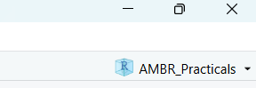
The current R Project
If it doesn’t, retrace your steps and try again. If it still doesn’t work, ask us for help.

1.3 Moving forwards
The instructions for the practicals will assume that you have set up R in this way. We will follow three key principles:
1) Open the R Project at the start of every session. You can do this by double clicking it from your file browser, or clicking File >> Open Project… from within RStudio.
2) Save the data files in the data folder, once you have downloaded them.
3) Save your scripts in the scripts folder.

2. Script format
In your Semester 1 modules, you learned how to integrate code and text using Quarto. We recommend that you use this file format for your scripts throughout the module, as it will allow you to chunk your sections of code and make notes easily as you go. Your assessment will also require you to submit a Quarto report, and so building your familiarity with this format and addressing technical issues within the practical sessions will be helpful.
However, as above, if you prefer to work in an alternative format (e.g., R script) then you may.

3. Other RStudio tips
There are a few other settings that can be useful to change when you first begin working in RStudio.

3.1 Saving the workspace
One irritating default of RStudio is that it saves everything automatically on exiting. This might sound like a great idea, but in reality it can mean that you have a very messy workspace and that mistakes can emerge from using old material. To turn this off (highly recommended):
1) At the top of RStudio, click Tools >> Global Options…
2) On the General panel that should open in the window, there is a section titled Workspace.
3) Make sure that the Restore .RData[…] box is unticked, and that it is set to never save the workspace on exit.
4) Click “Apply” to save the settings.
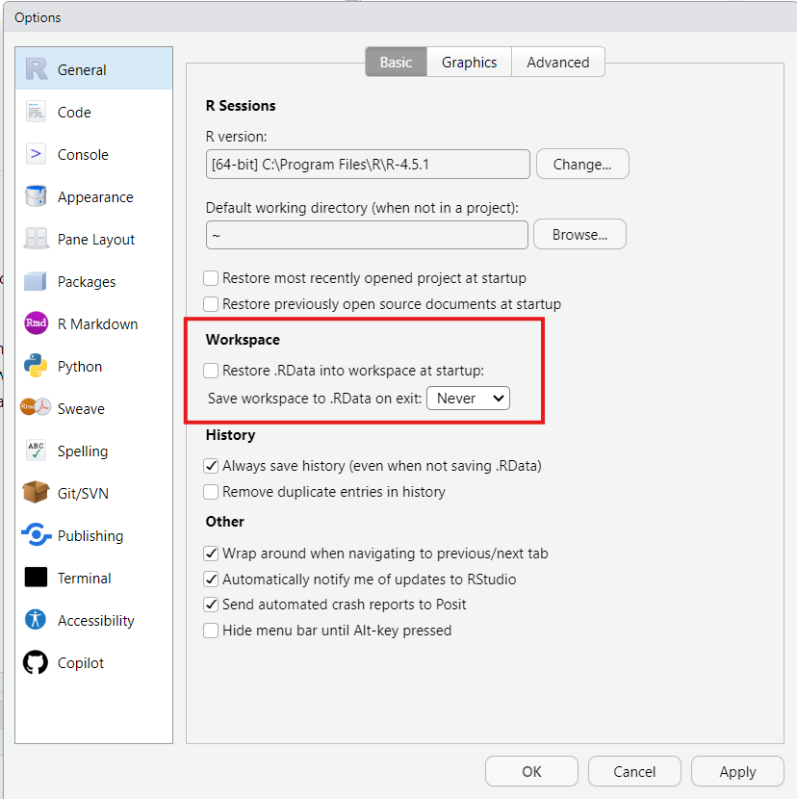
Global options window with recommended General settings

3.2 Rainbow parentheses
Sometimes we will need to wrap things inside multiple nested brackets. Whilst we’re on the settings, we might as well set up one of my favourite most useful features: rainbow parentheses! This setting colour codes your brackets so that you can tell which ones are paired together. And who doesn’t want a bit of colour on their scripts?!
1) On the Global Options… window you have open, click on “Code” down the left hand side.
2) Click the “Display” tab at the op.
3) Under syntax, check the box that says “Use rainbow parentheses”.
4) Then click “Apply”, and/or “OK” to close the window.
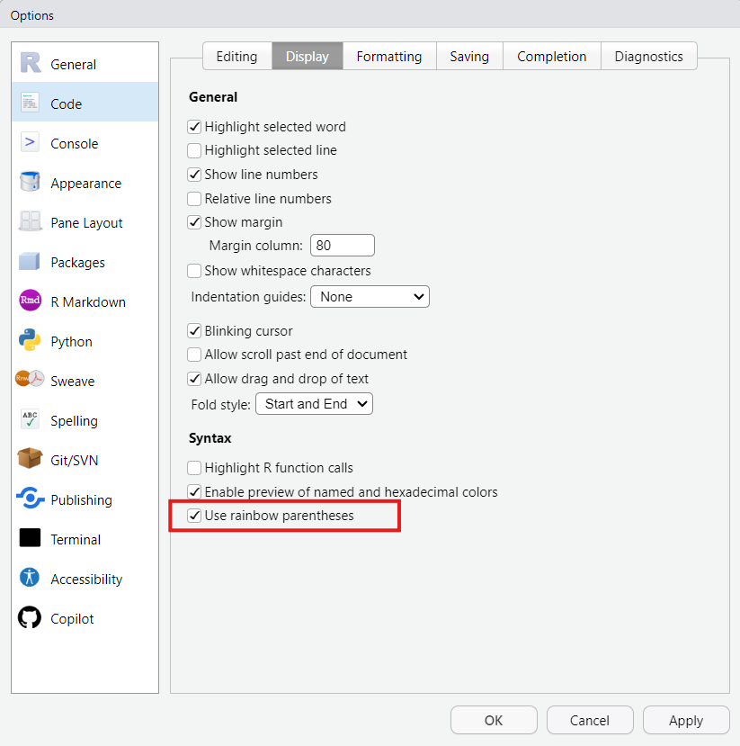
Global options window with recommended Code Display settings
As for what this has done? Well, you’ll just have to wait and see as we get writing scripts…

