**Remember** -- An app to record the anniversary

**Project value proposition:** in today's increasingly fast-paced life, people are busy working and learning. Many people forget the little things that need to be remembered in their lives. The app we wrote can help users record the days that need to be commemorated and experience the extraordinary feelings in the ordinary life. At the same time, the operation and interface of this app is also very simple, easy for users to use, and helps to increase user stickiness.

**UI SKETCH：**

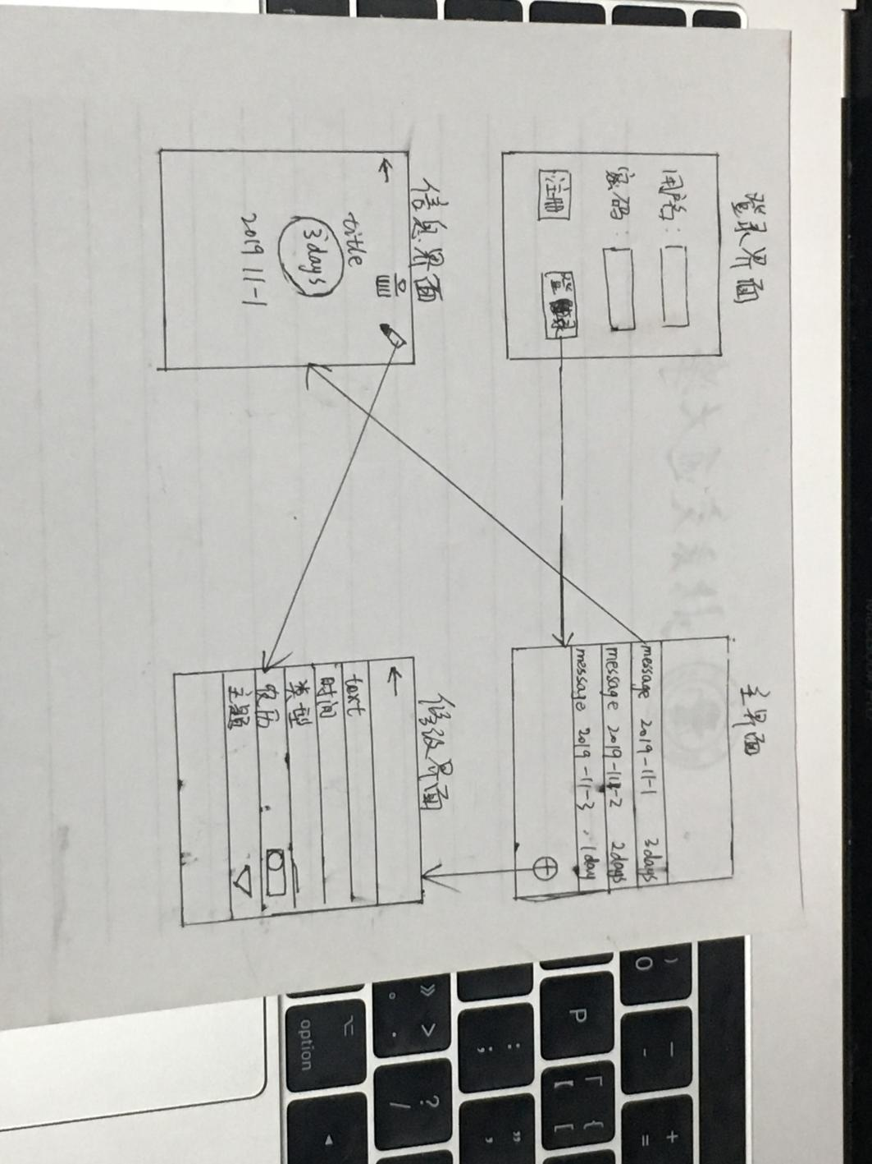

**System function narrative：**

1. Login: you can connect to the server through the login account, read the memorial day information stored on the server and synchronize it to the local.

2. Browse anniversary: you can browse all the created anniversary on the main interface.

3. View anniversary details: click any anniversary bar on the main interface to view the details, and modify and delete them in the pop-up page.

4. Create / modify anniversary information: create / modify anniversary information by filling in content, time, anniversary type, whether to use lunar date, theme and other information

5. Delete anniversary: click the delete button on the anniversary details page to delete the anniversary