CT413
Project Definition Document



Emma Fahy
22401746
Contents
- Project Overview
  - Introduction
  - Tools and Software
    - Development Tools
    - Framework and Libraries
  - Deliverables
  - Project Scope
  - Limitations
- Research
  - Background Research
  - Related work
  - Research Findings
  - Threat Analysis
  - Human factors in fishing
- Parent Objectives
  - Main Objectives
  - Goals
  - Success Criteria
- System Design
  - System Overview
  - Functional Requirements
  - Non-functional Requirements
  - Use Case
- Implementation plan
  - Development Stages
  - Project timeline
  - Resources required
  - Risk Assessment
- Testing and Evaluation
  - Test Cases
  - Evaluation of Criteria
- Conclusion
  - Summary of Project Definition
  - Future Enhancement
- References

Project Overview
  - Introduction
Phishing is one of the most prevalent and effective cyberattack techniques, targeting users through deceptive emails or websites designed to steal sensitive information such as passwords, credit card details and personal data. These attacks commonly take the form of fraudulent emails or websites that imitate legitimate organisations, making them difficult for users to distinguish from genuine communications. Despite increased awareness and ongoing advancements in technical security such as spam filters and email authentication protocols, phishing remains a leading cause of data breaches, largely due to the human error and the lack of cyber security training.

Through this project I am aiming to develop a web-based phishing simulator that educates users about phishing risks by simulating realistic phishing scenarios. Many users are unfamiliar with common phishing indicators such as unexpected attachments and urgent language. As attackers increasingly use sophisticated techniques like personalised messages, branding replication and AI content, phishing emails are becoming more convincing and harder to detect. This highlights the need for educational approaches that go beyond theoretical knowledge and provide users with real world experience in identifying and responding to phishing attempts. The simulator will allow administrators to design and send mock phishing campaigns, monitor user interaction like links clicks or submissions and evaluate overall user awareness levels. The system will also provide feedback and learning resources to help users and recognise phishing attempts in the future.

  - Tools and Software
    - Development Tools
- Visual Studio Code
- Git/GitHub
    - Framework and Libraries
- HTML
- SQL
  - Deliverables
- Fully functional web-based phishing simulator
- Admin dashboard to create, manage and track phishing campaigns
- Database for storing user responses
- Evaluation report summarising results
  - Project Scope
My project will focus on simulating phishing attacks in a controlled environment. It aims to demonstrate how users can be tricked into interacting with phishing content and to provide feedback that raises awareness.
In Scope:
- Designing and sending simulated phishing emails
- Tracking user interaction
- Admin tools for management and reporting
- Feedback and suggestions

Out of Scope:
- Sending real emails to corporate domains
- Collecting and storing personal data

  - Limitations
- Time limitations
- Limited user base for testing
- Restricted access to corporate email servers.

2. Research
2.1 Background Research
Phishing remains a prevalent cyber threat and a major contributor to data breaches. According to Huntress over 90% of cyber attacks start with phishing this makes it one of the leading method used by attackers to steal sensitive information [8]. Huntress also found that 75% of cyber attacks start with an email[8]. With the edition of Ai and deepfakes these statistics are only going to rise[7].
According to zensec a shocking 3.4 billion phishing emails are sent everyday, although google is said to block over 100 million of these daily many still reach the user[7]. The best way to protect users and keep personal and company data safe is to implement comprehensive training so that users are aware and know how to decipher between regular emails and phishing attacks[2].
According to Nordvpn simulation-based training, where users experience realistic phishing attempts in a safe environment has been show to reduce susceptibility over time[9]. Throughout my project I hope to create a product that provides an accessible, web-based simulator aimed at educating users, tracking behaviour and generating awareness reports for large or small scale academic use. A study done by KnowBe4 found that after 12 months of ongoing training for companies in sectors like healthcare, legal and hospitality there was an improvement of 91% in employee reaction to attempted phishing attacks[2]. Although phishing simulations are not a complete solution on their own they do provide an increased awareness to help combat the issue.

2.2 Existing/Related Work
There are several existing phishing simulation and awareness platforms currently used in education and industry.
- Go Phish
Overview: Open source phishing simulation toolkit used by security professionals and organizations to run phishing campaigns[1].
Strengths:
- Mature and widely adopted open-source platform[1].
- Supports email templates, landing pages, and tracking[1].
- Offers flexibility for custom configurations[4].
Limitations:
- Requires significant setup[4].
- Limited built-in reporting[3].
- Focused on penetration testing than on training or awareness feedback[3].
- KnowBe4
Overview: A commercial phishing training and security awareness platform[2].
Strengths
- Good user interface and extensive training modules[2].
- Detailed analytics and reporting[6].
- Large library of phishing campaigns[2].
Limitations
- High subscription cost[5].
- Closed source/no customisation[6].
- Can be too much for small organizations[5].

2.3 Research Findings
- Simulation-based training is effective at reducing susceptibility
- Open source tools like GoPhish exists but lack user-friendly interfaces for training
- Commercial tools like KnowBe4 are robust but expensive for small organizations
- There is a gap for lightweight, web-based and customisable phishing simulator

2.4 Threat Analysis
Phishing attacks can take many forms, each designed to exploit different weakness in the users systems. Common threats include generic phishing emails sent in bulk, spear phishing attacks targeting specific individuals and whaling attacks aimed at high level users[8]. Attackers often use impersonation, spoofed domains and urgent messaging to increase credibility[8]. My project focuses specifically on email based phishing due to its widespread use and continued effectiveness as an attack method[8].
2.5 Human Factors in Phishing
Human factors are a significant contributor to the success of phishing attacks, as attackers rely heavily on social engineering rather than technical exploits[9]. Users are often influenced by psychological triggers such as urgency, authority, fear and curiosity leading them to act without verifying authenticity[9]. Limited cybersecurity training and routine email usage further increase vulnerability[2]. Improving user awareness is as important as implementing technical safeguards, by incorporating realistic scenarios that demonstrate common manipulation techniques I hope to address behavioural weaknesses and support more informed decision making when users encounter suspicious communications[9].
3. Project Objectives
3.1 Main Objectives
To design and develop a phishing simulator that educates users on phishing awareness
3.2 Measurable Goals
- Create and deploy a working web app
- Record user interactions
- Generate reports for admins
3.3 Success Criteria
The success of my project will be measured by the above criteria. The system should support the creation and management of phishing campaigns while accurately recorinf user interaction. It should provide the administrator with meaningful insights into user behaviours through the reporting feature. The interface should be intuitive and accessible for both the administrator and participants. Additionally the system should be designed with security and scalability in mind, ensuring it can be

4. System Design and Architecture
4.1 System Overview
- The frontend provides the user interface, handles input , displays results and communicates with background through API requests.
- The backend processes logic, validates data, manages authentication and interacts with the database
- The database stores the user information, configuration settings, logs and reports.
4.2 Functional Requirements
- Users can receive simulated phishing emails
- Admins can create and manage campaigns
4.3 Non- functional requirements
- Secure login system
- Responsive web design
- Scalable
4.4 Use Case
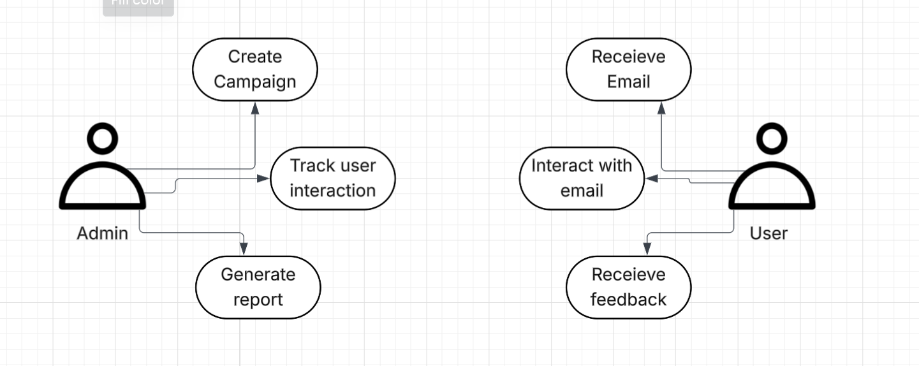
Use Case diagram made using Lucid Chart
5. Implementation
5.1 Development stages.
1. Design
2. Backend setup
3. Frontend
4. Testing
5.2 Resources required
- Hosting services
- Laptop
- Test Users
6. Testing and evaluation
6.1 Test cases and scenarios
- Test login
- Email sending
- Tracking Clicks
- Report generation
- Security Tests
6.2 Evaluation Criteria
- Functionality - Work as intended
- Usability - Easy to navigate
- Security – No data leakage
7. Conclusion
7.1 Summary
Phishing attacks remain one of the most significant cybersecurity threats, exploiting human error to gain unauthorized access to sensitive information. The goal of this project is to design and develop a web-based phishing simulator aimed at educating users about phishing risks in a safe and controlled environment. The simulator allows administrators to create and manage simulated phishing campaigns, monitor user interaction and generate reports to evaluate user awareness.
The anticipated outcome is a practical and accessible educational tool that improves phishing awareness for users in industries, while also providing a foundation for future enhancements such as real time analytics, Ai generated campaigns and corporate system integration
7.2 Expected outcomes
- Improved phishing awareness
- Educational tool for users
7.3 Future Enhancements
- Real-time analytics dashboard
- Ai powered phishing emails
- Integration with corporate systems

- Reference
[1] J. Wright, “Gophish - Open Source Phishing Framework,” Getgophish.com, 2012. https://getgophish.com/
[2] KnowBe4, “Security Awareness Training ,” Knowbe4.com, 2018. https://www.knowbe4.com/
[3] “AWS Marketplace: GoPhish Cloud - Enterprise Phishing Simulation Platform Reviews,” Amazon.com, 2021. https://aws.amazon.com/marketplace/reviews/reviews-list/B08134VNRK?rating=2
[4] S. Hsieh, “GoPhish: A Journey into Phishing Simulation,” Medium, Sep. 15, 2024. https://thstasy.medium.com/gophish-a-journey-into-phishing-simulation-85f811f6a206
[5] “KnowBe4 is rated ‘Poor’ with 1.9 / 5 on Trustpilot,” Trustpilot, Nov. 18, 2025. https://ie.trustpilot.com/review/knowbe4.com
[6] G. Inc, “KnowBe4 Reviews, Ratings & Features 2023 | Gartner Peer Insights,” Gartner. https://www.gartner.com/reviews/market/security-awareness-computer-based-training/vendor/knowbe4
[7] “2025 phishing statistics: The alarming rise in attacks - Zensec,” Zensec, Sep. 2025. https://zensec.co.uk/blog/2025-phishing-statistics-the-alarming-rise-in-attacks/
[8] L. Danielson, “Statistics on Phishing Attacks that Target Businesses | Huntress,” Huntress.com, 2024. https://www.huntress.com/phishing-guide/phishing-attack-statistics
[9] “Phishing simulation: What it is and how to prevent phishing attacks,” NordVPN, Nov. 24, 2024. https://nordvpn.com/blog/phishing-simulation/?srsltid=AfmBOop4wsX9mmBbSQln2IjmAE0PUafF9wUT5nXfbiCloW-9lmw8NpIx

Link to electronic notebook: PDD_EmmaFahy_Final.docx

