EXECUTIVE SUMMARY
The focus of this paper is the following objectives:
1. predicting demand by both pickup zones and respective drop-off zones (called routes);
2. analysing what drives this demand;
3. understanding how the average fare corresponds to this demand;
4. and how drivers may want to use this model to their advantage.

This project develops predictive models for both demand and average fare across the New York City borough of Manhattan. Predictions were made per pick-up zone, per drop-off zone, and per time of day - of which there are 5 categories. We used the Yellow Taxi NYC data (https://www.nyc.gov/site/tlc/about/tlc-trip-record-data.page) for 2024 only.

For demand, prediction rates proved as high as 88%, whilst average fare typically reported around 80%. Given the granularity of each prediction, it is reasonable to say that this dataset does provide highly predictable results, and contains many useful features. Additionally, extensive exploratory data analysis is provided, investigating various relationships and trends for the year of 2024.

INTRODUCTION
Manhattan, New York
The borough of Manhattan is the home to Wall Street, the New York Stock Exchange, the Nasdaq, the World Trade Center, and the headquarters almost all major US banks. Hence, it is one of the financial centers of the world. It’s also home to Silicon Alley (not Valley); the rising tech center of New York, with office headquarters for Verizon, IBM, Pepsico, etc. A 2023 paper (https://comptroller.nyc.gov/reports/spotlight-new-york-citys-office-market/) estimates that Manhattan has over 594 million² feet of office space. Manhattan is also a tourist hub, and surrounded by 3 major airports: LaGuardia, Newark, and JFK. In 2024, 65 million tourists visited New York (https://www.nyc.gov/mayors-office/news/2024/12/mayor-adams-celebrates-nearly-65-million-visitors-nyc-2024-second-highest-number-visitors). A narrative could be suggested then, that Manhattan is balancing at least 2 major customer bases: corporate commuters and tourists.

NYC Yellow Taxi Data, 2024
The data contains 12 months of NYC Yellow Taxi trip records for 2024 and was sourced from the NYC Taxi and Limousine Commission (TLC). The dataset consisted of approximately 41 million individual trip records that spanned all five New York City boroughs with each row representing a single taxi journey. Each of the records contains 19 fields, such as pickup and dropoff timestamps, pick-up and drop-off zones, trip distance, and fare amount.

Pickup locations were filtered to just Manhattan, whilst drop-off locations were kept for the entire dataset, but any drop-offs outside of Manhattan were aggregated to “Outside Manhattan”, except in the case of the 3 airports, which were left as is. Data was removed if it contained: invalid fares, zero or negative distances, or drop-off timestamps before their pickup timestamps.

The amount of rides was then aggregated; summing by pickup zone, drop-off zone and time of day. This yielded 4.3 million rows of data.

EXPLORATORY DATA ANALYSIS
Daily Demand Trends
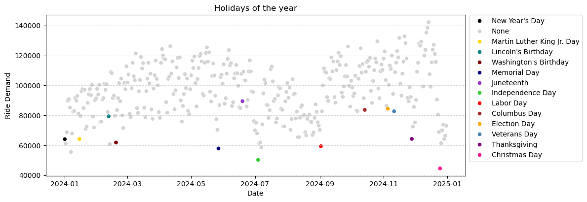
Although additional data is not the focus of this project, it is worth using both a caldendar and weather reports to get a sense of how the datasets are structured.

(a) Public holidays calendar
Since we are interested in both the corporate cycle and tourists, we have included calendar data from an API (https://www.officeholidays.com/countries/usa/new-york/2024), detailing the major public holidays in the US. Holidays that do not have days off (Father’s Day & Mother’s Day, for example) are removed. This helps to explain away almost all of our unusually low days. It is worth noting that there is an underlying assumption: that we are purely modelling the demand side, and have assumed the supply of taxis and drivers is not an issue – i.e., there are always enough taxi drivers not taking the day off to absorb the demand of customers. If this is not the case, additional data may be required to remodel this (holidays of taxi drivers taken, if possible). This assumption has been made through the entirety of the report.

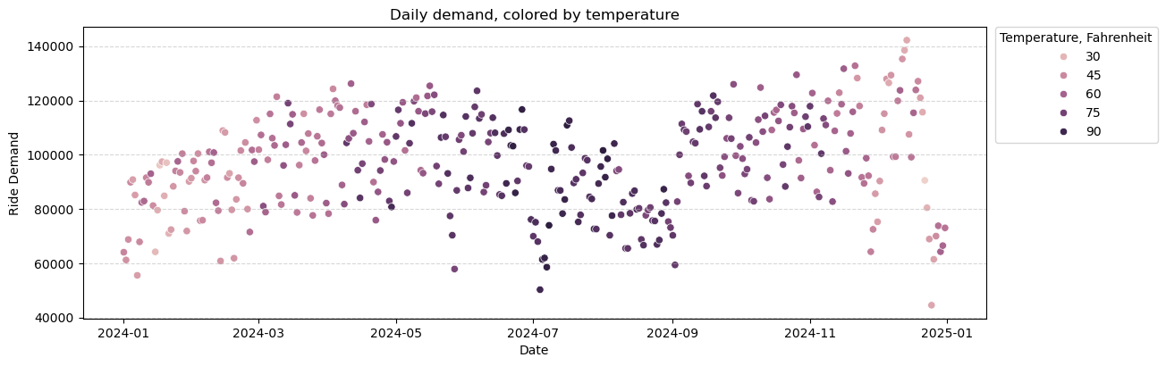
(b) Daily weather
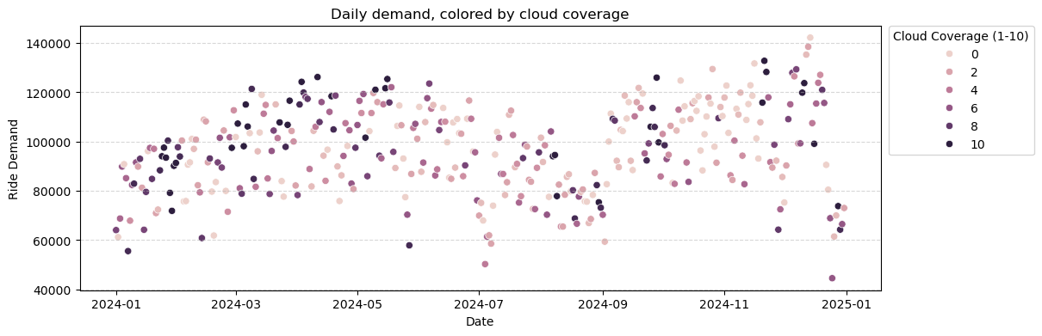
Using US National Weather data, stored in an archive by Iowa Environmental Mesonet (https://mesonet.agron.iastate.edu/nws/cf6table.php?station=KNYC&opt=bystation&year=2024), we can retrieve the daily maximum temperature, total precipitation, and cloud coverage (ranked on a scale of 1-10) for all of New York, in 2024. Precipitation and cloud coverage naturally showed very similar daily patterns, and cloud coverage turned out to be favored by almost every model. Therefore, precipitation was dropped in favor of cloud coverage. Though cloud coverage is not perfectly clustered, it generally appears to heighten on higher demand days.

(c) Lag features
The daily demand and daily average fare visualisations show clear signs of structured data; that each data point has information in common with the data points surrounding it. For this reason, it is appropriate (and advisable) to use the previous day’s demand/fare in predicting the current day’s demand/fare. This proves to be particularly useful in prediction.
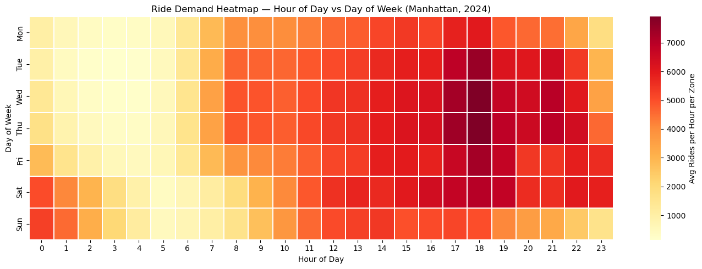
(d) Time of Day
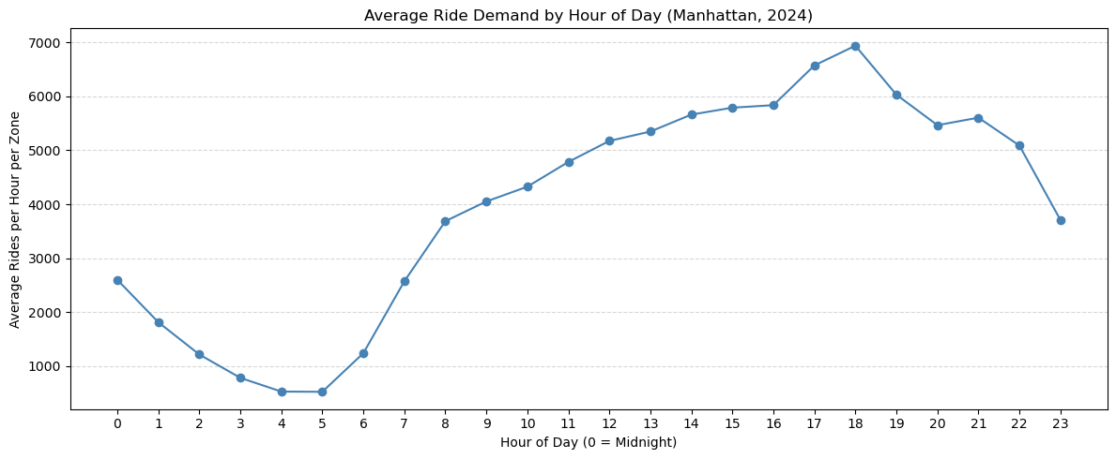
In order to model routes, hours had to be aggregated to 5 groups. This is because the computation required it too intensive for the average laptop, and this reduces the rows (by a multiple around 5/24). The final time of day labels were:

“Late Night”: 00:00 – 05:59
“Morning Rush”: 06:00 – 09:59
“Midday”: 10:00 – 15:59
“Evening Rush”: 16:00 – 19:59
“Late Evening”: 20:00 – 23:59

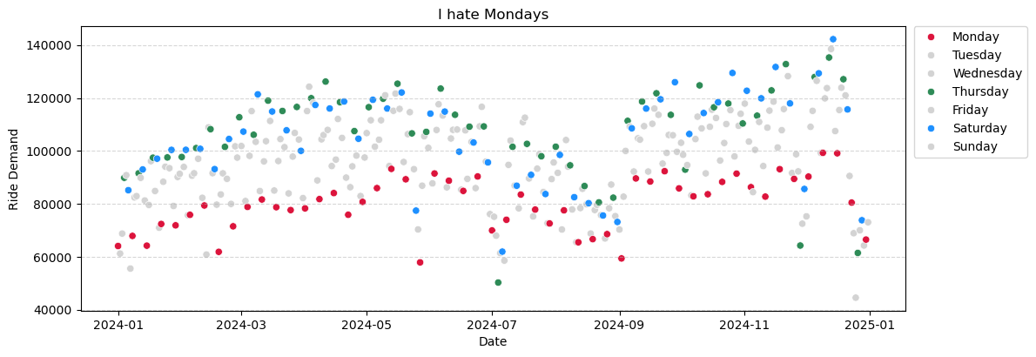
(e) Day of the Week
RIDE DEMAND PREDICTION MODEL
1. Random Forest
A very large collection of decision trees, the random forest algorithm is known to be strongest when data is easily seperable and many features to use. This ethos matches the nature of this dataset. Imagine a human being is trying to predict this data point:

It’s Monday, midday,
Upper East Side North to Upper East Side South,
yesterday’s midday demand was 400 for this route,
there’s minimal cloud coverage,
and today is not a holiday.

It would not be particularly difficult to give a good estimate of this point: Monday has the lowest values in the daily boundaries, midday is the highest of the day, no cloud coverage means it’s likelier to be a lower value, and yesterday’s value (Sunday – typically higher than Monday) was 400 at midday: maybe ... 380? Typically, you would try to build a decision tree: “well, 400 yesterday means it’s probably around 400 again, and Monday means it’s probably less than that, especially with reduced cloud coverage”, etc.

This is (crudely) the approach of the random forest, except it uses a core metric for information gain, known as Gini impurity, allowing it to define an exact heirarchy of the most important features. With regards to our particular models, there are a lot of features, and so the depth of the decision trees has to be manually set to a large value: at least 25. This requires a long time to compute, but also allows for overfitting (potentially learning the dataset exactly and returning poor prediction results), but regardless, it does achieve the highest accuracy.

2. Light Gradient-Boosting Machine (Light GBM)
This algorithm competed very closely with the random forest algorithm, however the Light GBM approach has 1 major improvement: it takes a fraction of the time to compute, versus both the random forest and the neural net. Therefore, it is particularly useful in analysis; one can fine-tune the model, or reorganise data structures, or redesign methods, and then simply rerun this model within less than 2 minutes. For this efficiency, Light GBM was the final algorithm of choice for predicting both demand and average fare.

3. Neural Net
Out of these 3 nonlinear models, the deep learning approach returned the worst results, however, it is important to note: this may be due to the limitation of our lack of computing power. Increasing the variable known as max iterations effectively allows the algorithm more time to compute, and in every case of increasing this variable, the training, validation and test scores all increased. The maximum iterations tried was 2000 (too large for the final report), but even this did not show any signs of an apex in performance. Therefore, if this project were to expand into production-ready prediction modelling, with improved hardware options provided, the Neural Net might actually be the top performer. Additionally, neural networks are better performers when custom-designed – we used a standard, out-of-the-box code package for this project.

Model Results
Using the score of R² (the percentage of total variance being explained by the model):

Model | Train | Validation | Test
Random Forest | 95.2% | 88.0% | 88.1%
Light GBM | 87.4% | 87.3% | 87.3%
Neural Net | 83.9% | 84.1% | 84.1%

Notice the dropoff between the Random Forest’s training (95.2%), and validation & testing (88.0% and 88.1%). This is likely a sign that it is overfitting. The other 2 models achieve great consistency, and only slightly less in accuracy.

AVERAGE FARE PREDICTION MODEL
In predicting average fare, the Light GBM and Neural Network were used (as described in Ride Demand Prediction Model), but the third model used Linear Regression, attempting to a straight line between relationships (though in many dimensions).

1. Linear Regression
The Linear Regression model demonstrates the weakest performance among the models for average fare prediction. It achieves a Mean Absolute Error (MAE) of approximately 7.21–7.23 across the training, validation, and test sets, indicating an average prediction error of around $7.22. The Mean Squared Error (MSE), ranging from 118 to 145.75, highlights the presence of larger errors, as this metric penalises extreme deviations more heavily. The R² values of 0.31–0.36 indicate that the model explains only around 30–36% of the variance in the data, suggesting that it struggles to capture the underlying complexity of fare behaviour. This confirms that the relationship between features and average fare is not purely linear.

2. MLP Neural Network
The MLP neural network improves upon the linear model by capturing non-linear relationships through multiple hidden layers. The model uses ReLU activation functions to introduce non-linearity, L2 regularisation to reduce overfitting, and early stopping based on validation performance. The results show a substantial improvement, with MAE values of approximately 4.23–4.25, representing a reduction in prediction error of around 40% compared to Linear Regression. The MSE ranges from 54.68 to 81.96, while R² values between 0.61 and 0.70 indicate that the model explains a significantly greater proportion of variance. This demonstrates the importance of modelling non-linear interactions between features such as time, location, and lagged values. However, the neural network still exhibits limitations, particularly in handling extreme values and variability across zones, and requires careful tuning to achieve optimal performance.

3. Light Gradient Boosting Machine
The best performance is achieved by the Light Gradient Boosting Machine (LightGBM). This model employs gradient boosting with leaf-wise tree growth, allowing it to efficiently capture complex feature interactions. Using a low learning rate (0.01), multiple estimators, and flexible tree depth, LightGBM is able to focus on the most informative splits in the data. It achieves MAE values of approximately 3.28–3.30, MSE values between 29.47 and 56.40, and R² values ranging from 0.73 to 0.84. This indicates a substantial improvement over both the linear and neural network models. In practical terms, the model is able to predict the average fare within approximately $3.30, which is relatively small given the overall fare range in the dataset.

The strong performance of LightGBM suggests that fare behaviour is driven by complex, non-linear relationships between features. The model generalises well, with similar performance across training, validation, and test sets, indicating minimal overfitting.
Model Results
Using the R² score again:

Model | Train | Validation | Test
Linear Regression | 95.2% | 88.0% | 88.1%
Light GBM | 87.4% | 87.3% | 87.3%
Neural Net | 83.9% | 84.1% | 84.1%

IDEAS FOR THE FUTURE: OPTIMIZING FOR PREDICTION
CURRENTLY UNIMPLEMENTED
Weather patterns are useful prediction data; they are free datasets, with very accurate forecasts available ahead of time. In the models analytical form, maximum daily temperature appears to be unhelpful in prediction, but from Data Features (b) we can see that temperature provides a clear time framework for the algorithm; i.e. throughout the year, the lowest and highest temperatures appear where there is lowest demand. Narratively, this is likely due to Christmas and Summer holidays. Therefore, we would expect temperature to be more more useful than it is, particularly when the summer experiences a deperession in demand, just before Labor Day, a time perfectly described by the peaking heat.

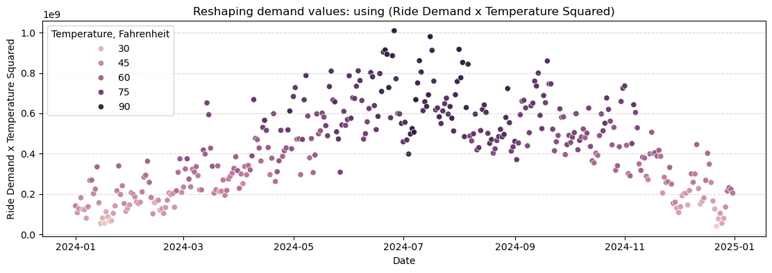
The issue lies in time of day. Each day is only exposed to a single max temperature – a limitation of our dataset. Splitting the data from the daily timeframe down to 5 times of day – where each time of day experiences a different average demand – means the algorithm has an impossible job of consolidating a pattern between 1 value of temperature and 5 different phenomena. To address this, we can multiply the lag demand by the temperature. This still inputs the information of temperature, but in such a way that can now scale to the 5 times of day. We can actually multiply the demand by the square of temperature to achieve a structure the algorithm can understand.

This yearly structure helps to separate out the y-values in such a way that every nonlinear algorithm increased testing prediction rates to around 95%.

CONCLUSION
The average fare model successfully estimates the typical fare for a given route and time period using aggregated taxi data. By incorporating temporal, spatial, and lagged features, the model captures key patterns in pricing behaviour while reducing the noise associated with individual trips.
Among the models evaluated, LightGBM achieved the best performance, demonstrating its effectiveness for structured, tabular data with non-linear relationships.

The results confirm that fare can be predicted reliably when appropriate feature engineering techniques are applied. When combined with the demand model, the average fare predictions provide a comprehensive framework for estimating revenue. This allows for practical insights into driver decision-making, such as identifying the most profitable zones and time periods to operate.

Therefore, the modelling approach demonstrates the value of separating demand and pricing into distinct components, enabling more accurate predictions and clearer interpretation of the factors driving revenue in ride-hailing services.

