Name:吳宜芬

Student ID:7106056001

Basic

1. Show the execution result (snapshot) of UDP server



1. Show the execution result (snapshot) of UDP client

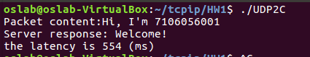

1. Show the execution result (snapshot) of TCP server



1. Show the execution result (snapshot) of TCP client

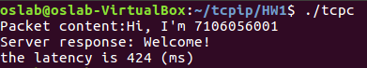

Advanced

1. How do you measure the latency?

在client端的程式中

sendto/send之前加上gettimeofday(&start,NULL);

recvfrom/recv之後加上gettimeofday(&end,NULL);

測量client端發送訊息到接收到server端回傳的Welcome!經過時間，再除以2得到client端到server端的latency

1. Show the latency result





1. How do you measure the throughput?

使用”tcpdump -i lo –e”指令擷取封包

在client與server端都開始執行，client端尚未發送訊息之前，執行”tcpdump -i lo –e”指令開始擷取封包。在結果中得到client到server的封包在ipv4的大小。

封包大小/latency=throughput。

1. 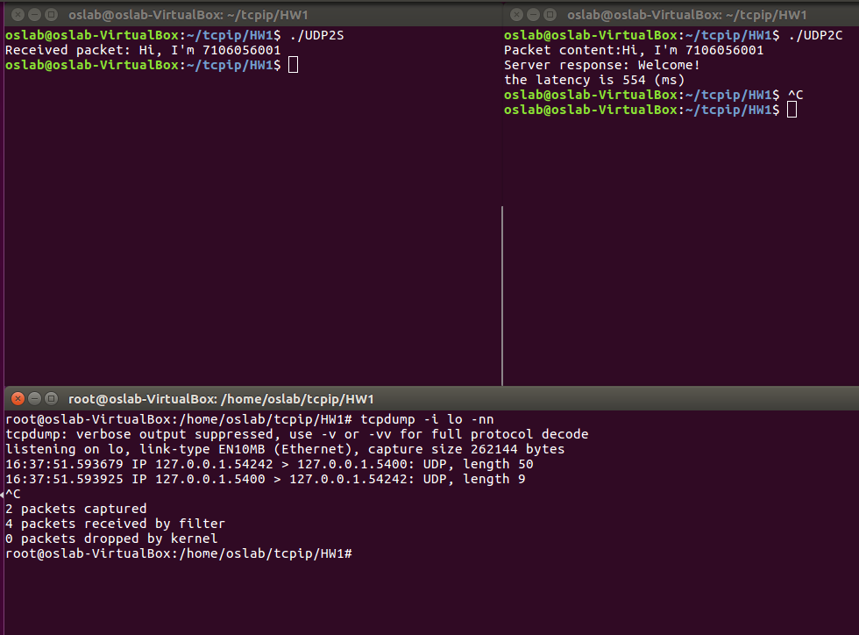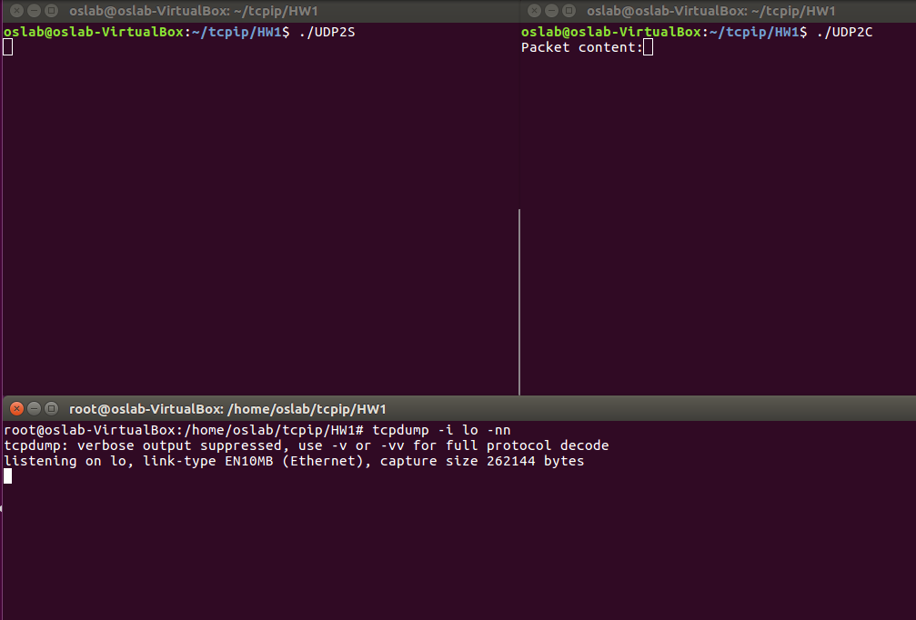Show the throughput result

UDP throughput = 50byte/554(us)= 90.2527076 kBps

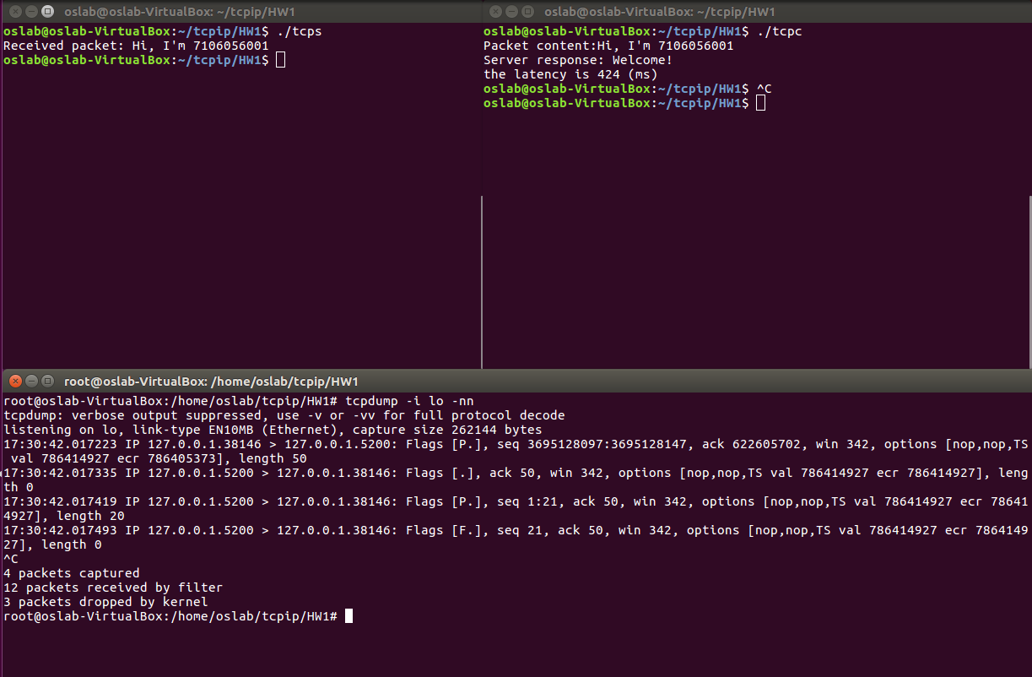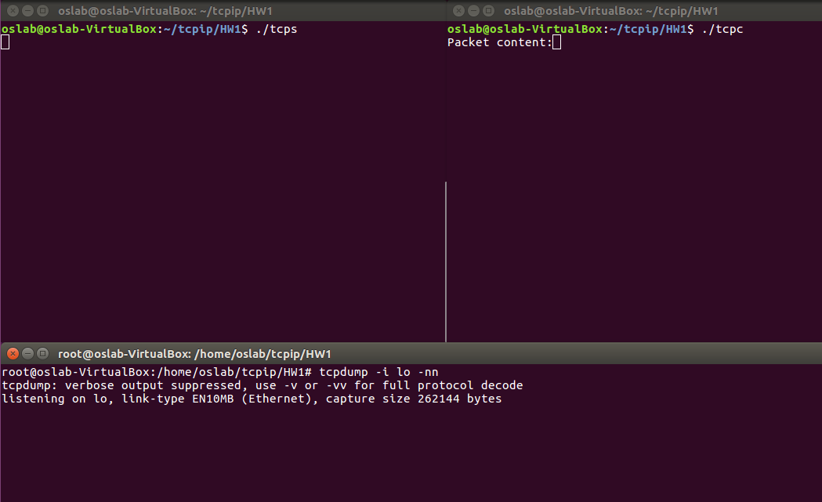TCP throughput = 50byte/424(us)= 117.924528 kBps