Name:吳宜芬

Student ID:7106056001

*Basic和Advanced搭配的client的檔案都相同

Basic

1. Show the execution result (snapshot) of server

* gcc –o tcpts tcpt_server.c –pthread

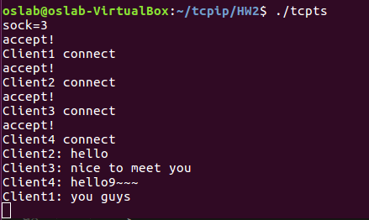

1. Show the execution result (snapshot) of client

* gcc –o tcptc tcpt_client.c –pthread

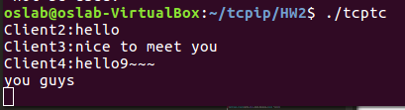 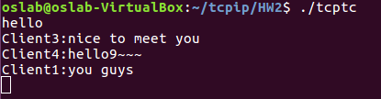

client 2

client 1

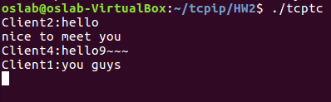 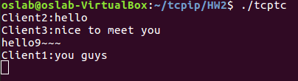

client 3

client 4

Advanced

1. Show the execution result(snapshot) of server

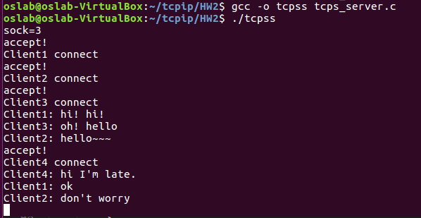

1. Show the execution result(sanpshot) of client

* gcc –o tcptc tcpt_client.c –pthread

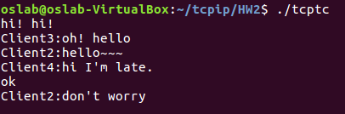

client 1



client 2

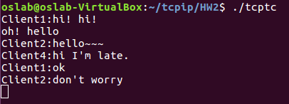

client 3

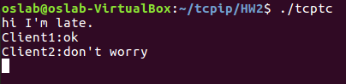

client 4

1. Please briefly describe how do you complete this project

宣告對所有的sock感興趣，一開始設server的socket為fdmax，並將表格內的sock值設為1，select的範圍是0~fdmax+1。

* 1. 當輪到server的sock時(檢查set=1)，做accept，並將accept完成後屬於client的sock(recfd)暫存起來等待下次的select，如果recfd比server的sock大，更新fdmax。
  2. 輪到client的sock(recfd)時(檢查set=1)，接收client的msg，儲存msg和client編號，等輪到其他client的sock時再將msg送給那些client。