Name: 吳宜芬

Student ID: 7106056001

Basic

1. Tell me how to run your program

sudo ./hw1-count

sudo ./hw1-udp

sudo ./hw1-tcp

1. Show the execution result (snapshot) of HW3-1

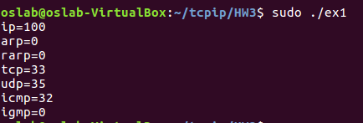

1. Show the execution result (snapshot) of HW3-2

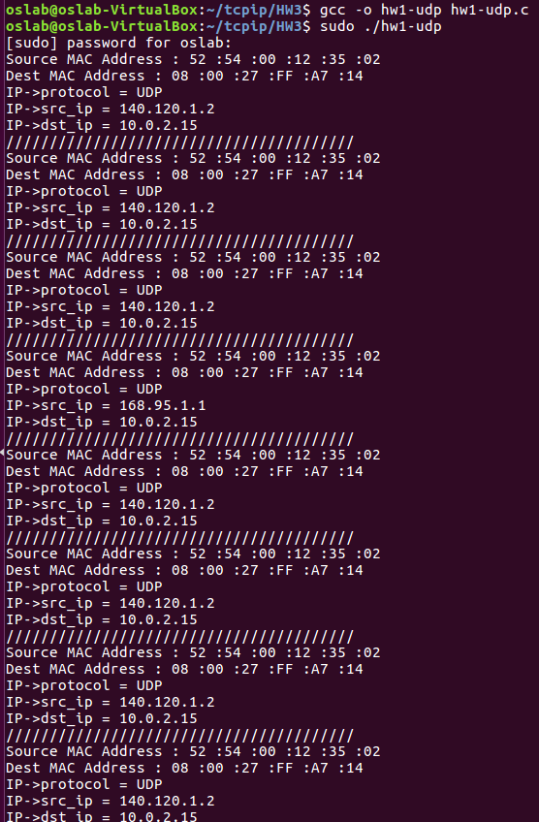

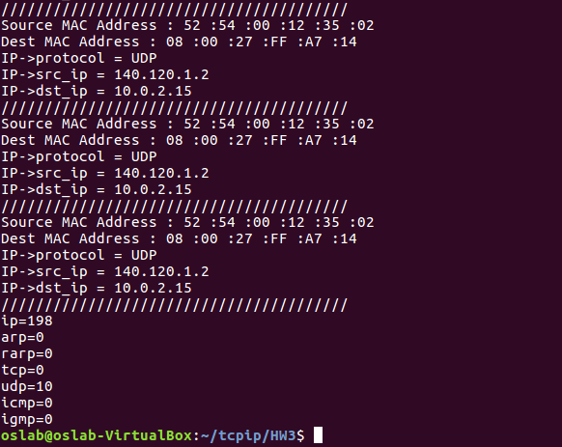

1. Show the execution result (snapshot) of HW3-3

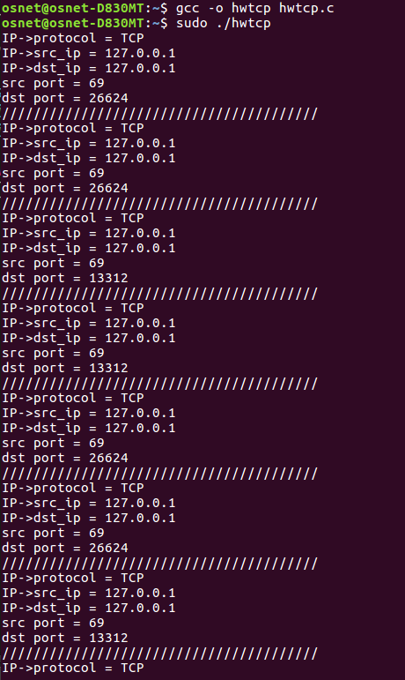

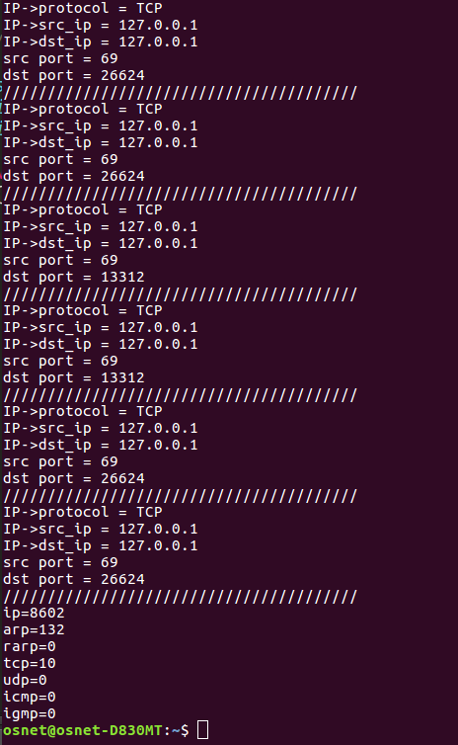

Advanced

1. Please describe the details about HW3-4?
   1. Tell me how to run your program
   2. Describe the how do you fake ip address
2. Show the execution result (snapshot) of HW3-4
3. Please describe the details about HW3-5
   1. Tell me how to run your program
   2. Please describe that how do you modify payload?
4. Show the execution result (snapshot) of HW3-5, please show the original payload and fake payload.