**網際網路通訊協定 第一次考試**

**請按照題目順序作答，否則不予計分!**

1. Match the following to one or more layers of the OSI model. (a) reliable process-to-process message delivery, (b) route selection, (c) defines frames, (d) transmission of bit stream across physical medium, (e) responsibility for carrying frames between adjacent nodes (10 pts)
2. (a) A packet in the data link layer is called a ___.

(b) A packet in the network layer is called a ___.

(c) A packet in the transport layer is called a ___, ___, or ___. (10 pts)

1. Assume a station (network address A and physical address 10) sends a packet to another station (Network address P and physical address 95). Please show the physical address and IP address (including both source and destination) in the following three frames. (12 pts)

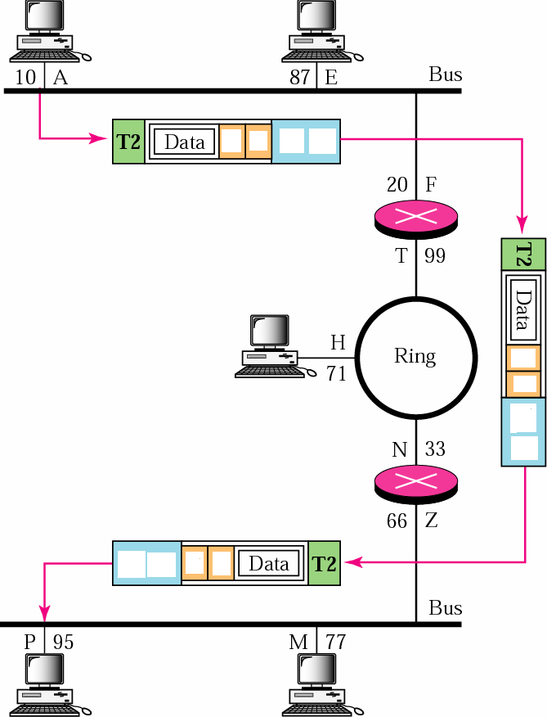

1. As shown below, what is the purpose of **type** field in the Ethernet frame header? (3 pts)

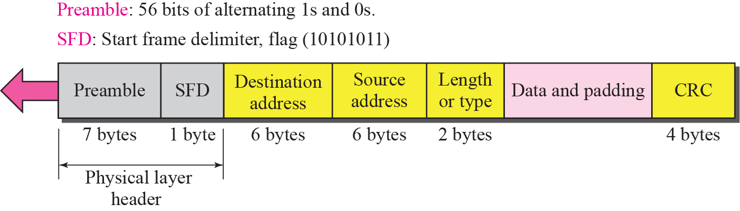

1. What is the flow control? (4 pts)
2. What is the congestion control? (4 pts)
3. Find the netid and the hostid of the following IP address: (a) 114.34.2.8, (b) 192.8.56.2 (4 pts)
4. Every station (or precisely, network interface) already has a physical address. Why every station (or precisely, NIC) also needs a network address? (5 pts)
5. Discuss why we need to do reassembly at the final destination, not at each router. (5 pts)
6. In a class B subnet, the IP address of one of the hosts and the mask are: IP address: 131.134.112.66, subnet mask: 255.255.224.0. What is the first address (subnet address)? What is the last address in this subnet? (6 pts)
7. Please show an example to demonstrate the operation of NAT, assuming that the translation table uses both a global IP address and port numbers. (6 pts)
8. IEEE 802.11, what is the purpose of network allocation vector mechanism? (6 pts)
9. (a) Please explain the hidden node problem in an IEEE 802.11 WLAN. (b) How to solve the hidden node problem? (8 pts)
10. Please show the network layer services provided at the source computer. ( 8 pts)
11. Please describe the operations (or functions) of performed by repeaters, bridges, and routers. (9 pts)