**第一次考試**

**請按照題目順序作答，否則不予計分!**

1. Match the following to one or more layers of the OSI model. (a) reliable process-to-process message delivery, (b) route selection, (c) defines frames, (d) transmission of bit stream across physical medium, (e) responsibility for carrying frames between adjacent nodes (10 pts)

Ans: (a) transport layer, (b) network layer, (c) data link layer, (d) physical layer, (e) data link layer

1. (a) A packet in the data link layer is called a ___.

(b) A packet in the network layer is called a ___.

(c) A packet in the transport layer is called a ___, ___, or ___. (10 pts)

Ans: (a) frame, (b) datagram, (c) user datagram, segment, packet

1. Assume a station (network address A and physical address 10) sends a packet to another station (Network address P and physical address 95). Please show the physical address and IP address (including both source and destination) in the following three frames. (12 pts)

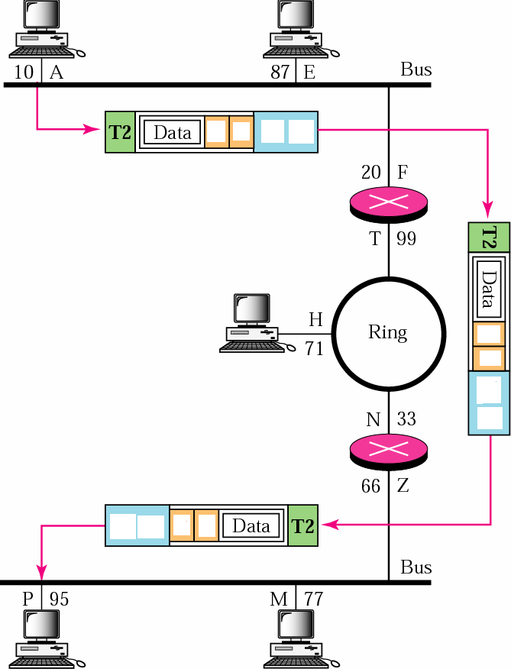

Ans: (source address, destination address)順序沒有關係，也就是(10, 20)=(20,但是，10)，(A, P)=(P, A)。但是，Layer 2 header一定要在Layer 3 header之前。換言之，physical address要在network address之前。

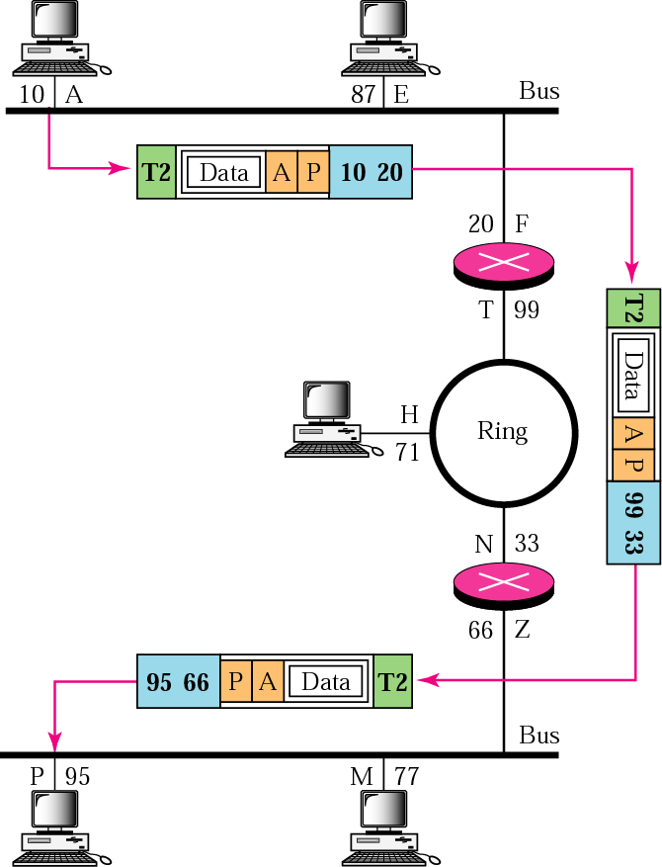

1. As shown below, what is the purpose of **type** field in the Ethernet frame header? (3 pts)

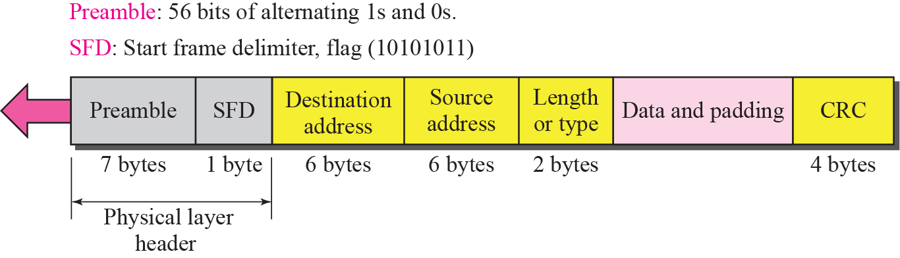

Ans: define the upper layer protocol

1. What is the flow control? (4 pts)
2. What is the congestion control? (4 pts)
3. Find the netid and the hostid of the following IP address: (a) 114.34.2.8, (b) 192.8.56.2 (4 pts)

Ans: (a) netid= 114, hostid=34.2.8 (b) netid = 192.8.56, hostid=2

1. Every station (or precisely, network interface) already has a physical address. Why every station (or precisely, NIC) also needs a network address? (5 pts)
2. Discuss why we need to do reassembly at the final destination, not at each router. (5 pts)

Ans: When a packet is fragmented, each fragment may go a different path. This means that not all fragments visit all routers. In other words, a router may not have all fragments belonging to the same packet to reassemble them. The only place that all fragments eventually arrive (if not lost) is the destination host. The reassembly can be done at the destination host.

1. In a class B subnet, the IP address of one of the hosts and the mask are: IP address: 131.134.112.66, subnet mask: 255.255.224.0. What is the first address (subnet address)? What is the last address in this subnet? (6 pts)

Ans: First address is 131.134.96.0, last address is 131.134.127.255

1. Please show an example to demonstrate the operation of NAT, assuming that the translation table uses both a global IP address and port numbers. (6 pts)
2. IEEE 802.11, what is the purpose of network allocation vector mechanism? (6 pts)

Ans: By NAV

* NAV: Network Allocation Vector
* All of the RTS/CTS/DATA frames’ header contains a duration field.
  + Indicate the amount of time the sender needs to occupy the channel
  + When other stations received this frame
    - Start a timer, called **NAV**, that equals to the duration value

If NAV has not expired, other stations should not sense the medium and send the frame

1. (a) Please explain the hidden node problem in an IEEE 802.11 WLAN. (b) How to solve the hidden node problem? (8 pts)
2. Please show the network layer services provided at the source computer. ( 8 pts)

Ans:

* ***Packetizing***
  + Encapsulate the data from upper layer into a datagram by adding a header
* ***Find the logical address of the next hop***
  + Usually, the datagram may pass through many network
  + Need to consult a routing table to find the logical address of the next hop
* ***Finding the physical (MAC) address of the next hop***
  + The delivery is actually perform at the data link layer
    - Need MAC address to do the delivery
  + Need to map the next-hop logical address to the MAC address
* ***Fragmenting datagram if necessary***
  + Most LAN and WAN has a MTU (maximum transfer unit) limit
  + Fragment is needed if the datagram is larger than the MTU

1. Please describe the operations (or functions) of performed by repeaters, bridges, and routers. (9 pts)

Ans:

* Repeater and Hub: the first layer
* Bridges: first two layers
* Routers: first three layers