Name:何語倩

Student ID:7106056093

Basic

1. Show the execution result (snapshot) of server
2. client1.2.3剛連上線時

四格分別為server(左上)client1(右上)client2(左下)client3(右下)

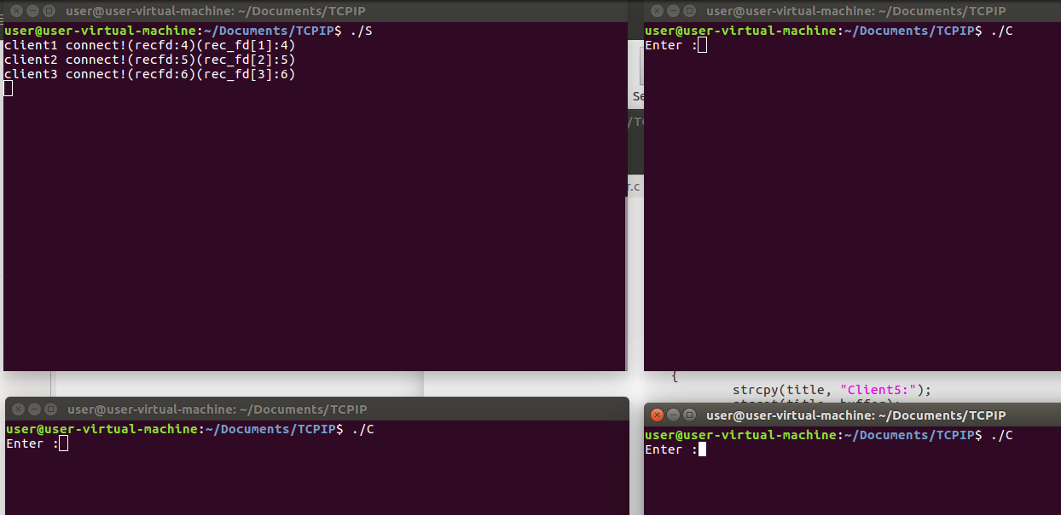

1. 當client1傳送訊息時

Server會收到client1傳送過來的訊息，  
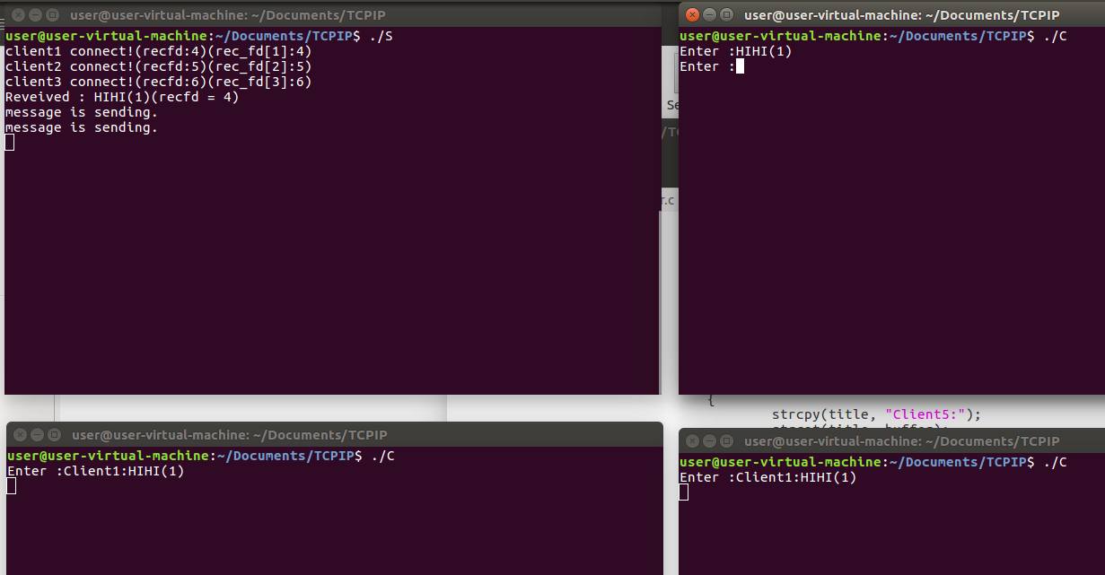

1. Show the execution result (snapshot) of client

總共開三個client  
黃色框框表示該client的input值，送出後，另外兩個client會接收到  
client1:

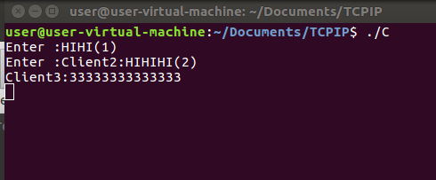

Client2: (下一頁)  
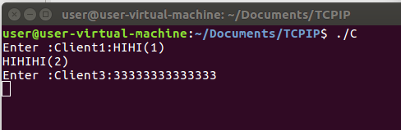

Client3  
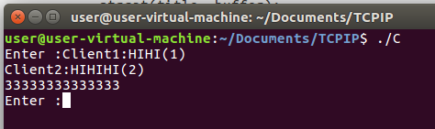

Advanced

1. Show the execution result(snapshot) of server

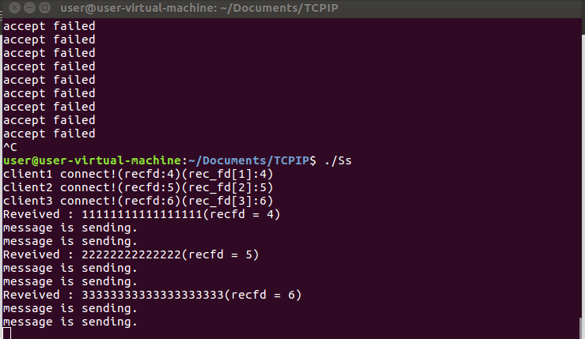

1. Show the execution result(sanpshot) of client

Client1

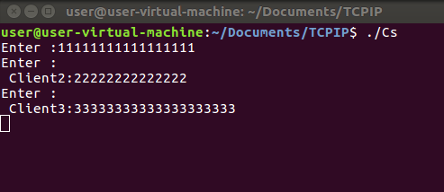

Client2

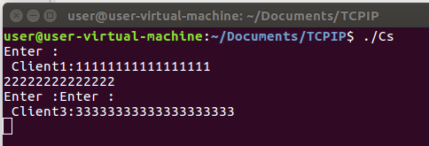

Client3

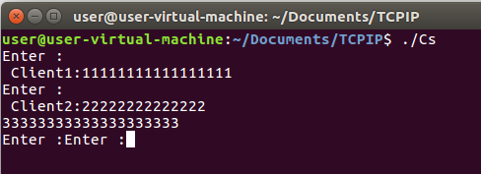

1. Please briefly describe how do you complete this project