**Prawnz survival manuscript – figures & tables**

**General figure feedback:**

* No main titles (except for multi-panel figure), just make sure the axis labels are self-explanatory
* For axis labels, capitalise first letter of first word only
* Make sure all axis labels include units, where appropriate
* This is annoying but we will need to re-write figures using TIFF format rather than PNG (in order to comply with CJFAS figure guidelines, see [here](https://cdnsciencepub-com.login.ezproxy.library.ualberta.ca/authors-and-reviewers/preparing-figures)). Can just replace png() function with tiff() function. Some of the arguments might have to be tweaked, see the ?tiff helpfile in R for full details.
* If possible, make text in figures larger. I think you should be able to use ‘pointsize’ argument in the tiff() function to do this (e.g., pointsize = 12).
* Right now, some of the figures are pixelated when viewed in full screen. Can increase the resolution using ‘res’ argument in tiff(). Note that the max file size CJFAS accepts is 6 MB so might have to compress post-hoc but don’t worry about that for now.

**Main text figures & tables**

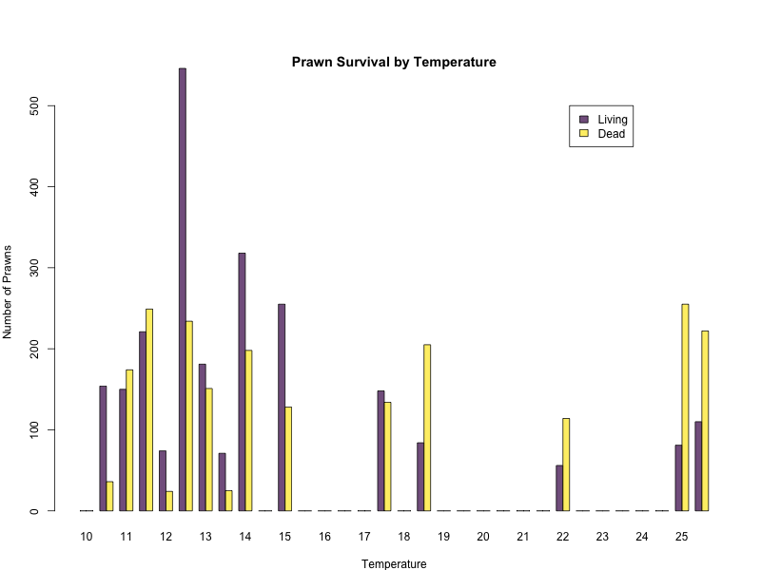

**Figure X feedback:**

* Add units to x-axis label
* Adjust legend position, flush right (maybe by replacing x/y position with ‘topright’?)
* Better to visualise as proportion alive vs. dead? A little hard to visually compare because of different numbers of trials (and thus prawns) at different treatments). Open to discussion!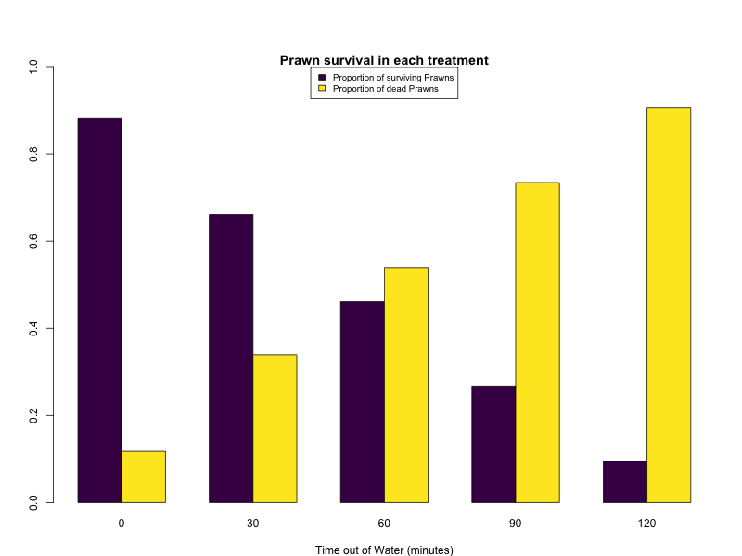

**Figure X feedback:**

* Add y-axis label
* Legend position adjusted flush right (remove capitalisation of ‘prawns’)

**Figure X feedback:**

* Combine these two figures as a two-panel
* Remove main titles
* For left panel, y-axis: “Estimated post-24-hour mortality (%)”
  + Adjust axis labels from proportions to % so both panels the same
* For right panel, move legend flush top right and adjust labels:
  + “Died after 24 hours (estimated)”
  + “Dead at 24 hours (observed)”
  + “Alive at 24 hours (observed)”

**Supplementary figures & tables (with feedback)**

**Figure X feedback:**

* x-axis revised to “Trial number”

**Figure X feedback:**

* Adjust panel titles
  + “Stage 0 prawns in each Trial” -> “Juvenile prawns”
  + Move panel titles up a bit, so not as crowded to bars
* Y-axis labels adjusted, “Number of prawns”
* Adjust y-axis so consistent across panels (if not too much of a hassle…)
* X-axis labels adjusted, “Trial number”
* Possible to fix x-axis so that all trial numbers are displayed? Might need to space bars out a bit more.

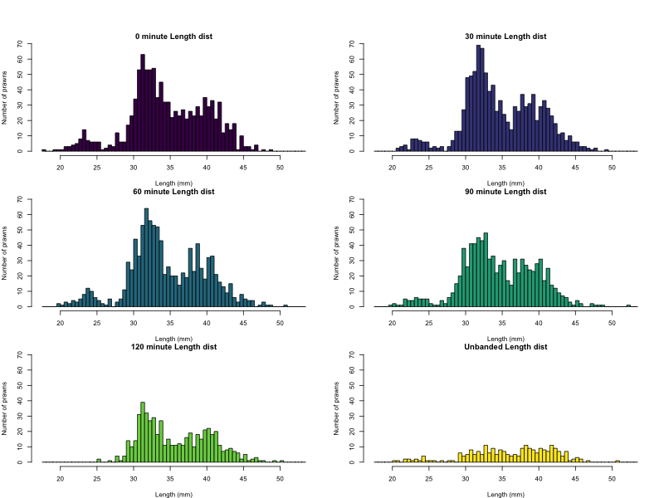

**Figure X feedback:**

* Main title adjusted, remove “Length dist” part.