SEM database assembly
 | Purpose of this document  This script is the first step of the SEM pipeline. It assembles all input variables from raw sensor and image data into a single analysis-ready database. Its outputs feed directly into:  - 2_SEM_diagnostic.qmd — sensitivity analysis to select the optimal model configuration  - 3_SEM_modelisation.qmd — full rolling-window SEM execution  - 4_SEM_results_analysis.qmd — figure production and ecological interpretation  Output File Description  Main SEM database SEM_database.csv One row per scanner × time step, with fauna counts, environmental variables, root metrics, and season labels  Taxa list fauna_vars.txt Names of invertebrate taxa retained for modelling (≥ 5% of total observations)  Microclimate indices microclimate_index.txt The two most informative and orthogonal microclimatic summary variables, selected by PCA  Pipeline config pipeline_config.json Time step, step_hours, steps_per_day

Data sources and processing steps
Five data streams are integrated:
Step | Source | Key processing
1. Fauna detections | In-situ scanner images | Filter to canonical scan times; recode fine taxa to higher levels; fill unobserved combinations with 0 (absent) vs. NA (missing image)
2. Soil probes | DIAMS sensors | Join by date × depth × position
3. Microclimatic indices | Derived from probes | Compute five rolling-window indices per variable; select the two most orthogonal via PCA (cos² ≥ 0.8)
4. Root density | Root pixel count images | Compute 9-day and 24-hour growth metrics using backward rolling joins (data.table); convert pixel counts to cm²
5. Seasons | Standard calendar dates | Equinox/solstice boundaries, 2023–2025
Key design choices
Taxonomic lumping — Fine-level taxa (e.g. julida, polydesmida) are promoted to their parent group (e.g. diplopoda) when too rare to model independently. The mapping is explicit in the code.
Missing data encoding — The distinction between 0 (taxon absent, scanner active) and NA (scanner produced no image) is preserved throughout the pipeline. Downstream scripts filter windows by data completeness rate rather than imputing.
Microclimate dimensionality reduction — Five indices summarise each variable over a rolling window (following Grooss et al., 2026). PCA then selects the two indices that are both well-represented on the first two PCA axes (cos² ≥ 0.8) and maximally orthogonal, minimising collinearity in the SEM.

Environment setup

Pipeline configuration

Fauna data

Loading and cleaning raw detections
Images are acquired every 6 hours (00:00, 06:00, 12:00, 18:00). Scanner IDs encode positional metadata:
- Character 4 → position (A, B, C): tree cover / intermediate / cultivated
- Characters 5–6 → depth (20 or 50 cm)
- Character 8 → orientation (O: West, E: East)

Build invertebrate taxa list from taxonomic hierarchy
Reads the hierarchical taxonomy JSON, extracts terminal (leaf) taxa under the “fauna” node, applies taxonomic lumping for small or structurally similar groups, and retains only taxa that represent ≥ 5% of total observations.

Function: filter taxa by minimum occurrence count
Recodes specific taxa to a higher taxonomic level and, optionally, drops taxa below a given occurrence threshold. Set filter_taxa = FALSE to keep all taxa.

Build the complete abundance matrix
Creates a full time × scanner grid, counts detections per taxon per image, and fills unobserved taxon–date–scanner combinations with 0 (taxon absent). Images with no scan at all remain NA (data missing).

Figure 1 — Missing data by scanner and month
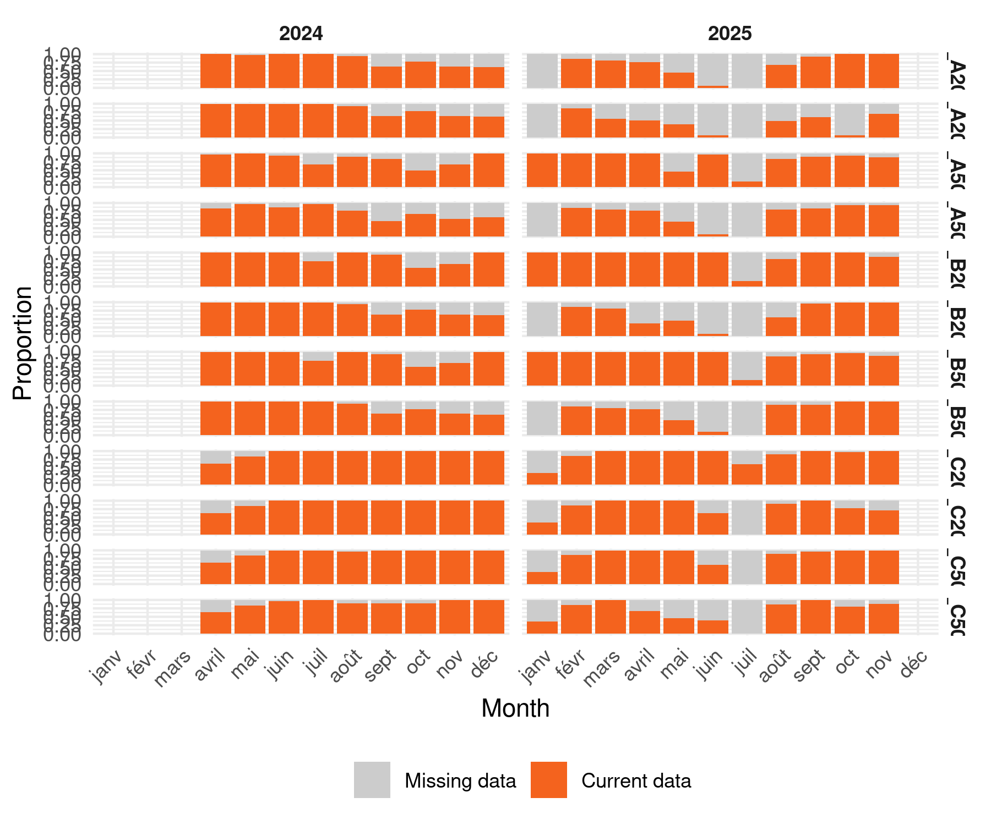
Figure 1: Proportion of missing vs. acquired images per scanner and month. Each bar stack sums to 1. Orange = image acquired; grey = missing (scanner downtime or quality-control filter). Facets are arranged by scanner identity (rows) and calendar year (columns).

Land-use grouping and SEM base table
Two land-use categories are compared:
Code | Land use | Scanner position
0 | Tree cover + herbaceous | A
1 | Cultivated cover | C
Position B (intermediate strip) is excluded from the analysis.

Function: filter dates with insufficient scanner coverage

Environmental data

Microclimatic indices

Index parameters

Compute rolling microclimatic indices
Following Grooss et al. (2026), five indices summarise each environmental variable over the rolling window:
Index | Description
median | Central tendency, robust to extremes
amplitude | 5th–95th percentile range (within-window variability)
change_ratio | Median of successive differences (instantaneous variability)
max | 97.5th percentile (warm/wet extreme)
min | 2.5th percentile (cold/dry extreme)

Select the two most informative, orthogonal indices via PCA
A PCA is performed on all computed indices. The two well-represented variables (cos² ≥ 0.8) with the smallest mutual cosine (most orthogonal in PCA space) are retained for the SEM.
Microclimate indices selected: temp_soil_max and hum_soil_max

Root density data
Root growth is computed by comparing pixel counts between two time points using high-performance rolling joins (data.table). Two temporal lags are calculated:
- 9-day lag (tolerance: ± 2 days) — captures medium-term root expansion
- 1-day lag (tolerance: ± 12 hours) — captures short-term root growth

Constants

Load and parse root pixel counts

Rolling joins to retrieve lagged pixel counts

Compute root area metrics

Merge root metrics into the SEM dataframe

Season variable
Seasons are defined by astronomical boundaries (equinoxes and solstices), covering 2023–2025.

Data summary
Period : 2024-04-01 → 2025-11-17 (595 days)
Images (total) : 18,634
Occ. raw : 128,155
Occ. filtered : 121,378
Taxa retained : 6 [acari, collembola, diplopoda, enchytraeidae, gastropoda, symphyla]
Scanners : 12 (A=4 treed, C=4 cultivated)
SEM grid rows : 4,788
Missing images : 1,122 / 4,788 (23.4%)
Missing rate per scanner:
scanner position n_total n_missing pct_miss
AF_A20_E A 596 180 30.2
AF_A20_O A 596 247 41.4
AF_A50_E A 616 106 17.2
AF_A50_O A 596 209 35.1
AF_C20_E C 596 56 9.4
AF_C20_O C 596 97 16.3
AF_C50_E C 596 89 14.9
AF_C50_O C 596 138 23.2

Export
The following files are written to ../output/ for use by S2–S4:
Output file | Contents
SEM_database.csv | Main modelling database (one row per scanner × time step)
fauna_vars.txt | Retained taxa names (one per line)
microclimate_index.txt | Selected microclimate index names (one per line)
pipeline_config.json | TIME_STEP, step_hours, steps_per_day

