Pre-modelling diagnostic calibration for the rolling-window piecewise SEM
 | Purpose of this document  This script is the second step of the SEM pipeline, following:  - 1_database_edition.qmd — assembles and quality-controls the SEM database  Its outputs feed directly into:  - 3_SEM_modelisation.qmd — full rolling-window piecewise SEM execution  - 4_results_visualisation.qmd — figure production and ecological interpretation  This script provides the complete methodological detail for the pre-modelling diagnostic calibration referred to in the main text (Section “Pre-modelling diagnostic calibration”). The calibration resolves three structural choices — window duration, minimum data completeness, and variance-stabilising transformation — before the full rolling-window piecewise SEM is executed, preventing circular model selection.

Rationale and design

Why calibrate before fitting the SEM?
The rolling-window piecewise SEM fits four structural equations to consecutive overlapping time slices of ecological data. Three upstream choices condition whether those equations are statistically valid:
Window duration ($W$, in days). A window must be long enough for the linear mixed-effects (LME) sub-models to converge with stable random-effect estimates, yet short enough to track within-season dynamics.
Minimum data completeness ($C_{min}$). Sensor downtime and quality-control filters create gaps in the time series. A completeness threshold defines the minimum ratio of fully observed to total rows within a window before that window is discarded as too sparse. The minimum threshold for data completeness must strike a balance to avoid dropping too many windows while maintaining stable coefficient estimates.
Variance-stabilising transformation ($f$). Fauna counts and root growth measures are right-skewed, with variance scaling roughly with the mean. The LME residuals should be approximately normal with constant variance. A mis-specified transformation inflates Type I error for the fixed-effect t-tests on path coefficients.
These choices cannot be validated after fitting without circularity (a transformation could be tuned to improve model fit on the very data it will be tested on). We therefore evaluate them systematically on a random subsample of windows before the full analysis.

Structural equations tested
The four structural equations encode the hypothesised causal hierarchy from land-use type through soil microclimate and root growth to faunal activity:
$${\text{mc}}_{1}∼β_{1}⋅\text{lu}$$
$${\text{mc}}_{2}∼β_{2}⋅\text{lu}$$
$$\text{root}∼β_{3}⋅{\text{mc}}_{1}+β_{4}⋅{\text{mc}}_{2}+β_{5}⋅\text{lu}$$
$$\text{fauna}∼β_{6}⋅{\text{mc}}_{1}+β_{7}⋅{\text{mc}}_{2}+β_{8}⋅\text{root}+β_{9}⋅\text{lu}$$
where lu = land-use type (0 = treed, 1 = cultivated), mc$​_{1}$ = daily maximum soil temperature, mc$​_{2}$ = daily maximum soil moisture, root = root growth area density (cm² per image), fauna = total invertebrate activity count.
At the diagnostic stage each equation is fitted independently as a classical LME rather than within the full piecewise SEM. This is intentional: the diagnostic criteria concern the residual structure of individual equations, and a piecewise SEM failure on Fisher’s C would conflate structural misspecification with residual non-normality. Once the residual properties are acceptable, Script S3 assembles the four validated equations into the full piecewise SEM.

Parameter space
The calibration evaluates the full factorial combination of:
Parameter | Candidates | Notation
Window duration | 10, 14, 21, 30 days | $W∈\{10,14,21,30\}$
Min. completeness | 5%, 10%, 20%, 30% | $C_{min}∈\{0.05,0.1,0.2,0.3\}$
Transformation | none, Freeman–Tukey, log(1+x), Hellinger | $f∈\{id,FT,log,H\}$
This yields 64 configurations, each tested on a random subsample of 30 windows for computational efficiency.
The transformation candidates are:
$$f_{\text{FT}}\left(x\right)=\sqrt{x}+\sqrt{x+1}$$
$$f_{\text{log}}\left(x\right)=log​\left(1+x+\left|min\left(x\right)\right|⋅1_{\left[min\left(x\right)≤0\right]}\right)$$
$$f_{\text{Hellinger}}\left(x\right)=\sqrt{\frac{x}{∑x}}$$
The Freeman–Tukey double-square-root and Hellinger are particularly suited to count data with many zeros. For transformations requiring strictly positive input, a small positive shift is applied when $min\left(x\right)≤0$.

Completeness definition
Completeness is defined as the ratio of fully observed to total rows within a window:
$$C\left(w\right)=\frac{\left|\{i∈w:x_{i}\text{ complete}\}\right|}{\left|w\right|}$$

Diagnostic criteria
For each (configuration × window × equation) triple, three residual diagnostics are assessed simultaneously. A window is classified as diagnostically valid only when all three criteria are satisfied concurrently.

Heteroscedasticity
We use the Spearman rank correlation between absolute normalised residuals and population-level fitted values as a monotone measure of variance non-constancy:
$$ρ_{\text{hetero}}=\text{Spearman}​\left(\left|{\hat{ε}}_{\text{norm}}\right|, \hat{y}\right)$$
Criterion C1: $\left|ρ_{\text{hetero}}\right|<0.40$. A positive correlation indicates that residual variance grows with fitted value (the classical heteroscedastic pattern).

Skewness
$$\text{skew}\left({\hat{ε}}_{\text{norm}}\right)=\frac{\frac{1}{n}\sum_{i=1}^{n}{{\left({\hat{ε}}_{i}−\overset{‾}{ε}\right)}^{3}}}{{\left[\frac{1}{n}\sum_{i=1}^{n}{{\left({\hat{ε}}_{i}−\overset{‾}{ε}\right)}^{2}}\right]}^{3/2}}$$
Criterion C2: $\left|\text{skew}\right|<1.50$. Large skewness of normalised residuals indicates the chosen transformation has not adequately symmetrised the response distribution, inflating Type I error on the fixed-effect path coefficients regardless of whether variance is constant.

Collinearity
The variance inflation factor for continuous predictor $j$ is computed via an OLS proxy (the binary land-use term is excluded because VIF is undefined for a binary variable with no associated multicollinearity risk in an orthogonal design):
$${\text{VIF}}_{j}=\frac{1}{1−R_{j}^{2}}$$
where $R_{j}^{2}$ is the coefficient of determination from regressing predictor $j$ on all remaining continuous predictors.
Criterion C3: $\max_{j}{\text{VIF}}_{j}<5.0$. VIF exceeding 5 inflates the standard errors of individual path coefficients, making it impossible to distinguish genuine mediation from collinearity artefact.

Joint validity
A window $w$ is diagnostically valid for equation $e$ under configuration $θ$ when all three criteria hold simultaneously:
$$V\left(w,e,θ\right)=1_{\left[C1∩C2∩C3\right]}$$
The proportion of valid windows for a given (equation, configuration) pair is:
pe,θ=1Ww∈W​Vw,e,θ

Configuration selection
The optimal configuration is chosen by a two-step procedure that avoids privileging one equation at the expense of another.

Step 1 — Best transformation per equation
For each response variable $e$ and each $\left(W,C_{min}\right)$ pair, the transformation $f^{*}$ maximising the product of diagnostic validity and explanatory power is selected:
$$f^{*}\left(e,W,C_{min}\right)=\underset{f}{argmax} \hat{p}\left(e,θ\right)×\overline{R_{m}^{2}}\left(e,θ\right)$$
where $\overline{R_{m}^{2}}$ is the mean marginal $R^{2}$ (variance explained by fixed effects only) across the sampled windows. This product rewards configurations that are both residually adequate and ecologically informative; a transformation that passes all diagnostics but explains nothing would score near zero.

Step 2 — Joint $\left(W,C_{min}\right)$ selection across biological responses
Among the 12 $\left(W,C_{min}\right)$ combinations, the pair maximising the joint score
$$\text{score}\left(W,C_{min}\right)=\min_{e∈\{\text{root}, \text{fauna}\}}\hat{p}\left(e,θ^{*}\right)×\overline{R_{m}^{2}}\left(W,C_{min}\right)$$
is retained, where $θ^{*}=\left(W,C_{min},f^{*}\right)$ uses the equation-specific optimal transformation from Step 1.
Using the minimum across biological responses as the validity term (rather than the mean) is deliberate: a configuration that works well for fauna but produces heteroscedastic root residuals would receive a low score, preventing one response from masking the other’s poor fit. Microclimate equations are excluded from Step 2 because their simpler structure (single predictor, depth-only grouping) makes them diagnostically robust across nearly all configurations.

Window retention for the full SEM
Using the calibrated configuration, every window in the full time series is evaluated and those in which fewer than 50 % of equations pass all diagnostic thresholds are excluded from Script S3. This retains periods of genuine ecological signal while discarding brief intervals (e.g. extreme weather events, sensor artefacts) where the model structure is locally misspecified.

Implementation

Setup

Helper functions

Rolling window splitter

Transformation functions
The five candidate transformations described in Section 2.3 (Eqs S2.1–S2.3):

Marginal and conditional R² for nlme::lme

Independent LME fitting (Eqs S1.1–S1.4)

Main diagnostic pipeline

Sensitivity grid and execution

Results

Global optimisation
The two-step selection procedure (Eqs S3.6–S3.7) identifies the optimal (window, completeness, transformation) combination.
Table 1: Top 5 configurations ranked by joint validity then mean R²m. Highlighted row = selected configuration.
Window (days) | Max missing data | Transfo root | Transfo fauna | Transfo mc1 | Transfo mc2 | Validity (joint min.) | R²m (mean) | Score
10 | 0.1 | sqrt_plus_one | hellinger | none | hellinger | 0.750 | 0.462 | 0.347
10 | 0.2 | hellinger | hellinger | log | log | 0.600 | 0.468 | 0.281
30 | 0.2 | none | sqrt_plus_one | sqrt_plus_one | hellinger | 0.600 | 0.380 | 0.228
10 | 0.3 | sqrt_plus_one | log | hellinger | none | 0.600 | 0.360 | 0.216
14 | 0.1 | sqrt_plus_one | sqrt_plus_one | sqrt_plus_one | sqrt_plus_one | 0.500 | 0.335 | 0.168

Per-equation summary under selected configuration
Table 2: Diagnostic summary per equation under the selected configuration. Validity = proportion of windows passing all three criteria. ΔR² = R²c − R²m (variance attributable to random effects).
Equation | Transform | Validity | R²m | R²c | ΔR² | Skewness | Heterosced. | VIF max
Faunal activity | hellinger | 1.000 | 0.410 | 0.548 | 0.138 | -0.038 | -0.005 | 1.82
Root growth | sqrt_plus_one | 1.000 | 0.644 | 0.680 | 0.037 | 0.051 | 0.181 | 1.76
temp_soil_max | none | 0.750 | 0.616 | 0.616 | 0.000 | 0.129 | 0.027
hum_soil_max | hellinger | 0.750 | 0.180 | 0.180 | -0.000 | -0.147 | -0.126
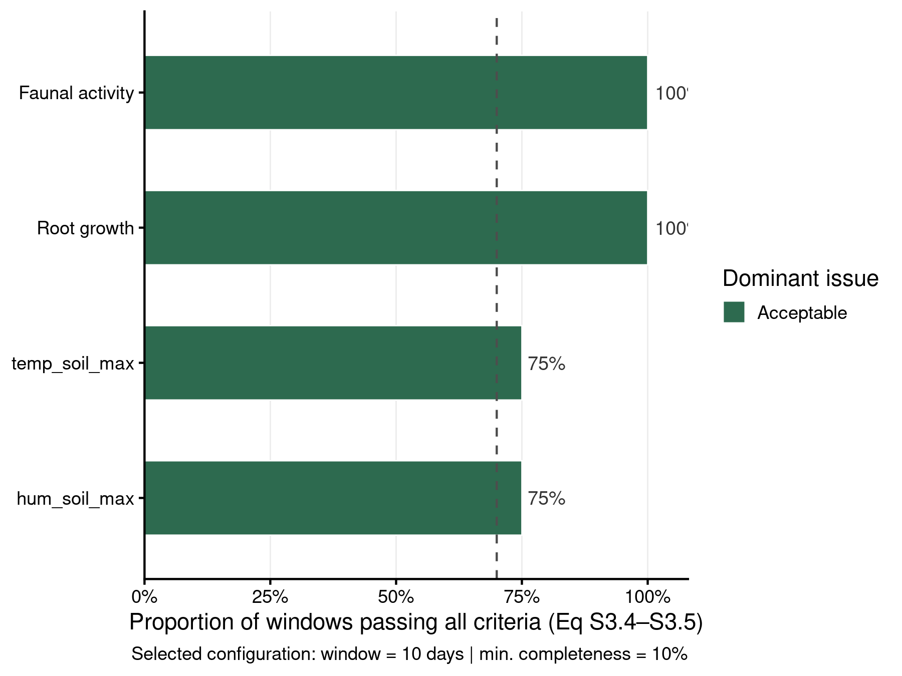
Figure 1: Proportion of windows passing all diagnostic criteria per equation. Each bar is coloured by the dominant failure mode. The dashed line at 70 % marks a reference target for adequate coverage. C1 = heteroscedasticity; C2 = skewness; C3 = collinearity (Eqs S3.1–S3.3).

Temporal window retention
Every window in the full time series is evaluated under the selected configuration. Windows where fewer than 75 % of the four equations satisfy all criteria concurrently are excluded from the rolling-window SEM in Script S3.
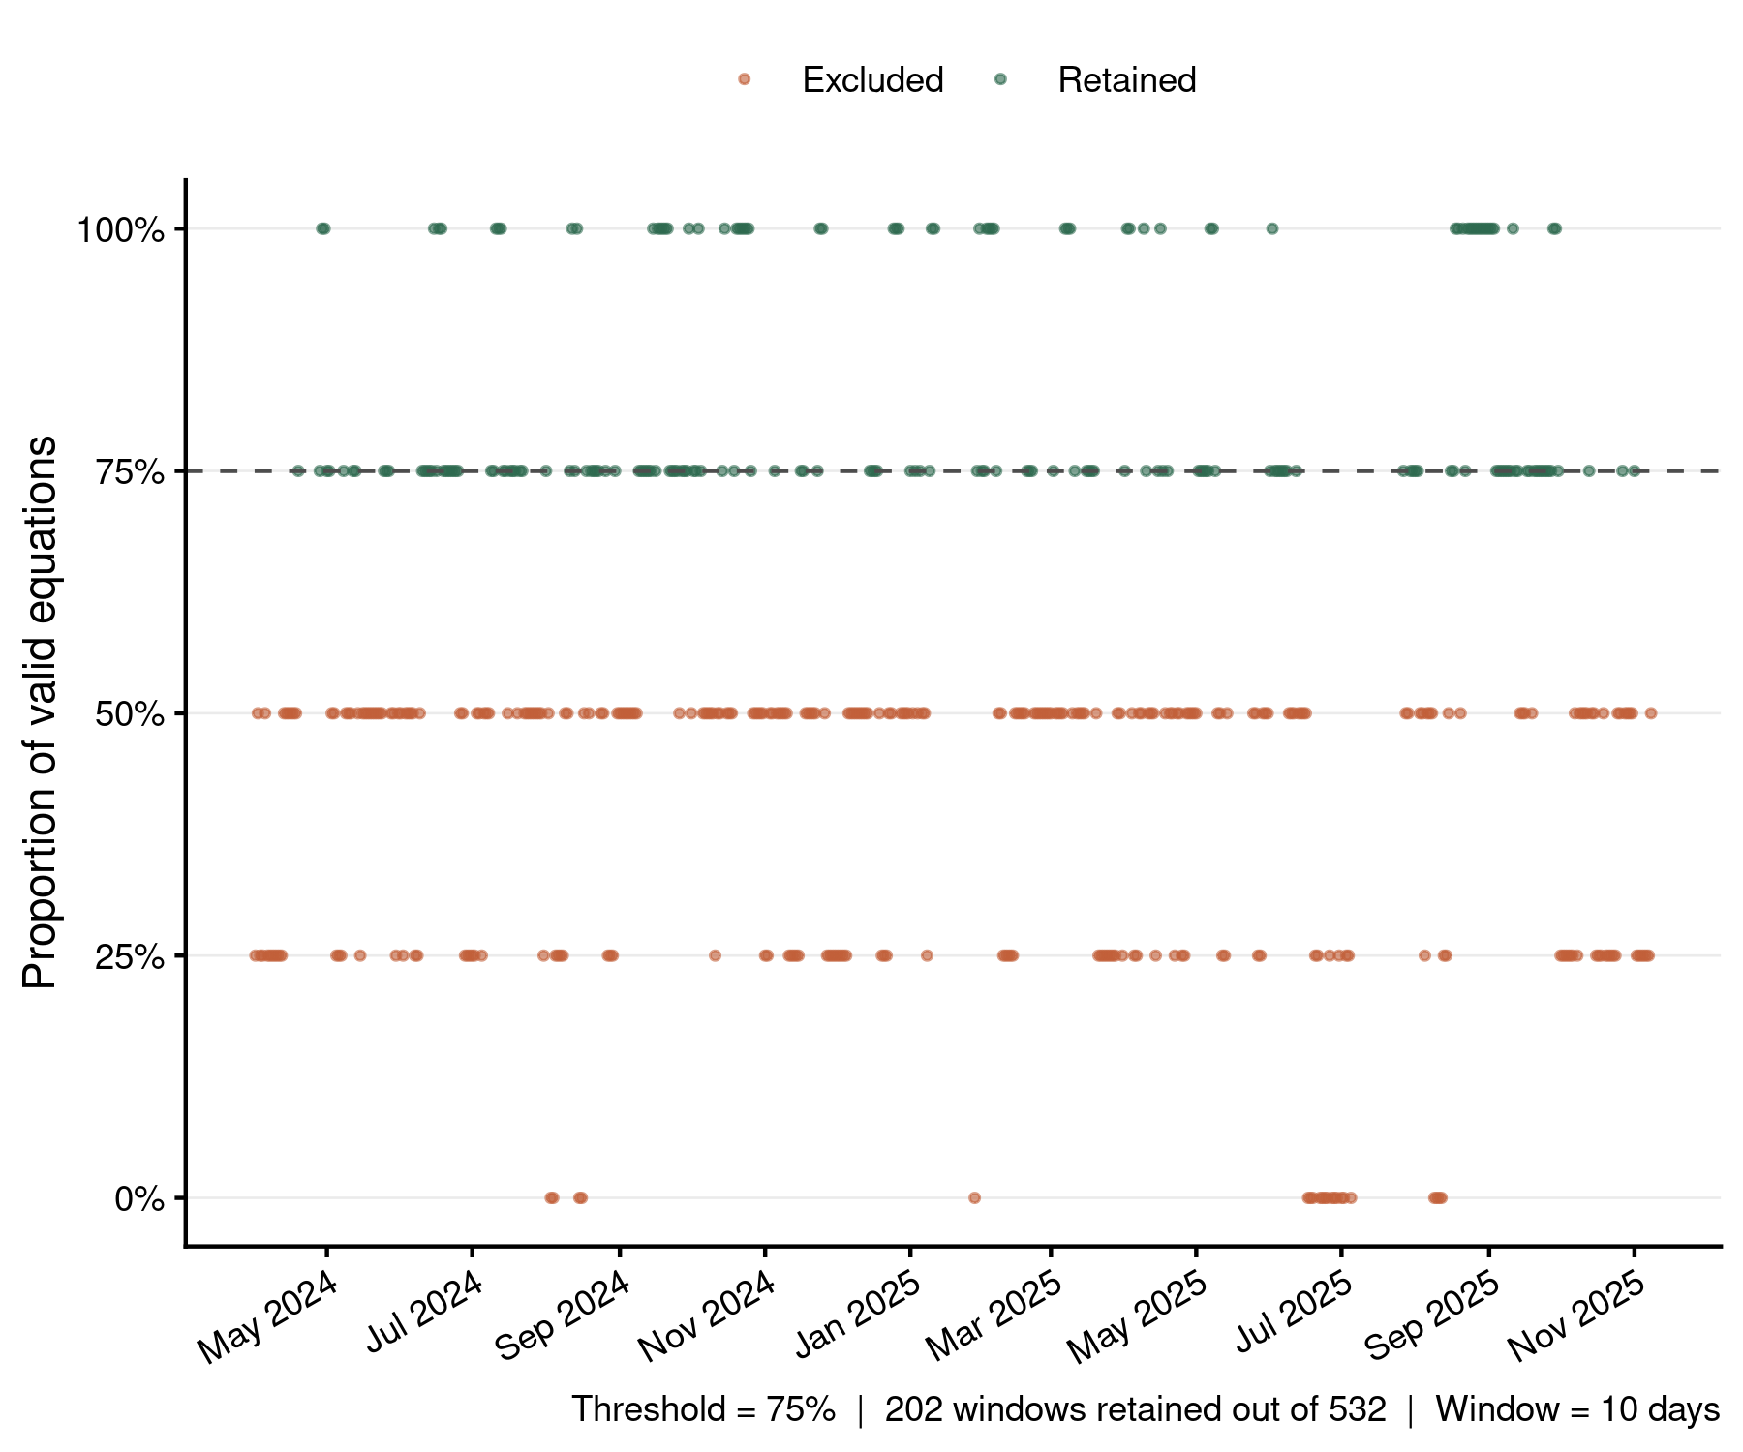
Figure 2: Window-level diagnostic validity over time. Each point is one rolling window; the y-axis is the proportion of the four structural equations (Eqs S1.1–S1.4) that simultaneously satisfy all three criteria (Eq S3.4). Green = retained; red = excluded. Clusters of excluded windows typically co-occur with abrupt transitions in microclimate or crop management events.

Visual model checks — selected configuration
The following six-panel figures pool per-observation diagnostics from a random subsample of 100 retained windows for each structural equation. Panels follow the standard model-checking workflow: posterior predictive check, linearity, homogeneity of variance, influential observations, collinearity, and normality of residuals.
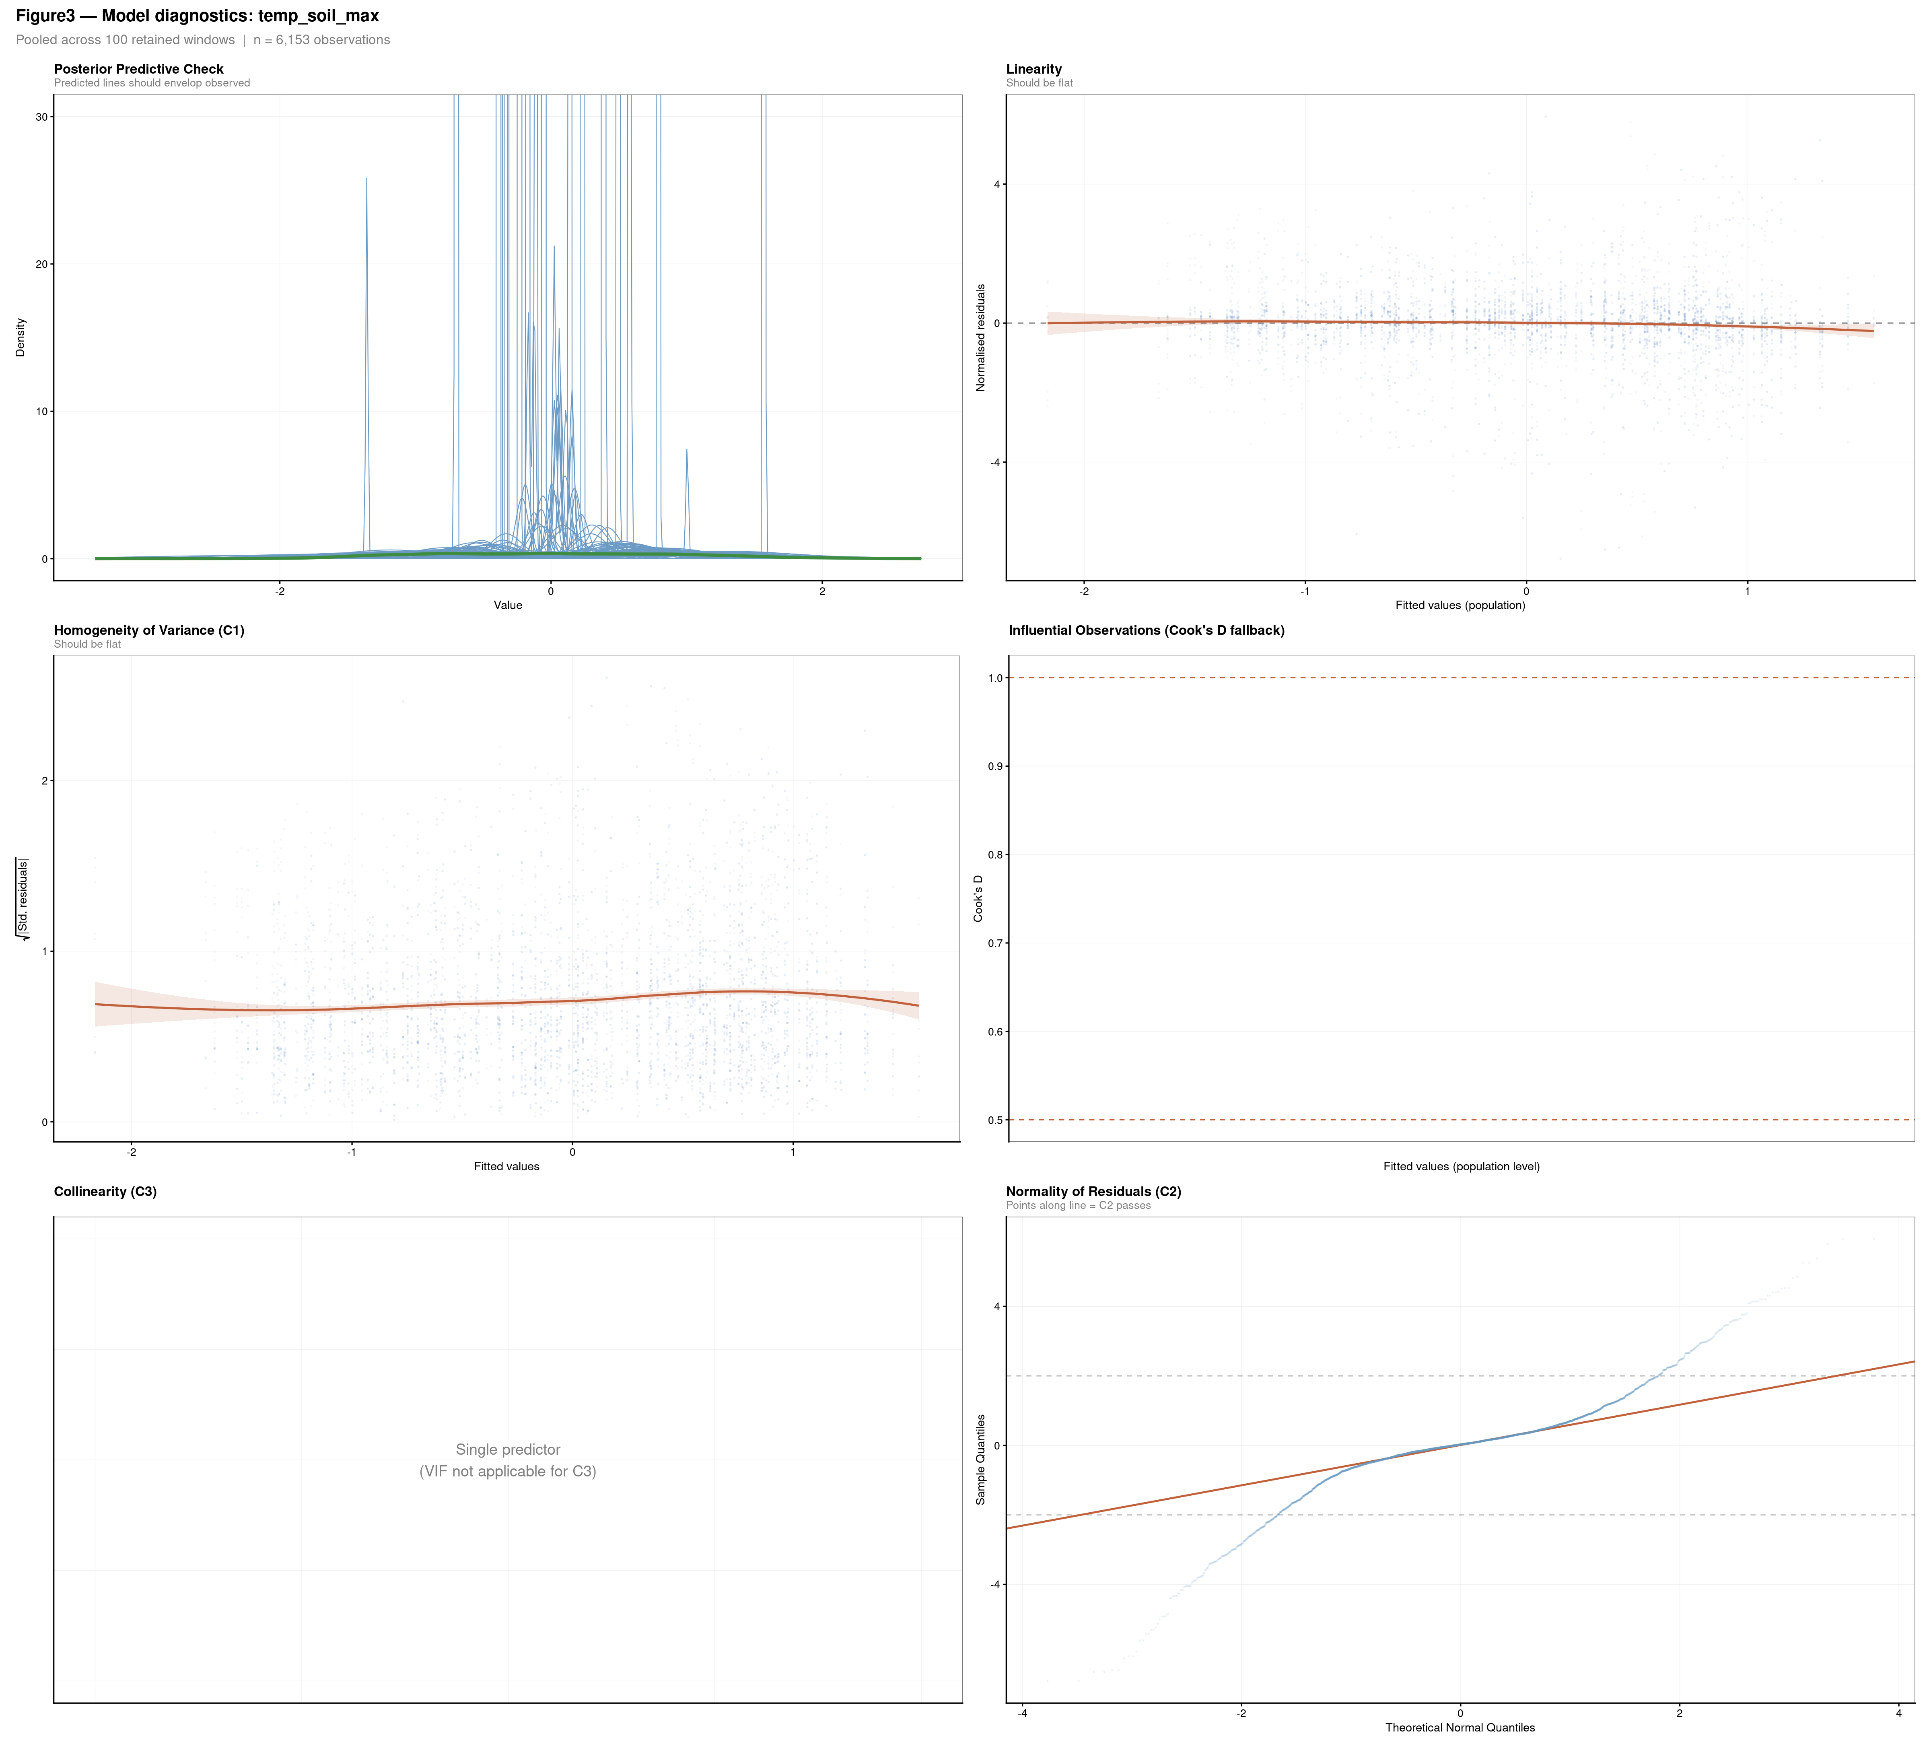
Figure 3: Six-panel model diagnostics for each structural equation. Panels: (1) Posterior Predictive Check — predicted densities should envelop the observed distribution; (2) Linearity — LOESS on residuals vs. fitted should be flat; (3) Homogeneity of variance (C1) — square-root scaled residuals vs. fitted; (4) Influential observations — residuals vs. leverage with Cook’s D contours at 0.5 and 1.0; (5) Collinearity (C3) — per-predictor VIF across windows; (6) Normality (C2) — Q-Q plot of normalised residuals.
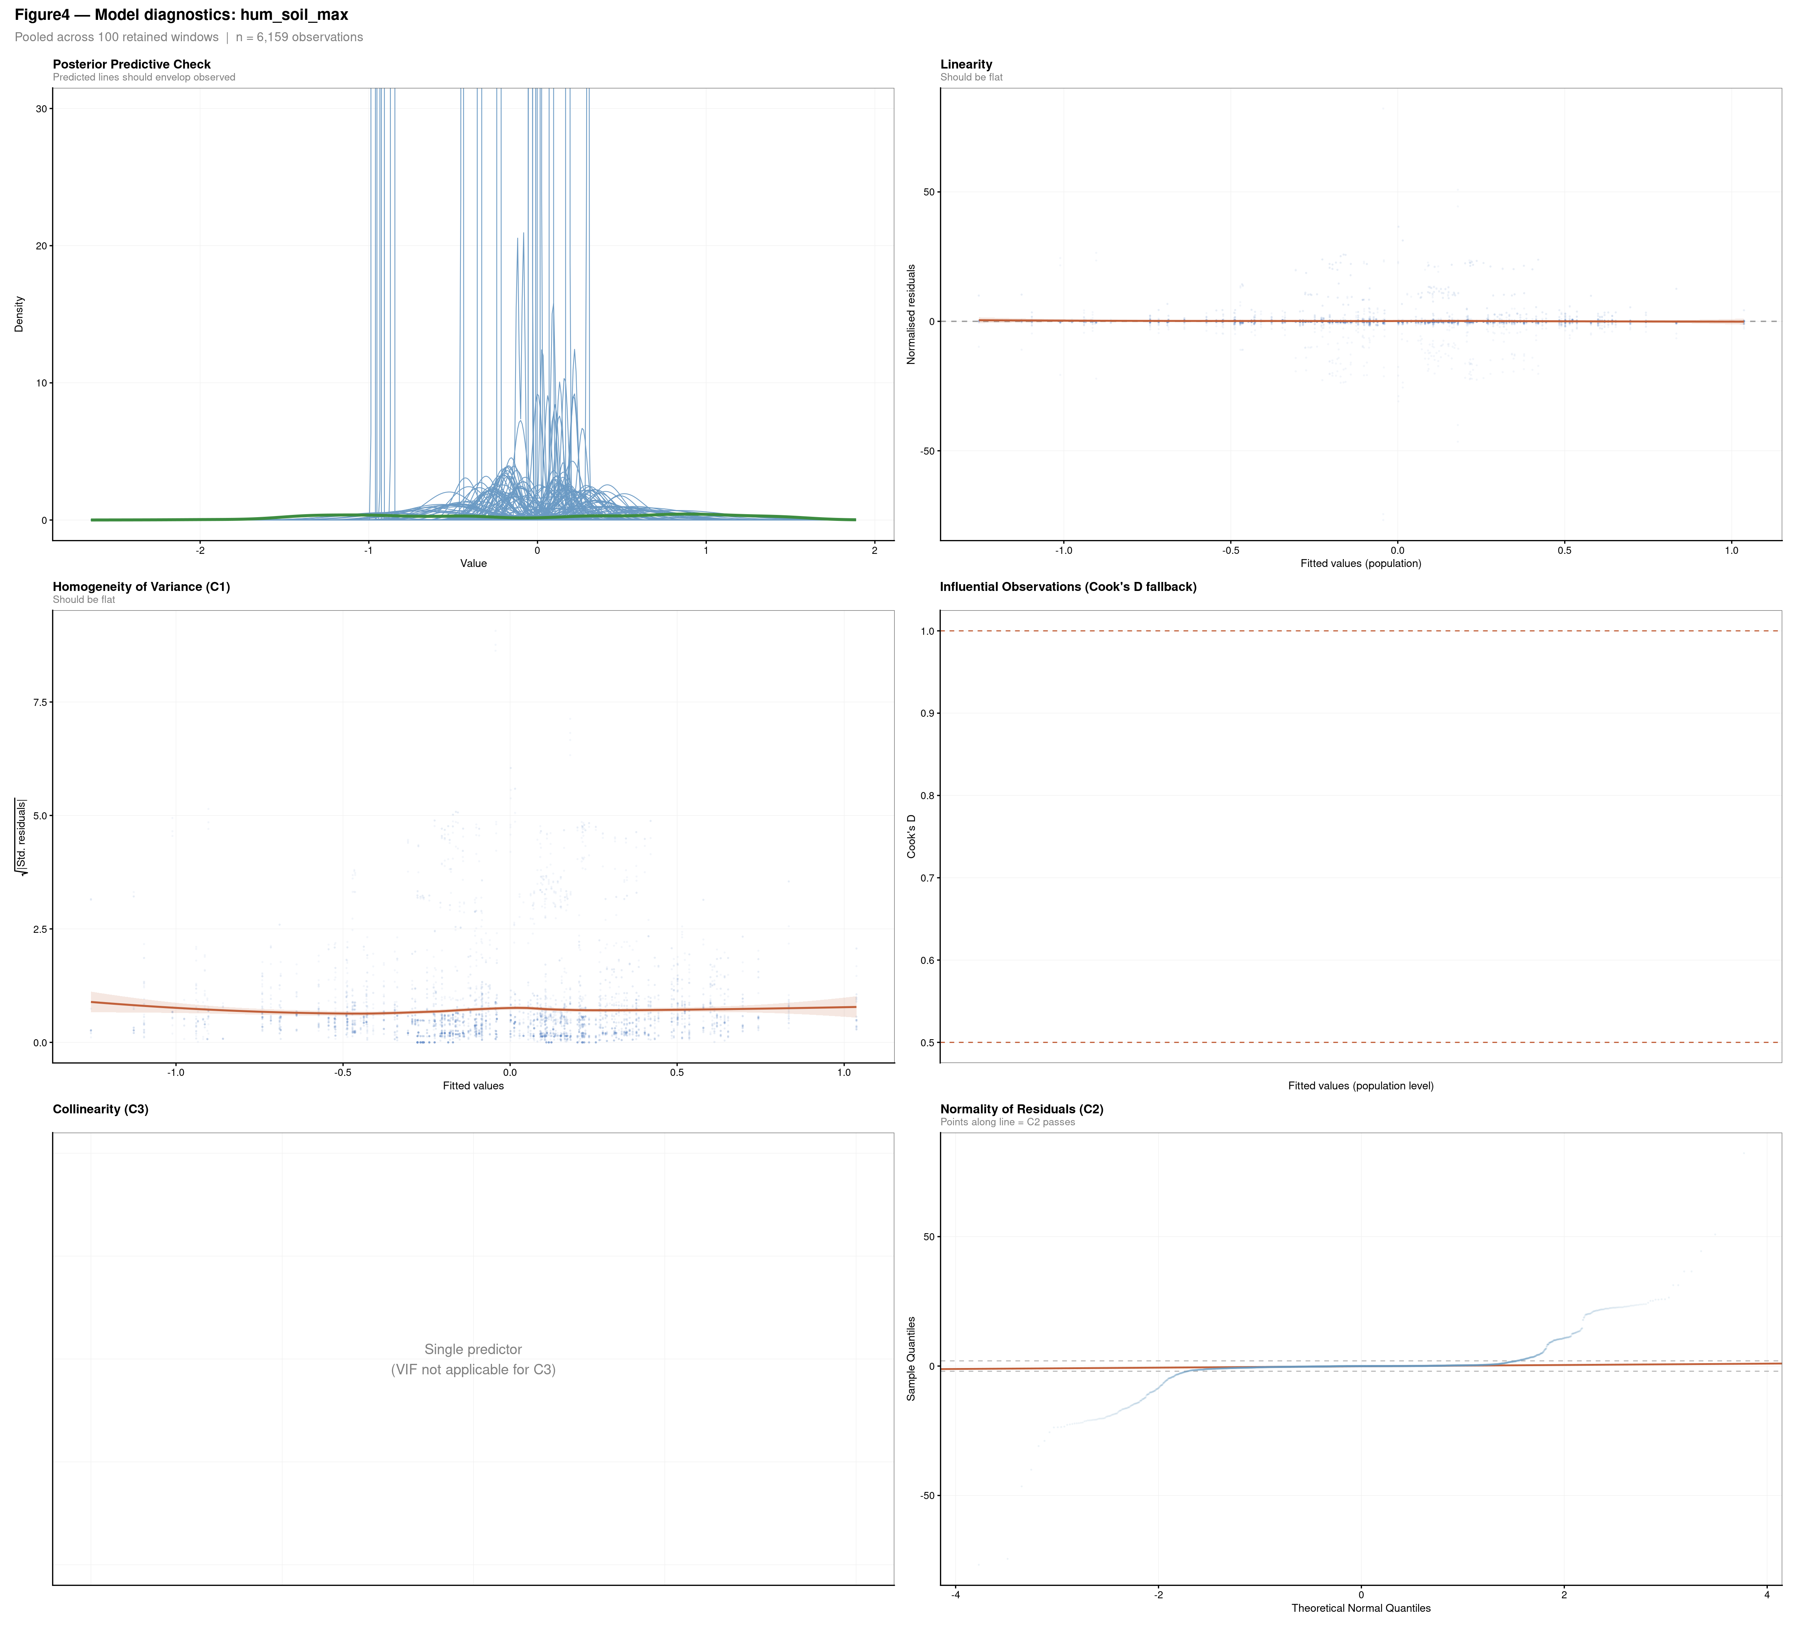
Figure 4: Six-panel model diagnostics for each structural equation. Panels: (1) Posterior Predictive Check — predicted densities should envelop the observed distribution; (2) Linearity — LOESS on residuals vs. fitted should be flat; (3) Homogeneity of variance (C1) — square-root scaled residuals vs. fitted; (4) Influential observations — residuals vs. leverage with Cook’s D contours at 0.5 and 1.0; (5) Collinearity (C3) — per-predictor VIF across windows; (6) Normality (C2) — Q-Q plot of normalised residuals.
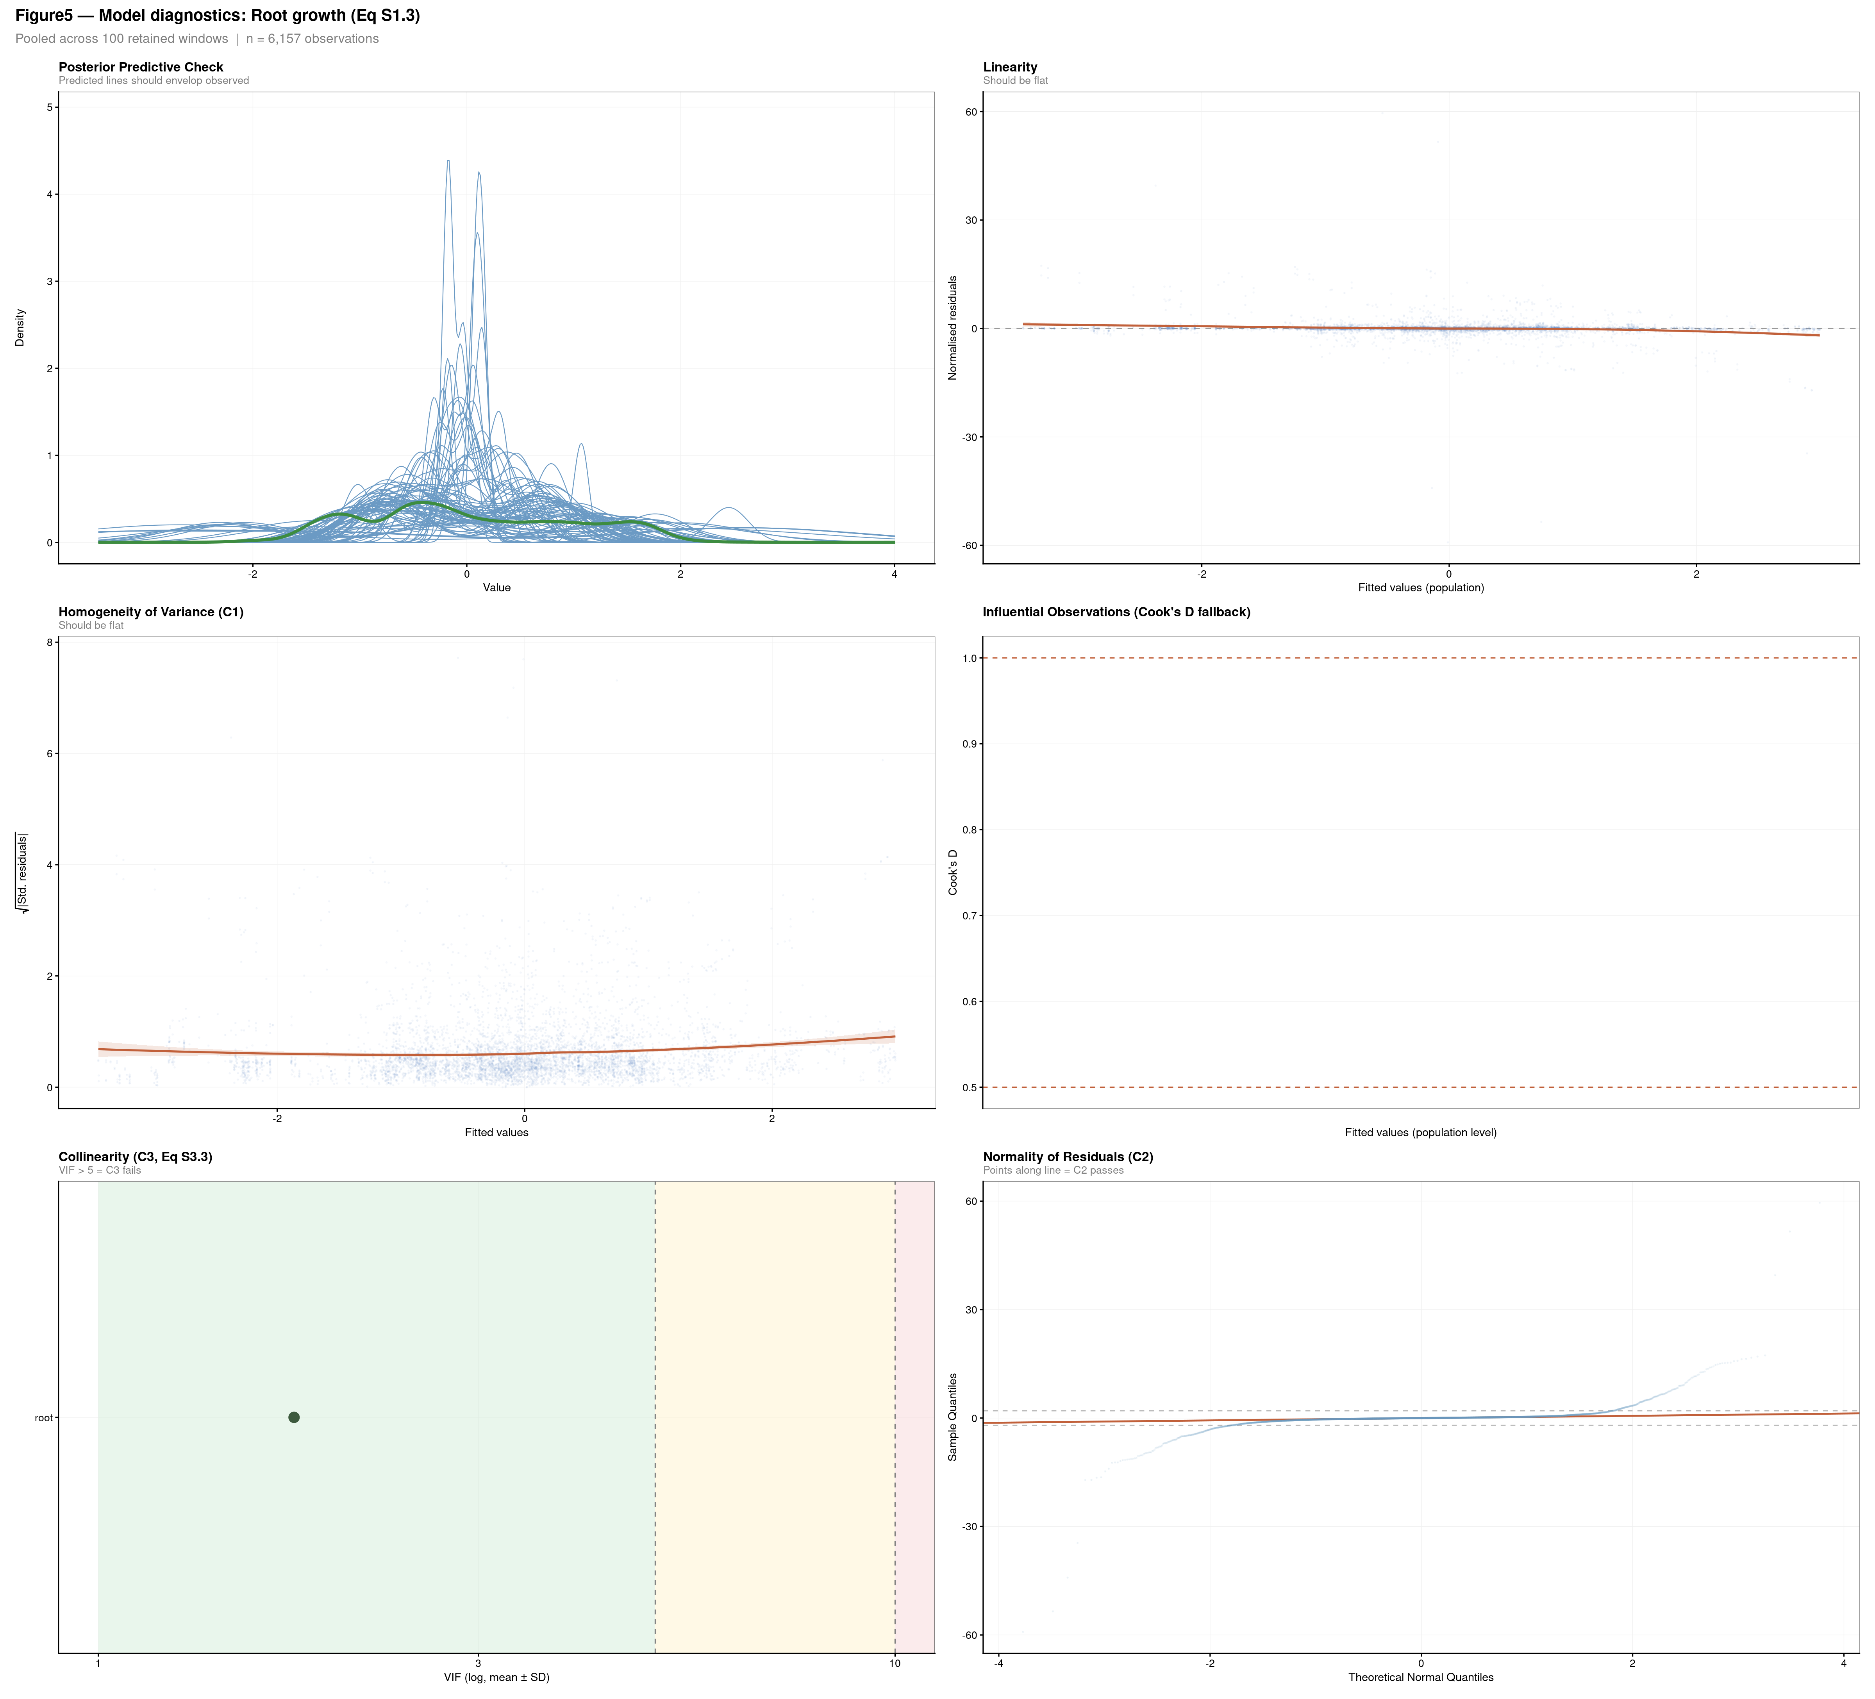
Figure 5: Six-panel model diagnostics for each structural equation. Panels: (1) Posterior Predictive Check — predicted densities should envelop the observed distribution; (2) Linearity — LOESS on residuals vs. fitted should be flat; (3) Homogeneity of variance (C1) — square-root scaled residuals vs. fitted; (4) Influential observations — residuals vs. leverage with Cook’s D contours at 0.5 and 1.0; (5) Collinearity (C3) — per-predictor VIF across windows; (6) Normality (C2) — Q-Q plot of normalised residuals.
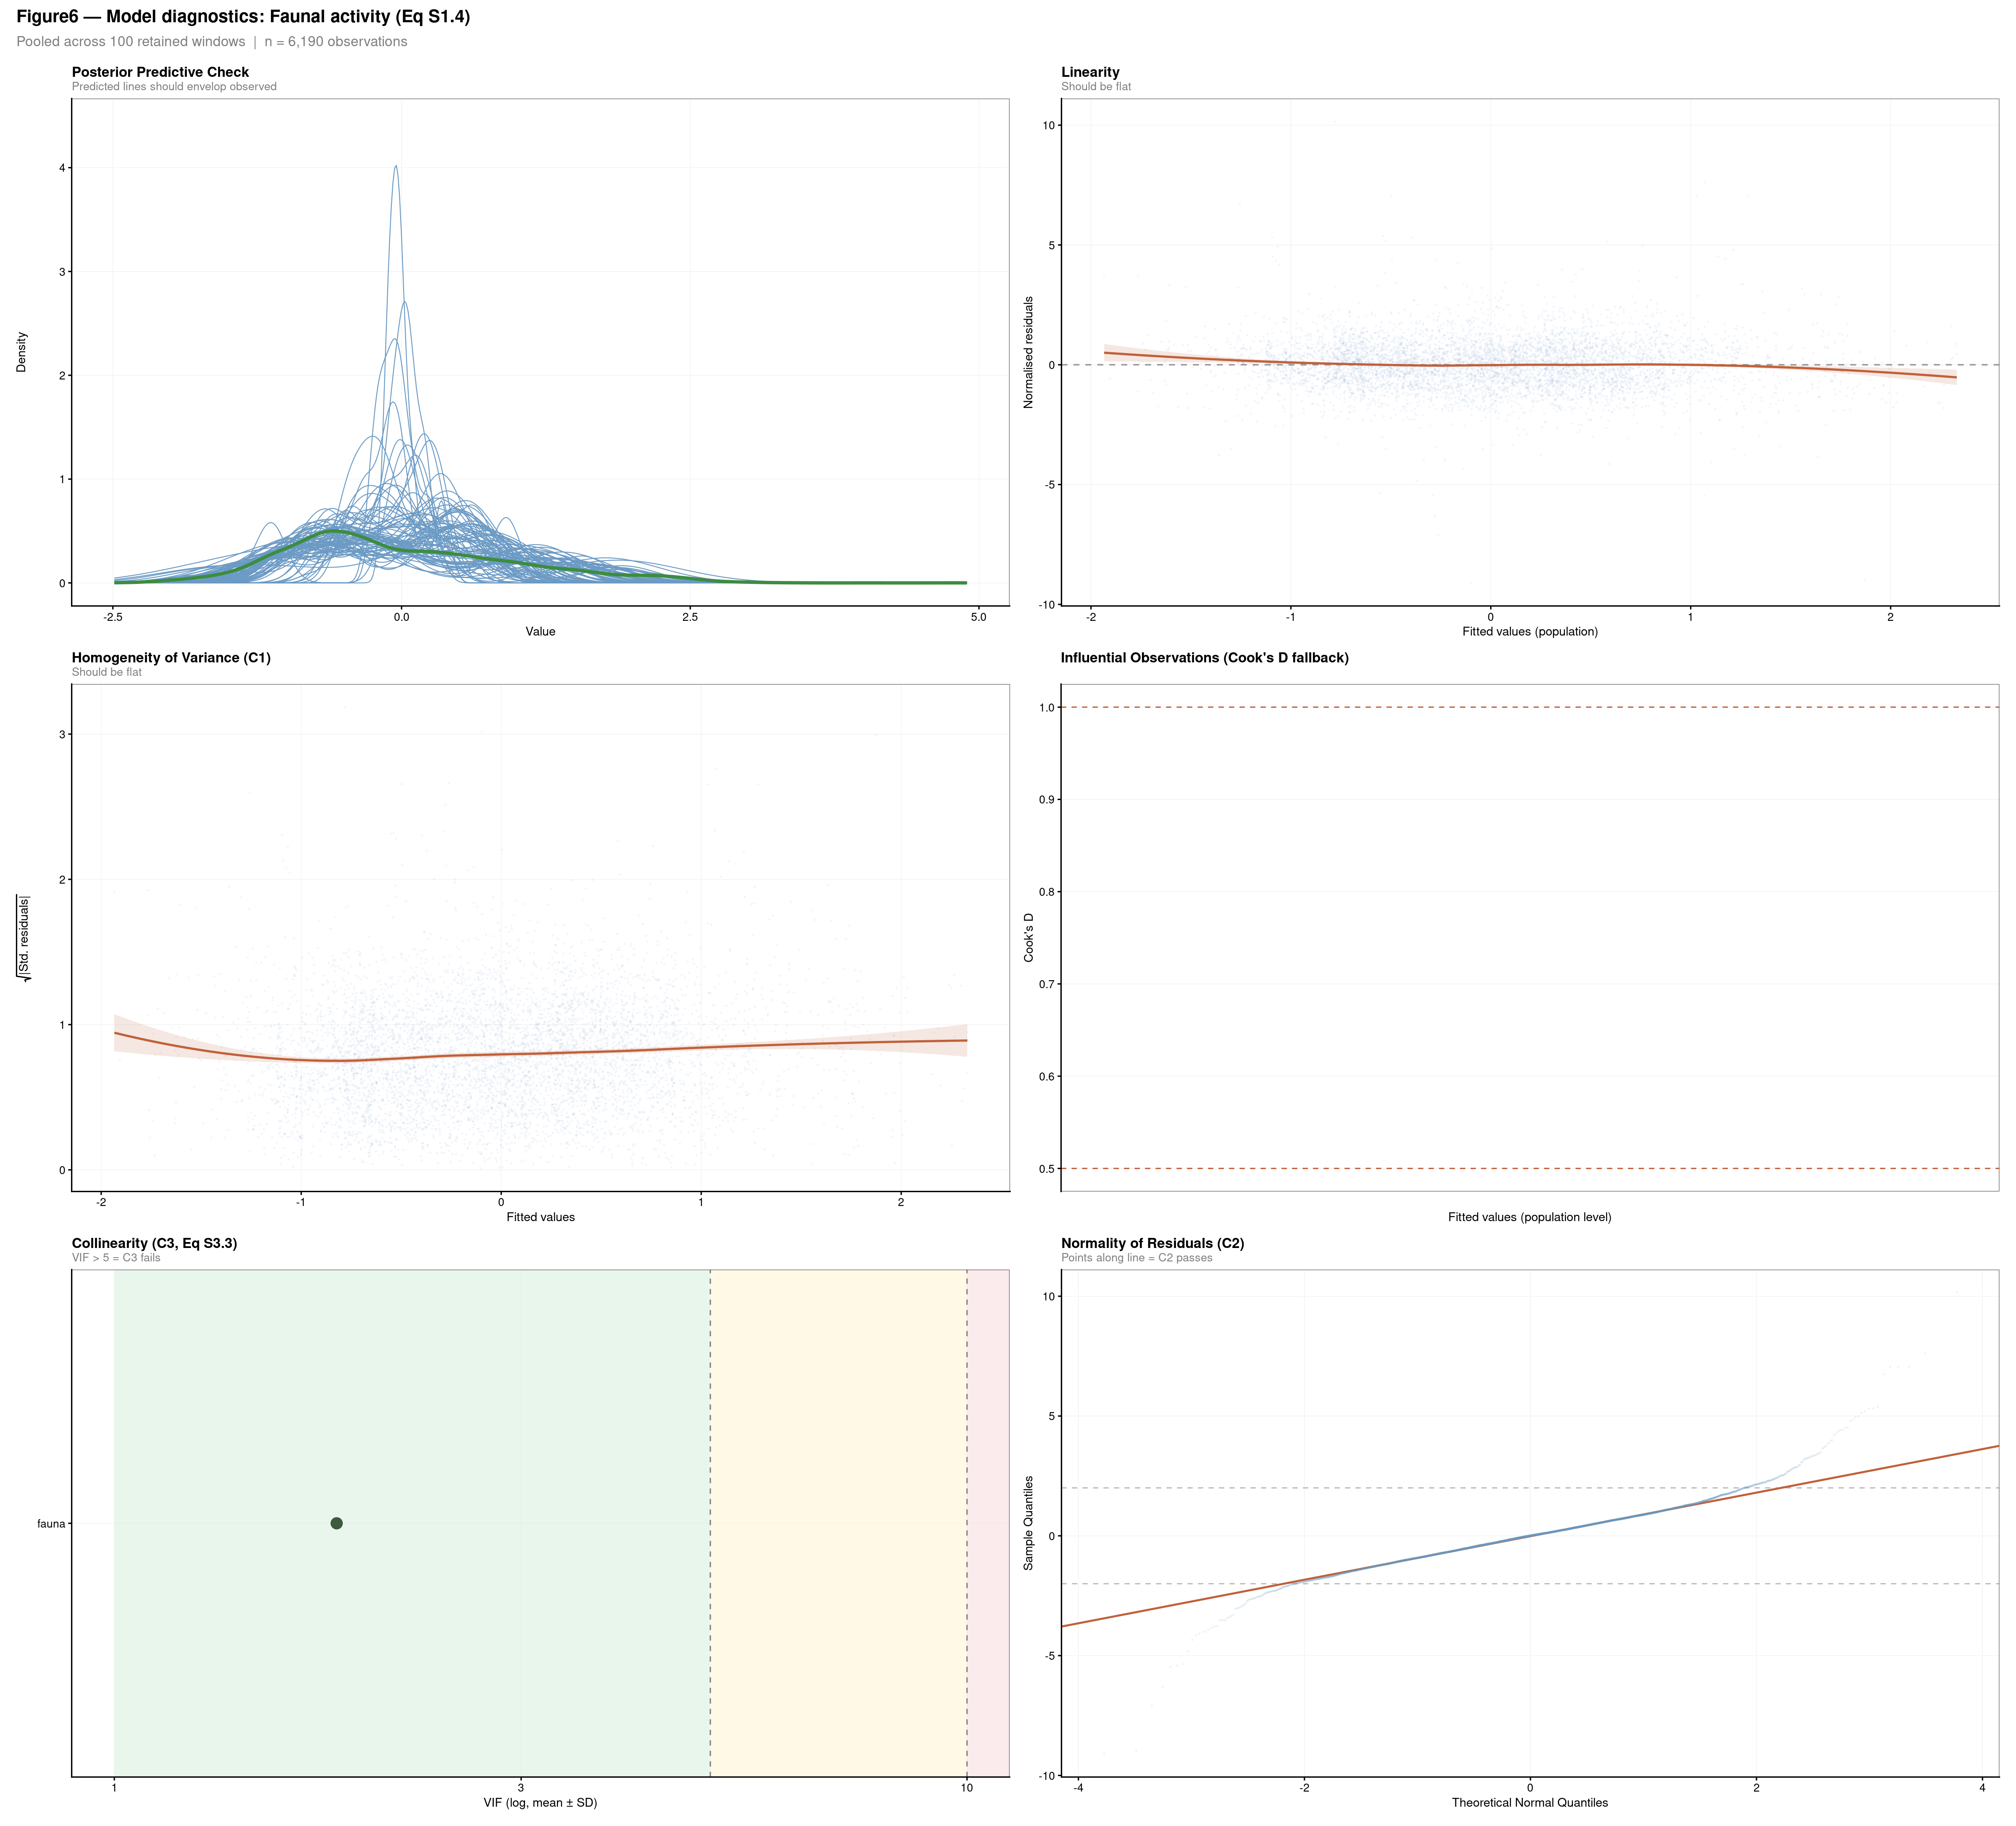
Figure 6: Six-panel model diagnostics for each structural equation. Panels: (1) Posterior Predictive Check — predicted densities should envelop the observed distribution; (2) Linearity — LOESS on residuals vs. fitted should be flat; (3) Homogeneity of variance (C1) — square-root scaled residuals vs. fitted; (4) Influential observations — residuals vs. leverage with Cook’s D contours at 0.5 and 1.0; (5) Collinearity (C3) — per-predictor VIF across windows; (6) Normality (C2) — Q-Q plot of normalised residuals.

Export
The following files are written to ../output/ for use by Script S3 (3_SEM_modelisation.qmd):
Output file | Contents
benchmark_results_database.csv | Full sensitivity grid results (Table S2.1 expanded)
selected_windows.txt | Dates of retained rolling windows (one per line)
model_parameters.txt | JSON: selected window, completeness, and transformations
FigS2_*_diagnostics.tiff | Six-panel check figures for each structural equation

