Land-use effects on soil fauna are temporally unstable

Study description
Soil invertebrate communities were monitored at 6-hour resolution over nearly two years using eight buried scanners deployed across two contrasted land-use positions within the same Mediterranean agroforestry system: position A (unmanaged — treed cover with permanent herbaceous vegetation) and position C (managed — open cultivated area). By combining faunal activity time series with continuous measurements of root dynamics and paired microclimate indices, we apply a rolling-window piecewise structural equation model (pSEM) to characterise both the direction and the temporal variability of causal pathways linking edaphic conditions to soil faunal activity.
The rolling-window approach — fitting the model on successive overlapping 14-day windows advanced in daily steps rather than on the full time series — is central to the study design. It yields a distribution of standardised path coefficients over time, capturing how the strength and sign of causal links fluctuate across seasons and in direct response to management events. A divergence index is additionally computed per window to track whether land-use forcing compresses or sustains inter-taxon response heterogeneity.

Study site
The study was conducted at the experimental agroforestry site DIAMs (Dispositif Instrumenté en Agroforesterie Méditerranéenne sous contrainte hydrique) established in 2017 at the INRAE experimental station UE Diascope (Mauguio, Hérault, France; 43.612°N, 3.976°E), under a semi-arid Mediterranean climate (mean annual temperature 15.7 °C, mean annual precipitation 511 mm). Soils are classified as Skeletic Rhodic Luvisols with high stone content (> 60%) and a clay-rich horizon below 100 cm.
The system combines annual crop rotations with rows of black locust (Robinia pseudoacacia L.) spaced 17 m apart, each row bordered by a 2 m-wide permanent grass strip. During the study period, the cropping sequence was: durum wheat (sown Dec 2023, harvested 8 Jul 2024) → sorghum (sown 15 Jul 2024, mown 22 Nov, tilled 25 Nov 2024; irrigated three times in Jul–Aug 2024) → chickpea (sown 14 Mar 2025, harvested 10 Jul 2025).

Hypotheses
Table 1: Research hypotheses for the rolling-window pSEM analysis
# | Statement
H1 | Land-use effects on soil fauna are inherently non-stationary: their magnitude and direction shift through time in response to seasonal cycles and discrete management events.
H2 | The indirect pathways linking land use to faunal activity vary over time in intensity, as the dominant causal mechanism alternates between microclimatic forcing and resource-mediated (root) pathways.
H3 | Periods of strong land-use forcing reduce response diversity by driving convergence in taxon-specific responses, thereby transiently constraining the functional heterogeneity of the community.

Causal model (piecewise SEM)
All variables are z-score standardised within each window prior to modelling; land-use type is retained on its binary scale (treed = 0, cultivated = 1). Each structural equation is fitted as a linear mixed-effects model with a nested random intercept (orientation / depth) and an AR(1) correlation structure. A residual covariance term (microclimate_1 %~~% microclimate_2) captures shared physical drivers not represented by the binary land-use contrast.
Tier 1 — Land use shapes microclimate * ${\text{microclimate}}_{1}←β_{1}⋅\text{land_use}$ * ${\text{microclimate}}_{2}←β_{2}⋅\text{land_use}$
Tier 2 — Microclimate × Land use drives root growth * $\text{root}←β_{3}⋅{\text{mc}}_{1}+β_{4}⋅{\text{mc}}_{2}+β_{5}⋅\text{land_use}$
Tier 3 — Microclimate + Root × Land use drives fauna * $\text{fauna}←β_{6}⋅{\text{mc}}_{1}+β_{7}⋅{\text{mc}}_{2}+β_{8}⋅\text{root}+β_{9}⋅\text{land_use}$
Indirect effects are computed as products of standardised path coefficients along each causal route. A total of seven pathway estimates are derived per window: five indirect routes, the total indirect (sum of the five), and the total effect (direct + total indirect).
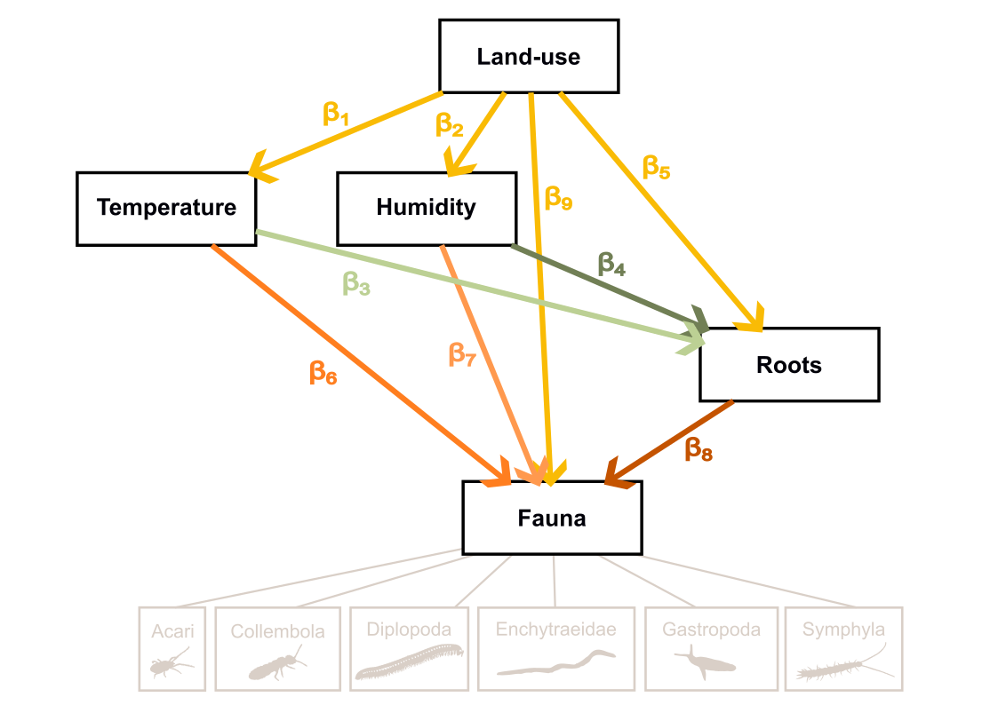
Figure 1: Structural Equation Meta-Model (DAG) detailing the hypothesized causal pathways.

Response diversity (H3)
The rolling-window pSEM is fitted independently for six focal taxa: Acari, Collembola, Enchytraeidae, Julida, Gastropoda, and Symphyla. Per-window divergence in taxon-specific β-estimates is quantified using the index of Ross et al. (2023):
D(w,k) = [max(β) − min(β) − |max(β) + min(β)|] / [max(β) − min(β)]
D = 1 when taxon responses span zero symmetrically (half positive, half negative); D = 0 when all taxa respond in the same direction. The relationship between D and the absolute community-level β is modelled with a GLS incorporating an AR(1) error structure.

Pipeline
Scripts must be run in order. Script 2 is computationally intensive.
Script | Role | Key outputs
1_database_edition.qmd | Assembles fauna, microclimate, root, and season data into one analysis-ready table | SEM_database.csv, fauna_vars.txt, microclimate_index.txt
2_SEM_diagnostic.qmd | Sensitivity analysis over 120 (window × completeness × transformation) combinations; selects the optimal modelling configuration | model_parameters.txt
3_SEM_modelisation.qmd | Fits the full rolling-window pSEM for all taxa; computes indirect effects and the divergence index | SEM_results_database.csv, indirect_effects.csv, H1_*.csv, DAG_*.csv
4_SEM_results_analysis.qmd | Produces all figures and tables for H1–H3; no modelling performed | Fig1–Fig4 TIFF files
quarto::quarto_render("scripts/1_database_edition.qmd")
quarto::quarto_render("scripts/2_SEM_diagnostic.qmd")
quarto::quarto_render("scripts/3_SEM_modelisation.qmd")
quarto::quarto_render("scripts/4_SEM_results_analysis.qmd")

Repository structure
project/
├── data/
│ ├── fauna_data.csv # Raw invertebrate detections
│ ├── root_pixels_count.csv # Root pixel counts per image
│ ├── Diams_AF1W_soil.csv # Soil temperature and moisture
│ └── Diams_AF1W_air.csv # Air temperature and humidity
├── output/ # Generated by the pipeline — not versioned
│ ├── SEM_database.csv
│ ├── microclimate_index.txt
│ ├── fauna_vars.txt
│ ├── model_parameters.txt
│ ├── SEM_results_database.csv
│ ├── indirect_effects.csv
│ ├── H1_adjusted_values.csv
│ ├── H1_model_summary.csv
│ ├── DAG_coefficients.csv
│ ├── DAG_model_fit.csv
│ └── Fig*.tiff
└── scripts/
├── 1_database_edition.qmd
├── 2_SEM_diagnostic.qmd
├── 3_SEM_modelisation.qmd
└── 4_SEM_results_analysis.qmd

Dependencies
All analyses were performed in R 4.5.2. Core packages:
Package | Role
tidyverse | Data wrangling and visualisation
nlme | Linear mixed-effects models
piecewiseSEM | Piecewise structural equation modelling
MuMIn | R² via variance partitioning
data.table | High-performance rolling joins for root data
ade4 | Microclimate PCA
zoo | Rolling-window calculations
patchwork | Figure composition

The scanner-based imaging methodology is described in:
Belaud E., Jourdan C., Barry-Etienne D., Marsden C., Robin A., Taschen E., Hedde M. (2024). In situ soil imaging, a tool for monitoring the hourly to monthly temporal dynamics of soil biota. Biology and Fertility of Soils 60, 1055–1071. https://doi.org/10.1007/s00374-024-01851-8

