**VALLEY VIEW UNIVERSITY**

**INSTITUTE OF COMPUTER SCIENCE**

**DEPARTMENT OF INFORMATION TECHNOLOGY**

**A THESIS SUBMITTED IN PARTIAL FULFILLMENT OF THE REQUIREMENTS FOR THE BACHELOR OF EDUCATION IN INFORMATION TECHNOLOGY DEGREE**

**TOPIC:**

**SCHOOL GUIDANCE ADVISER SYSTEMS**

**BY:**

**KOFFIE KARLVAN**

**218EI11006138**

**MAY 2020**

**DECLARATION**

This is to declare that, the research work underlying this senior research project has been carried out by the under mentioned student under the supervisor. Both student and the supervisor certify the work documented in this project is the output of the research conducted by the student as part of the final year project work in the partial fulfilment of the requirement of the Bachelor of Education with information Technology in the secondary education degree.

STUDENT: SUPERVISOR:

KARLVAN KOFFIE MR. WILLIAMS NABARE

……………………………………… ………………………………………

SIGNATURE SIGNATURE

DATE …………………………………….. DATE………………………………………………….

Contents

CHAPTER ONE 5

1.0 Introduction 5

1.1 Subject and Field of Study 6

1.2 Study Objectives 7

1.2.1 Global (General) Objectives 7

1.2.2 Specific Objectives 8

1.3 Background to the Study 8

1.4 Scope of Study 9

1.5 Justification of the Study/Significance of Study 9

1.6 Expected Results of the Study & Possible Use 10

1.7 Presentation of Thesis 11

CHAPTER 2 13

Literature Review 13

2.0 Introduction 13

2.1 Review of Related Works 14

2.2 Similar Available System 15

2.4 The Proposed Work 27

2.5 Project Scope 30

CHAPTER 3 31

Crystallization of the Problem 31

3.0 Background and History 31

3.1 Components and Features 32

3.2 Strength and Advantages 34

3.3 Weakness and Disadvantages 35

3.4 Methodology 35

CHAPTER 4: 38

Analysis of the Proposed System 38

4.0 Overview of the proposed system 38

4.0.1 Functional Requirements 39

4.0.2 Non-functional Requirements 40

4.1 Major Features and Components of the proposed system 40

4.1.1 Major Features 40

4.1.2 Component of the proposed system 40

4.2 Benefits/Advantage of the proposed system 41

4.3 System Context Diagram of the proposed system 41

Chapter 5: 43

Detailed Design of the Proposed System 43

5.0 Functional Processes of the Proposed System 43

5.1 Algorithm and flowchart of the processes 43

5.2 Data Flow Diagrams 43

5.3 Data Dictionary 43

Chapter 6: 46

System Implementation & Testing 46

6.0 Implementation 46

6.1 Testing 47

6.2 Statement of Test Cases Strategy 49

Chapter 8: 55

Conclusion and Recommendation 55

8.0 Conclusion 55

8.1 Recommendation 55

6.4 Challenges and Observation 55

Reference 56

# CHAPTER ONE

**1. General Introduction**

## Introduction

A decision support system (DSS) is a flexible, interactive, computerized approach intended to support administrators in their decision making activities and which is capable of providing direct, personal support for complex, management decisions (TURBAN et al., 1988). A well designed DSS aids decision makers in compiling, personal knowledge from employee’s management, executives and business models. DSS analysis helps companies to identify and solve problems with comparative results obtained from well-organized data structure for rapid response.

Academic resource planning is a highly complex administrative procedure based on extensive analysis of data related to the educational framework, such as teaching and learning resources, offered course and curricula (Vinnik & Scholl, 2005). A typical information gathered by a DSS may include class size, age limit, income and expenditure, classes’ hours per subject etc. DSS applications are used in many diverse fields, including medical diagnosis, credit loan verification, business management, agriculture production at the farm, Information Technology and a lot more.

The purpose of this project is to first outline the benefits of having a career guidance system in the education sector. The goal of this project is to develop a career guidance (DSS) to assist final year junior high school students in selecting their preferred senior high schools and senior high school graduates to make the right career choice.

## Subject and Field of Study

**Data Science**

Due to a growing competition in higher education environments, universities try to apply strategies and develop new instruments so to enhance the quality of teaching and research activities and provide the communities with relevant services and knowledge.(Provost & Fawcett, 2013)

**Expert System**

Computers can be programmed with rules to use information to make simple decisions. This is knowledge that has been passed on from the programmer. A simple example of this is a spreadsheet application that monitors pupils' test marks and calculates average scores.

A more sophisticated example of this is an expert system. This is where computers are programmed to accept a large number of items of information based on rules set in the program. The best-known examples of these are automatic pilots in aero planes and diagnosis applications used to help doctors. In both cases these systems are only as good as the rules programmed by the human computer programmer and cannot deal with the unexpected. They need to be used as aids to human decision making only.

## Study Objectives

### 1.2.1 Global (General) Objectives

The aim of this project is to ensure that students make the best choice in their senior high school selection and career path selection to ensure that students do not have any regret in the near future concerning their chosen careers or profession.

### 1.2.2 Specific Objectives

* To formulate a guideline in decision making in relations to school selection
* To formulate a guideline in decision making in relations to career guidance.
* Provide data analysis on existing schools based on categories, performance and courses offered.

## Background to the Study

Due to a growing competition in higher education environments, universities try to apply strategies and develop new instruments so to enhance the quality of teaching and research activities and provide the communities with relevant services and knowledge. Hence the need of a system to aid in decision making is very important.

The Decision making process is fundamentally one of the recognizing and problem solving ways towards the objective of producing a decision (Dss, 2012). Structured decisions support has proper steps for solving problems and reaching a decision While unstructured decisions have only few steps. The Modern Decision support systems make use of internal and external sources of data, distributed databases, real-time information, models and intelligent techniques. This project aims to discuss relevant measures needed to adapt a decision support system for Senior High Schools selection, career guidance for senior high school students and a database source for data reference.

## Scope of Study

Despite the enormous benefits of career guidance systems for decision making most stakeholders in the education sector have not yet adapted one to help final year JHS student in selecting their preferred SHS and making right career choices. A large number of students don’t get admission to their preferred school because they don’t make it to the cut-off point whereas such student stands a higher chance to gain admission in another school.

## Justification of the Study/Significance of Study

We are building a career guidance system that accepts student’s grade points from their mock exams, hobbies, interest, favorite subjects against SHS cut-off point in decision making for the right SHS to select and to also suggest the right career path for senior high school students. We will study the feasibility of automatic report generated based on the form input by the user. This evaluation will be carried out using the system design life cycle (SDLC) approach.

Firstly, we kickoff with the functionality layout of the system (what goes in and what comes out). Identifying the school selection and career choice problem and setting up the goals and objectives to overcome those characteristics. Our design phase will show a physical model that will satisfy all documented requirements for the system. The application architecture will be determined by the users since the system will be mostly used by teenagers. Selective users will be employed to interact with the system for performance evaluation and modification. Finally, security controls will be setup to safeguard the system from internal and external threats.

## Expected Results of the Study & Possible Use

DSS is among the most important explosion propelled by the internet transformation. This allows users to fruitfully gather knowledge both by synchronous and asynchronous methodology to effectively make decision based on the generated report by the career guidance system. This project is highly recommended for study and can yield great result.

Listed below are a few of expected results at the end of this projects;

* Graphical representation of all SHS base on categories, performance and courses offered.
* Generated output from the system will be meaningful to the end-user.
* Definitive conclusion in selecting preferred SHS.
* Definite conclusion in selecting right career path.

## Presentation of Thesis

CHAPTER 1: General Introduction.

Chapter 2: Literature Review.

CHAPTER 3: Crystallization.

CHAPTER 4: Analysis of the Proposed system.

CHAPTER 5: Detailed Design and implementation.

CHAPTER 6. System Implementation and Testing.

CHAPTER 7. System Documentation.

CHAPTER 8. Conclusion and Recommendations.

1.8 **Study work Plan**

The project will be in two phases.

Phase 1 will cover:

* Preliminary investigation.
* System analysis and design
* Risk analysis

It is expected to be completed in December 2019.

Phase 2 will cover:

* User Design of the Career Guidance Adviser system.
* Risk analysis
* Testing
* Implementation/ Development.
* Other presentations
* It is expected to be completed in May 2020.

# CHAPTER 2

# Literature Review

## Introduction

In chapter 1 the development of a career guidance support system for SHS selection and career guidance was introduced. Its objective was to develop and discuss the relevance of having a career guidance system for SHS selections and assisting senior high school students in selecting the ight career path. This project is aimed at developing the system using the latest web technologies so as to make its platform independent and more interactive.

As mentioned in the introduction, DSS is the area of the Information System discipline that is focused on systems that support and improve managerial decision-making While the overwhelming majority of DSS articles clearly address management support and some authors even call the field “management support systems”. This makes it difficult to distinguish between managerial decision-making and the strategic decision making of senior professionals such as analyst, economists and medical specialists.

## Review of Related Works

According to the International Encyclopedia of Business and Management Journal, ever since the first electronic general-purpose computer was put into full operation in the early 1940s, data-processing techniques have been continuously advancing. It was in the late 1950s that many organizations began to utilize transaction processing systems (TPS) or electronic data processing (EDP) systems to automate routine clerical tasks such as payroll, inventory and billing (Making, 1970).

The International Journal of Current Engineering and Technology also stated that the idea of “decision support systems” was given in 1971, although some writers point the starting date of the term in 1965 (Ashraf, 2014). It was indicated that Gory and Scott Morton (1971) built an interface for enhancement of information system management through distribution of managerial activities and classification of decision variations during 1960-1970. Gory and Scott Morton consider DSS as a system which can support different management activities for decision making that are completely defined.

Other findings by the journal argued that the early engineers of DSS was to make an atmosphere in which the managers and decision makers could work together in an IT-based ecosystem to diagnose and solve problems. Requirement of DSS is not just to provide the user with an application that could solve user’s queries effectively but the basic requirement is to provide the user an environment in which problems which looked impossible to solve earlier could be solved.

So, we can say that the basic aim of creating decision support system is to enhance the capability of users. Concisely we can consider DSS as an idea of integrating information systems with the user’s to enhance the decision making in different situations.

## Similar Available System

1. **RISKTURN: Risk-Based Investment Valuation and Capital Budgeting Software.**

Every business is exposed to a number of uncertainties. In many cases these uncertainties are not considereddue to the lack of capacity and the inability to address them properly.

RISKTURN is an innovative solution based on a well proven approach (Monte Carlo Simulation) that supports small and medium enterprises in evaluating all uncertainties that could impact their business development.

**Main Benefit**

1. RISKTURN delivers a complete risk-based financial planning in a few hours. It is suitable also for non-experts in probabilistic finance modeling.
2. RISKTURN is providing a 360° visibility on investment risks and opportunities, delivering clear and communicable resultson any future cash flow evaluation.
3. RISKTURN model is fully reliable**.** It is supported by 20 years of experience in probabilistic modeling in various sectors and applications.

**Applications**

RISKTURN is dedicated to organizations that are confident in their potential for growth, while increasing visibility on strategic decision making**:**

1. **Small and Medium companies** quickly assess the uncertainties on their investment with RISKTURN and tackle them pro-actively.
2. **Investment funds** are using RISKTURN to have powerful quantitative indicators in the due diligence on their investments.
3. **Startups** strengthen their business plans through with RISKTURN, providing potential financial sponsors or lenders with a transparent evaluation of the risks.

(RISKTURN, n.d.)

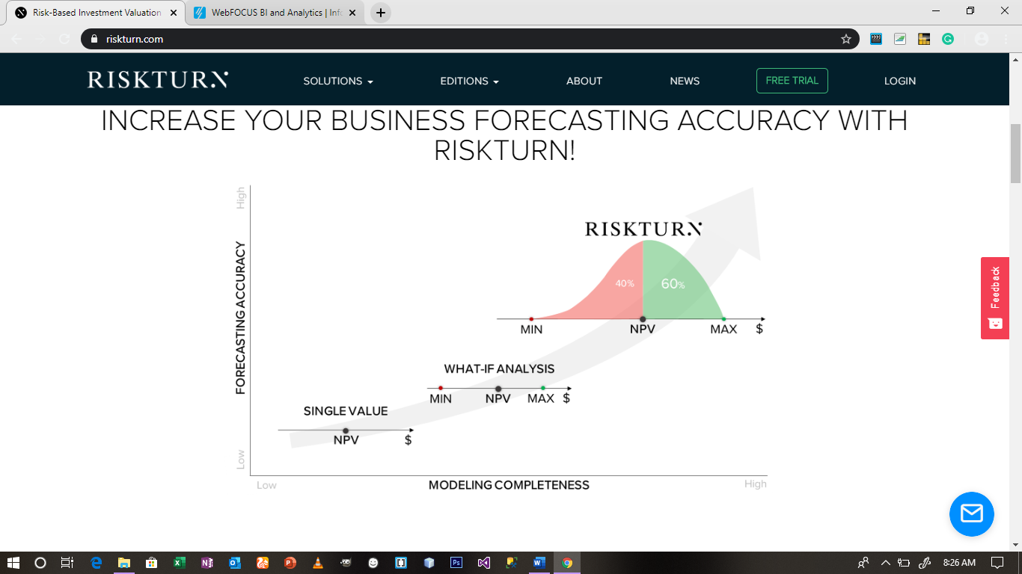

1. **Information Builders WebFOCUS**

Information Builders WebFOCUS is the industry’s most flexible and pervasive Business Intelligence and analytics platform able to deliver a broad range of governed analysis, applications, reports and documents to any and all business stakeholders. It is a comprehensive platform that provides an array of analytical and operational benefits inside and outside the enterprise, whether to management, analysts, line-of-business workers, partners or customers.

**Decision Support Features**

1. Budgeting & Forecasting
2. Data Analysis
3. Decision Tree Analysis

**Business Intelligence Features**

* Dashboard
* Key Performance Indicators
* Predictive Analytics
* Profitability Analysis
* Strategic Planning

(Information Builders, n.d.)

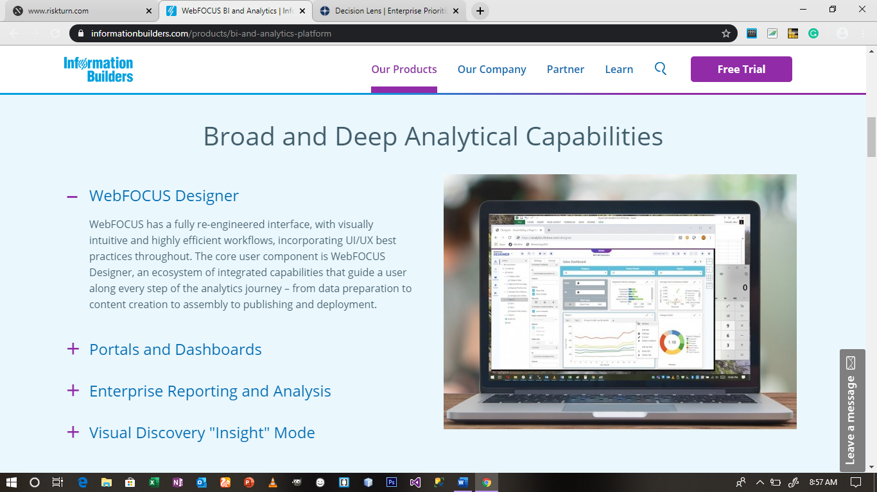

**3. An Educational Data Mining System for advising higher Education Students.**

In a research study conducted by Heba Mohammed Nagy, Walid Mohamed Aly and Osama Fathy Hegazy suggested and designed a student advisory framework that makes use of classification and clustering to develop an intelligent guidance system to provide consultations or guidance to first year university students to pursue or study a certain educational program where he or she is likely to succeed in (Nagy et al., 2013).

The purpose of designing this system is to reduce the high rate of academic failure among students. The suggested framework made use of both classification and clustering techniques to suggest recommendations for a certain course or department for a student. The framework considered students’ academic performance before entering into the university, department chosen by student and students’ grade in the first year.

1*.* **Classification Phase**

The classification phase applied an algorithm on the educational dataset to find an efficient classifier. The role of the classifier is to output the department recommended for the student by comparing the student’s performance to a certain standard. Steps used are as follows*:*

* Remove all the records for the student who failed in his/her first year.
* Use the training dataset and apply different classification algorithm with the department attribute as the class.
* Record the set of rules for the classification algorithm with highest F-Measure.

2. **Clustering Phase**

In this phase a clustering algorithm is applied on the educational dataset to divide student records into a number of clusters based on marks similarly. The steps in this phase are as follows:

* Remove all attributes regarding the department chosen by the student.
* Remove all attributes regarding first year grade.
* Choose the number of clusters.
* Use k-means algorithm to identify the clusters.
* Identify the distribution percentage of each department along the clusters.
* Remove the set of rules.

**Strengths**

* The system proved its effectiveness by assisting students in selecting a career path or course of study where their strength lies.
* The system helped in reducing the rate at which students fail academically due to not selecting the right course to study.
* The system combined results of both clustering and classification operations to predict the best or accurate results.

**Weaknesses**

* The system does not give detailed report to the student for the recommendation made.
* The system does not have a user-friendly interface.

**4. Decision Lens**

Decision Lens is cloud-based software that makes it easy to identify, prioritize, analyze and measure which investment or project will deliver the highest returns. Through advanced analytics and flexible custom visualizations and scenarios, organizations can make selections and immediately see the trade-offs to move forward with confidence. Decision Lens improves the speed and quality of prioritization and resource optimization while maximizing portfolio outcomes.

**[Decision Support Features](https://www.capterra.com/p/80889/Decision-Lens/)**

* Budgeting & Forecasting
* Data Analysis
* Decision Tree Analysis

**[Business Intelligence Features](https://www.capterra.com/p/80889/Decision-Lens/)**

* Dashboard
* Profitability Analysis
* Strategic Planning

(Decision Lens, n.d.)

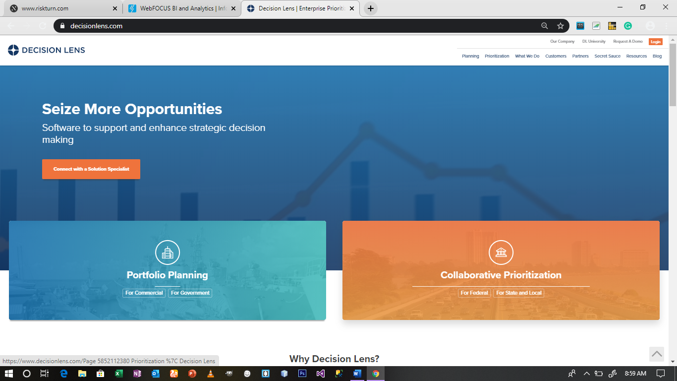

5. **Career Master: A Decision Support System (DSS) for Guidance and Counseling in Nigeria.**

A research which was also published in the Pacific Journal of Science and Technology by V.F. Balogun (M.Sc.1) and A.F. Thompson (M.Tech) discussed the design and the result of implementation of a Decision Support System for proper guidance and counseling of students, especially those leaving the secondary school, to guide and suggest a list of best courses that could be pursued in the tertiary institution (Balogun et al., 2009).

These suggestions are however based on some basic parameters used by human counselors such as: Intelligence Quotient, hobbies, parents’ and friends’ influences, etc.

The DSS implemented in this paper was model based on the conceptual

model. The model consists of the following:

1. **Data Management Model**

This model deals with the storing of data ranging from private, internal and external data necessary for the Career Master in making decisions. It comprises of database tables such as course table, study table, subject table and pass table. The pass table consist of password for the administrator of the system to enable edit, update and delete data from the database.

1. **Model Management**

This model takes care of making decisions based on the available data presented to the system. The dataset required to make decisions in this model are the class (art, science, commercial), age, I.Q test, hobbies, friend suggestions and parent suggestions. An algorithm is therefore implemented to decide on the best possible career opportunity for counselee based on the data obtained from the above dataset.

1. **Knowledge Management**

This model implements an algorithm to aid with complex problems which require expertise for their solution in addition to the regular DSS capabilities. This system makes use of certain production rules in its rule base to solve problems such as clients with clashing subject combination, hobbies, friends’ and parents’ suggestions.

1. **Dialog Management**

This component takes care of the software and hardware that provide the user interface for the DSS. This includes the text boxes for input of client’s name and school; option buttons for client’s class and level of study; list boxes for displaying course lists to clients; and command buttons for knowing client’s selection, asking the DSS for reasons for asking questions and adding selections to list of courses for comparison by the DSS.

1. **Manager (User) & Tasks**

This component is where the user interacts with the DSS. Navigating through the user interface provided by the DSS.

**Strengths**

1. Career proposed was based on personal information obtained from and about the client.
2. Structure of the system was efficient and provided good result.
3. The DSS provides enough feedback for user to understand decision made,

**Weaknesses**

1. The system can only be used by the Guidance and Counseling coordinator.
2. The software runs only on a local computer platform. Not available on the internet or any other platform.
3. User interface was not friendly enough.
4. **About Engage2Serve**

Engage2serve is a cloud-based constituent relationship management solution that helps educational institutions streamline the entire student lifecycle, from admissions to academic operations and career preparation. It allows supervisors to sort, prioritize and distribute prospect inquiry tickets based on enrollment counselors' skills and experience.

Engage2serve allows the faculty to report academic, psychological or behavioral student issues and refer them to advising, counseling and tutoring sessions. Engage2serve career platform is a job board, which allows students to create resumes, set reminders, make appointments and enroll in mentorship programs, improving employability. Additionally, administrators can create dashboards and utilize the drag-and-drop interface to gain insights into marketing budgets, recruitment performance, return-on-investment (ROI) and admissions efficiency.

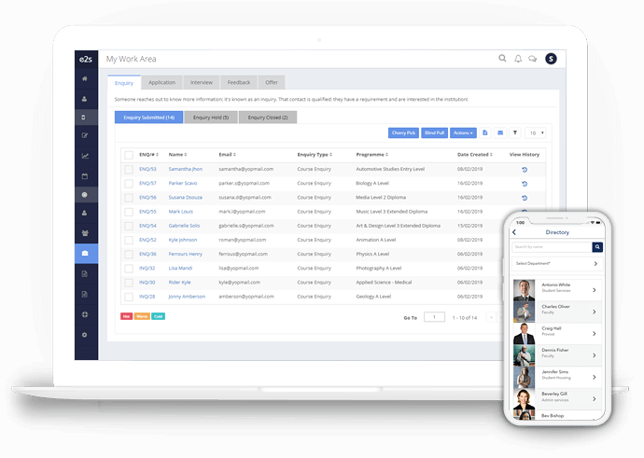

**E2S Dashboard**

**Features of E2S**

**Student Engagement Platform**

1. Communication tools
2. Student group management
3. Mobile app
4. Polls and voting

**Admission**

1. Application management
2. Candidate management
3. Colleges and universities
4. Recruitment management
5. Career guidance

**Weakness**

1. Interactive learning
2. Evaluation management
3. Financial aid management
4. **Career Center by JobTeaser**.

JobTeaser is the European leader for career guidance and the recruitment of young talent. They have built a unique ecosystem that brings together a range of businesses as well as schools and universities around the world to offer career platform that have been developed in response to specific needs. Helping students connect to the business world and support them with their career path.

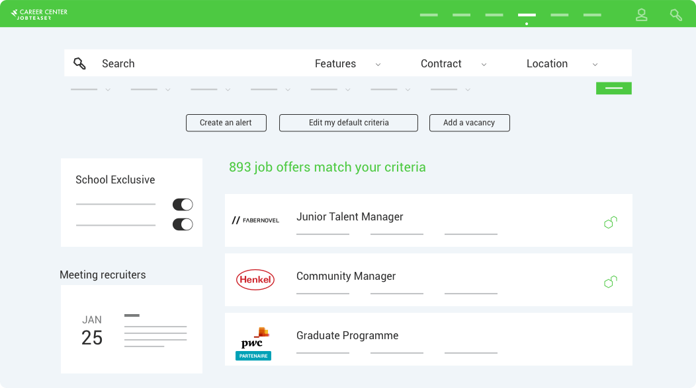

**Career guidance at JobTeaser**

**Components of JobTeaser**

1. Company presentation pages for getting to know a company’s teams, careers and recruitment processes.
2. A modern and intuitive jobs board with targeted advertising.
3. An intuitive back office for creating and managing all your events: coaching workshops, forums, recruitment sessions, etc.
4. Personalized dashboards and reports

**Weakness**

**2.3 Comparative Analysis of reviewed system**

|  |  |  |  |  |  |  |
| --- | --- | --- | --- | --- | --- | --- |
| **FEATURES** | **RISKTURN** | **Information Builders WebFOCUS** | **DATA MINING DSS** | **Decision Lens** | | **CAREER MASTER** |
| Budgeting & Forecasting | **✓** | **✓** | **🗶** | **✓** | **🗶** | |
| Data Analysis | **✓** | **✓** | **🗶** | **✓** | **🗶** | |
| Decision Tree Analysis | **✓** | **✓** | **✓** | **✓** | **🗶** | |
| Profitability Analysis | **✓** | **✓** | **✓** | **✓** | **✓** | |
| Strategic Planning | **🗶** | **✓** | **🗶** | **✓** | **🗶** | |

**Career Guidance Development Theoretical Model**

Career development theory is the study of career paths, success and behavior. It aims to explain why a person might be a good fit for a certain career and provide advice on how to attain a promising trajectory. It also focuses on identifying common career stages when education, guidance and other interventions are necessary (*Career Development Theory: Definition and Examples | Indeed.com*, n.d.).

Career Development theories come from these main areas of study:

* Differential psychology
* Personality
* Sociology
* Developmental psychology

We hereby state the career guidance theoretical model developed by

Holland (The Theory of Vocational Types) as a study guide to this research.

The Holland theory of vocational types focuses on personality types as the main factor in career choice and development. John L. Holland developed his theory on the idea that career choice is based on personality. He believed that a person’s work satisfaction is linked to similarities between their personality and job environment.

Holland’s theory has six personality types, sometimes call the Holland Codes or Holland Occupational Themes:

**Realistic (R):** Also called “Doers,” people in this type solve problems by taking action rather than discussing it. Realistic types are interested in work that requires skill and strength. Carpenters, chefs and personal trainers all fit into the realistic personality type.

**Investigative (I):** Also called “Thinkers,” people in this type like to work with information. Investigative types enjoy working by themselves rather than with a group. Actuaries, lawyers and doctors all fit into the investigative personality type.

**Artistic (A):** Also called “Creators,” people in this type are creative, inventive and typically more emotionally aware than other Holland Types. Artistic types are independent but enjoy working with other people. Graphic Designers, writers and musicians all fit in the investigative personality type.

**Social (S):** Also called “Helpers,” people in this type enjoy teaching or helping others. Social types value working with others and creating relationships. Teachers, counselors and human resource professionals all fit in the social personality type.

Enterprising (E): Also called “Persuaders,” people in this type enjoy working with people and information. Enterprising types of value status and security. Entrepreneurs, stockbrokers and salespeople all fit in the enterprising personality type.

**Conventional (C):** Also called “Organizers,” people in this type enjoy rules and regulations. Like enterprising types, they put a value on status and money. However, they have a dislike for unclear or unstructured work. COOs, personal financial planners and economists fit in the conventional personality type.

(Zealand, 2012)

**The System Theory Framework (Theoretical Background)**

The International Journal for the Advancement of Counselling elaborated on the STF as a theoretical background to career counselling. The STF provides a map for understanding the origins of career counselling and the dilemma it is now facing. Career counselling is a unique discipline built on a foundation of career theory and counselling theory. Traditional career theory has tended to focus on specific discrete concepts relevant to individual career behavior.

Central to the STF is the individual system within, which is depicted a range of intrapersonal influences on career development such as personality, ability, gender and sexual orientation. Some of these influences have received considerable attention by career theorists and others have not. As individuals do not live in isolation, the individual system is connected with influences that comprise the individual’s social system as well as the broader environmental/societal system. All of the systems of influence are located within the context of time - past, present and future - all of which are inextricably linked; past influences the present, and together past and present influence the future.

(Patton & McMahon, 2006)

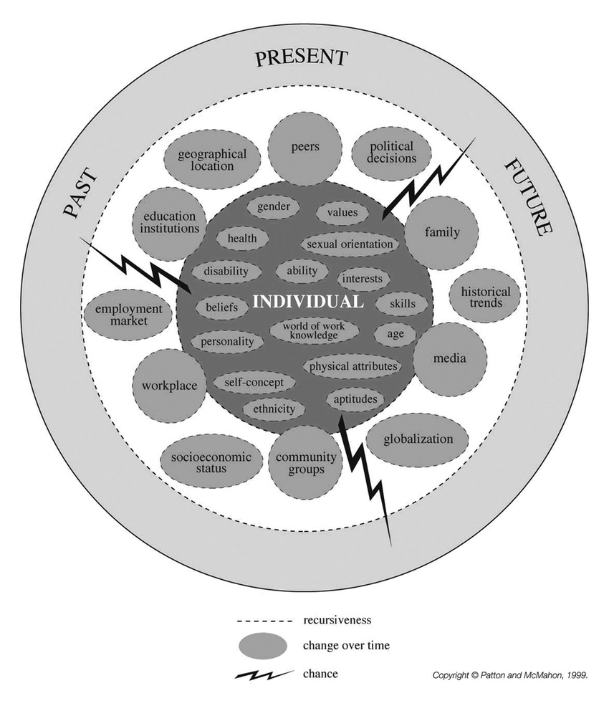

## 2.4 The Proposed Work

After the study of the existing system and some selected available systems, a proposed system will be discussed to oversee the existing ones. Although some features from the selected available systems will be adopted in the development of the proposed system. The proposed system to be developed will be blended with the existing manual ways of senior high schools’ selections and career guidance.

The objective of this phase of the project is to construct the design elements for a web-based DSS system that can be used to enhance the selection of senior high schools and career paths for senior high school students. The school selection form is made up of schools grouped in categories (A-E). Each category is made of schools with the best ranking. Category A been the highest-ranking followed by B, and C, D been compulsory day schools for students to select from and category E, being pure technical schools for students who wish to pursue technical courses can select from.

**Modules of the Proposed System**

Here, we design a computer integrated platform based on the proposed site map. We divide the system into their respective group of users. That is students and administrators. Each category of users is given a unique functionality. They are as follows;

**Administrator’s Backend:**

The administrator is the ultimate controller of the application with the highest authority. He or she manages the schools’ records and modules of the system. Its features include;

1. Designing page layout for easy navigation and content management.
2. Displays a list of schools based on categories.
3. Over sees all records for database management.

**Students Frontend:**

Students are the end users of the system. They are provided with the right information which can help them with their school selection. Once a student visits the website, he or she should see the following features;

1. Graphical presentation of schools based on categories and regions with the stated number of schools in each category as well as the regions.
2. A live data table which is made up of schools with their name, category, region, location and courses offered at the school.
3. A form mechanism that accepts inputs (mock results), hobbies, interests etc which will be used as the base line to suggest the schools suitable for selection.
4. A form mechanism that interacts with the student to suggest suitable career path or courses to pursue in the university

## 2.5 Project Scope

This project is an online career guidance DSS for Ghana Education Service which is made for the purpose of providing a more data mining source with live query to assist students in selecting their preferred SHS and career path. Some features of the system are:

* Maintain a catalog of schools.
* Graphical representation of data.
* Data table with live query.

The features which are currently out of scope and may be added later on as an extension to the system are:

# CHAPTER 3

# Crystallization of the Problem

## Background and History

Despite the enormous benefits of DSS systems for decision making most stakeholders in the education sector have not yet adapted one to help final year Junior High School student in selecting their preferred SHS and making right career choices.

Due to lack of data sorting a large number of students do not get admission or preferred schools. In most cases the top rank SHS schools receives less admission leading to most students with good grade points to lose admission whereas such student stands a higher chance to gain admission in another school. The DSS will support them in making the right school selection and career path which will match their qualification.

## Components and Features

The system currently in used has two major components;

* 1. A catalog of schools to select your preferred SHS.
  2. A form to fill out for your preferred SHS.

**Features**

* 1. Descriptive representation of the schools.
  2. Easy form to fill out.
  3. Students are given the chance to select up to five schools.
  4. A wide range of schools to select. Base on location, category or courses offered.

**Data flow Diagram**

Figure 3.1 gives us the data flow diagram of the current system

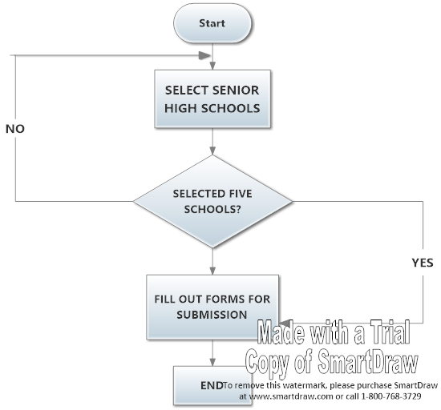

Figure 3.1 Data Flow Diagram

**Context Diagram**

Figure 3.2 shows the context diagram for selecting your preferred SHS. 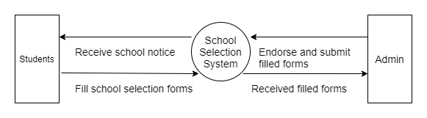

Figure 3.2 shows the context diagram for selecting your preferred SHS.

## Strength and Advantages

* 1. Students are presented with a catalog of schools to select from.
  2. Each page of the catalog contains the name of the SHS, category, description, courses offered, school statistics and achievement which gives the student a better idea of the school he or she is selecting.
  3. Schools are categorized to help students decide on which school best suit his or her performance.

## Weakness and Disadvantages

* 1. The catalog is made up of over 200 schools which the students have to go through to select their best five schools. Most students end up getting confused and cannot decide as to which school they should select.
  2. The catalog is a hardcopy which makes it impossible to narrow down and select a school base on category or location.

## Methodology

The software development life cycle (SDLC) chosen for this project is the incremental development process. Incremental development is a staging and scheduling strategy in which various parts of the system are developed at different times or rates and integrated as they are completed. The system will go through developmental stages with each stage given a thorough study for effectiveness and result oriented. Figure 1.1 gives an overview of the incremental development process stating each phase

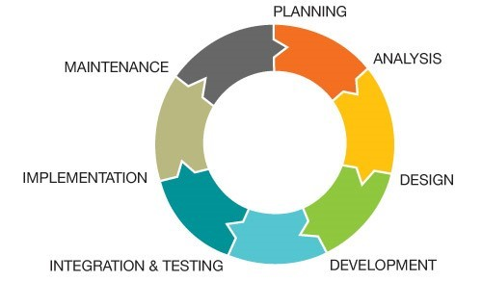

**Figure: 1.1**

**Planning Phase**

* Conducting interviews and surveys for users and hardware requirements.
* Functionality Layout of the system (i.e. what goes into the system, how the system processes it and the output it generates).

**Analysis Phase**

* Identifying the schools selection and career guidance problems and setting up the goals and objectives to overcome those characteristics.
* Analyze the method of schools selection for Human Computer Interaction and the timeline for the project.

**Design Phase**

* Creating a physical model that will satisfy all documented requirements for the system.
* Design user interface for Human-Computer-Interaction.
* Design internal and external controls to ensure maintainability and security.

**Development Phase**

* Determine the application architecture.
* Using PhP programming language for server-side scripting and MySqli for database manipulations.
* Frontend tools such as bootstrap will be deployed for user interface design.

**Integration and Testing Phase**

* A test run is done to remove all bugs.
* Selective users are employed to interact with the system for performance evaluating and modification.

**Implementation Phases**

* Registration of a domain name for hosting.
* Administrative access for data input.
* Search Engine Optimization (SE0) for publicity.

**Maintenance Phase**

* Security controls to safeguard the system from internal and external threats.
* Information system development is always a work in progress.

# CHAPTER 4:

# Analysis of the Proposed System

## Overview of the proposed system

In the previous chapter a critical analysis was done in respect to the system which is currently in use. Its flaws make it very uncomfortable to use since students have to go through hundreds of pages just to select only five schools out of it.

The proposed system will be used as a supplementary in order for the users to narrow down the list base on their own preference whereas others can also fill out the forms using their mock results, hobbies etc. as cutoff points for the system to generate likely preferred schools for selection and also suggest career paths. These actions are supported by tools which are implemented within the system.

The system analysis defines the architecture, components, modules, interfaces, and data for a system to satisfy specified requirements. Therefore, the development of well-structured system architecture is crucial for an adequate and successful implementation. This chapter will describe the requirements and major component for the system architecture.

### 4.0.1 Functional Requirements

Functional requirements refer to services, tasks or functions the system is required to perform in order to satisfy its users. Therefore, the proposed system is likely to:

1. Give administrators the ability to add new schools to the system.
2. Provide data analysis with graphs and live data tables.
3. The system will generate suitable senior high schools for students to select based on their strength.
4. Provide Career guidance option for SHS students.

### 4.0.2 Non-functional Requirements

Non-functional requirements are requirements that are not core service of the intended system but are very crucial to the operation of the system. Thus, the proposed system does the following:

1. The system has high performance and reliability level. That means the accuracy of the generated results are very high.
2. The system has user-friendly interfaces. This ensures the ease with which the system can be used.
3. The system can be accessed on any device with little or no training.

## Major Features and Components of the proposed system

### Major Features

* Mobile Responsive.
* Data analysis with graphical representation.
* Live data table.

### Component of the proposed system

* Administrative backend for data entry.
* Form input for suggested SHS for selection.
* Form entry for suggested career guidance.
* Live data table to narrow down SHSs base on user’s preference.

## Benefits/Advantage of the proposed system

* The system will serve as a point of reference for all SHS.
* Quick decision making in selecting preferred SHS.
* Providing career guidance path for SHS students.

## System Context Diagram of the proposed system

**Context Diagram**

Figure 4.1 shows the context diagram for career advisor.

Student

Administrator

0

Career

Guidance

System(DSS)

Enter mock results

Enter preferred courses

Enter courses studied

Enter other suggestions

Generate report based on inputs

Add courses details

Add SHS details

Add subject details

General feedback

Figure 4.1: Context diagram of proposed system.

# Chapter 5:

# Detailed Design of the Proposed System

## Functional Processes of the Proposed System

## Algorithm and flowchart of the processes

**SHS PLACEMENT**

**STRAT**

**IF** User click on search Button

Echo “required fields”

**ELSE IF** User

Enter Grade for English

Enter Grade for Mathematics

Enter Grade for Social Studies

Select 1st Subject -> Enter Grade

Select 2nd Subject -> Enter Grade

**SHOW** Result Page

**END**

**CAREER ADVISOR**

**START**

**IF** User click on search Button

Echo “required fields”

**ELSE IF** User

Select your SHS Course

Enter WASSCE/SSCE

Enter Preferred University

Enter Programme to Study

Enter Hobby

**SHOW** Result Page

**END**

## 5.2 Data Flow Diagrams

## 5.3 Data Dictionary

* + - Database Schema

Tables

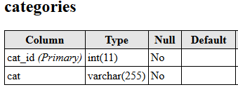

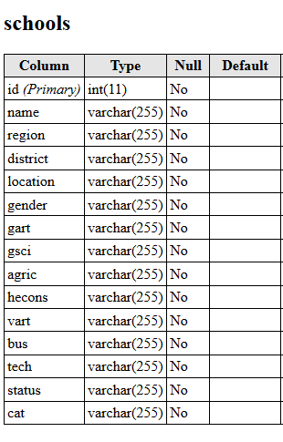

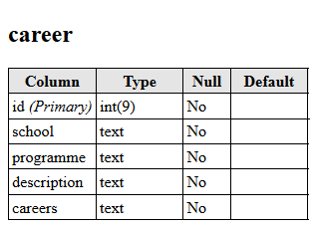

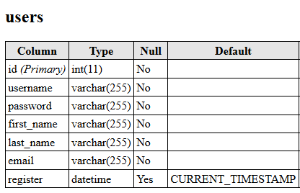

Table Relationship Diagram

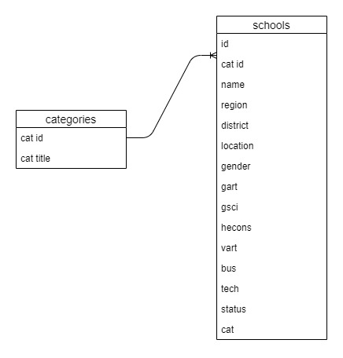

Entity Relationship Diagram

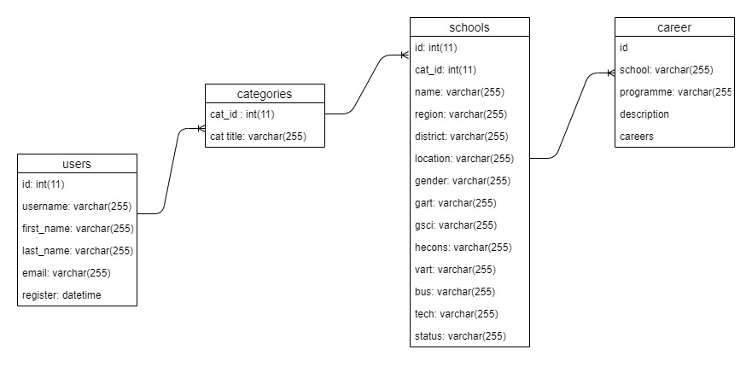

**Use Cases or User Scenarios**

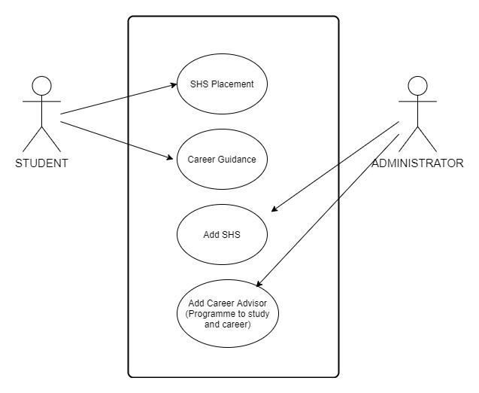

UML Class Diagram

# Chapter 6:

# System Implementation & Testing

## 6.0 Implementation

Theimplementation is the final and important phase. It involves user training, system testing and successful running of the developed proposed system. Implementation is the process of converting a new or revised system design into an operational one. It is the key stage in achieving a successful new system because usually it involves a lot of adjustment in the user department and therefor it must be carefully planned and controlled.

**Description of Both Hardware and Software Required for Implementation.**

**Hardware Requirements for Implementation**

|  |  |
| --- | --- |
| **Hardware Components** | **Requirement** |
| Processor | Intel Pentium III or above |
| Processor Speed | 800MHZ or above |
| Web Browser | 128MB RAM or above depending on the Operating System |
| 128MB RAM or above depending on the Operating System | Disk Space |
| Bandwidth | 100MBps or more |

**Software Requirements for Implementation**

|  |  |
| --- | --- |
| **Software Component** | **Requirement** |
| Web Server | Apache Wamp Server Version 2.2 or  above |
| Web Browser | 1. MS Internet Explorer 6.0 or   above   1. Monzilla Firefox 25 or above 2. Google Chrome |
| Database  Management System | MySQL server version 3:23.48 |

## 6.1 Testing

**Description of the testing strategy**

Before any application or piece of software is releases, it undergoes a thorough process to ensure that the application is working in the manner in which it was intended. There are four main stages of testing that need to be completed before a program can be cleared for use. Unit testing, integration testing, system testing and acceptance testing. We will discuss each of these stages in regards to our program and it users.

**Unit testing**

During this first round of testing the program is submitted for assessments that focus on specific units or components of the system to determine whether each one is fully functional. The main aim of this exercise is to determine whether the application functions as designed. It benefit is that it can be run every time a piece of code is changed, allowing issues to be resolved as quickly as possible.

**Integration Testing**

This testing phase combines all of the units within a program and test them as a group. This is done to find interface defects between the modules and functions. It determines how efficiently the units are running together. The units as to be properly integrated no matter how each unit is running.

**System Testing**

System testing is the first level in which the complete application is tested as a whole. The goal at this level is to evaluate whether the system has complied with all of the outline requirements and to see that it meets quality standards. System testing is very important because it verifies that the application meets the technical and functional requirements in order to satisfy the user.

**Acceptance Testing**

The final level of testing is conducted to determine whether the system is ready for release. During the software development life cycle, requirements changes can sometimes be misinterpreted in a fashion that does not meet the intended needs of the users. The user is given the chance to test the system with live data before releasing it for production.

**Statement of Test Cases Strategy**

1. Home page visit Test Case

|  |  |  |  |
| --- | --- | --- | --- |
| **Test Case** | **Test Case Description** | **Expected Results** | **Actual Results** |
| 01 | Type the url into the browser address bar. | It should take you to the landing page on the browser. | It has opened the landing page of the system |
| 02 | Page scroll and responsiveness. | The page should scroll smoothly without any delays and must be responsive. | Responsive on all devices with perfect grid and without any delay in scrollbar. |

1. Analytics Test Case

|  |  |  |  |
| --- | --- | --- | --- |
| **Test Case #** | **Test Case Description** | **Expected Results** | **Actual Results** |
| 01 | Graphical representative of data. | Display of graphs as data demonstration. | Showing graphical representation of data stored in the database. |
| 02 | Live data query | Real time response for data search. | Data table with real time data query. |

1. School Placement Test Case

|  |  |  |  |
| --- | --- | --- | --- |
| **Test Case #** | **Test Case Description** | **Expected Results** | **Actual Results** |
| 01 | Input fields to accept numbers only. | Input should accepts numbers only. | Unable to submit forms if input field is not a number. |
| 02 | Click on search button without giving details | It should be asking for enter details | It shows red border around the input fileds. |
| 03 | Enter grades (number) for school placement | It should take you to placement result page | Redirect to placement result page showing accepted inputs with results. |

1. Career Guidance Test Case

|  |  |  |  |
| --- | --- | --- | --- |
| **Test Case #** | **Test Case Description** | **Expected Results** | **Actual Results** |
| 01 | Input fields to accept text. | Input should accepts text. | Successful input field with text. |
| 02 | Click on search button without giving details | It should be asking for enter details | It shows red border around the input fields. |
| 03 | Enter details for career guidance. | Should submit forms after fields input | Redirect to career guidance page showing results and input details. |

6.2 Sample Code

i. Schools placement form

<form method="post" action="shs-result.php">

<div class="form-group row">

<label for="" class="col-sm-6 col-form-label">English Language</label>

<div class="col-sm-6">

<input type="number" class="form-control" name="english" required>

</div>

</div>

<div class="form-group row">

<label for="" class="col-sm-6 col-form-label">Mathematics</label>

<div class="col-sm-6">

<input type="number" class="form-control" name="maths" required>

</div>

</div>

<div class="form-group row">

<label for="" class="col-sm-6 col-form-label">Science</label>

<div class="col-sm-6">

<input type="number" class="form-control" name="science" required>

</div>

</div>

<div class="form-group row">

<label for="" class="col-sm-6 col-form-label">Social Studies</label>

<div class="col-sm-6">

<input type="number" class="form-control" name="social" required>

</div>

</div>

<p>Select additional best two subjects</p>

<p>Select first best subject</p>

<div class="form-group row">

<select class="form-control col-sm-6" name="subj1" required>

<option value="">Select 1st BestSubject</option>

<option value="French">French</option>

<option value="BDT">BDT</option>

<option value="ICT">ICT</option>

</select>

<div class="col-sm-6">

<input type="number" class="form-control" name="subj1g" required>

</div>

</div>

<div class="form-group row">

<select class="form-control col-sm-6" name="subj2" required>

<option value="">Select 2nd Subject</option>

<option value="French">French</option>

<option value="BDT">BDT</option>

<option value="ICT">ICT</option>

</select>

<option class="" value=""></option>

<div class="col-sm-6">

<input type="number" class="form-control" name="subj2g" required>

</div>

</div>

<div class="form-group row">

<input type="submit" name="shs_submit" value="Search" class="btn btn-primary mt-3">

</div>

</form>

1. Career guidance form

<form method="post" action="career-result.php">

<div class="form-group row">

<label for="" class="col-sm-6 col-form-label">Select your SHS Course</label>

<select class="form-control" name="shsCourse">

<option value="">Select Course</option>

<option value="Gen. Science">Gen. Science</option>

<option value="Business">Business</option>

<option value="Gen. Arts">Gen. Arts</option>

<option value="Visula Arts">Visula Arts</option>

<option value="Home Economics">Home Economics</option>

</select>

</div>

<div class="form-group">

<label for="" class="col-form-label">Total Aggregate Obtain from WASSCE/SSCE</label>

<div class="">

<input type="text" class="form-control" name="wassce" required>

</div>

</div>

<div class="form-group ">

<label for="" class="col-form-label">Preferred University to study</label>

<div class="">

<input type="text" class="form-control" name="uni" required>

</div>

</div>

<div class="form-group">

<label for="" class="col-form-label">Preferred Programme To Study</label>

<div class="">

<input type="text" class="form-control" name="programme" required>

</div>

</div>

<div class="form-group">

<label for="" class="col-form-label">Hobby</label>

<div class="">

<input type="text" class="form-control" name="hobby" required>

</div>

</div>

<div class="form-group row">

<input type="submit" name="career_submit" value="Search" class="btn btn-primary mt-3">

</div>

</form>

# Chapter 7: System Documentation

## User Manuel for the system

**Home Page**



***Hint***: The home page as no navigation bar but rather have three different cards display for each for the major components of the system.

**SHS Selection Analysis**

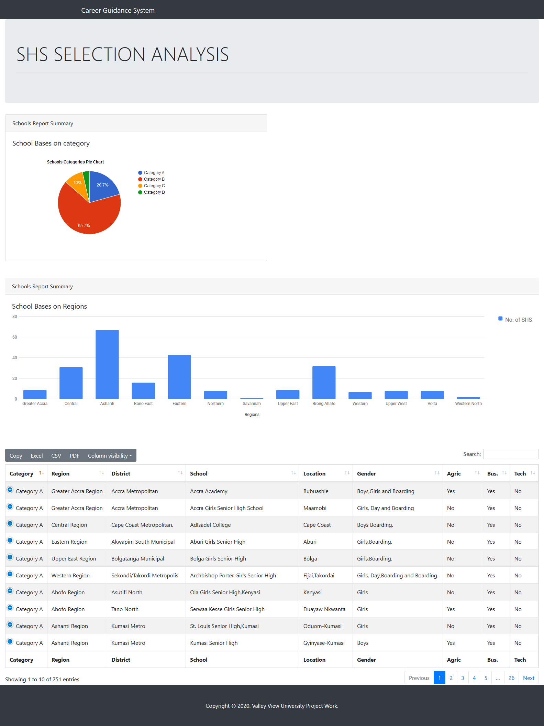

***Hint***: The first card at the home page takes you to the analytical page. Data-table with live query is available.

**SHS Placement**

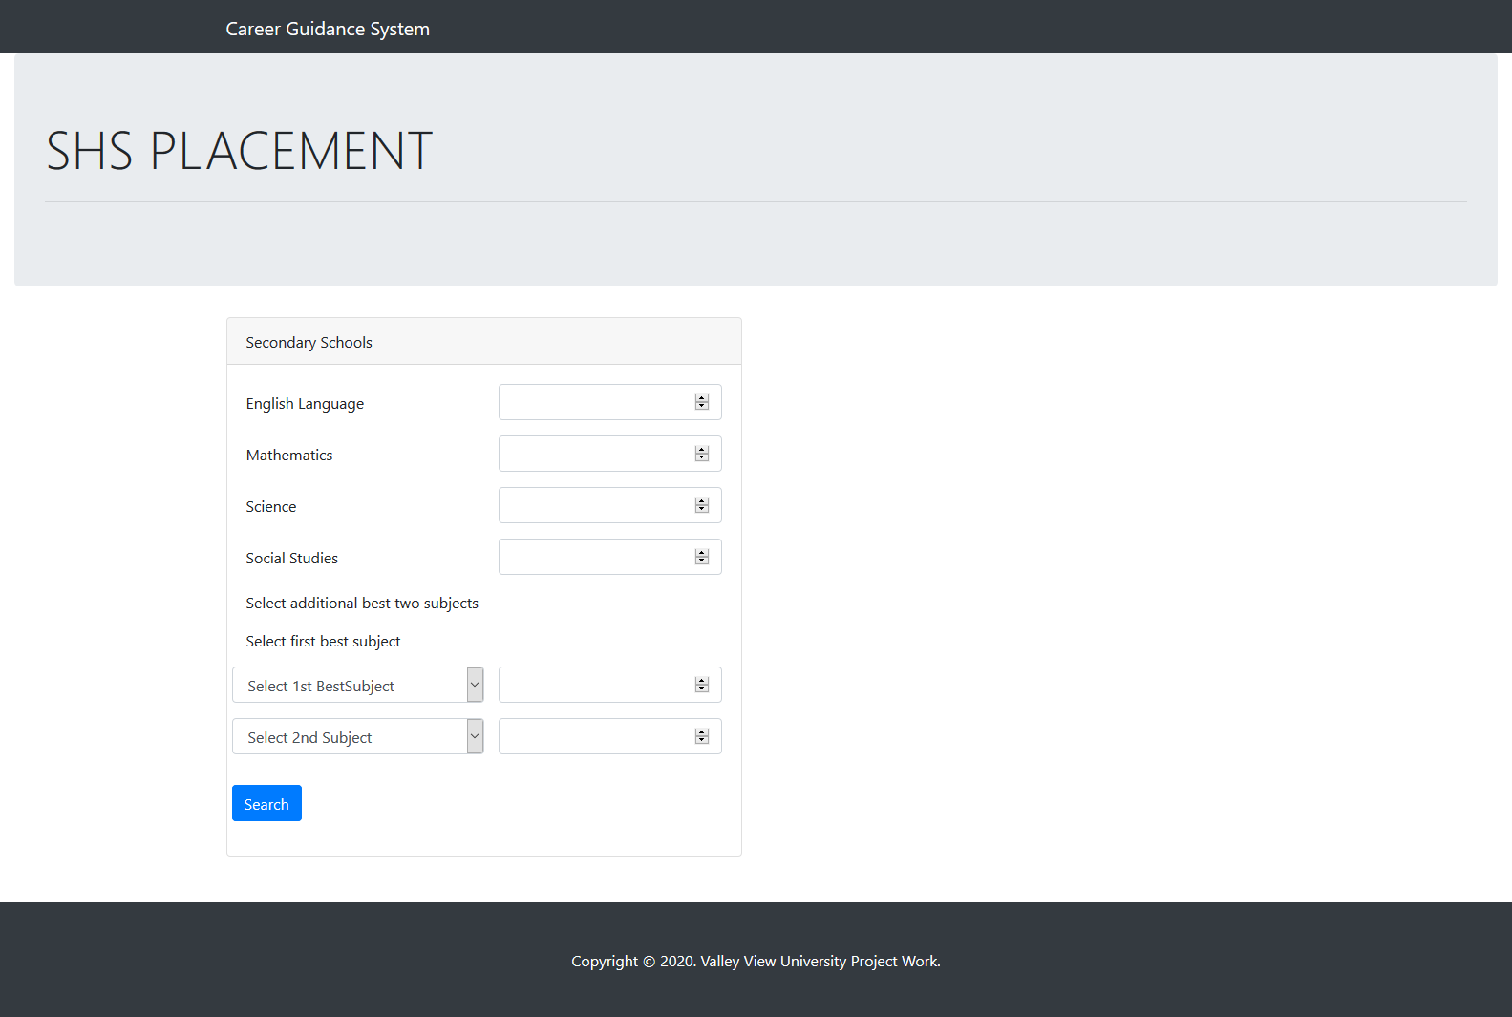

***Hint***: The second card lead you to the SHS Placement page where students have to fill all compulsory fields to generate their suggested schools.

**SHS Placement Results**

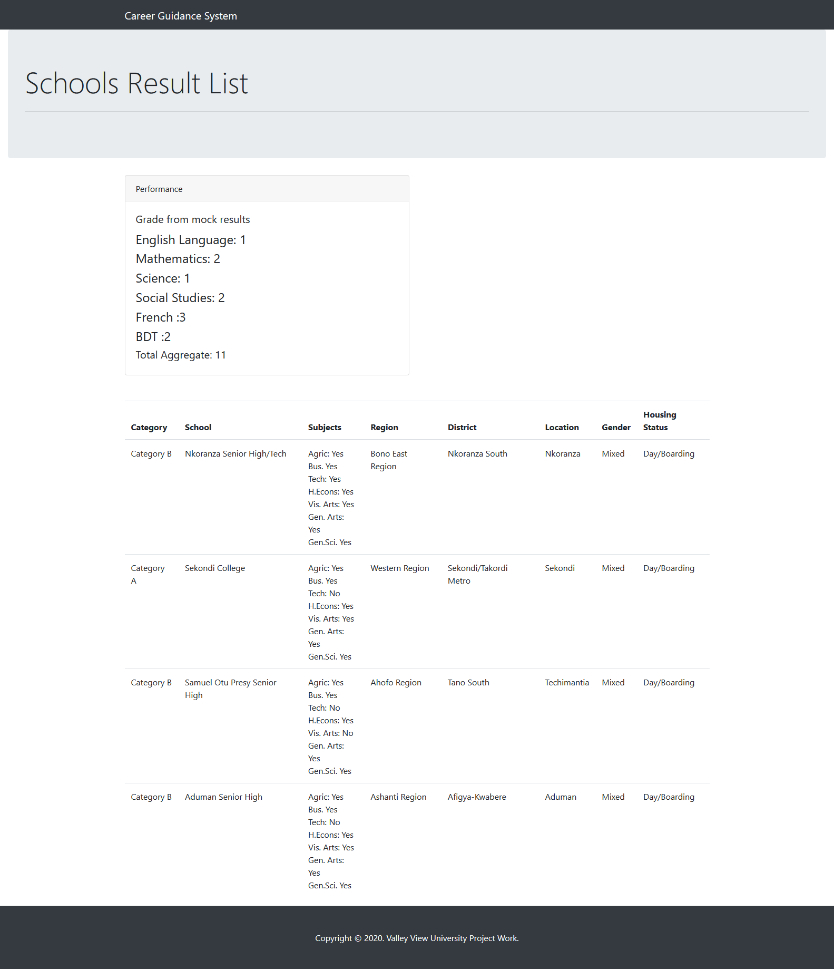

***Hint***: SHS generated page with input summery.

**Career Advisor**

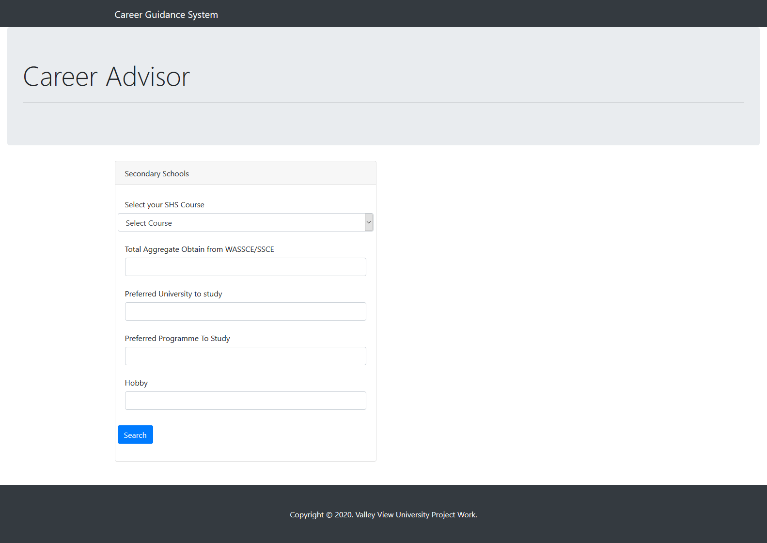

***Hint***: the last card on the home page brings you to the career advisor page with compulsory fields to generate career guidance.

**Career Advisor Results**

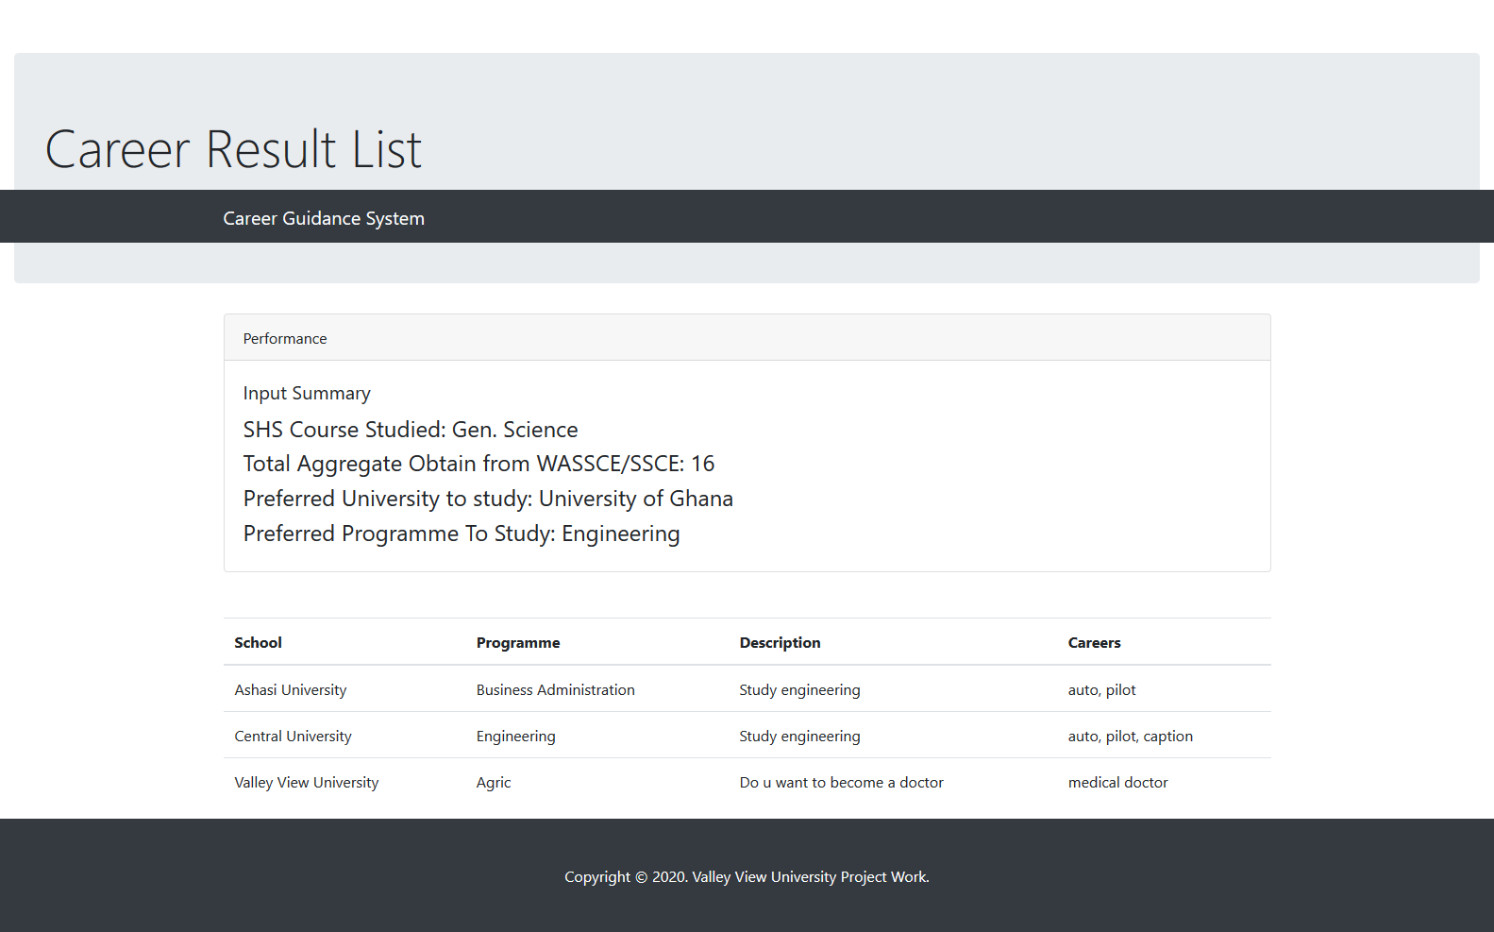

***Hint***: Display of career guidance with input summery.

**Admin Login**

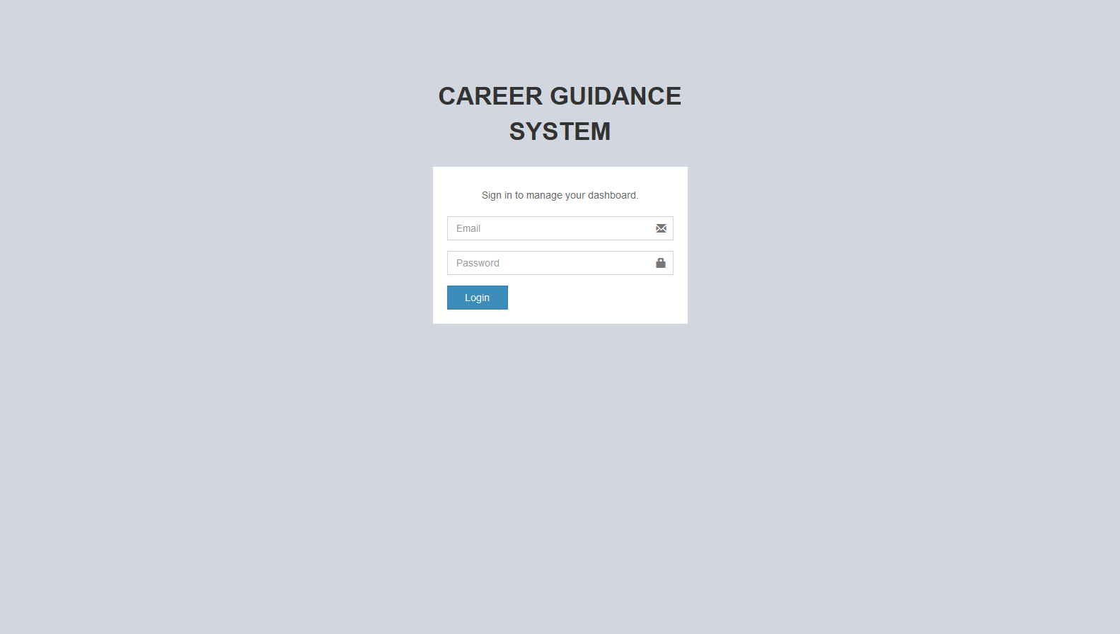

***Hint***: Admin login page

**Admin Dashboard**

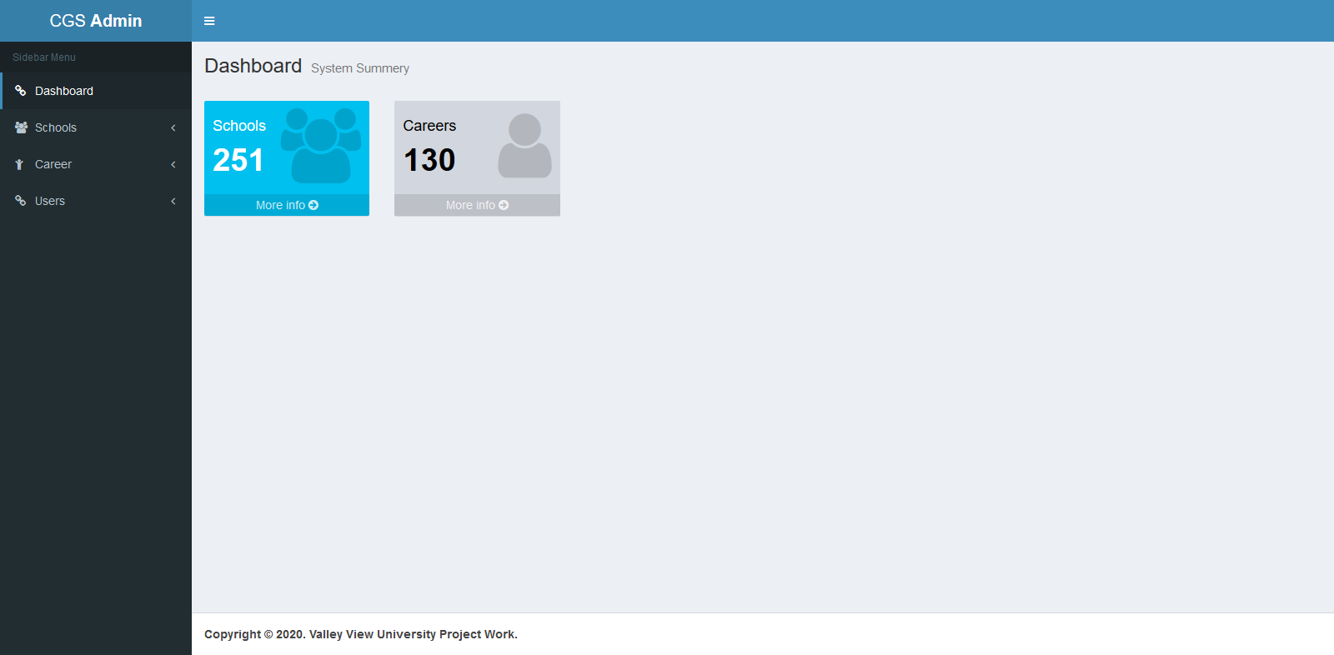

***Hint***: Dashboard after login

**Add New School**

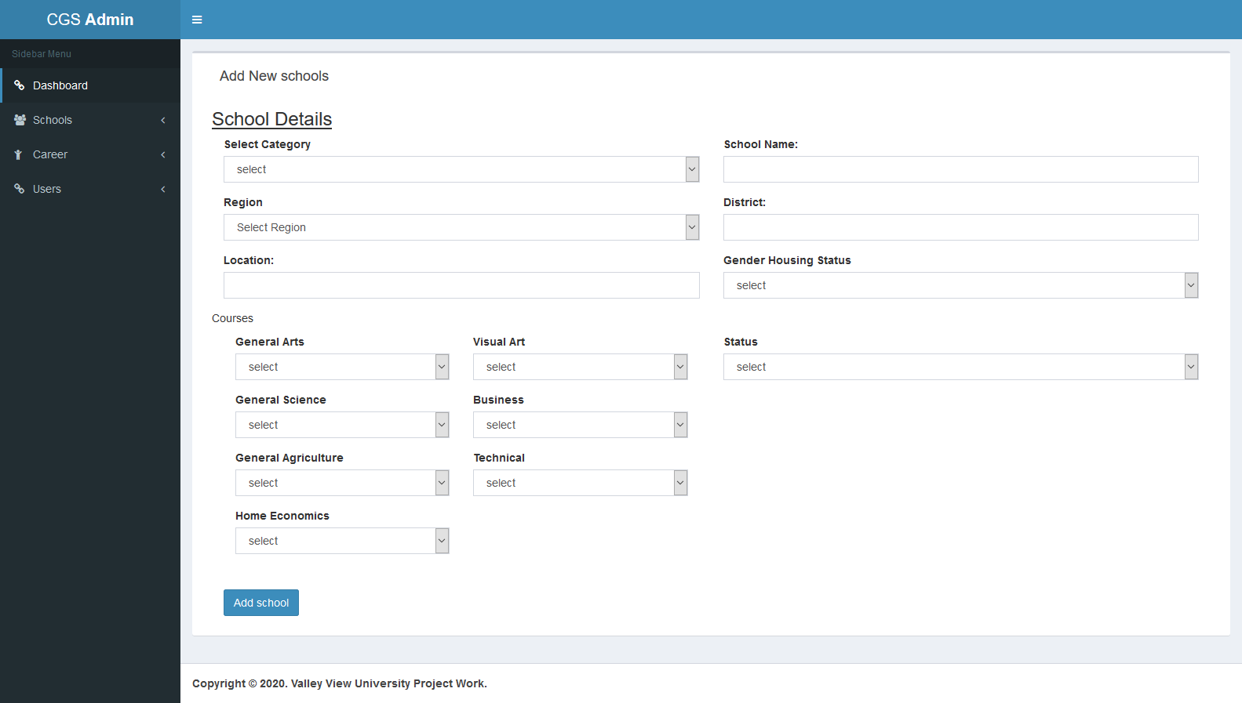

***Hint***: Input form for adding new school.

**Add New Career Guide**

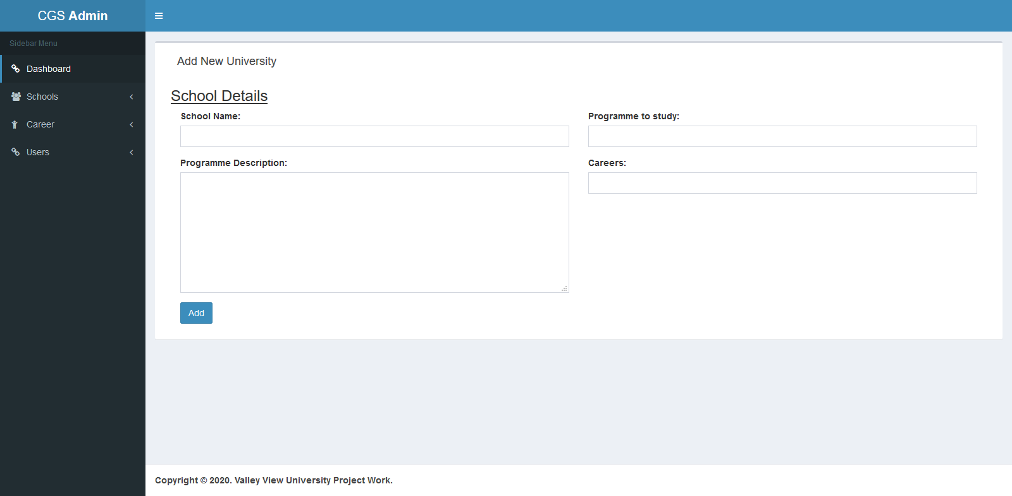

***Hint***: Input form for adding new career.

**All Users**

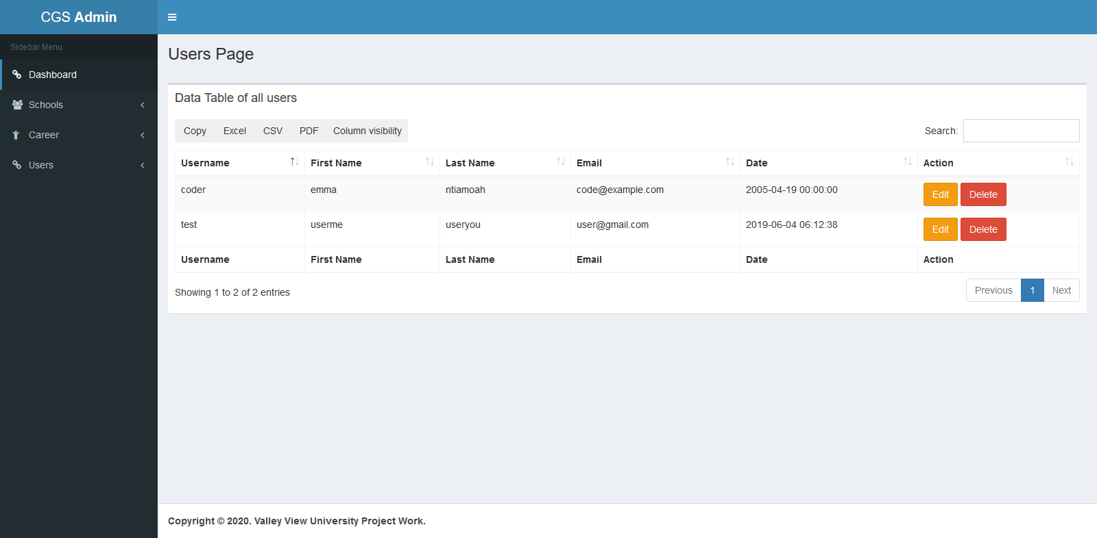

***Hint***: Display of users for login.

# Chapter 8:

# Conclusion and Recommendation

## 8.0 Conclusion

This chapter discuss and summarizes what is been carried out in this project. The design, implementation, limitation, conclusion and recommendations for future enhancement. Key notes where taken on the problems faced when developing the system, the strength and weaknesses and suggestion for the future enhancements. This system serves as a convenient and easy way for the users to check for their educational information and guide them in the choice of career. The basic information provided to users is sufficient on how to select their schools for placement and career guidance.

## 8.1 Recommendation

I therefore recommended that the system will be made available to all students does hosting it online. All students must see this system as their frontline guide in schools placement and career guidance.

**8.2 Future Enhancements**

The system captures only certain aspects of schools placement and career guidance, student login was not captured use to time constraints. Those areas that are not tackled in this study can be given attention in order to have a full functioning school guidance advisor system.

# Reference

Ashraf, N. A. and I. (2014). Significance of Decision Support Systems. *International Journal of Current Engineering and Technology*, *4*(4), 2740–2743.

Balogun, V. F., Thompson, A. F., & State, O. (2009). Career Master : A Decision Support System ( DSS ) for Guidance and Counseling in. *The Pacific Journal of Science and Technology.*, *10*(2), 337–354.

*Career Development Theory: Definition and Examples | Indeed.com*. (n.d.). Indeed Career Guide. Retrieved May 14, 2020, from https://www.indeed.com/career-advice/career-development/career-development-theory

Decision Lens. (n.d.). *Decision Lens | Enterprise Prioritization and Resource Optimization Solution for the Public Sector*. Retrieved August 9, 2019, from https://www.decisionlens.com/

Dss, A. (2012). *PROCESS TO BUILD AN EFFICIENT DECISION – I DENTIFYING IMPORTANT ASPECTS OF*.

Information Builders. (n.d.). *Information Builders WebFOCUS Reviews and Pricing - 2019*. Retrieved August 9, 2019, from https://www.capterra.com/p/118/WebFOCUS/

Making, D. (1970). Decision support systems. *International Encyclopedia of Business and Management, 2nd Edition*.

Nagy, H. M., Aly, W. M., & Hegazy, O. F. (2013). An Educational Data Mining System for Advising Higher Education Students. *International Journal of Computer, Electrical, Automation, Control and Information Engineering*, *7*(10), 1266–1270. https://doi.org/http://scholar.waset.org/1999.4/16952

Patton, W., & McMahon, M. (2006). The systems theory framework of career development and counseling: Connecting theory and practice. *International Journal for the Advancement of Counselling*, *28*(2), 153–166. https://doi.org/10.1007/s10447-005-9010-1

Provost, F., & Fawcett, T. (2013). Data Science and its Relationship to Big Data and Data-Driven Decision Making. *Big Data*, *1*(1), 51–59. https://doi.org/10.1089/big.2013.1508

RISKTURN. (n.d.). *Risk-Based Investment Valuation and Capital Budgeting | RISKTURN*. Retrieved August 9, 2019, from https://www.riskturn.com/

TURBAN, E., CAMERON FISHER, J., & ALTMAN, S. (1988). DECISION SUPPORT SYSTEMS IN ACADEMIC ADMINISTRATION. *Journal of Educational Administration*, *26*(1), 97–113. https://doi.org/10.1108/eb009943

Vinnik, S., & Scholl, M. H. (2005). Decision support system for managing educational capacity utilization in universities. *Proc. IEEE Conference on Engineering and Computer Education*, *50*(2), 143–150.

Zealand, I. of C. N. (2012). Holland ’ s theory of career choice. *Career New Zealand*, 2. www.career.govt.nz

Ashraf, N. A. and I. (2014). Significance of Decision Support Systems. *International Journal of Current Engineering and Technology*, *4*(4), 2740–2743.

Balogun, V. F., Thompson, A. F., & State, O. (2009). Career Master : A Decision Support System ( DSS ) for Guidance and Counseling in. *The Pacific Journal of Science and Technology.*, *10*(2), 337–354.

*Career Development Theory: Definition and Examples | Indeed.com*. (n.d.). Indeed Career Guide. Retrieved May 14, 2020, from https://www.indeed.com/career-advice/career-development/career-development-theory

Decision Lens. (n.d.). *Decision Lens | Enterprise Prioritization and Resource Optimization Solution for the Public Sector*. Retrieved August 9, 2019, from https://www.decisionlens.com/

Dss, A. (2012). *PROCESS TO BUILD AN EFFICIENT DECISION – I DENTIFYING IMPORTANT ASPECTS OF*.

Information Builders. (n.d.). *Information Builders WebFOCUS Reviews and Pricing - 2019*. Retrieved August 9, 2019, from https://www.capterra.com/p/118/WebFOCUS/

Making, D. (1970). Decision support systems. *International Encyclopedia of Business and Management, 2nd Edition*.

Nagy, H. M., Aly, W. M., & Hegazy, O. F. (2013). An Educational Data Mining System for Advising Higher Education Students. *International Journal of Computer, Electrical, Automation, Control and Information Engineering*, *7*(10), 1266–1270. https://doi.org/http://scholar.waset.org/1999.4/16952

Patton, W., & McMahon, M. (2006). The systems theory framework of career development and counseling: Connecting theory and practice. *International Journal for the Advancement of Counselling*, *28*(2), 153–166. https://doi.org/10.1007/s10447-005-9010-1

Provost, F., & Fawcett, T. (2013). Data Science and its Relationship to Big Data and Data-Driven Decision Making. *Big Data*, *1*(1), 51–59. https://doi.org/10.1089/big.2013.1508

RISKTURN. (n.d.). *Risk-Based Investment Valuation and Capital Budgeting | RISKTURN*. Retrieved August 9, 2019, from https://www.riskturn.com/

TURBAN, E., CAMERON FISHER, J., & ALTMAN, S. (1988). DECISION SUPPORT SYSTEMS IN ACADEMIC ADMINISTRATION. *Journal of Educational Administration*, *26*(1), 97–113. https://doi.org/10.1108/eb009943

Vinnik, S., & Scholl, M. H. (2005). Decision support system for managing educational capacity utilization in universities. *Proc. IEEE Conference on Engineering and Computer Education*, *50*(2), 143–150.

Zealand, I. of C. N. (2012). Holland ’ s theory of career choice. *Career New Zealand*, 2. www.career.govt.nz