Name: Emma English

Student no: x15575767

Host: origamiforyou.gear.host

Github: https://github.com/emmaeng/origamiforme

This site is an origami how-to site. It offers an introduction on the home page to what origami is and also a history page. On the instructions page it offers a short how to piece to show what the website is promoting and on the links page there’s a link to the origami how to video youtube (the one used is currently the most popular music video on youtube) and and it’s social media links. On a phone the website displays a picture link instead for the youtube.

Original Wireframes:

Desktop

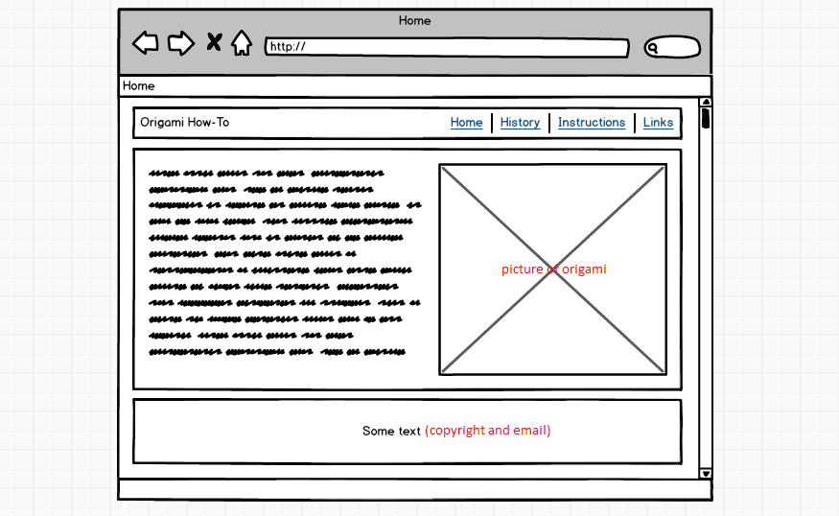

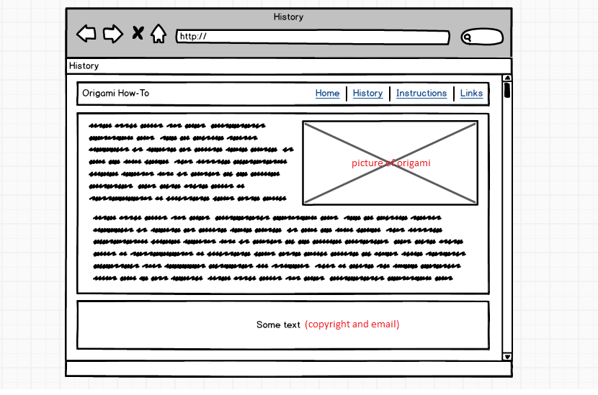

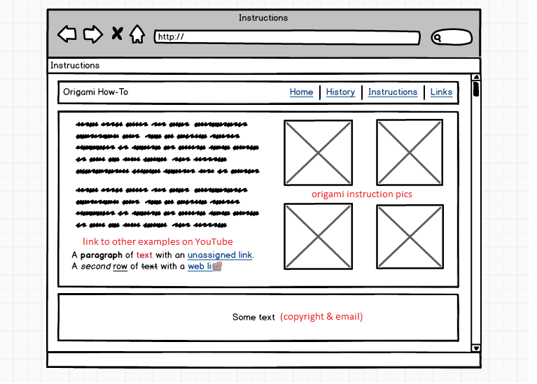

Tablet

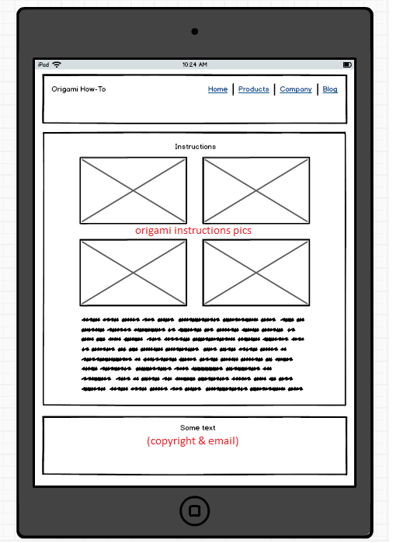

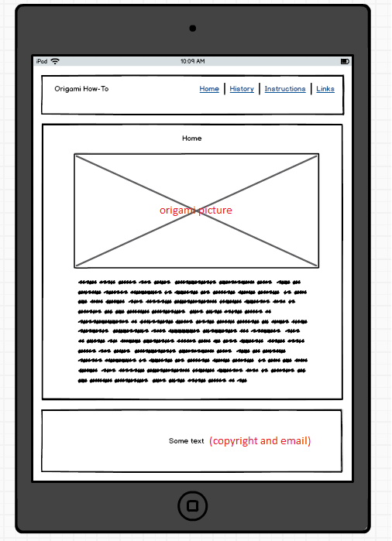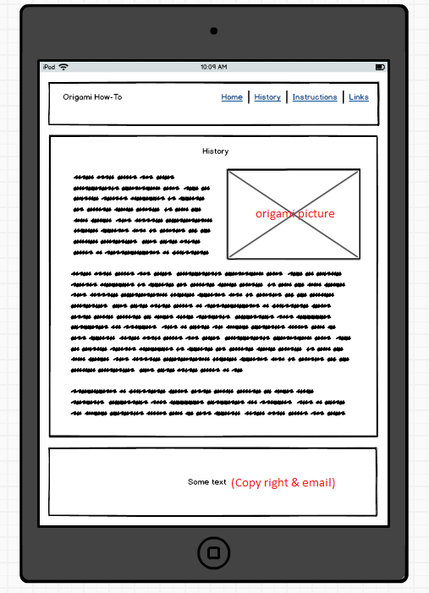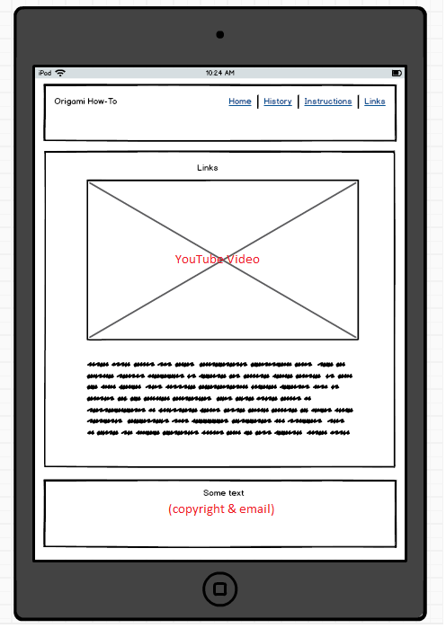

Phone

