PARCEL DELIVERY TRACKING SYSTEM
A Data-Structures-Driven Logistics Platform for the Kenyan Courier Sector
CAT II — Data Structures & Algorithms | Group Project
Instructor: Salome Monthe Chemiat
Strathmore University
Group members: [add names and student ID numbers here]
Date: July 2026

Table of Contents

1. Problem Statement
Kenya’s courier and e-commerce sector moves thousands of parcels a day between towns, yet many small and mid-size delivery operators still track parcels on paper logs or spreadsheets. This creates four recurring problems:
- No fast way to look up a parcel’s status — staff scroll through long lists by hand.
- Pricing is a flat guess rather than being based on the actual road distance a parcel will travel.
- Urgent (express/overnight) parcels have no formal way to jump ahead of standard ones in the dispatch line.
- There is no audit trail of status changes, so a wrongly-updated status cannot be reversed with confidence.
This project builds a Parcel Delivery Tracking System that solves all four problems by pairing a functional web dashboard with a backend built entirely on classic data structures and algorithms — a hash table for instant lookup, a weighted graph with Dijkstra’s algorithm for distance-based pricing, a priority queue for dispatch order, and a stack for a reversible status log.

2. Objectives
- Build a functional web UI (HTML/CSS/JS) that interacts with a real backend over a REST API — no business logic lives in the browser.
- Correctly implement at least two data structures beyond a plain array: this project implements six (Array, Hash Table, Stack, FIFO Queue, Priority Queue, Graph).
- Correctly implement at least two algorithms: this project implements six (Linear Search, Binary Search, Bubble Sort, Selection Sort, Merge Sort, Dijkstra’s Shortest Path).
- Support full CRUD parcel management with a data flow that can be explained and defended line by line.
- Provide a documented time and space complexity analysis for every structure and algorithm.
- Demonstrate genuine real-world relevance and a creative design choice (route-based pricing and priority dispatch).
- Prepare full documentation — problem statement, objectives, architecture, complexity analysis, and screenshots — and a rehearsed live demo.

3. System Architecture
The system is a classic four-layer architecture. The frontend is intentionally "dumb" — it holds no parcel data and runs no business rules; every data structure and algorithm lives in the backend, so the UI genuinely interacts with backend structures rather than a local copy of the data.
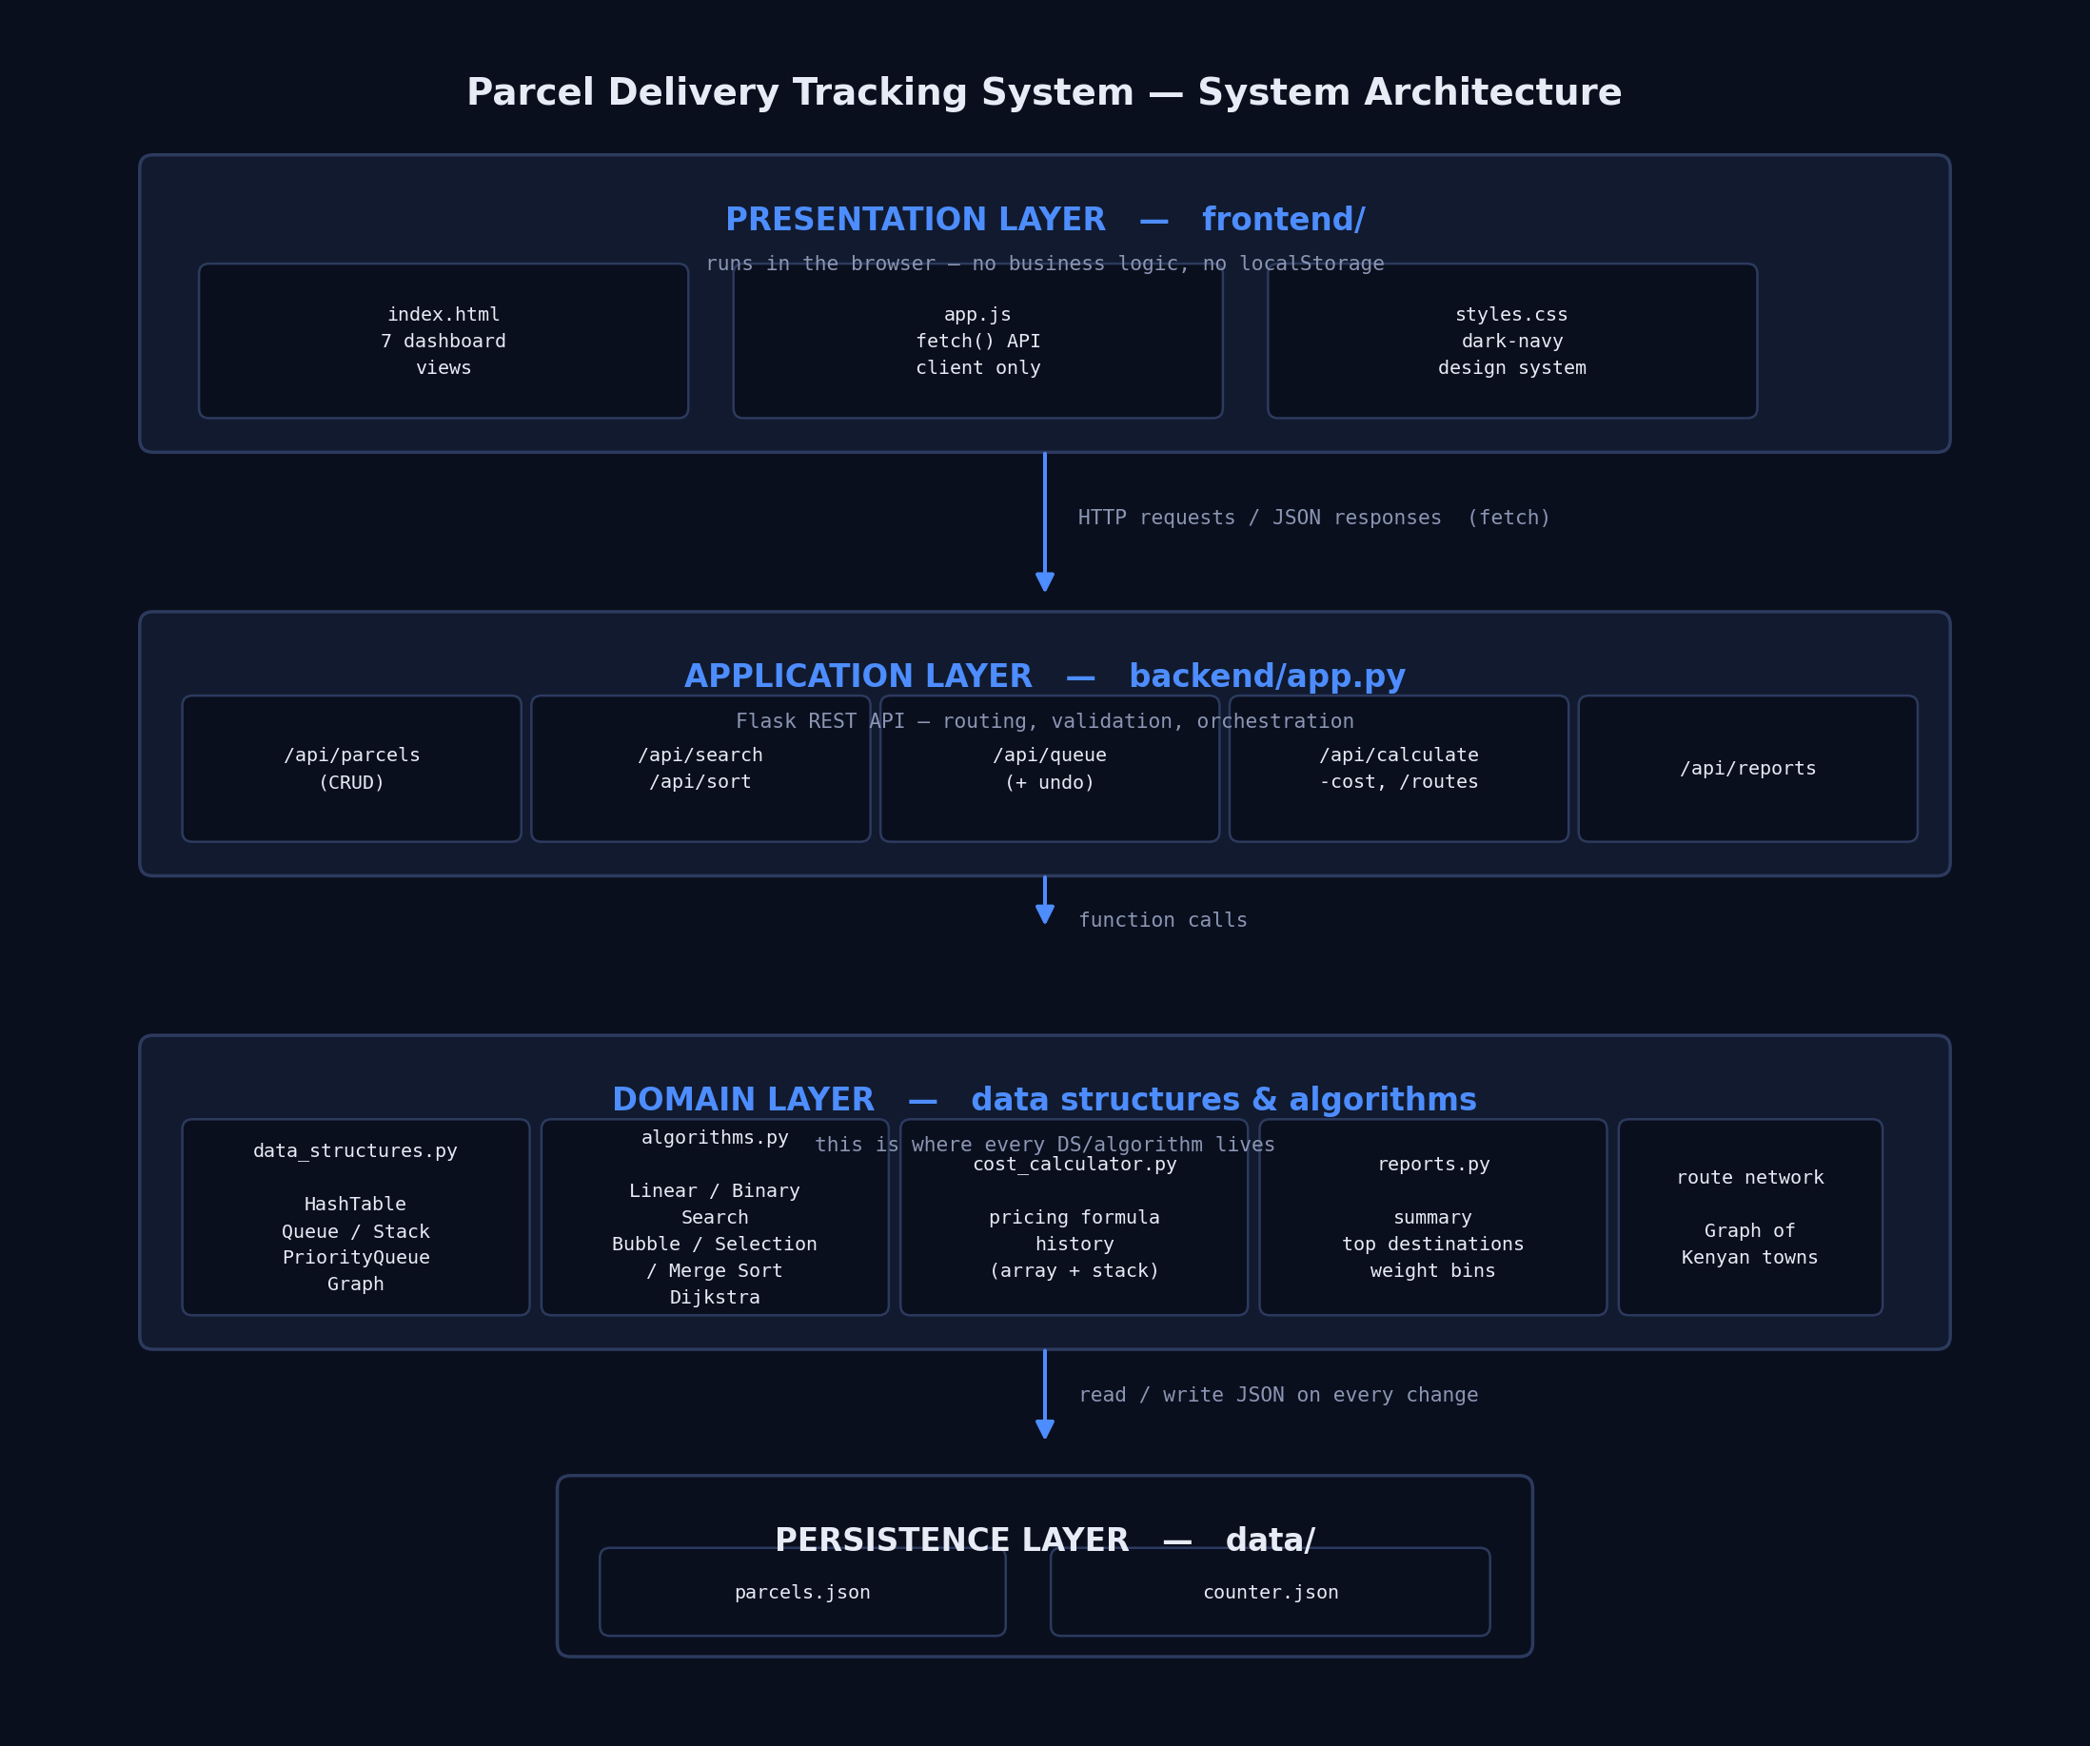
Figure 1. Four-layer system architecture.
Layer | Technology | Responsibility
Presentation | HTML / CSS / vanilla JS | Renders the 7 dashboard views; calls the API with fetch(); shows results.
Application | Flask (Python) | Routes HTTP requests, validates input, calls the domain layer, returns JSON.
Domain | Python modules | Every data structure and algorithm: HashTable, Stack, Queue, PriorityQueue, Graph, search/sort/Dijkstra, pricing.
Persistence | JSON files | parcels.json (the array, saved after every write) and counter.json (next tracking number).

4. Data Structures Implemented
All six structures are hand-built in backend/data_structures.py (not just a wrapped Python dict/list) so each one can be explained and defended in the demo.
Structure | Used for | Time complexity | Space
Array (parcels_array) | Primary chronological store of every parcel | Append O(1)*; linear scan O(n) | O(n)
Hash Table (chaining, prime-sized buckets) | O(1) average lookup of a parcel by tracking number | get/set/delete: O(1) avg, O(n) worst | O(n)
Stack (LIFO) | System-wide log of status changes; supports "undo last status change" | push/pop/peek: O(1) | O(n)
Queue (FIFO) | Chronological record of the order parcels were dispatched | enqueue/dequeue: O(1) | O(n)
Priority Queue (binary min-heap) | Dispatch order — overnight/express parcels served before standard ones | push/pop: O(log n) | O(n)
Graph (weighted, undirected, adjacency list) | Town-to-town road network used to compute delivery distance | add_edge: O(1) | O(V + E)

5. Algorithms Implemented
All six live in backend/algorithms.py, kept deliberately separate from the data structures they operate on.
Algorithm | Used for | Time complexity | Space
Linear Search | Search parcels by any field (sender, receiver, status…) | O(n) | O(1)
Binary Search | Fast lookup once the list is sorted on the search field | O(log n) + O(n log n) to sort first | O(1)
Bubble Sort | Baseline comparison sort, kept for algorithm comparison in the demo | O(n²) | O(1)
Selection Sort | Second baseline comparison sort | O(n²) | O(1)
Merge Sort | Efficient sort; also prepares the list Binary Search runs on | O(n log n) | O(n)
Dijkstra’s Shortest Path | Shortest road distance between origin and destination town, used to price a parcel | O((V + E) log V) with a binary heap | O(V)
Why these complexities:
- Binary Search halves the remaining search space on every comparison, giving O(log n) — but it requires a sorted list, so in practice it costs O(n log n) once (the sort) plus O(log n) per lookup after that.
- Bubble Sort and Selection Sort both use two nested loops over n elements, giving O(n²) in the worst and average case.
- Merge Sort halves the list log₂(n) times and does O(n) work merging at each level, giving O(n log n).
- Dijkstra visits every vertex once and relaxes every edge once; each heap push/pop costs O(log V), so the total is O((V + E) log V).
- The Hash Table’s O(1) average case assumes a reasonably even spread across buckets; the true worst case (everything hashing to one bucket) is O(n), which is why the table uses a prime bucket count to reduce collisions.

6. Data Flow and CRUD Operations
Every parcel operation is a normal REST call. The table below maps each CRUD action to its HTTP route and the structures it touches; Figure 2 walks through the most detailed one — Create — step by step.
CRUD action | Route | Structures touched
Create | POST /api/parcels | Graph (route), Array, Hash Table, Priority Queue, Stack
Read (one) | GET /api/parcels/<tracking> | Hash Table
Read (all) | GET /api/parcels | Array
Update | PUT /api/parcels/<tracking>/status | Hash Table (lookup), Stack (log the change)
Delete | DELETE /api/parcels/<tracking> | Array, Hash Table
Undo | POST /api/undo-last-status | Stack (pop), Hash Table (revert)
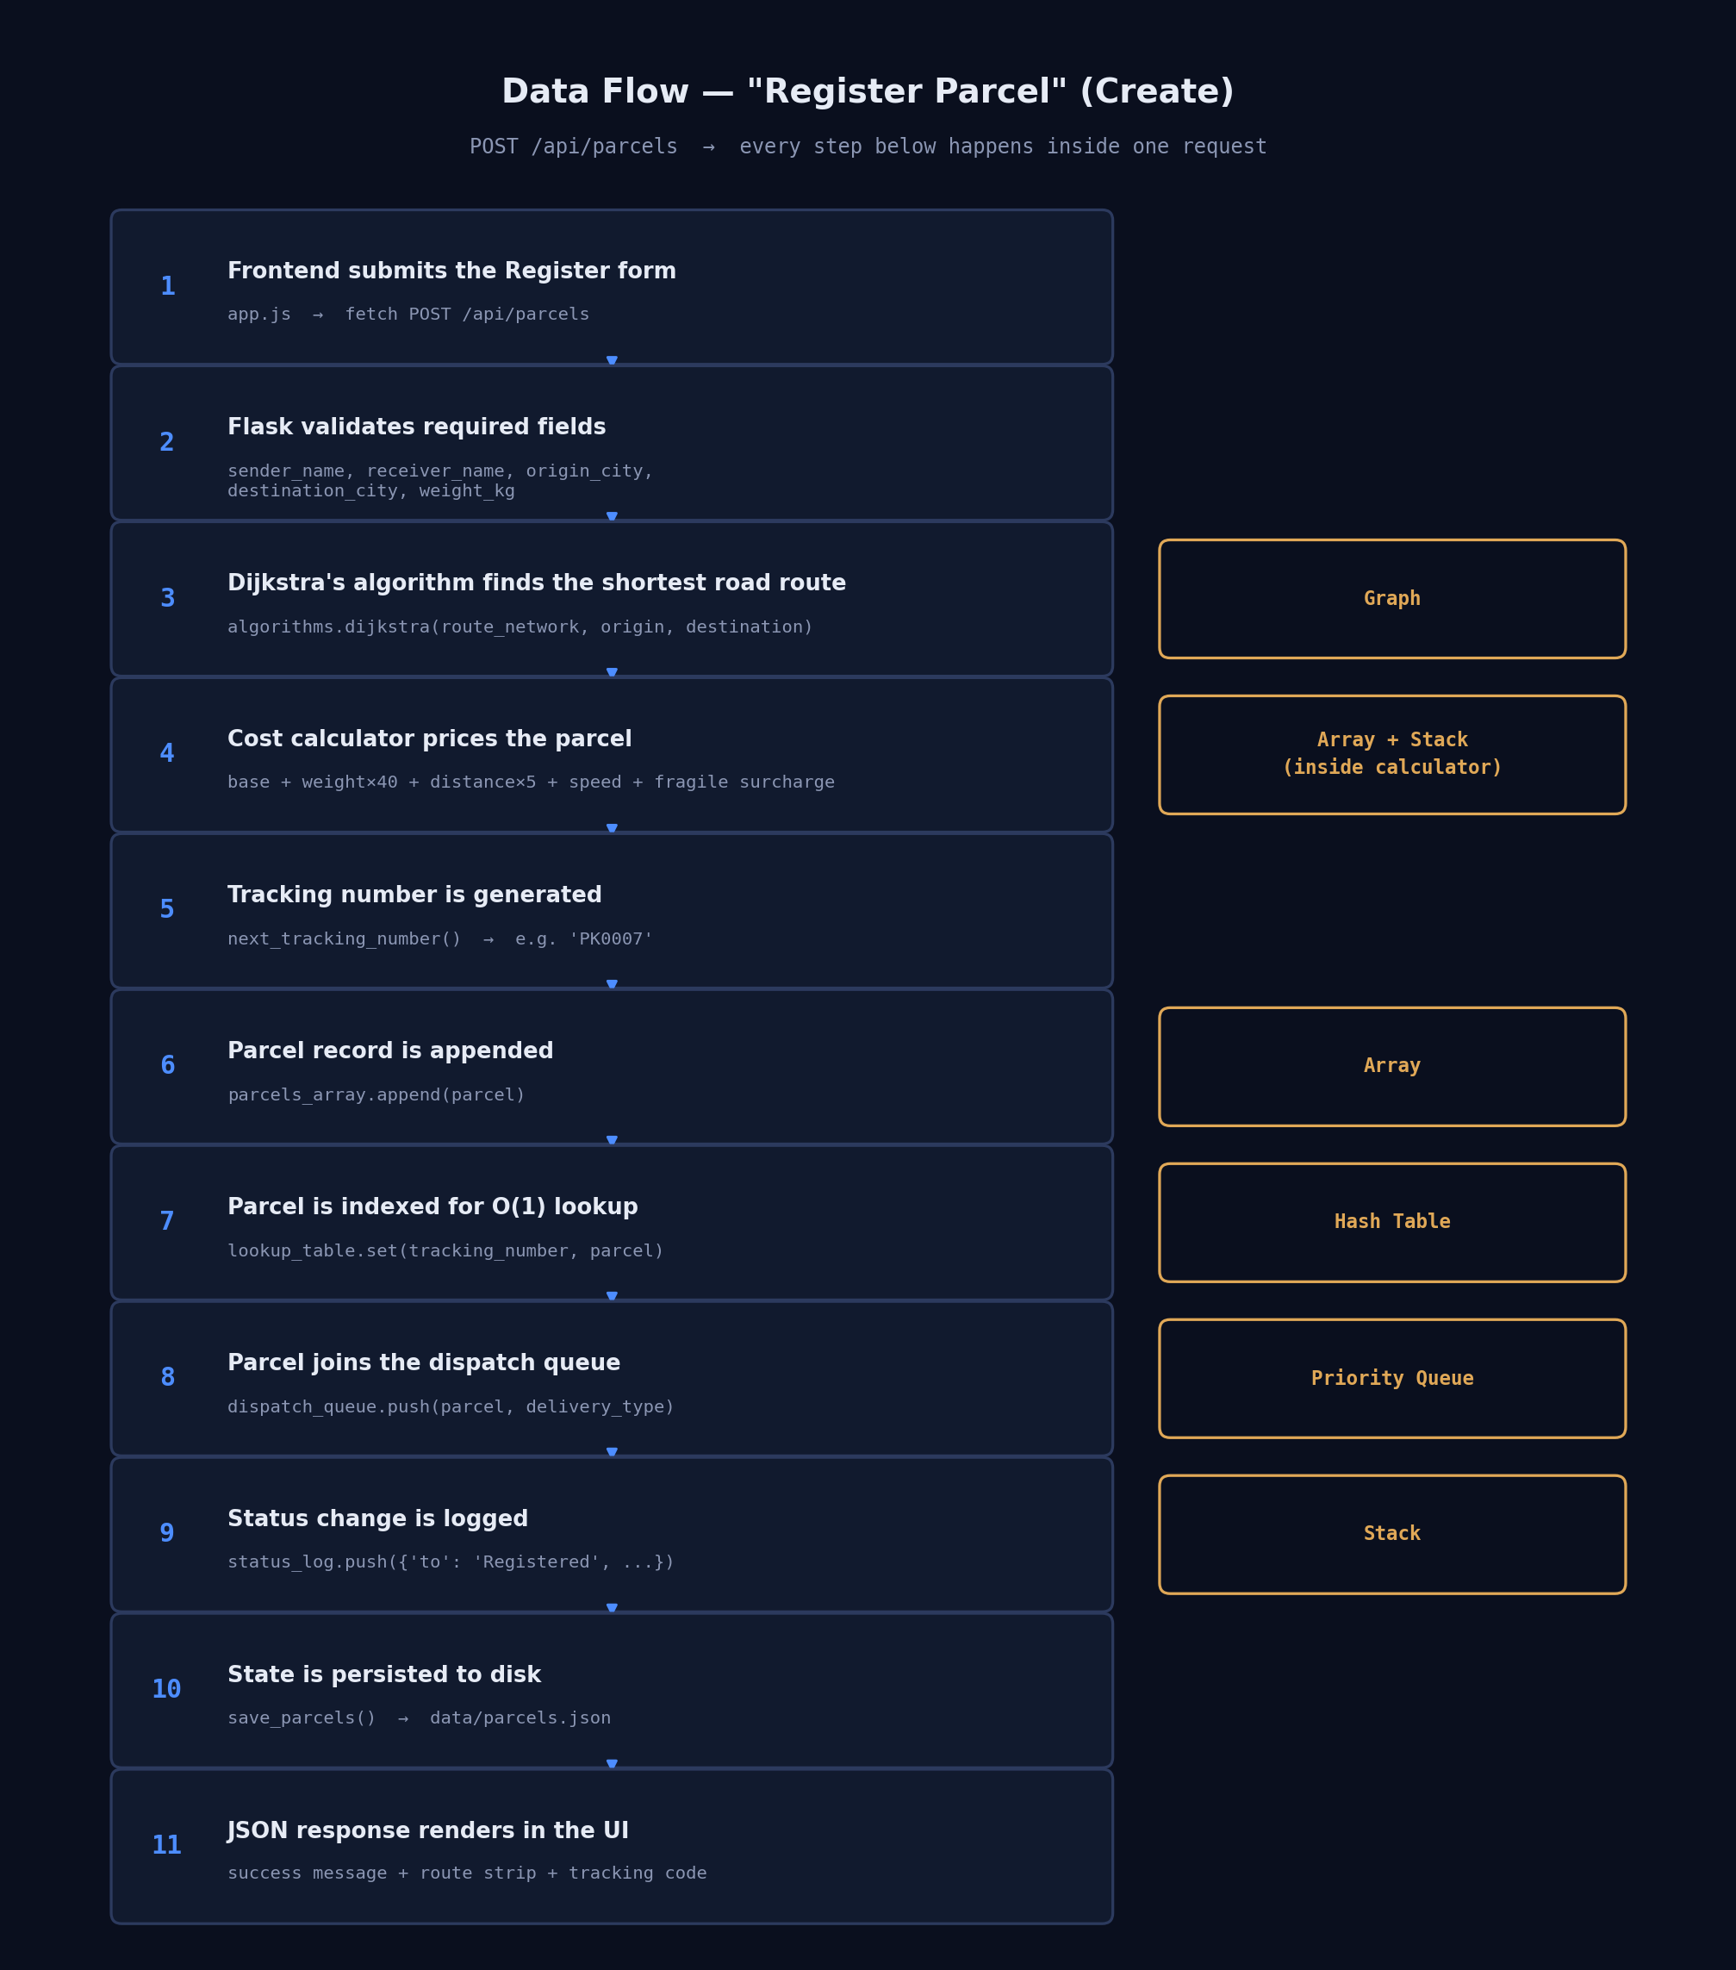
Figure 2. Step-by-step data flow for POST /api/parcels (Create).

7. Real-World Application and Creativity
The system mirrors two ideas that already exist in real Kenyan logistics and are recognisable, real-world design patterns:
- Distance-based pricing: instead of a flat delivery fee, the cost calculator prices a parcel using the actual shortest road distance between two towns, computed live with Dijkstra’s algorithm over a small network of Kenyan towns (Nairobi, Mombasa, Kisumu, Nakuru, Eldoret, and others).
- Priority dispatch: the dispatch queue is a min-heap, so overnight and express parcels are served before standard ones — the same idea as a hospital triage queue or airport priority boarding, applied to parcels.
- Reversible status log: every status change is pushed onto a stack, so a mistaken update (e.g. marked "Delivered" by accident) can be undone with one click — a small but genuinely useful operational safety net.

8. Screenshots
The two images below are design mockups generated to match the app’s actual CSS (same colours, spacing, and layout) — replace them with real screenshots of your own running instance before you submit. See Section 9 for how to capture them in under five minutes.
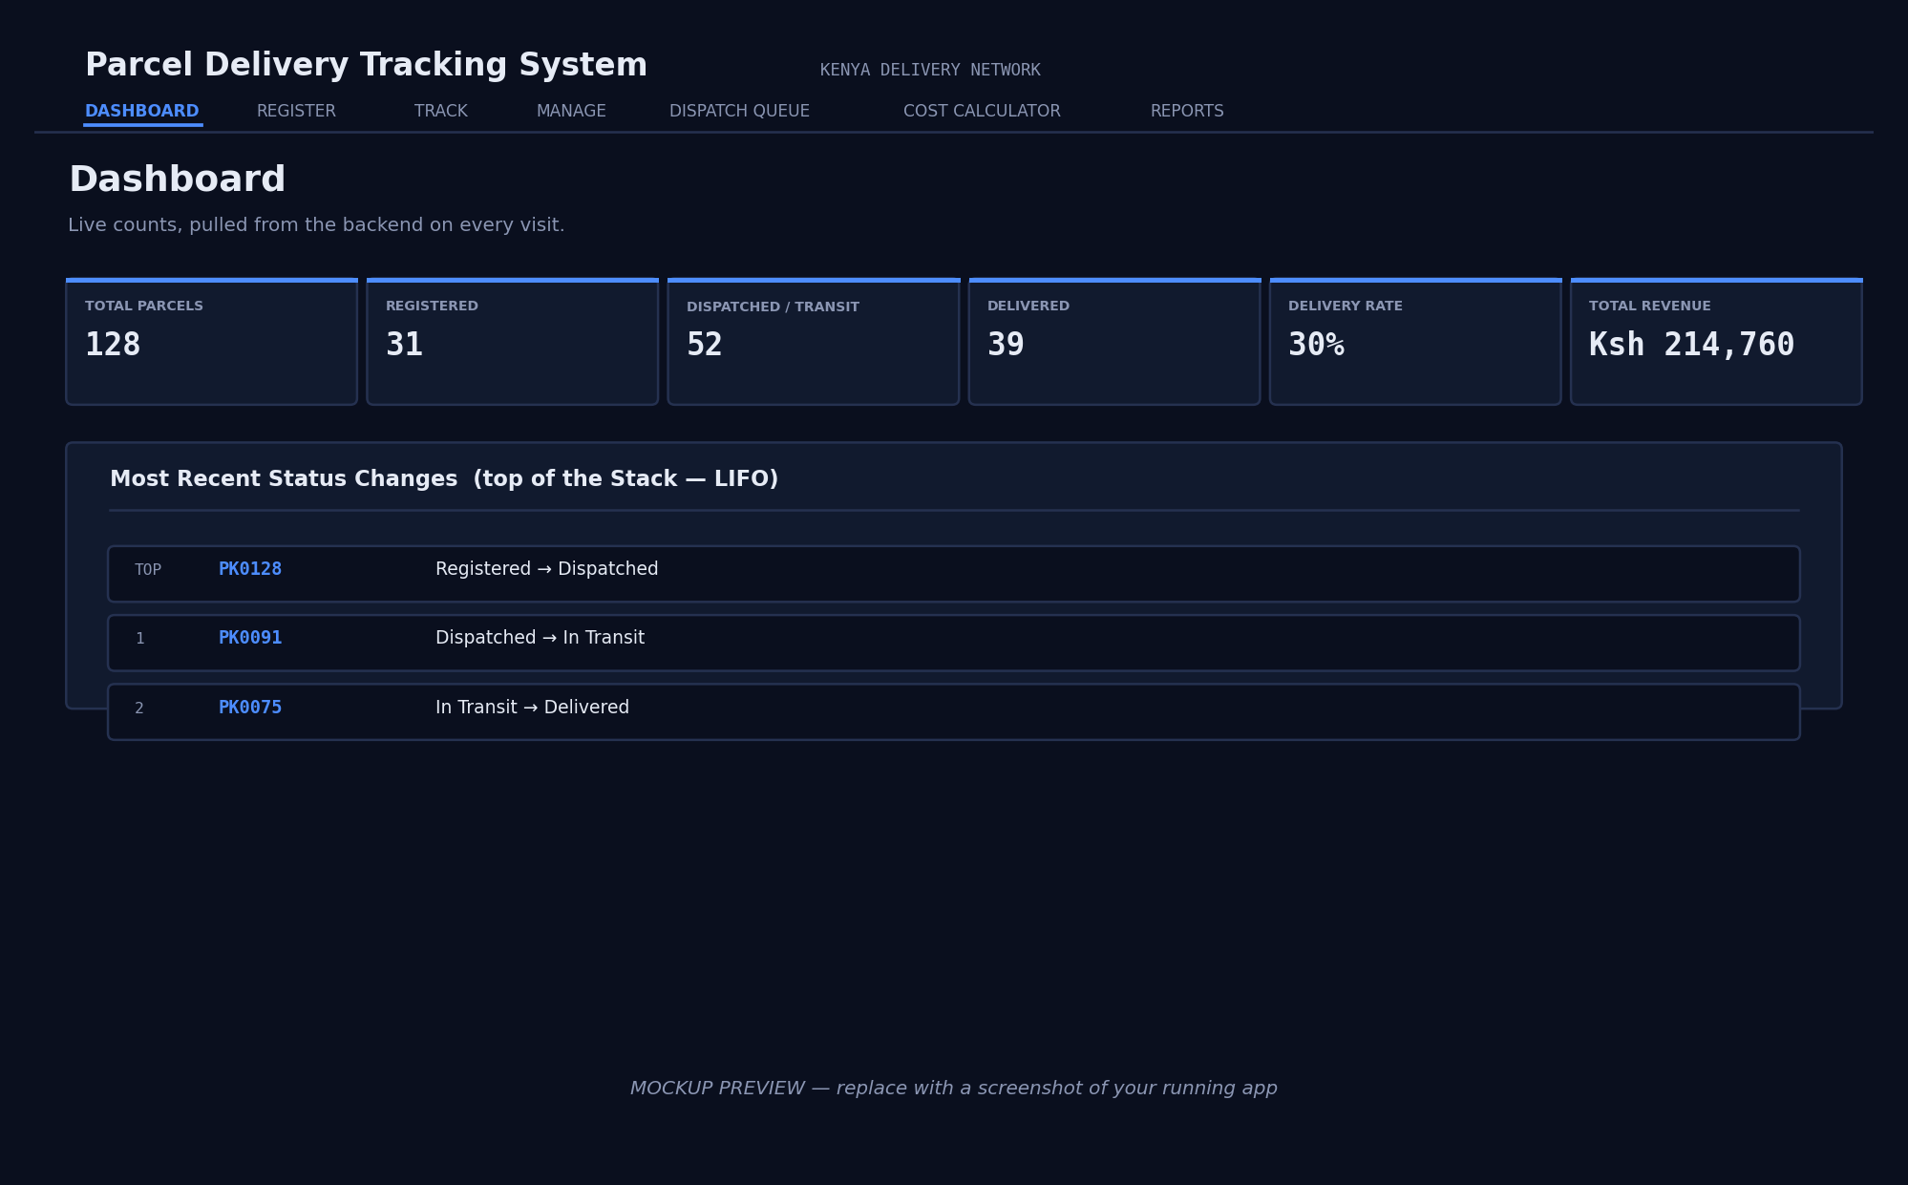
Figure 3. Dashboard view (mockup — replace with a live screenshot).
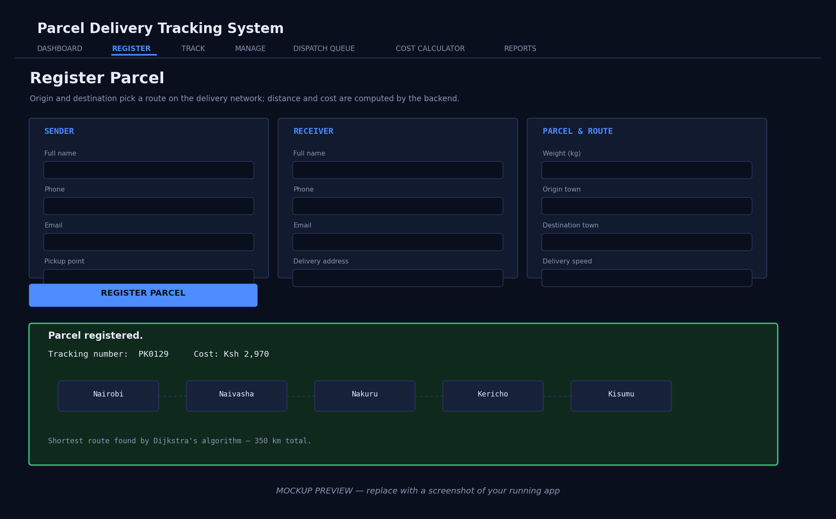
Figure 4. Register view showing the computed route (mockup — replace with a live screenshot).

9. Setup, Screenshots, and Demo Script

9.1 Running it locally
- cd backend
- pip install -r requirements.txt
- python app.py
- Open http://localhost:5000 in a browser.

9.2 Capturing your own screenshots
- Register 2–3 sample parcels between different towns so the Dashboard and Manage table aren’t empty.
- Use your OS screenshot tool (Win + Shift + S on Windows, Cmd + Shift + 4 on Mac) to capture: Dashboard, Register (after a successful submit, showing the route strip), Manage (with the table populated), Dispatch Queue, and Cost Calculator.
- Replace the two mockup images in Section 8 with your captures, and add the others as additional figures.

9.3 Suggested live-demo order
- Register a parcel — point out the route strip and explain Dijkstra found that path.
- Manage — run the same search with Linear vs Binary Search, and the same sort with Bubble vs Merge, to show the algorithms concretely.
- Dispatch Queue — register one standard and one express parcel, show the express parcel jumps to the front, then click Undo to show the Stack in action.
- Cost Calculator — change origin/destination and show the price change with the distance.
- Reports — close with the aggregate statistics.

10. Anticipated Defense Questions
Question | Short answer
Why a hash table instead of just scanning the array? | Scanning is O(n); the hash table gives O(1) average lookup by tracking number, which matters once there are hundreds of parcels.
Why chaining instead of open addressing? | Chaining is simpler to implement correctly and degrades gracefully under collisions; open addressing needs careful handling of deletions (tombstones) which adds complexity without a clear benefit at this scale.
Why a heap for the priority queue instead of just sorting the list each time? | Sorting on every insert/removal costs O(n log n) each time; a binary heap keeps both push and pop at O(log n).
Why does Binary Search need Merge Sort first? | Binary Search only works on a sorted sequence; Merge Sort (O(n log n)) is used to produce that ordering before the search runs.
What happens if two towns aren’t connected in the graph? | Dijkstra returns no path and the API responds with a 400 error explaining that no route exists between those towns.
How is data kept safe if the server restarts? | Every write (create, status update, delete) immediately saves parcels.json; the hash table and priority queue are rebuilt from that file on startup.

11. Conclusion
The Parcel Delivery Tracking System meets every rubric requirement with room to spare: a working UI backed by a real REST API, six data structures and six algorithms (three times the minimum of two each), full CRUD with a documented and defensible data flow, a complete time/space complexity analysis, and a real-world, creative pricing and dispatch model built on Kenya’s own road network. The codebase is deliberately kept simple and readable — every class and function is commented with its purpose and Big-O cost — so it can be explained confidently in the live defense.

