 | PROVIDENCE ENGLISH PRIVATE SCHOOL  Science · Year 8 · Worksheet · Cambridge Lower Secondary Science (Stage 8)  Properties of Materials: Dissolving, Solutions, Solubility and Paper Chromatography  Reinforcement sheet

Name |  | Class | Year 8 | Section | B
Date |  | Teacher | Miss Emmah M. Tamnai | Points | ______ / 45

INSTRUCTIONS
• Answer all questions.
• Read the Remember box first. Try the Challenge questions at the end when you have finished.
• Write your answers in the spaces provided. Use a pencil for diagrams and graphs.
• The number of points for each question is shown in brackets [ ].
• Total: 45 points. Time allowed: 40 minutes.

REMEMBER
• A solute dissolves in a solvent to make a solution. Mass is conserved: mass of solution = mass of solute + mass of solvent.
• Soluble substances dissolve; insoluble substances (such as sand) do not. A saturated solution cannot dissolve any more solute at that temperature.
• Solubility is the largest mass of solute that dissolves in 100 g of water at a given temperature. For most solids, solubility increases as temperature increases.
• Concentration tells us how many solute particles are in a volume of solvent. More solute in the same volume = more concentrated.
• Paper chromatography separates the dissolved substances in a mixture. Rf = distance moved by spot ÷ distance moved by solvent front.
Example: a spot moves 3.0 cm and the solvent front moves 6.0 cm. Rf = 3.0 ÷ 6.0 = 0.50. Rf is always between 0 and 1.

1 | Complete the sentences. Use words from the box.  When sugar ........................................ in water, the sugar is the ........................................ and the water is the ........................................ . The clear liquid that forms is called a ........................................ .  [4 points]
  solute solvent solution insoluble dissolves
2 | Draw a line from each word to its meaning.  [4 points]
  soluble ● |  | ● No more solute can dissolve in it
  insoluble ● |  | ● Has a lot of solute in a small volume of solvent
  saturated solution ● |  | ● A liquid that is boiling
  concentrated solution ● |  | ● Does not dissolve in a solvent
   |  | ● Dissolves in a solvent
3 | Amina dissolves 10 g of salt in 100 g of water. What is the mass of the salt solution?  Tick (✓) one box.  [1 point]
   | 90 g |  | 100 g |  | 110 g |  | 10 g
4 | Number the boxes 1 to 5 to show how to make up a salt solution. 1 is the first step.  Write 1, 2, 3 … in the boxes (1 = first).  [4 points]
  Stir with a glass rod until no crystals can be seen.
  Measure 100 cm³ of water with a measuring cylinder.
  Label the beaker with the name and concentration of the solution.
  Weigh 5 g of salt on a balance.
  Add the salt to the water in a beaker.
5 | Does each substance dissolve in water?  Tick (✓) one box in each row.  [6 points]
  Substance | soluble | insoluble
  Table salt
  Sand
  Sugar
  Chalk
  Copper sulfate
  Iron filings
6 | The diagrams show three solutions of the same solute.  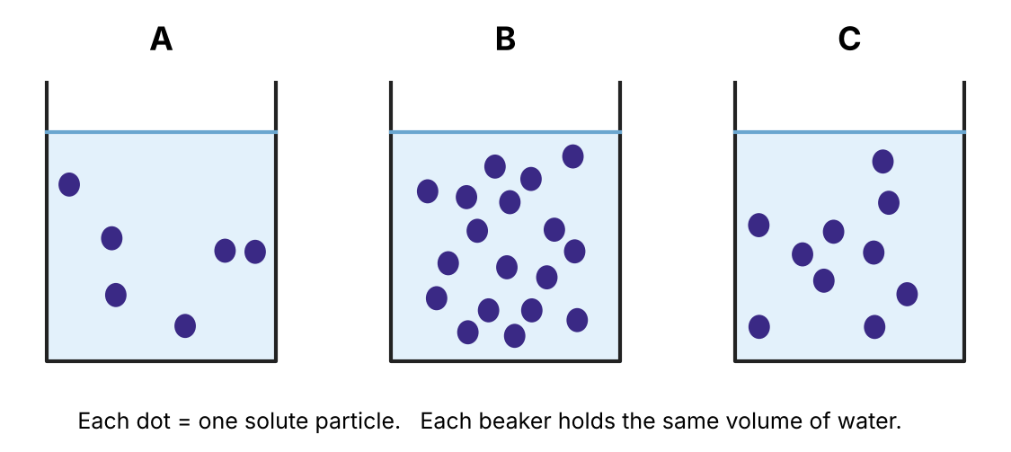  (a) Which solution is the most concentrated?  Tick (✓) one box.  (b) Explain your answer.  ..............................................................................................................  ..............................................................................................................  [2 points]
   | A |  | B |  | C
7 | The table shows the solubility of potassium nitrate at different temperatures.  Solubility of potassium nitrate  (a) Describe the pattern in the results.  ..............................................................................................................  [1 point]  (b) What mass of potassium nitrate dissolves in 100 g of water at 40 °C?  ............................................ g  [1 point]  (c) A saturated solution in 100 g of water is cooled from 60 °C to 20 °C. Crystals appear. Calculate the mass of crystals that form.  ..............................................................................................................  Mass of crystals = ............................................ g  [2 points]
  Temperature / °C | Solubility / g per 100 g of water
  0 | 13
  20 | 32
  40 | 64
  60 | 110
  80 | 169
[Total: 4 points]
8 | Ali wants sugar to dissolve faster in his tea. Does each change help?  Tick (✓) one box in each row.  [4 points]
  Change | faster | not faster
  Stirring the tea
  Using hot tea instead of cold tea
  Using one big sugar lump instead of granulated sugar
  Crushing the sugar into a powder
9 | Are these statements about dissolving true or false?  Tick (✓) one box in each row.  [3 points]
  Statement | true | false
  When salt dissolves, it disappears and its mass is lost.
  When salt dissolves, its particles spread out between the water particles.
  A substance that dissolves in water may not dissolve in other solvents.
10 | Hana used paper chromatography to test three inks, A, B and C, and an ink from a mystery note, X.  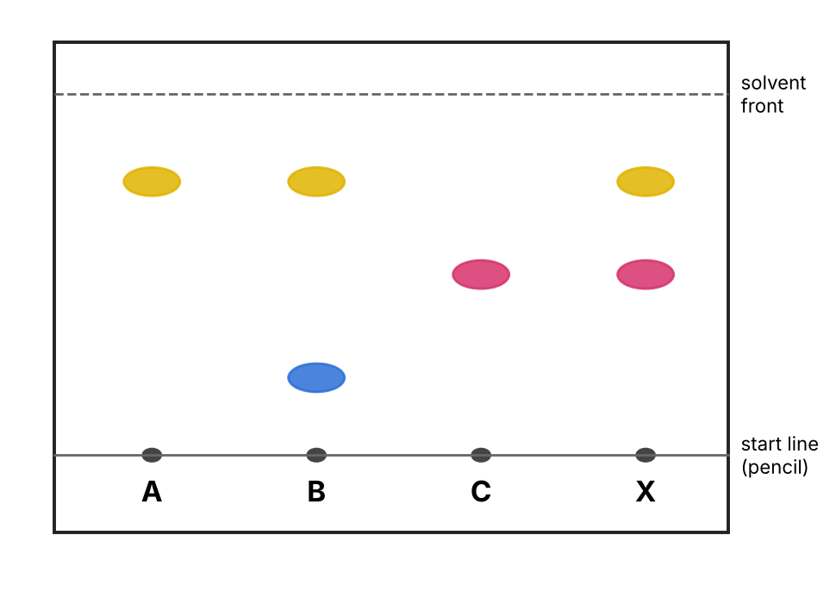  (a) Which two inks are pure substances (one dye only)? .................... and ....................  (b) How many dyes are in ink X? ....................  (c) Which two inks were mixed to make ink X? Explain how you know.  ..............................................................................................................  ..............................................................................................................  [4 points]
11 | Why must the start line be drawn in pencil, not in ink?  Tick (✓) one box.  [1 point]
  Pencil is easier to see.
  Pencil does not dissolve in the solvent, so it will not run up the paper.
  Ink makes the paper heavier.
  Pencil makes the solvent move faster.
12 | Why must the solvent level be below the start line?  Tick (✓) one box.  [1 point]
  So the spots dissolve into the beaker instead of moving up the paper.
  So the spots do not dissolve into the solvent in the beaker.
  So the paper does not get wet.
  So the solvent evaporates faster.
13 | In one chromatogram, a red spot moved 3.6 cm. The solvent front moved 8.0 cm. Calculate the Rf value of the red spot.  Show your working.  ..............................................................................................................  Rf = ............................................  [2 points]
★ CHALLENGE
Try these harder questions when you have finished.

14 | Fatima wants to find out how temperature affects the mass of sugar that dissolves in water.  (a) What is the independent variable, the thing Fatima changes?  ..............................................................................................................  (b) What is the dependent variable, the thing Fatima measures?  ..............................................................................................................  (c) Give one variable Fatima should keep the same to make the test fair.  ..............................................................................................................  [3 points]
15 | Use the particle model to explain why more solute dissolves in hot water than in cold water.  ..............................................................................................................  ..............................................................................................................  ..............................................................................................................  [2 points]

TEACHER ANSWER KEY
Q | Answer | Points
1 | dissolves, solute, solvent, solution | 4
2 | soluble → dissolves in a solvent; insoluble → does not dissolve in a solvent; saturated solution → no more solute can dissolve in it; concentrated solution → a lot of solute in a small volume of solvent | 4
3 | 110 g (mass is conserved: 10 g + 100 g) | 1
4 | Measure water (1), weigh salt (2), add salt to water (3), stir (4), label (5). Award 4 for all correct; 1 point off per error. | 4
5 | Soluble: salt, sugar, copper sulfate. Insoluble: sand, chalk, iron filings. | 6
6 | (a) B (1). (b) It has the most solute particles in the same volume of water (1). | 2
7 | (a) As temperature increases, solubility increases (1). (b) 64 g (1). (c) 110 − 32 (1) = 78 g (1). | 4
8 | Stirring – faster; hot tea – faster; big lump – not faster; powder – faster. | 4
9 | False; true; true. | 3
10 | (a) A and C (1). (b) 2 (1). (c) A and C (1) – the yellow and pink spots in X are the same colours and travelled the same distances as the spots in A and C (1). | 4
11 | Pencil does not dissolve in the solvent, so it will not run up the paper. | 1
12 | So the spots do not dissolve into the solvent in the beaker. | 1
13 | Rf = 3.6 ÷ 8.0 (1) = 0.45 (1). | 2
14 | (a) Temperature of the water (1). (b) Mass of sugar that dissolves (1). (c) Any one: volume of water, type of sugar, stirring, size of portions (1). | 3
15 | Water particles move faster / have more energy in hot water (1), so more solute particles are pulled apart and spread out between the water particles (1). | 2
 | Total | 45

