ABSTRACT
As formal sex education becomes more polarizing, online communities have grown into an informal source of reproductive health information. This project scores 770 Reddit comments from three contraception-focused subreddits against a medical ground truth document, using an LLM pipeline, human-validated at 87.5% agreement. Factual claim-making is a minority register (11% of comments). Within the claim-bearing comments, accuracy varies sharply—withdrawal and condom claims are mostly correct, while 57% of emergency contraception (i.e. Plan B) claims are inaccurate. The most-discussed category, the birth control pill, is dominated by overconfident effectiveness language, citing perfect-use effectiveness as if it described typical-user outcomes.
TABLE OF CONTENTS

1. INTRODUCTION 1
2. RELATED WORK 2
3. DATA 3
3.1 Corpus Source 3
3.2 Subreddit Selection 3
3.3 Collection And Filtering 3
3.4 Final Sample 4
4. METHODS 4
4.1 Ground Truth Document 4
4.2 Two-Pass Classification 4
4.3 Iterative Prompt Refinement 5
4.4 Validation 5
5. RESULTS 6
5.1 Composition 6
5.2 Subreddit Portions 6
5.3 Claim-Based Comments 6
5.3.1 Topics Covered 6
5.3.2 Accuracy 6
5.4 Engagement 8
6. DISCUSSION 9
7. LIMITATIONS 9
8. ETHICS 10
9. CONCLUSION 11
References 12

INTRODUCTION

Access to formal, regulated, medically accurate sex education has become increasingly contested and unevenly distributed in the United States (Guttmacher Institute, 2024; SIECUS, 2024). State policies vary dramatically in what may and may not be taught (i.e. abstinence-only curricula are mandated in many jurisdictions, and the inclusion of LGBTQ+ content remains restricted or prohibited in others [KFF, 2023; Guttmacher Institute, 2024]). The post-Dobbs political landscape has further politicized what information young people receive in classrooms, particularly regarding contraception and reproductive health (Dobbs v. Jackson Women’s Health Organization, 2022; Brookings Institution, 2023). There is a strong public health case for delivering this information through schools rather than relying solely on parents as not every child has parents available to teach them, not every parent has the relevant knowledge to do so, and in many households the topic may be taboo (CDC, 2024; UNESCO, 2018; AAP, 2016).
When formal sources of information become inaccessible, the gap is filled informally. Online peer communities, Reddit in particular, have become an increasingly common informal source (Pew Research Center, 2013; Park et al., 2015). With its topic-specific communities via subreddits and norms of anonymity, Reddit provides a comfortable environment for asking questions about that may be difficult to raise elsewhere (De Choudhury & De, 2014). While Reddit delegates moderators of each thread to maintain community guidelines regarding harm or misinformation, the accuracy of all the claims circulating in these communities is not systematically measured against and/or regulated based on authoritative public health guidelines (WHO, 2022; Reddit, 2024). Historically, the tools needed for that measurement have been computationally expensive due to requirements of reading and analyzing large volumes of text, adjudicating each substantive claim against a reference standard (Thorne & Vlachos, 2018). Large language models (LLMs), paired with a carefully constructed ground truth document, makes basic automated verification feasible, with the accompaniment of externally validation against human judgment (Guo et al., 2023).
This paper measures how reproductive health information is communicated within three Reddit communities focused on contraception and sexual health, and how accurate the medical content is when compared to authoritative guidelines from the American College of Obstetricians and Gynecologists (ACOG), the Centers for Disease Control and Prevention (CDC), the Food and Drug Administration (FDA), and Planned Parenthood. This analysis aims to answer these questions in two steps. First, what is the composition of discourse in these communities—how much of it consists of statements made as factual medical claims versus personal experience, social-emotional support, or off-topic chatter? Second, conditional on a comment suggesting a factual claim within one of five focal categories (condoms, emergency contraception, fertility, pill, withdrawal), how accurate is it (accurate, partially accurate, inaccurate)?
Among the three subreddits analyzed (r/birthcontrol, r/sex, r/WomensHealth) claim-making is a minority mode of discourse in these communities. Only about 11% of comments in our corpus advance a generalizable factual claim, while roughly half consist of personal experience or social-emotional support. Among claims that do appear, accuracy varies sharply by topic. Claims about withdrawal and condoms are mostly accurate; claims about emergency contraception and the fertility window are frequently wrong. The dominant pattern across categories is perfect-use overconfidence—citing perfect-use effectiveness numbers as if they describe what the typical user will actually experience (Guttmacher Institute, 2024; CDC, 2024).
The contribution of this work is both methodological and substantive. Methodologically, a low-cost LLM-based pipeline is demonstrated (under one dollar in API spend for 770 comments) for scoring medical claims against an explicit, externally grounded reference document, with human validation of 87.5% agreement. Substantively, we provide a quantitative description of where misinformation concentrates in a domain of clear public health importance, and we identify perfect-use overconfidence as a measurable, recurring mode of discourse.
This work is descriptive and measures prevalence within a specific corpus over a specific time window. It does not generalize to any specific population, does not estimate population-level harm, and does not adjudicate any specific sex education policy. Reddit users are not a representative sample of the U.S. public, the three subreddits we sample are not a representative sample of Reddit, and the five claim categories we score are a small slice of the reproductive health information landscape. These limitations will be discussed further.

RELATED WORK
There are few projects which examine reproductive health discourse on Reddit. Pleasants et al. (2023), in the Journal of Medical Internet Research, conducted a language analysis of contraceptive experiences in r/birthcontrol, documenting the lexicon and thematic structure of how users describe side effects, method-switching, and access. A 2024 study in the African Journal of Reproductive Health applied topic modeling to a broader Reddit corpus to surface global reproductive health themes, identifying misinformation as one recurring concern. Most directly relevant to this project, a 2026 study in the Journal of Pediatric and Adolescent Gynecology examined posts across eight subreddits and reported that approximately 15% contained contraception-related misconceptions. Together, these studies establish how Reddit functions as a resource for informal sex education and that misinformation is detectable within it.
This analysis builds on this prior work by scoring comments are against an explicit, medically sourced reference document, whereas prior work has used topic modeling, clustering, or single-pass classification. This shifts the focus to the accuracy of the comments made rather than just the topic of the comments. Second, the ground truth document is available as part of the replication package, making this measurement instrument inspectable and reusable. However, this method using category coverage is narrower than a clustering approach. We measure five specific topics in depth rather than the full thematic landscape of reproductive health discourse.

DATA

3.1 Corpus Source
The corpus consists of Reddit posts and the comments on those posts. A hybrid retrieval strategy was used, posts are discovered via the PullPush archive (api.pullpush.io), a third-party Reddit data service that succeeds the now-discontinued Pushshift archive that has been the standard tool in academic Reddit research for nearly a decade. Comments are retrieved directly from Reddit's anonymous JSON endpoint, because pilot scraping revealed that PullPush's stored comment archive is incomplete, for the same threads, PullPush returned one to five comments where Reddit's live JSON returned twenty or more. PullPush is used where it is reliable and JSON is used where it is the only complete source.
For each post, the following variables are collected—post ID, subreddit, title, body text, author handle, score, comment count, and creation timestamp. For each comment—comment ID, parent ID, post ID, body text, score, and timestamp. Author handles are retained only to apply spam filters and are stripped from any data shared in the replication package.

3.2 Subreddit Selection
We collected from three subreddits: r/birthcontrol, r/sex, and r/WomensHealth. r/birthcontrol is the highest-density contraception-focused community on Reddit and is the same subreddit analyzed by Pleasants et al. (2023); its norms center on pragmatic discussion of methods, side effects, and access. r/sex is a substantially larger community covering sexual health more broadly. r/WomensHealth covers a wider topic range (menstruation, gynecological symptoms, general wellness) of which reproductive health is one component.

3.3 Collection And Filtering
Posts were collected from a 12-month window ending in April 2026, with a target of up to 400 posts per subreddit. Several filters were applied in sequence. We first dropped any post whose body text was missing or marked [deleted] or [removed]. We then applied an engagement filter, at least five top-level comments, to bias toward posts with substantive discussion. The engagement filter was applied after fetching live comment counts from Reddit rather than against PullPush's stored num_comments field, because the stored counts reflect a snapshot taken at archive-ingest time and are systematically stale. For each surviving post we retrieved up to twenty-five top-level comments, dropping any whose body was deleted, removed, or empty.
We then removed bot and moderator content via an exact-match exclusion list. AutoModerator, accounts whose handle ended in -ModTeam, and the literal string [deleted]. We considered substring-matching on the token "bot" but rejected it after observing false positives on human handles such as Both-Performance7970. The exact-match approach is more conservative and was sufficient for this corpus—193 comments were removed at this step, leaving 770 human-authored comments for analysis.
To respect rate limits and avoid unnecessary load on either service, requests were paced at four seconds per request, with exponential backoff on HTTP 429 responses (15 s, 30 s, 60 s, 120 s) and explicit honoring of Retry-After headers.

3.4 Final Sample
After all filtering, the working corpus comprised 770 comments across 106 source posts.
Table 1. Sample composition by subreddit
Subreddit | Posts | Comments retrieved | Comments after bot removal
r/birthcontrol | 44 | — | 268
r/sex | 42 | — | 340
r/WomensHealth | 20 | — | 162
Total | 106 | 963 | 770
The middle column reports comments retrieved before bot/moderator removal; the right column reports the human-authored comments used in analysis. All posts are drawn from a 12-month window ending April 2026.

METHODS

4.1 Ground Truth Document
The reference standard against which claims are scored is a hand-authored medical ground truth document covering five claim categories: (1) emergency contraception timing and effectiveness, (2) the fertility window and ovulation timing, (3) the withdrawal method, (4) condom effectiveness and use, and (5) birth control pill missed-dose rules. For each category the document specifies authoritative facts (sourced to ACOG, CDC, FDA, and Planned Parenthood), enumerates common misinformation patterns to watch for, and documents edge cases and nuance.
The document additionally specifies a cross-cutting perfect-use principle: claims that cite perfect-use effectiveness figures (e.g., "the pill is 99% effective," "withdrawal is 96% effective if you do it right") in contexts that imply this rate is what the reader will personally achieve are classified as MISLEADING/PARTIALLY_ACCURATE, even when the underlying number is technically correct, because perfect use is a strict research standard rarely achieved in real-world conditions. The full document — approximately 21 KB of text — is included in the replication package and is reusable for future work on related corpora.

4.2 Two-Pass Classification
Each comment was passed to Claude Haiku 4.5 via the Anthropic Messages API with a structured system prompt that included the entire ground truth document as reference material. The model returned a JSON object with five fields:

- comment_type: one of claim_fact, personal_experience, social_encouragement, or other. A priority rule was specified: when a comment combined a generalizable factual claim with personal framing (e.g., "I take it on day 4 and it works — Plan B is good for 5 days"), claim_fact takes precedence.
- category: one of the five focal categories, plus outside_ground_truth for reproductive-health claims falling outside the document's scope.
- classification: one of ACCURATE, INACCURATE, PARTIALLY_ACCURATE, NOT_APPLICABLE, or OUTSIDE_GROUND_TRUTH.
- claim_text: a paraphrase of the claim being evaluated (used for downstream illustration; we never quote user text in this paper).
- hedged: a boolean flag for claims framed with epistemic hedges ("I think," "isn't it like").
The system prompt was placed in a cacheable block with prompt caching enabled at a 98% hit rate, the full 770-comment run completed in 24 minutes for $0.95 in API spend, with zero permanent failures across the corpus (transient errors were handled by a three-attempt retry with exponential backoff at 2 s, 5 s, and 15 s).

4.3 Iterative Prompt Refinement
The classification prompt was refined across three iterations on a 10-comment pilot before the full run, with each iteration addressing a specific failure mode observed in the pilot output:
- The initial schema combined claim extraction and verification into a single prompt, with a comment_type field added to capture the broader composition of discourse.
- An advice-framing clarification was added after the model misclassified comments like "the pill increases your appetite" as personal experience rather than as factual claims. The clarification specifies that assertions of the form "X causes Y" embedded in advice still count as factual claims regardless of framing.
- A Category 5 scoping note was added to clarify that general pill-effectiveness claims belong in the pill category, not in outside_ground_truth. This was prompted by observing the model defaulting to outside for general effectiveness claims that should have been evaluated against the pill category's content.
The perfect-use principle was a fourth refinement that emerged earlier in ground-truth construction and was reinforced in prompt instructions; its over-application by the model is discussed under validation below.

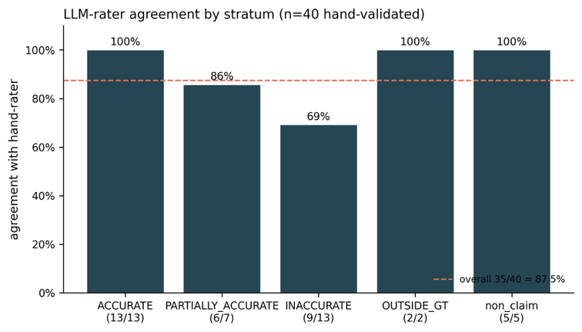
4.4 Validation
Figure 1. Per-stratum agreement between the LLM classifier and the human coder, on the 40 hand-validated comments
Overall agreement (red dashed line) is 87.5%. The INACCURATE stratum is the weakest at 69%; in 4 of the 5 disagreements, the LLM applied the perfect-use principle aggressively, classifying hedged pill-effectiveness claims as INACCURATE where a human coder would have called them PARTIALLY_ACCURATE.
To validate the classification pipeline, the author hand-coded a stratified random sample of 59 comments drawn from the LLM's outputs (15 ACCURATE, 14 INACCURATE [all available], 15 PARTIALLY_ACCURATE, 5 OUTSIDE_GROUND_TRUTH, and 10 non-claim, sampled with a fixed seed for reproducibility). Hand-coded labels were applied independently after reading the comment body, prior to consulting the LLM's reasoning, to minimize anchoring bias. Of the 59 sampled rows, 40 were validated in the round reported here.
The overall agreement rate between the human coder and the LLM was 87.5% (35 of 40). Agreement varied by stratum: the LLM's ACCURATE, OUTSIDE_GROUND_TRUTH, and non-claim strata each achieved 100% agreement with the human coder, the PARTIALLY_ACCURATE stratum achieved 86% agreement (6 of 7), and the INACCURATE stratum was the weakest at 69% agreement (9 of 13). Disagreements concentrated almost entirely in one direction and one pattern. In 4 of the 5 disagreements, the LLM applied the perfect-use principle aggressively, classifying hedged pill-effectiveness claims as INACCURATE where a human coder would have called them PARTIALLY_ACCURATE. The reverse pattern, the LLM under-flagging misinformation, did not appear in this sample.

RESULTS

5.1 Composition
Of the 770 comments in the corpus, only 86 (11.2%) were classified by the model as including a generalizable factual claim (claim_fact). The remainder is dominated by personal experience (183 comments, 23.8%) and social-emotional support—encouragement, sympathy, validation, and affirmation without specific factual content—(199 comments, 25.8%). The residual other category, capturing tangential or off-topic comments, accounted for 39.2%. (A further three comments were flagged contains_claim=True in an intermediate field but resolved to a non-claim_fact comment_type after a schema cleanup; we treat the 86-comment claim_fact set as the analytical denominator and note 89 as the upper bound on claim-bearing comments.)
This composition is itself a finding as factual claim discourse does not dominate, with the dominant mode being experiential and supportive; factual claim-making is a minority occurrence.

5.2 Subreddit Portions
The three subreddits contribute very unequally to the claim-bearing portion of the corpus. Of the 86 claim_fact comments, 78 (91%) come from r/birthcontrol, 6 from r/WomensHealth, and 2 from r/sex. r/sex contributes the largest comment volume (340 comments, 44% of the corpus) but only 0.6% of its comments are factual claims; the community's discourse, in our sample, is overwhelmingly experiential and supportive (10.6% personal experience, 26.8% social encouragement, 62.1% other). r/WomensHealth is similar: 3.7% claim-bearing, with most of the substantive discussion involving symptoms outside our five focal categories. r/birthcontrol stands out: 29.1% of its comments advance a factual claim, an order of magnitude higher than either of the other two subreddits.
This pattern reframes the multi-subreddit design. The comparison was not redundant; it surfaced a finding. Substantive contraception claim-making on Reddit concentrates in r/birthcontrol; the other two communities, while topically adjacent, function more as venues for experience-sharing and peer support than as venues for factual instruction. We treat the r/birthcontrol-heavy concentration as a constraint on interpretation, but it is also itself a descriptive result worth reporting.

5.3 Claim-Based Comments

5.3.1 Topics Covered
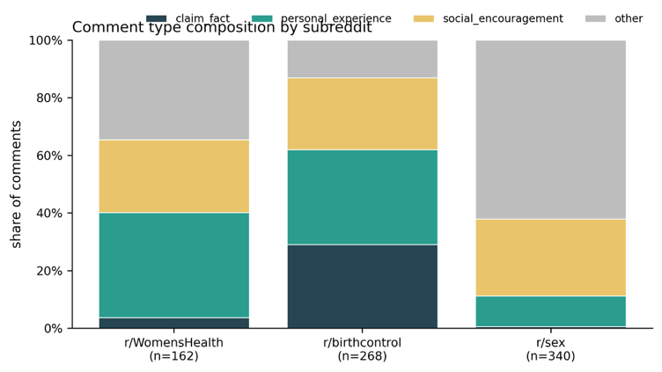
Within the 86 claim-based comments, the topical distribution is heavily skewed toward the birth control pill (33 comments, 38.4%), with a further 28 comments (32.6%) classified as making reproductive-health claims outside our five focal categories. Withdrawal accounts for 10 claims (11.6%), emergency contraception for 7 (8.1%), the fertility window for 5 (5.8%), and condoms for 3 (3.5%).
Figure 2. Composition of comments by subreddit (n = 770)
r/birthcontrol stands apart: roughly 29% of its comments advance a generalizable factual claim (claim_fact, dark blue), against 0.6% in r/sex and 3.7% in r/WomensHealth. The other two subreddits' discourse is dominated by personal experience, social-emotional support, and tangential or off-topic content. The cross-subreddit comparison was not redundant; it surfaced where substantive claim-making concentrates on Reddit.
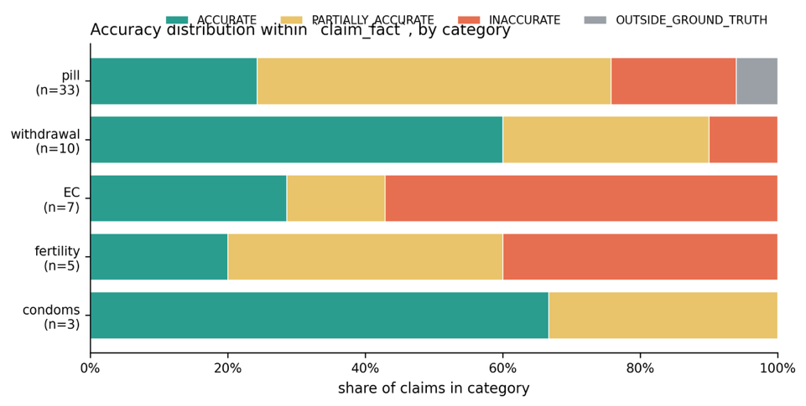
The skew toward the pill is consistent with the r/birthcontrol concentration documented above, but the size of the gap is notable: there are more pill claims in our corpus than there are claims about the other four categories combined. The condom and fertility-window cells are small enough (n=3 and n=5 respectively) that we treat their per-category accuracy estimates as suggestive rather than precise.
Figure 3. Accuracy distribution within claim_fact comments, by category, ordered by sample size
Two patterns are visible. First, withdrawal (60% ACCURATE) and condoms (67% ACCURATE) are mostly correct in our corpus, contrary to popular framings of withdrawal as a canonical site of misinformation. Second, emergency contraception is the inverse: 57% of EC claims are classified INACCURATE, against the corpus baseline of 16%. The pill, the most-discussed category, shows a distinct profile dominated by PARTIALLY_ACCURATE (52%) — the perfect-use overconfidence signature discussed in the text. Cells with n<10 (EC, fertility, condoms) should be read as suggestive directional signals.

5.3.2 Accuracy
Of the 86 in-scope claims, 19 (22%) were classified ACCURATE, 14 (16%) INACCURATE, 24 (28%) PARTIALLY_ACCURATE, and 29 (34%) OUTSIDE_GROUND_TRUTH. Excluding the OUTSIDE comments, which the pipeline flags but does not evaluate against the ground truth, the in-scope claim base contains 57 evaluable claims, of which 19 (33%) are strictly accurate and 38 (67%) are not strictly accurate. Throughout the rest of this section we report the in-scope figures as the more defensible headline.
Table 2. Accuracy distribution within in-scope claim categories
Category | ACCURATE | INACCURATE | PARTIALLY_  ACCURATE
Pill | 24% | 18% | 52%
Emergency contraception | 29% | 57% | 14%
Fertility window | 20% | 40% | 40%
Withdrawal | 60% | 10% | 30%
Condoms | 67% | 0% | 33%

Two findings stand out. First, withdrawal and condom claims are mostly accurate. This is counterintuitive: in popular discussion, withdrawal is often treated as the canonical example of a folk-wisdom contraceptive method prone to overstated reliability. In our corpus, the visible withdrawal discourse is in fact mostly correct—commenters generally acknowledge that withdrawal carries non-trivial pregnancy risk and that pre-ejaculate is a real concern, rather than promoting the method as foolproof. The condom cell is too small to support strong claims, but the available data point in the same direction.
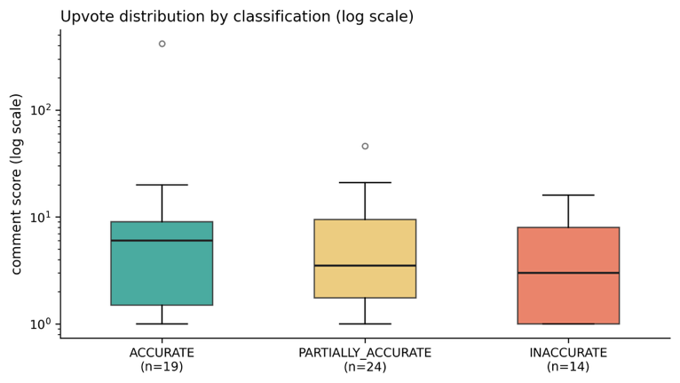
Second, emergency contraception is the category where the wheels come off. A 57% INACCURATE rate on EC claims, against a 29% ACCURATE rate, is a striking inversion of the corpus average. The EC sample is small (n=7) and so the precise rate should be read with caution, but the qualitative pattern is clear: the EC claims in our corpus repeatedly conflate Plan B's 72-hour window with Ella's 120-hour window, conflate Plan B with the abortion pill, or overstate Plan B's effectiveness. We speculate — without testing — that EC misinformation may be especially prevalent because EC has the most complex product landscape (three distinct products with three distinct timing windows), because the 72-hour window is widely misremembered as five days, and because users seeking EC information are often doing so urgently and with limited time to cross-reference.
Figure 4. Comment score (Reddit upvotes) by accuracy classification within the 57 in-scope evaluable claims, plotted on log scale
Median scores are slightly higher for ACCURATE claims (6) than for PARTIALLY_ACCURATE (3.5) or INACCURATE (3), but the boxes overlap substantially and the distribution is heavy-tailed: a single high-scoring ACCURATE outlier dominates the upper end. We report this as a qualitative observation and do not characterize Reddit's voting mechanism as a reliable accuracy signal in this domain.
The pill, the most-discussed category, shows a different pattern: a low INACCURATE rate (18%) but a very high PARTIALLY_ACCURATE rate (52%). This is the perfect-use overconfidence signature. The dominant pattern in pill comments is not flat falsehood — commenters know the pill works and know it requires daily use — but rather a chronic understatement of the gap between perfect-use effectiveness (~99%) and typical-use effectiveness (~91%). Comments cite the 99% figure or its variants as if it described what an attentive user will achieve, rather than as a research-standard ceiling.
Two paraphrased examples (substance preserved, wording rewritten) illustrate the pattern. One commenter, asked whether the pill is reliable, responded that the pill is 99% effective if taken correctly, with no further qualification; this is technically accurate as a perfect-use figure but misleading as a description of what a typical user will achieve. Another commenter, replying to a question about a missed dose, asserted that as long as you take your pill at roughly the same time each day you have nothing to worry about — collapsing the distinction between combination pills (which tolerate up to a 48-hour delay before backup contraception is recommended) and progestin-only pills (which tolerate only a three-hour window for traditional formulations).
The validation finding from Section 4.4 modulates this result modestly. The LLM was over-strict in classifying hedged pill claims as INACCURATE; some comments tagged INACCURATE would, on human review, become PARTIALLY_ACCURATE. Both categories are within the "not strictly accurate" combined figure, so the 76% combined-failure rate within the pill category is robust to the disagreement, but the within-category split between INACCURATE and PARTIALLY_ACCURATE should be read with this asymmetry in mind.

5.4 Engagement
Upvote scores within the claim-bearing subset weakly tracked accuracy. Median scores were 6 for ACCURATE claims, 3 for INACCURATE, 3.5 for PARTIALLY_ACCURATE, and 5 for OUTSIDE_GROUND_TRUTH; means were more dispersed and dominated by a small number of high-scoring outliers. Per-cell sample sizes preclude formal inferential testing, and we report this only as a qualitative observation: in our corpus, accurate claims received slightly higher engagement than inaccurate ones, but the gap is small and the distribution is heavy-tailed enough that we do not characterize Reddit's voting mechanism as a reliable accuracy signal in this domain.

DISCUSSION
Public health communication that targets all contraceptive misinformation as if it were the same problem will misallocate effort. In our corpus, withdrawal information was largely correct and emergency contraception information was largely wrong. If correction efforts are scarce, they should be directed where the misinformation concentrates itself.
The pill finding is conceptually distinct; the problem is not falsehood but implied attainability. Commenters cite real numbers in ways that imply those numbers are within reach of an ordinary user. This is a measurable manifestation of a long-standing problem in public health communication. Treatment leaflets, manufacturer marketing, and even some clinical handouts routinely lead with the perfect-use figure and do not provide context of error. Distinguishing between the perfect-use and typical-use rates in patient-facing materials is not a new recommendation, but our results suggest the recommendation has not propagated into peer discourse as 52% of pill claims in our corpus fall short of conveying the distinction.
The corpus' compositional finding of factual claims being a minority mode of discourse is worth noting. Most of what happens in these communities is not factual instruction at all; it is shared experience, mutual support, and procedural advice ("call your gyn," "ask the pharmacist"). The misinformation problem is real but localized — to a specific subreddit (r/birthcontrol), to a specific minority of comments (claim-bearing posts), and to specific topics within that minority (EC, the pill, the fertility window).
Methodologically, the results provide qualified support for LLM-based claim verification against an explicit ground truth document. The pipeline's overall agreement with a human coder was high (87.5%), the cost was negligible (under $1 for the full corpus), and the iteration cycle on the prompt was short.

LIMITATIONS
Several limitations bound the interpretation of these results. The corpus is purposive, not representative. r/birthcontrol, r/sex, and r/WomensHealth are known venues for the discourse the paper studies, but they are not random samples of Reddit, of online sex education, or of anything else. Reddit users in turn are not a representative sample of the U.S. public, of contraceptive-information seekers, or of any specific population. Our results characterize the visible information environment in three specific subreddits over a 12-month window; they do not estimate any population-level quantity. The introduction motivates this work by reference to populations for whom informal sources increasingly substitute for formal ones, but our data do not directly characterize what any specific population reads or believes. Future work could implement an author-level filter (for example, restricting to commenters who self-identify in the relevant age range) and revisit the accuracy distribution within that subset.
Substantive claim-making concentrated overwhelmingly in r/birthcontrol (91% of in-scope claims). This means that our category-level accuracy estimates are effectively estimates from r/birthcontrol, with r/sex and r/WomensHealth contributing primarily contextual and compositional information. Findings about, e.g., pill misinformation should be interpreted as findings about r/birthcontrol's pill discourse specifically.
Several per-category cells are small. Condoms (n=3) and fertility-window claims (n=5) yield estimates that should be read as suggestive directional signals rather than precise rates. The EC cell (n=7) is small enough to motivate caution about the precise 57% figure, though the qualitative pattern of conflated products and timing windows is consistent enough to warrant reporting.
The validation exercise was conducted by a single coder; we do not report inter-rater reliability across multiple human coders, nor do we report agreement across multiple LLM verifiers. This is a known limitation of single-coder validation and would be addressed in a fuller methodological replication.
The validation exercise itself surfaced a systematic LLM bias: the model over-applies the perfect-use principle, classifying hedged pill claims as INACCURATE where a human coder would call them PARTIALLY_ACCURATE. We report this transparently; the consequence is that within-pill INACCURATE rates are slight overestimates and PARTIALLY_ACCURATE rates are slight underestimates, with the combined "not strictly accurate" figure unaffected.
Finally, the ground truth document is itself a constructed artifact. While it is grounded in ACOG, CDC, FDA, and Planned Parenthood guidelines, edge cases were adjudicated by the author. The decision to classify perfect-use citations as MISLEADING when they imply attainability is an analytic choice that could reasonably be made differently. We publish the full document so that this choice and its consequences are inspectable.

ETHICS
All analyzed content is publicly visible on Reddit at the time of collection. Nevertheless, we treat the data with several precautions appropriate to its sensitivity.
We never quote user text in this paper; all illustrative examples are paraphrased with the original wording rewritten while substance is preserved. This is intended to reduce the risk of any single comment being traced back to its author through search and to reflect the fact that our object of study is the discourse, not specific individuals. Author handles were stripped from the working dataset after spam filtering and are not retained in any version of the data shared in the replication package.
PullPush retains content even when later deleted by users. This is a methodological feature — it stabilizes the corpus against ongoing moderation activity — but it has ethical implications. We mitigate this by paraphrasing rather than quoting and by not retaining usernames; we do not believe further mitigation is required for descriptive aggregate analysis of the kind reported here, but it is a non-trivial consideration that future work in this area should weigh deliberately.
The paper frames findings as analyses of public discourse rather than as analyses of the people producing it. We do not characterize individual commenters, do not infer their identities, and do not draw conclusions about specific users.

CONCLUSION
We measured the prevalence and patterns of reproductive health misinformation in three Reddit communities, using an LLM-based pipeline scored against an explicit medical ground truth document and validated against human judgment. Three findings stand out. First, factual claim-making is a minority register in these communities, most of the discourse is experiential and supportive rather than instructional. Second, accuracy varies sharply by topic: withdrawal and condom claims are mostly correct, while emergency contraception and the fertility window are where errors concentrate. Third, the dominant misinformation pattern in the most-discussed category, the birth control pill, is not flat falsehood but perfect-use overconfidence — citing real numbers in ways that imply they describe typical user outcomes.
Methodologically, the project demonstrates that low-cost LLM-based claim verification, paired with a tight ground truth document and a routine human validation step, is a viable measurement strategy for medical claim accuracy in online text. The ground truth document itself is published as part of the replication package and is reusable for future work on related corpora.

References
- American College of Obstetricians and Gynecologists. (2015). Practice Bulletin No. 152: Emergency contraception. Obstetrics & Gynecology, 126(3), e1–e11.
- Curtis, K. M., Nguyen, A. T., Tepper, N. K., Zapata, L. B., Snyder, E. M., Hatfield-Timajchy, K., ... Wright, S. (2024). U.S. Selected Practice Recommendations for Contraceptive Use, 2024. MMWR Recommendations and Reports, 73(No. RR-3), 1–77. DOI: 10.15585/mmwr.rr7303a1.
- Guttmacher Institute. (2024). Sex and HIV education [State policies in brief]. Guttmacher Institute. https://www.guttmacher.org/state-policy/explore/sex-and-hiv-education
- Pew Research Center. (2024). Social media use in 2024. Pew Research Center.
- Pleasants, E., Ryan, J. H., Ren, C., Prata, N., Gomez, A. M., & Marshall, C. (2023). Exploring language used in posts on r/birthcontrol: Case study using data from Reddit posts and natural language processing to advance contraception research. Journal of Medical Internet Research, 25, e46342. DOI: 10.2196/46342.
- SIECUS: Sex Ed for Social Change. (2024). State profiles. https://siecus.org/state-profiles/
- Sundaram, A., Vaughan, B., Kost, K., Bankole, A., Finer, L., Singh, S., & Trussell, J. (2017). Contraceptive failure in the United States: Estimates from the 2006–2010 National Survey of Family Growth. Perspectives on Sexual and Reproductive Health, 49(1), 7–16.
- Trussell, J. (2011). Contraceptive failure in the United States. Contraception, 83(5), 397–404.
- Arul Selvi, A., & Arulchelvan, S. (2024). Decoding global reproductive health discourse on Reddit: themes, regions, and misinformation challenges. African Journal of Reproductive Health, 28(1), 22–30. DOI: 10.4314/ajrh.v28i1.
- Smith, C., Cobos, C., Odom-Konja, R., Pleasants, E., Makhijani, S. A., Hummel, E., Dolgins, E., Leo, L., Rodriguez, R., Sleath, B., Shea, C. M., Gilkey, M., Allison, B. A., & Frerichs, L. (2026). Contraception-related posts from adolescents, young adults, and caregivers on Reddit: A qualitative content analysis. Journal of Pediatric and Adolescent Gynecology. DOI: 10.1016/j.jpag.2026.01.004.
- Reddit. (2024). Moderator Code of Conduct. Reddit. https://www.redditinc.com/policies/moderator-code-of-conduct
- World Health Organization. (2022). Infodemic. World Health Organization. https://www.who.int/health-topics/infodemic
- OpenAI. (2023). GPT-4 technical report. arXiv. https://arxiv.org/abs/2303.08774
- Guo, Z., Schlichtkrull, M., Vlachos, A., & Christensen, T. (2023). A survey on automated fact-checking with large language models.
- UNESCO. (2018). International technical guidance on sexuality education: An evidence-informed approach. UNESCO.
- American Academy of Pediatrics. (2016). Sexuality education for children and adolescents. Pediatrics, 138(2), e20161348.
- De Choudhury, M., & De, S. (2014). Mental health discourse on Reddit: Self-disclosure, social support, and anonymity. Proceedings of the International AAAI Conference on Web and Social Media, 8(1), 71–80.
- Park, A., Conway, M., & Chen, A. T. (2018). Examining thematic similarity, difference, and membership in three online mental health communities from Reddit: A text mining and visualization approach. Computers in Human Behavior, 78, 98–112. DOI: 10.1016/j.chb.2017.09.001.

