Outline
I have built a platform that organizers can use to post fitness classes and attendees can use to book said classes. The organizer can change the website settings and can also publish and unpublish classes. They can also see who has booked classes. The attendees can see published classes and can book classes. The number of available tickets decreases as tickets are booked. There are individual logins and registrations for organizers and attendees. There is also a simple about page and a way for people to search published classes.

Architecture
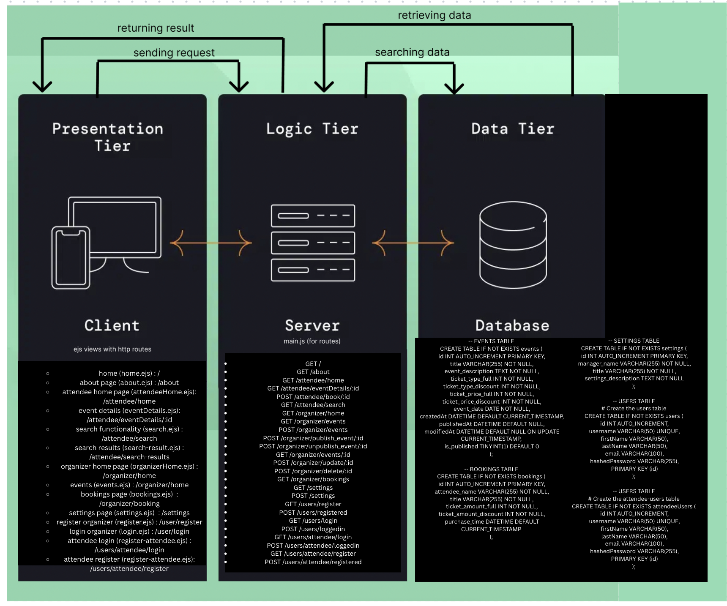
The application uses a three-tier architecture. Users interact with the system through a web browser, which sends HTTP requests to a Node.js application built with the Express framework. The application tier handles routing, validation, authentication, and renders dynamic pages using EJS templates. Data is stored and retrieved from a MySQL relational database. The application communicates with the database using SQL queries to manage users, events, bookings, and application settings.

Data Model
The system uses a relational MySQL database. The users table stores registered user information and authentication details. The events table stores information about published and unpublished events, including ticket availability and dates. The bookings table records ticket purchases made by attendees. The settings table stores application-wide configuration such as organiser details and homepage text. Each table uses a primary key.

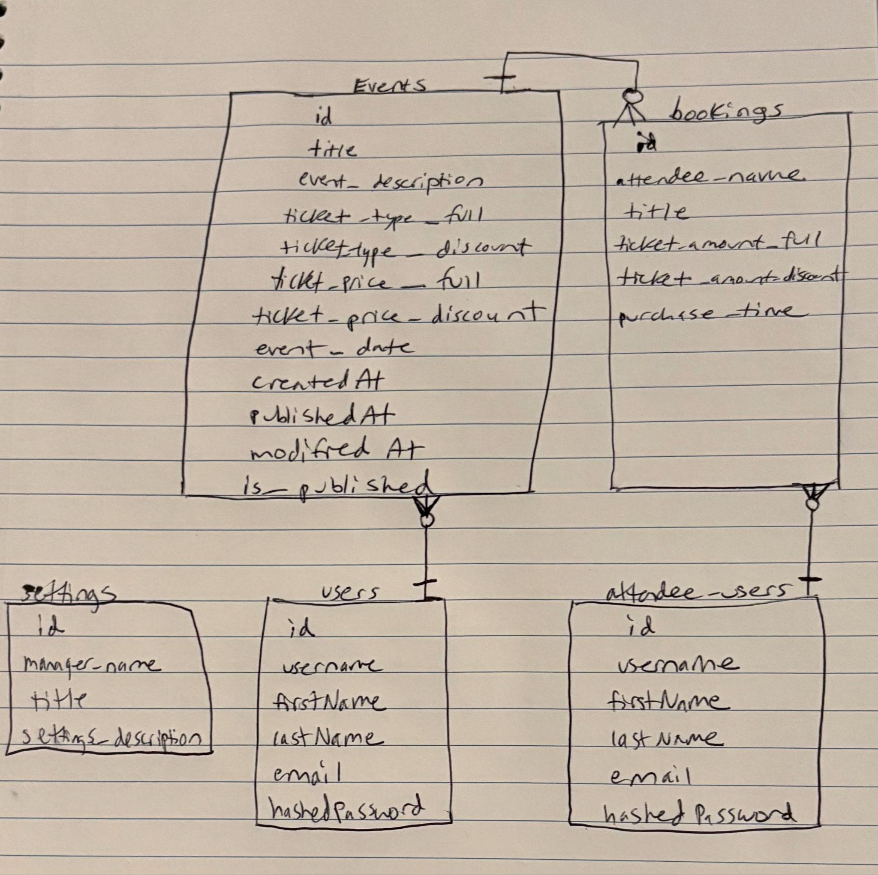

User Functionality
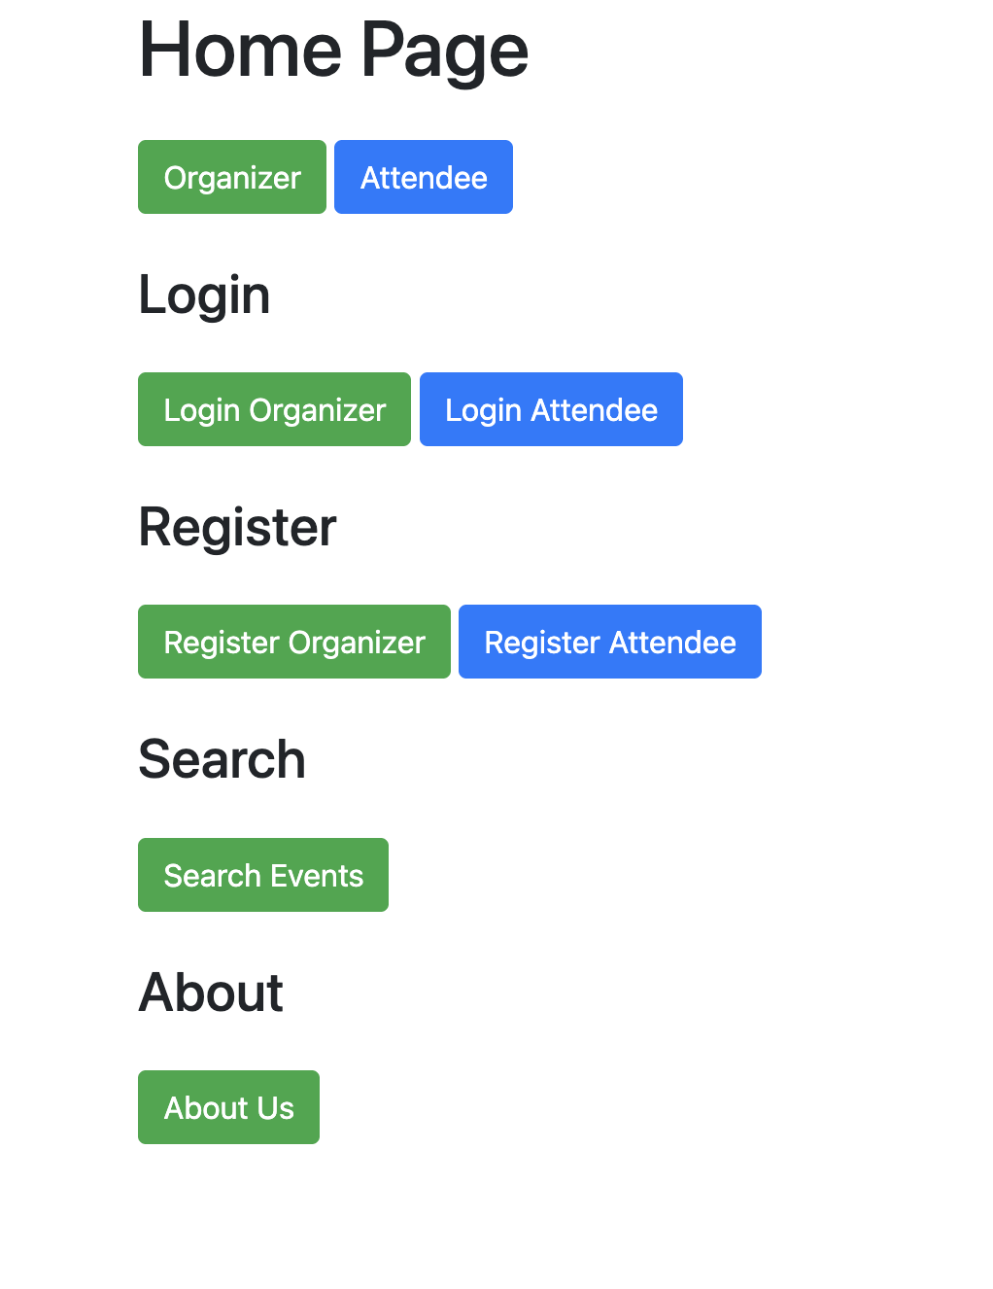
Users can go to the first home page and see their options. You can register as an organizer or an attendee. You can also login as an organizer or an attendee. There is also a simple about us page where users can learn more about the platform. There are also two home pages, one for organizers and one for attendees. You have to be registered and logged in to see both of those pages. You can also search events which will return events with the keywords you type. 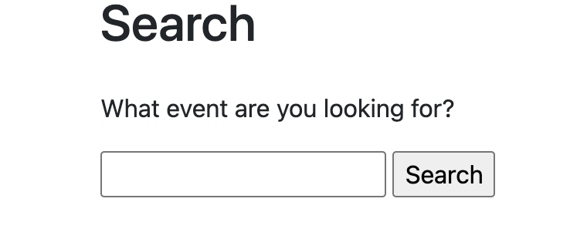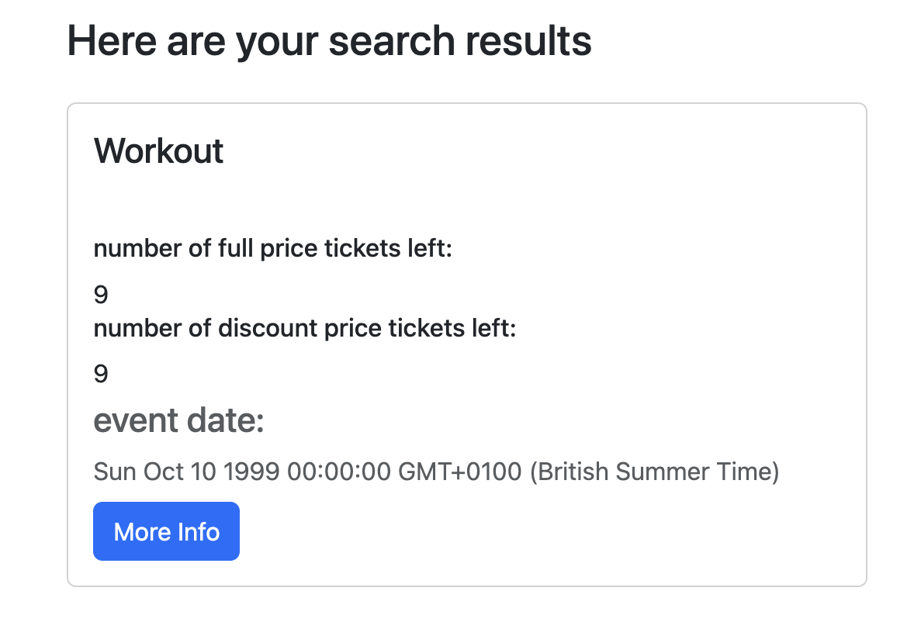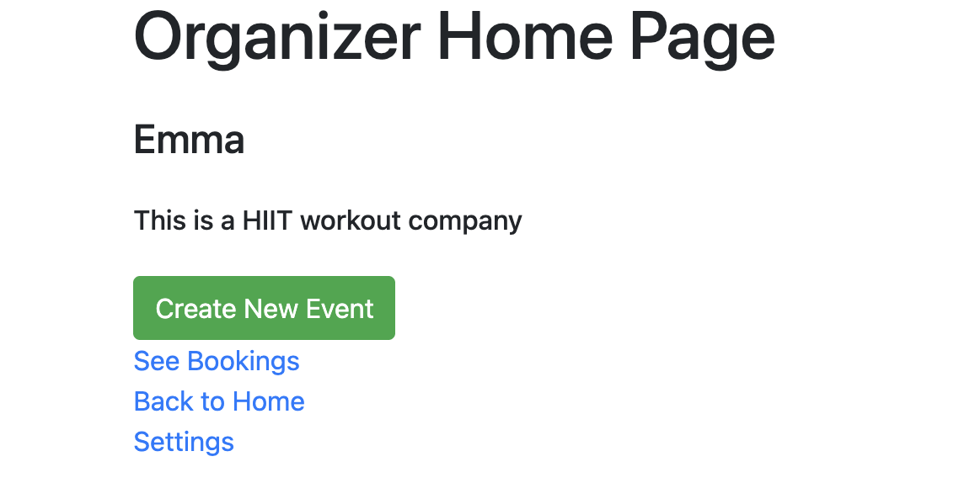
The organizer home pages lists the name of the organizer and the description of the company. These can be changed in the settings. 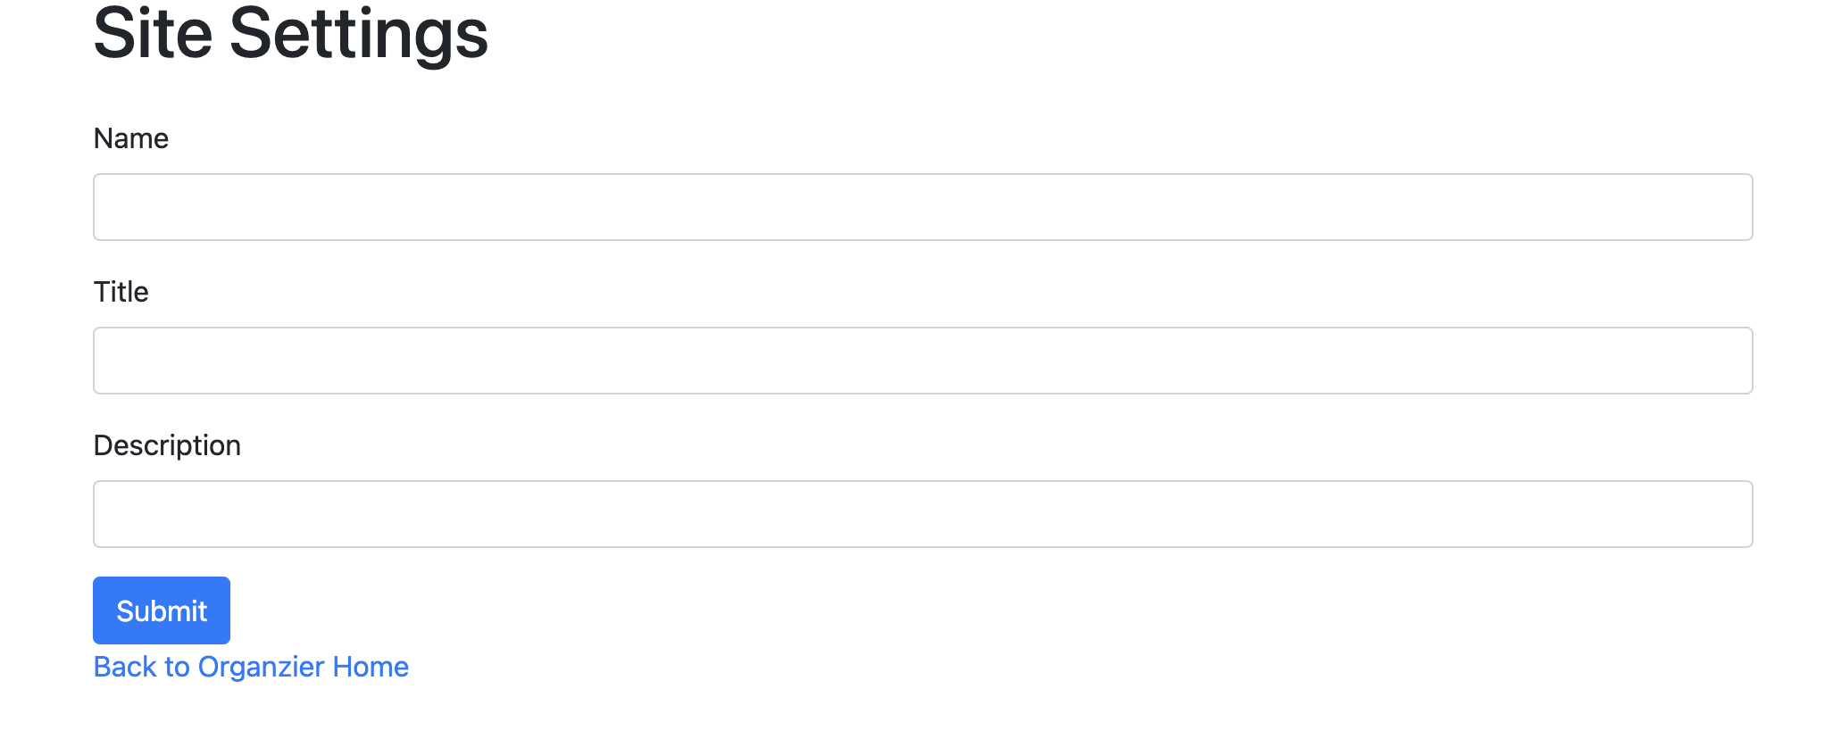
You can also see bookings from this page for events you created. 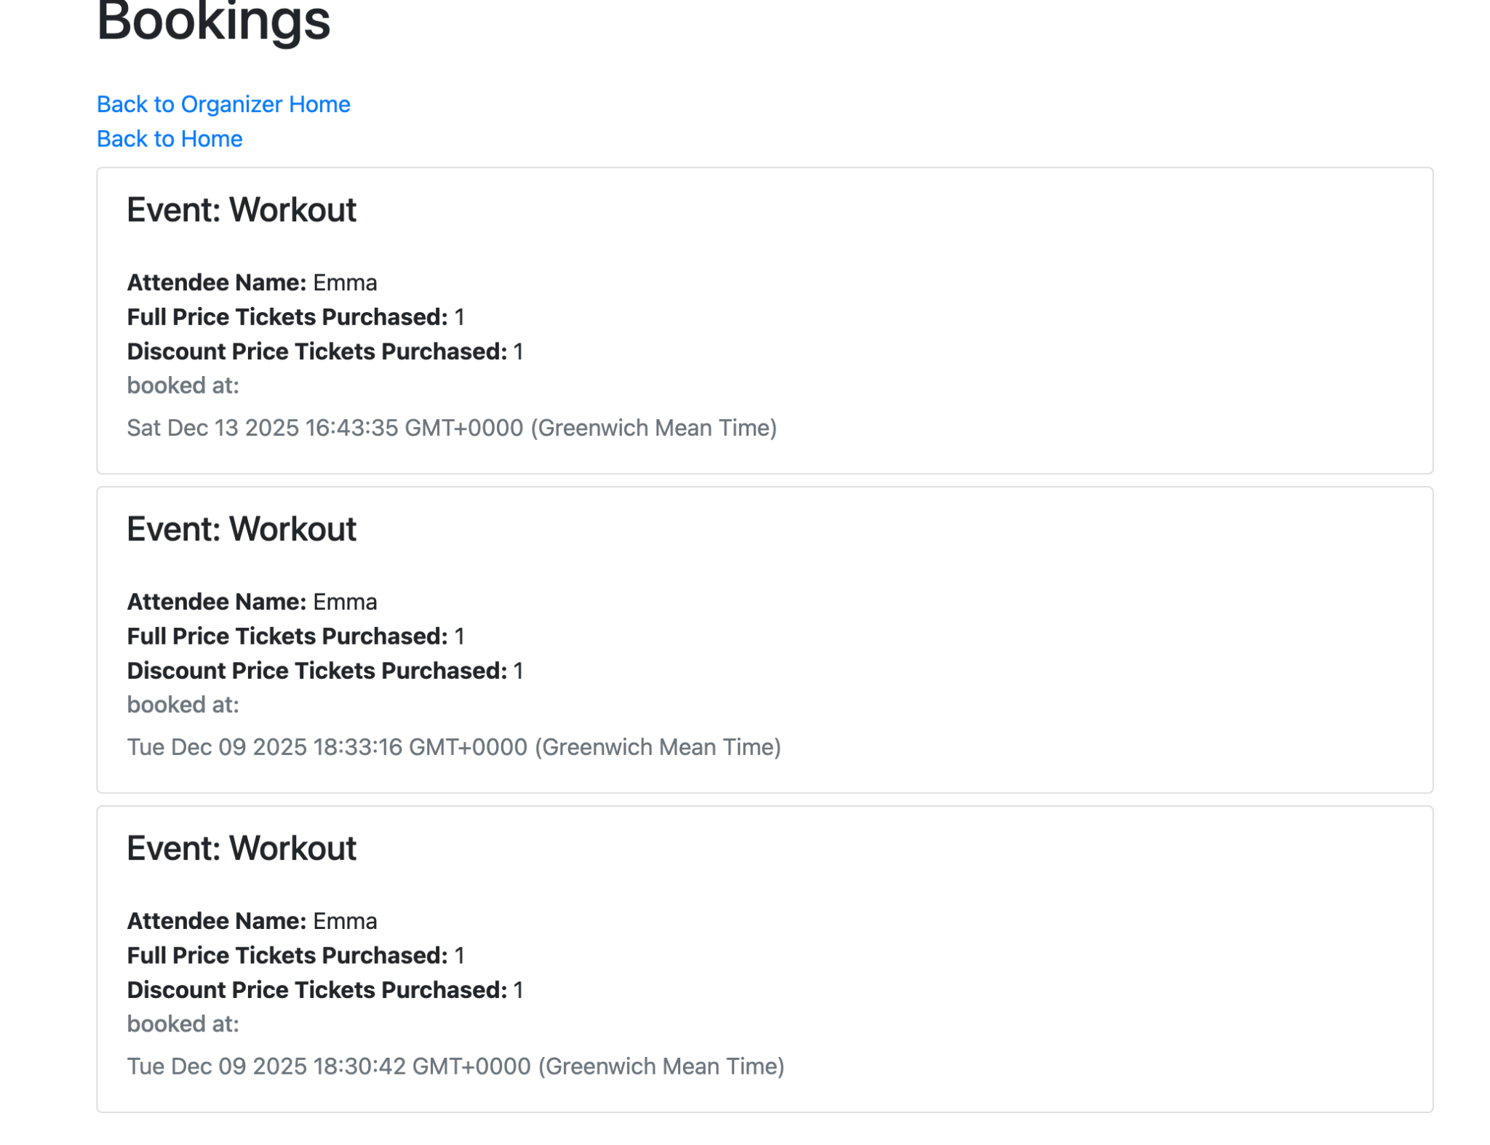
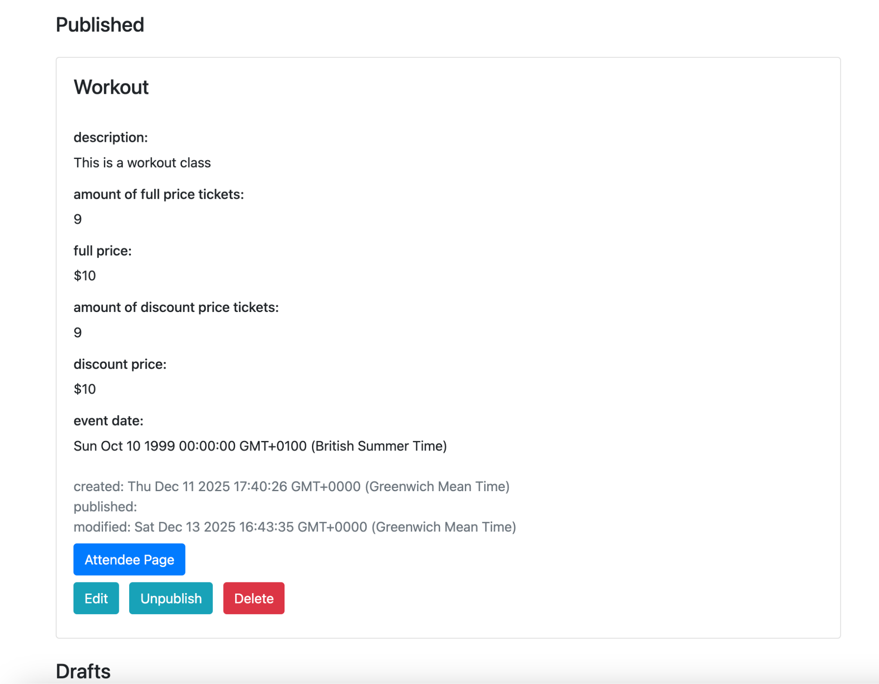
The page will also show which events you have published and unpublished and you have the option to edit, unpublish, publish or delete an event. You can also see the attendee page of your events. You can also create new events. 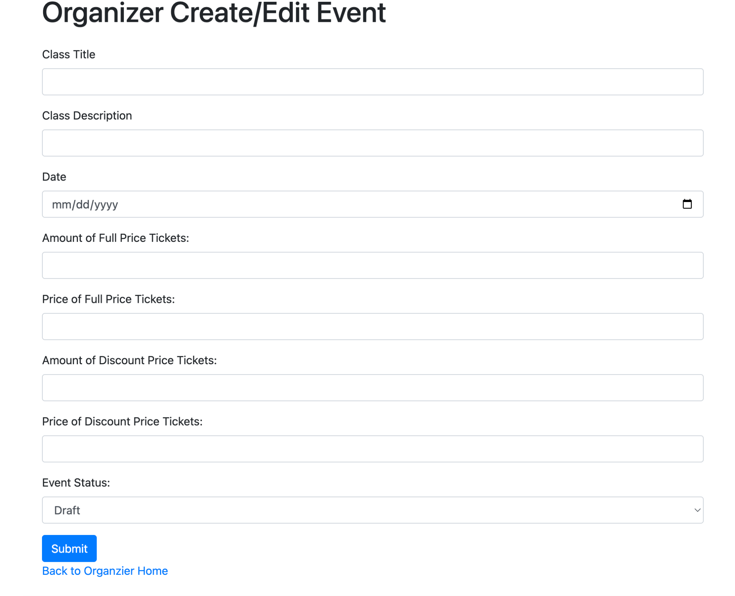
You can decide to publish these upon making them or just save them as a draft to publish later.

The attendee page allows you to see published events. 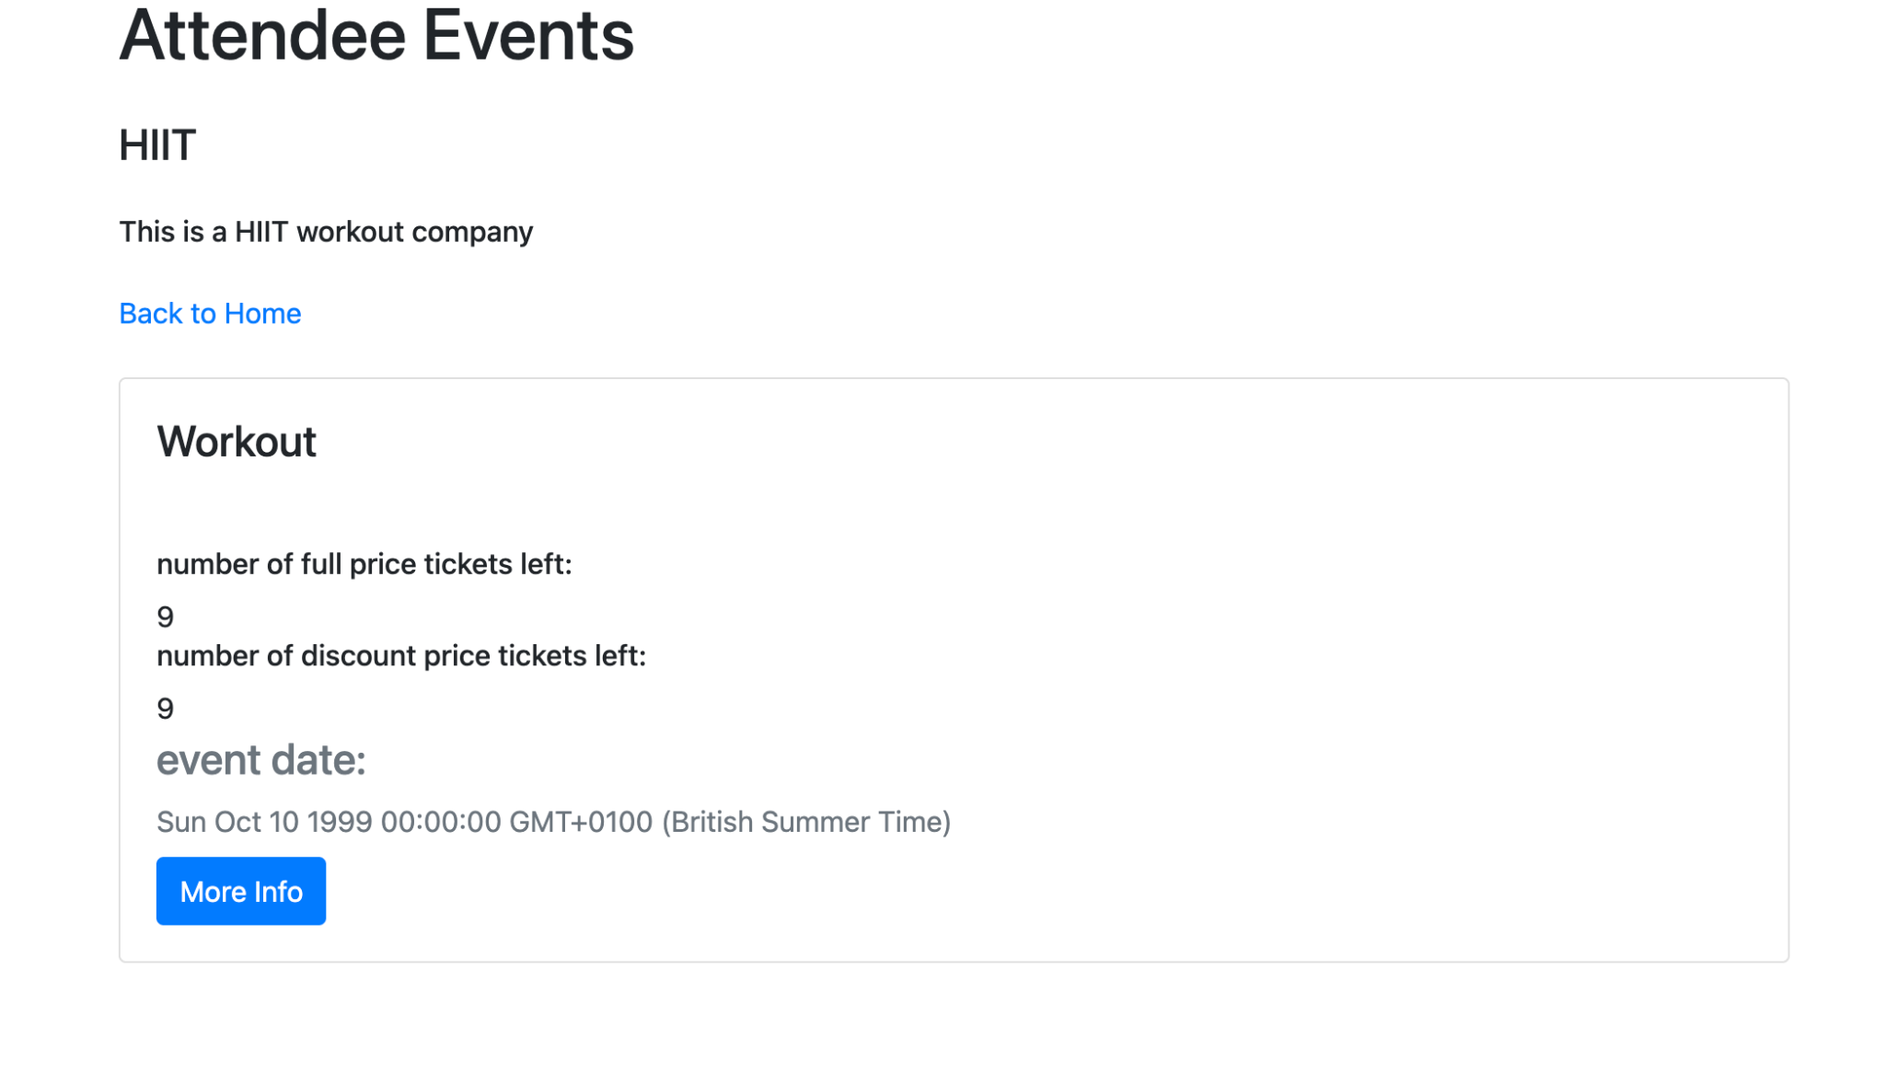
You can see the amount of tickets left for both full price and discount, along with the time the event is. If you click on more info, it will take you to more information about the event and you can book tickets. 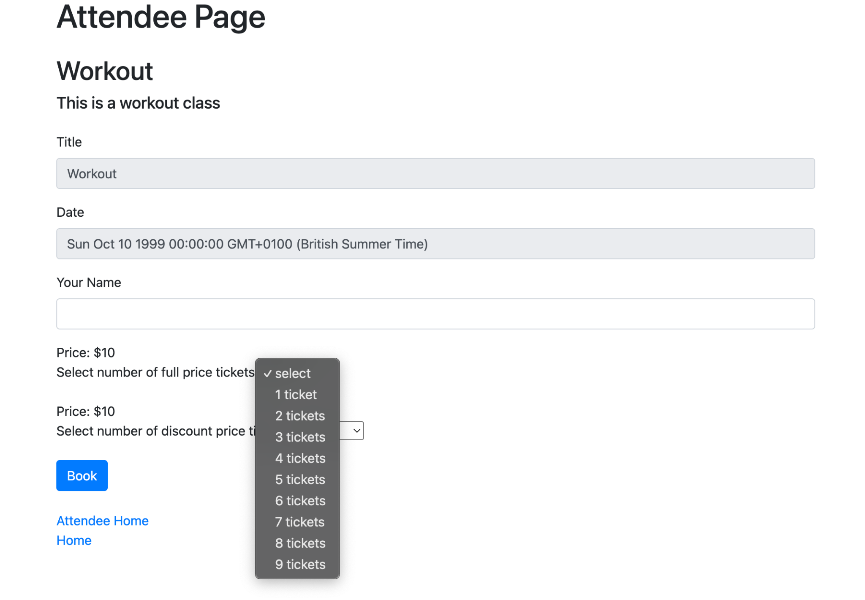
The amount of tickets will decrease as people book tickets.

AI Declaration
This project was loosely based around another project that I completed but using sqlite. I used AI to understand the syntax differences between mysql and sqlite but I made the changes to the database systems myself. I also used it for some minor debugging when things did not work and I could not understand why. In most cases, I had just typed something incorrectly that chatGPT caught or I had incorrectly written out a route. AI was not used to complete any of the major portions of this project or to completely write code for me. As previously stated, it was mostly used for debugging and understanding issues that I could not understand.

