Jimmy Wales

Co-founder of Wikipedia

# Introduction

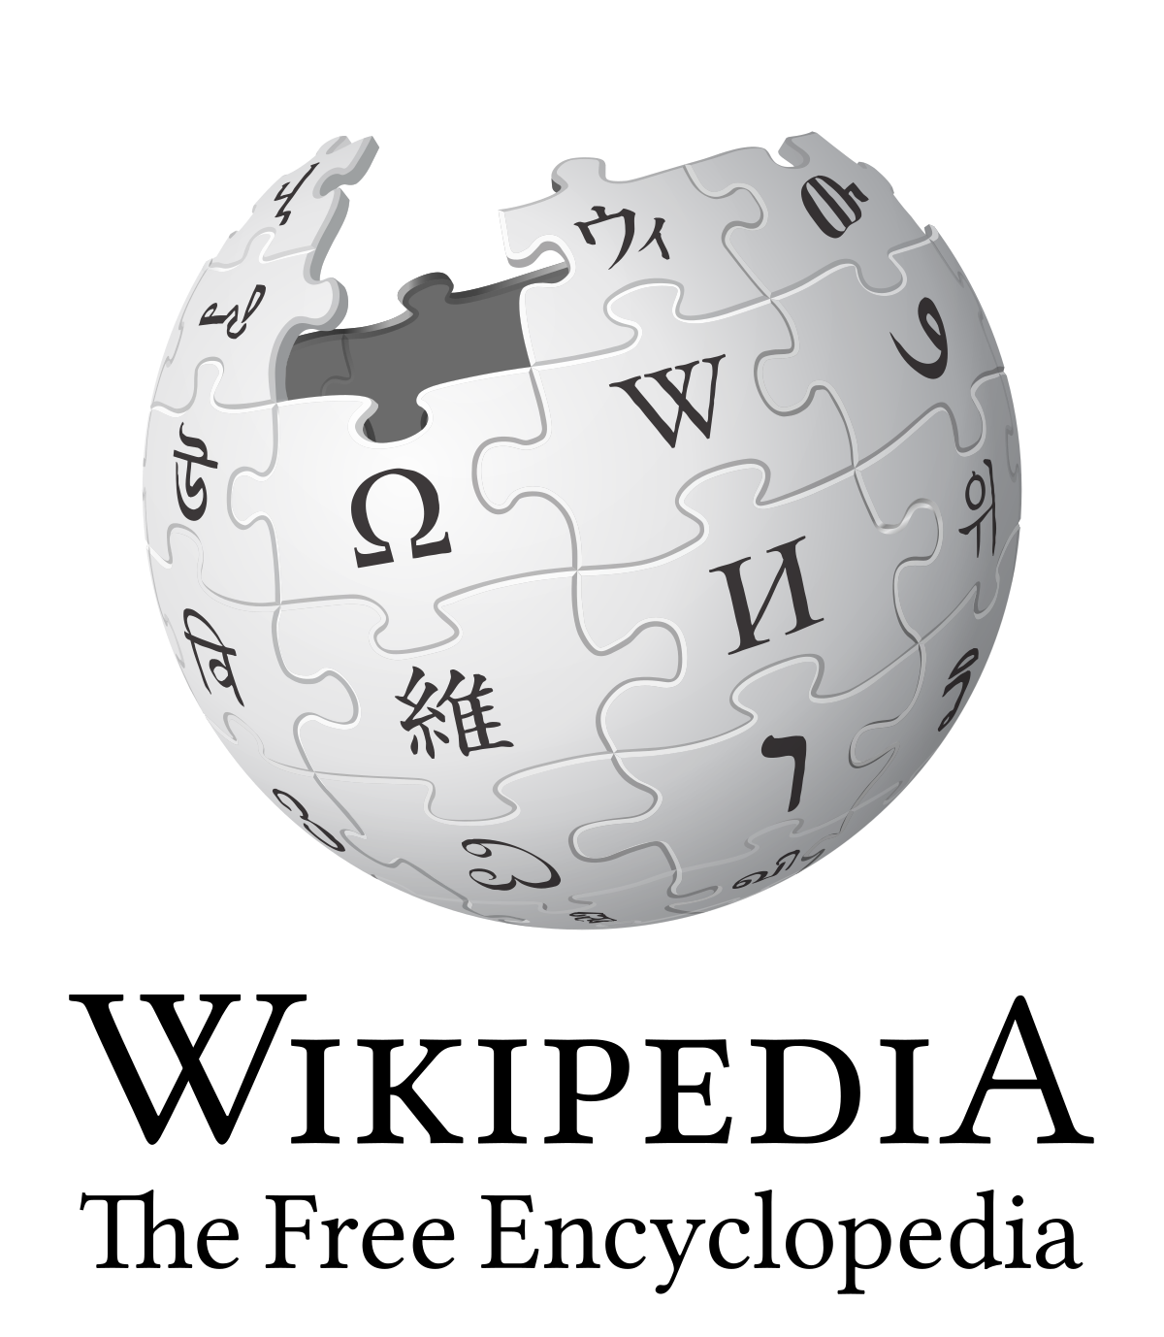

“Imagine a world in which every single person on the planet is given free access to the sum of all human knowledge. That’s what we’re doing.”

Jimmy Wales is a key software engineer who is best known for co-founding the online encyclopaedia Wikipedia and the web hosting company Wikia. I have chosen Wales as the software engineer on which to write this essay as I believe his quest to deliver a world in which every single person on the planet is given free access to the sum of all human knowledge is truly remarkable.

Many of the points touched upon in the paper “No Silver Bullet” reverberated through the work accomplished by Wales in his creation of Wikipedia. In this paper, Brooks speaks of the essence of a software entity – the construct of interlocking concepts – the data sets, the relationships between them, the algorithms and the invocations of functions. Brooks argues that the hard part of building software is the specification, design and testing of this conceptual construct.

In creating Wikipedia, Wales envisaged and incorporated the wiki software into his work, arguably the ideal software structure for maintaining a collaborative, expandable, open-source online encyclopaedia that can be built upon and enhanced into the future.

# Early Life & Education

Wales was born in Alabama, USA on the 7th of August 1966. Throughout his early life, Wales spent a considerable amount of time reading encyclopaedias. This self-directed upbringing indicated Wales’ attributes as a self-starter and his ability to think creatively. This echoes the sentiment in “No Silver Bullet” where the answer to the question of improving software art centres is, of course, people. This unique interest of Wales’ as a child undoubtedly helped him to architect the software engineering project for which he is renowned.

He obtained a Bachelor’s degree in Finance from Auburn University and a Master’s degree in Finance from the University of Alabama. Wales started work on a PhD, but took a job in finance before completing it. In 1994, Wales started working with Chicago options Associates, a futures and options trading firm in Chicago.

Wales displayed intense interest in the internet from its earliest days. In his spare time, Wales wrote computer code and was very interested in a virtual role playing game called Multi-User Dungeons. This experience inspired him and gave him an insight into the potential of computer networks to foster large-scale collaborative projects.

In 1996, he left his job in Chicago to co-found a start-up called Bornis. However, this venture was not successful.

# Nupedia

Wales was keen on pursuing an encyclopaedia project and in March 2000, he launched “Nupedia”, an open-content, peer moderated reference site. He hired Larry Sanger to serve as editor-in-chief. The idea behind Nupedia was to collect expert-written entries on a variety of topics, and to sell advertising in order to make profit. The project was controlled using an extensive peer-review process that was designed to make sure that the articles submitted and published were of professional encyclopaedia quality.

However, there were problems with Wales’ first software development. The academic peer review committees were critical of the articles and the work was organised in a very-top-down, structured way.

The issues faced in Wales’ first software development, Nupedia, are reminiscent of the essential difficulties described in “No Silver Bullet”. Wales would need some kind of ‘silver bullet’ to fix the restrictive and overly-structured nature of Nupedia so that it could become fully open, collaborative and, above all, functional.

# Wiki – the sliver bullet?

In January 2001, extreme programming enthusiast Ben Kovitz introduced Sanger to the concept of a wiki. Wiki software is a collaborative software that allows users to create and collaboratively edit pages and entries via a web browser. The content is stored in a file system or database and its significance is that it allows editors to contribute simultaneously and incrementally throughout a project. This was the software architecture that Wales needed as the foundation for his online encyclopaedia project to solve the problems of the Nupedia model. It is interesting to see the way in which the wiki software shares a lot of the characteristics of GitHub; the collaborative computer programming platform.

Initially, Wales had intended that the wiki would enhance the peer-review process of Nupedia. However, the expert volunteers of Nupedia were unhappy with this new model, fearing that the collaborative editing platform would allow amateur content to be mixed with the material that they had reviewed, potentially reducing its standard.

As a result, “Wikipedia” went live as a separate domain five days after its creation. Wales, a forward-thinking and open-minded software designer recognised the potential in the Wikipedia architecture and the need for open, collaboration on the project.

Wikipedia and Nupedia co-existed for a short time, however it was clear after a this period of time that Wikipedia was going to be a far more popular platform, with more traffic and more edits than its predecessor.

# Wikipedia

Wikipedia’s impact in the world as a free encyclopaedia that empowers people to have the information that they need to make good decisions is phenomenal. Wales has managed to provide the world with access to the sum of all human knowledge with a non-profit, free service with no advertising revenue. It is undoubtedly Wales’ choice of wiki software as the backbone of his software project that has enabled this outcome. Wikipedia is the 5th most popular website in the world and is more popular than the New York Times.

A key facet of the software structure behind the website is that it is efficient enough, and cost effective enough to facilitate a free service to all of its users. It has a free licencing model that enables all internet users to use the content for their own purposes: commercially, non-commercially or otherwise. This is an aspect of the software model that was key to Wales – it needed to be financially viable to achieve this aim.

The website has been engineered in such a way as Wikipedia can survive with only one employee, their lead software developer, and all of the editing can be done by volunteers. There are 90 servers for the data in 3 locations that are managed by volunteer system administrators that are online. It is a fascinating, unorthodox software design that is not seen in companies.

Wikipedia is available in over 302 languages. This is another example of how the effective software, put in place by Wales was able to be developed and expanded to account for this.

The beauty of Wikipedia is that the wiki structure at the heart of the project was the ideal kernel from which Wales could expand his vision for the Wikipedia project. The collaboration on the wikis could be enhanced for the real-time peer review.

Wales explains during his TED talk in 2005 how Wikipedia works and why it had such an impact in the encyclopaedia space:

Every change on the site goes to a "Recent Changes Page" that is then fed into an IRC channel. This is an Internet chat channel that people are monitoring with various software tools. Users can get RSS feeds, email notifications of changes and set up their own personal watch list.

Naturally, the need arose for watch lists, as certain, more controversial pages became the victim of “vandalising”, i.e., false information being added to a page. The software structure could be expanded as described above so that if “vandalising” of a page did occur, then someone would notice the change very quickly, and then they could revert the change.

The software has also been expanded to keep track of any new pages with a “New Pages Feed”. People can start an article on some interesting topic and other people who know about the subject matter can then contribute to the article.

The vast majority of the edits that go on the website are from a very close-knit community of approximately 600 to 1,000 people who are in constant communication. There are lots of tools that allow the Wikipedia community to monitor all of their work. When you look at a page, you can enter a view that allows you to see immediately the changes that have taken place, who has made them and the changes that they have made which appear in red. This allows people to easily see what has been changed on the page.

The software has been engineered in such a way as to account for the open-ended nature of the work of Wikipedia. For example, when deciding what pages to keep and what pages to delete, the project could be easily modified to include a “Votes for Deletion Page”. When deciding on which pages to keep and which to delete, there needed to be a social method for deciding as it is impossible for software to detect articles that are verifiable, true, relevant and appropriate for Wikipedia. Wales explains how the software compliments this selection process in his TED Ed talk: “And what's interesting about this software is - these votes are just text typed into a page. This is not really a vote so much as it is a dialogue.”

# Wikimedia Foundation onwards

In 2003, Wales founded the non-profit Wikimedia Foundation which is responsible for overseeing the development of Wikipedia.

He also extended the wiki model to several other projects, including Wiktionary  and Wikinews. This supposedly is the essence of successful software engineering – the formation of a model that can be extended to provide additional functionality as the needs of people, and the world, advance.

In 2004, Wales and colleague Angela Beesley founded a for-profit internet company called Wikia. Wikia is a wiki hosting service that is free of charge and for-profit. He stepped down from his position as CEO in 2009.

In 2017, Wales conducted an interview with the Financial Times, saying, “The idea that, in your pocket, you’ve got this incredible storehouse of knowledge that’s completely free is kind of staggering, I mean, even today.” The impact of his creation is indeed quite astounding, even today.

However, Wales is restless and is committed to “fixing” the news. He released a video announcing the formation of a new media organisation called WikiTribune in partnership with Orit Kopel. This platform aims to expand on and enhance the underlying software engineering of Wikipedia. With this news service, Wales aims to provide a more localised, ongoing stream of news, in contrast to the sensationalised and fleeting spotlight that current mainstream media tends to shine on events. Because Wales’ wiki model is so cost effective, the site will not rely on advertising revenue. As a result, Wales hopes that the news stories provided by volunteer writers will be more accurate and of a higher standard. His insistence on keeping his projects on a shoestring budget is in order to maintain his creative control over the product and the process.

What is evident from Wales creation, the Wikipedia platform, is that it is a software engineering project that continues to grow to the needs of the modern day society. It continues to enhance the lives of all-internet users and remain relevant as the needs of these internet users change.

# Awards

Wales has received a number of major awards and honorary degrees from institutions.

In 2006, TIME Magazine named him as one of their “100 most influential people” in the “Scientists & Thinkers” category.

The World Economic Forum recognized Wales as one of the “Young Global Leaders” of 2007.

Wales is a Fellow of the Berkman Center for Internet & Society at Harvard Law School. He serves on the Board of Directors of Socialtext, a provider of wiki technology to businesses and the non-profit organization Creative Commons. Wales has also received an honorary doctorate from Knox College of Illinois and was presented with a Pioneer Award from the Electronic Frontier Foundation in 2006.

# Bibliography

The following sources were used in my research for this essay:

Jimmy Wales’ blog:

http://jimmywales.co m/about-jimmy/

<http://jimmywales.com/category/wikia/>

Jimmy Wales’ TED Talk at TEDGlobal 2005:

<https://www.ted.com/talks/jimmy_wales_on_the_birth_of_wikipedia/>

Jimmy Wales interviews with the Financial Times:

<https://www.ft.com/content/7a635e90-d49d-11e7-8c9a-d9c0a5c8d5c9>

<https://www.ft.com/content/9eb2ff3e-800c-11dd-99a9-000077b07658>

Other biographies written about Wales:

<https://www.conservapedia.com/Jimmy_Wales>

<https://www.internethalloffame.org/inductees/jimmy-wales>

<https://www.biography.com/people/jimmy-wales-39135>

<https://successstory.com/people/jimmy-donal-wales>

<https://en.wikipedia.org/wiki/Jimmy_Wales>

Wales explaining Wikia:

<https://www.youtube.com/watch?v=LQjkDW3UPVk>

Article in the New York Times:

<https://www.nytimes.com/2013/06/30/magazine/jimmy-wales-is-not-an-internet-billionaire.html>

No Silver Bullet:

<http://faculty.salisbury.edu/~xswang/Research/Papers/SERelated/no-silver-bullet.pdf>