**Palate Tailor**

**User Manual**

**Created by:**

**Emma Lurie and Dorothy Sun**

**User’s Manual**

1. **Overview**

Palate Tailor is a computer program for Wellesley College students to identify the best dining hall for lunch or dinner on a given day. Palate Tailor uses Wellesley College student dining hall reviews of common dining hall dishes to select the best dining hall option for lunch or dinner on that day.

Palate Tailor stores data collected in April 2016 on dining hall dishes that have appeared in the month of April. The weekly menu is extracted from a text file that stores the dishes from Wellesley Fresh website for a given week. That day’s lunch or dinner options are compared to the user reviews. Each dining hall is then given a score based on the quality of that meal’s menu. Additionally, the user may also elect to indicate if one of today’s top rated choices is one of his or her favorites. If the menu contains one of the user’s favorites, the dining hall’s score will be recalculated to reflect the user’s unique tastes.

This program implements a GUI with three tabs. The “Instructions” tab acts as an introduction to the program. The “Today’s Choice” tab asks the user which meal he or she would like to be advised about. The GUI will display the top two best locations for having that meal, as well as a recommended dish of the first choice dining hall. The “Just For You” tab adds a more personalized approach. Users can select their favorite dishes out of the five options displayed, each checkbox represents the top rated dish from each dining hall at that given meal. Checking the box next to the user’s favorite dishes increases the score of the dining hall where that dish is located. While a dining hall serving the user’s favorite dish doesn’t ensure that it is the best choice, it sure gives that dining hall a nice boost!

**II. How to Run This Program**

Once you have access to the PalateTailor folder, open the **SelectorGUI.java** in a text editor, compile and run the program. Please let Emma or Dorothy know if you have trouble compiling or running the program.

**III. “Instructions” Tab**

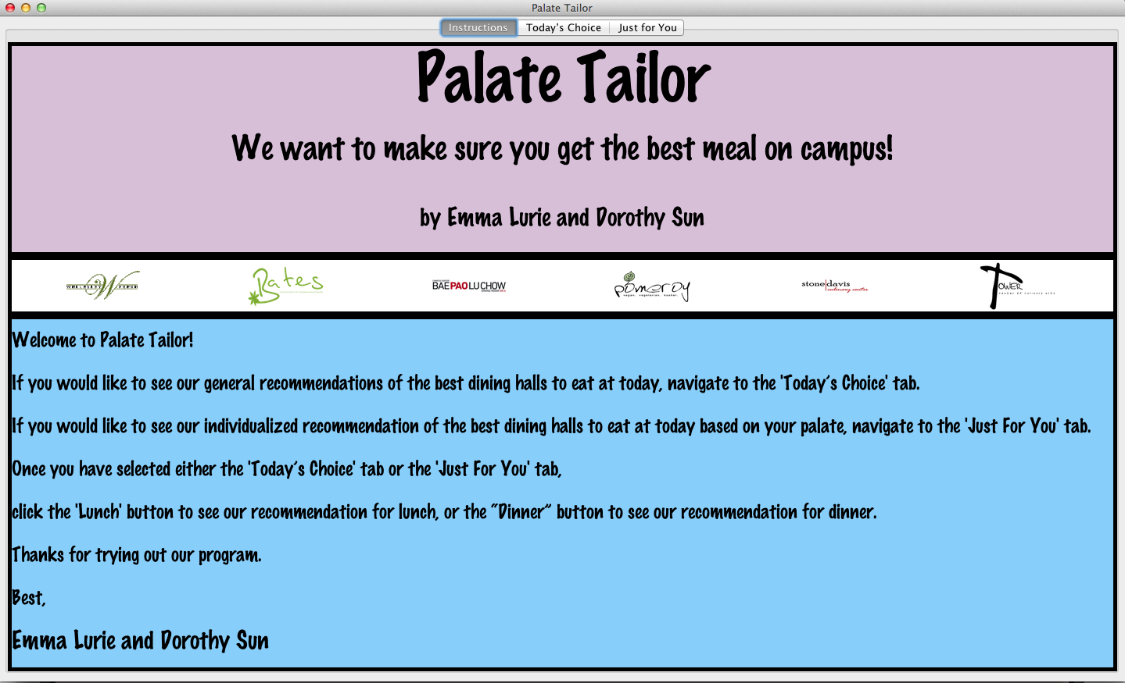

When **SelectorGUI.java** is run, the program automatically navigates to the “Instructions” tab. The “Instructions” tab outlines how to most effectively use this program. The instructions suggest that users either click on the “Today’s Choice” or ‘Just For You” tab. Once they select a tab, they should click either the “Lunch” or “Dinner” button to receive a recommendation for that meal.

**IV. Today’s Choice Tab**

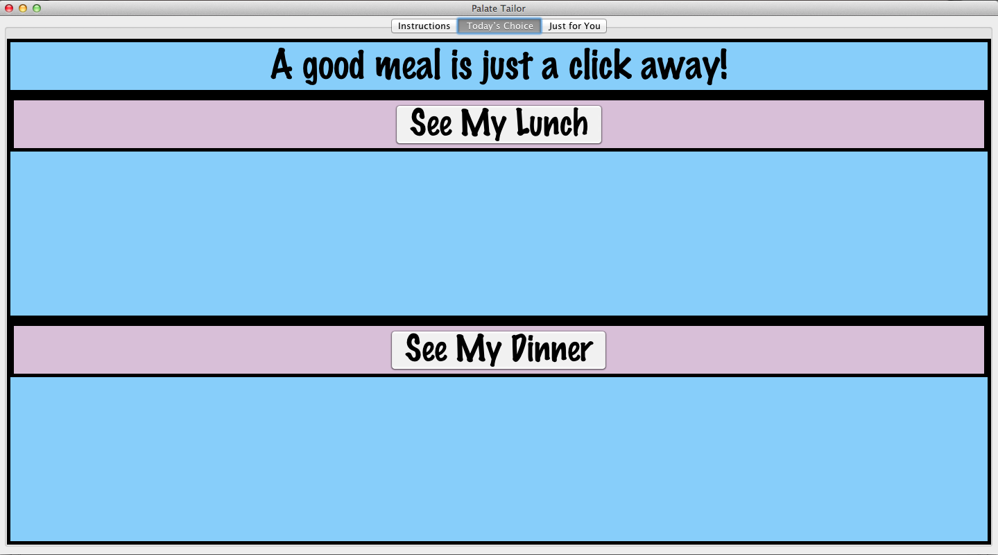

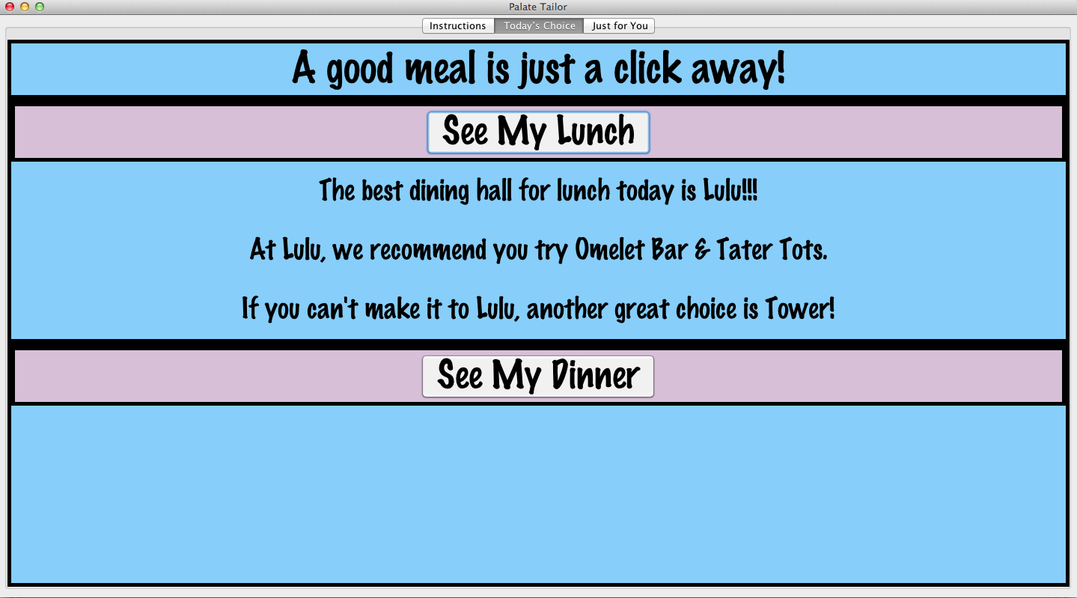

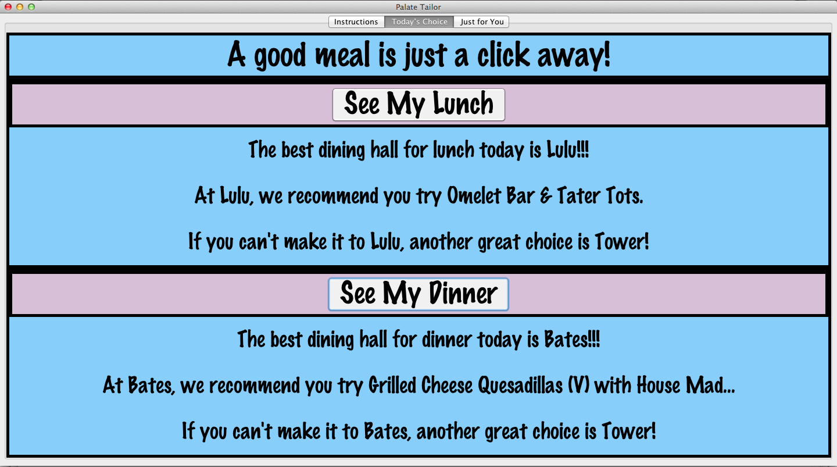

The “Today’s Choice” tab produces a recommendation on the best dining hall to have meal solely based on the student reviews of every dining hall menu for lunch and dinner.

The first image reveals what the tab should look like when it is navigated to from any other panel. It contains a “Lunch” button and a “Dinner” button. The user should select a meal they would like a recommendation for and click the corresponding button.

The second image is a sample depiction of what the display should look like after the user clicks the “Lunch” button. Three lines of text should be displayed. The first line on the display is the name of our top choice dining hall for you to go to for that meal. The second line is the highest rated dish at that first choice dining hall. The third line is the name of the second highest rated dining hall.

The third image is a sample output of a user who has clicked both the “Lunch” and “Dinner” button. Under the “Lunch” button are the results for lunch, and under the “Dinner” button are the recommendations for “Dinner” in the same format as the lunch results (the first line is the best choice, second line is the best dish option at the first choice dining hall, third line is the second highest rated dining hall).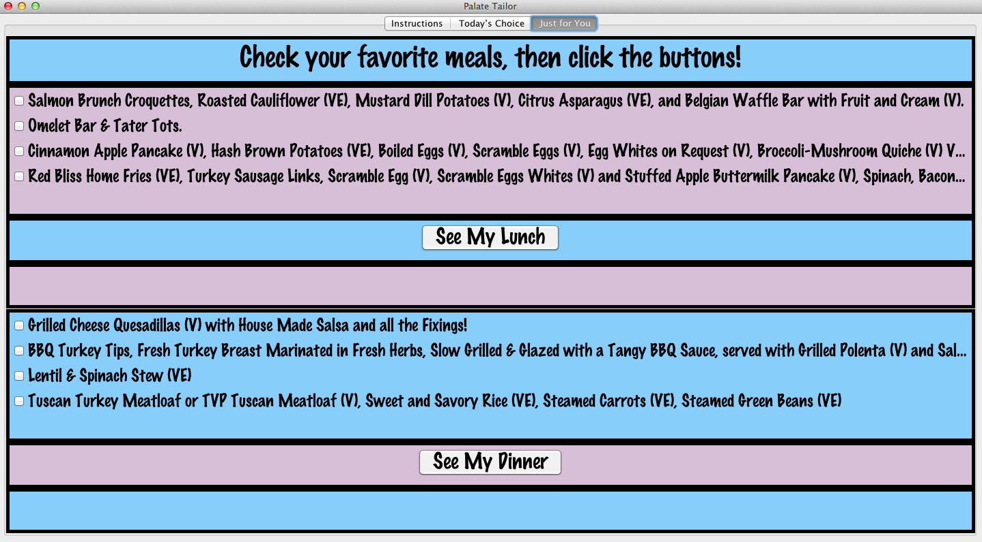

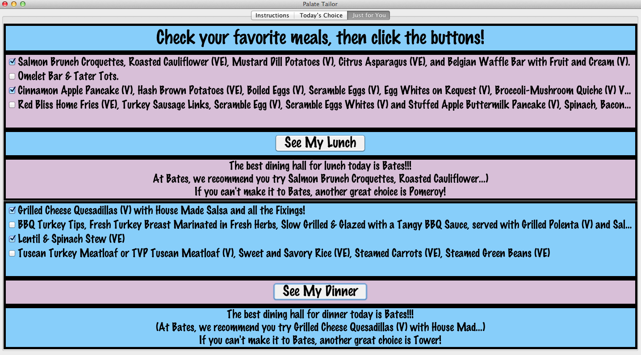

**V. Just For You Tab**

The “Just For You” tab takes your preferences into account when selecting the best dining hall for you to attend that day for lunch or dinner.

The first image shows a sample output of the tab when the user navigates to it from another tab. The user should then select his or her favorite meals by checking the box next to that meal option. After the user has selected all of their preferred meals, they should click the “See My Lunch” button or the “See My Dinner” button, or both.

Once the button corresponding to that meal has been clicked the results will appear. The format of the results is the same as the “Today’s Choice” tab: the first line is the name of the top dining hall, the second line is the top-rated dish at the highest rated dining hall, and the third line is the second highest rated dining hall for that meal. The rankings that are displayed take the user’s preferences into account, so the results of the “Just For You” panel will usually be different than the results of the “Today’s Choice” panel.