Jodie Burnett

Meghan Hamannwright

Trevor Kinaman

Emma Manchester

Arunima Singh

**System Sequence Diagrams**

**System Sequence Diagram: Process Hiring an employee UC1**

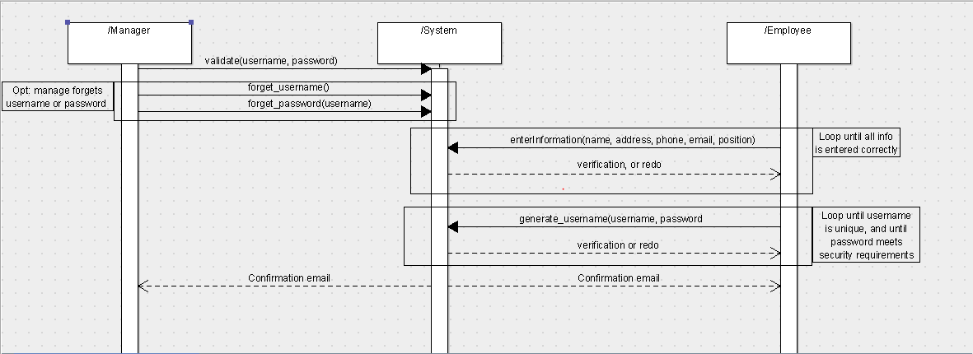

**Use case 1: Process hiring**

**------------------------------------------------------------------------------------------**

**Primary Actor:** Restaurant Manager

**Stakeholders and Interests**: All employees are affected. All employees have to be registered in order to have access to the system. This is an automated way to keep track of employee records.

**Preconditions:** The manager must be identified and authenticated in order to register a new employee.

**Success guarantee:** The employee is registered with the system. The employee is also given an employee ID. Confirmation is sent to the employee’s and managers email account.

**Main success scenario:**

1. Employee and manager are both present to register employee.
2. Manager authenticates, and is given permission by the system to add, edit, or remove employees.
3. Manager or employee enters standard employee information. Information could include name, address, phone number, email, job, relevant education/certifications, etc.
4. System adds employee to database.
5. System asks employee to generate username and password in order to use system.
6. Employee enters a valid username and password.
7. System generates a profile for the employee, and associates username and password with employee profile.
8. Confirmation emails are sent to both the employee and manager.

**Extensions:**

2a) Manager enters incorrect username and password

1. System notifies the manager that the username and password are incorrect.
2. System prompts the manager for the username and password again.
   1. Manager does not remember username/password
      1. Email is sent to the manager with a temporary username/password.
      2. Manager uses temporary login information, and resets password if needed.

3a) Missing fields for information

1. System notifies user that necessary fields are needed in order to register the employee.
2. System highlights fields with missing or incomplete information.
3. System is redirected to the “enter information” page.

3b) Employee with same information is entered twice

1. System identifies two employees with the same email address.
2. System notifies user that the employee could not be added
   1. Note: If existing profile contains a mistake, the manager must edit or delete existing profile separately.

6a) Employee username already exists

1. The system notifies the employee that the username already exists.
2. System then re-prompts user to select a username and password.

6b) Employee password is invalid

1. System notifies employee that the password entered is not valid.
2. System defines parameters for a password. (ie. must be x characters long, and contain y special characters)
3. System re-prompts employee to enter a password.

**Special Requirements**: System must be able to generate employee profile in less than 10 seconds.

**Technology and Data Variation List:**

2a) Manager must be given special permissions to add, edit, or delete an employee profile.

3a) Employee information is entered via a keyboard (touch or physical).

**Frequency of Occurrence:** On average, a few times a year.

**Sequence Diagram: Process Firing Employee UC2**

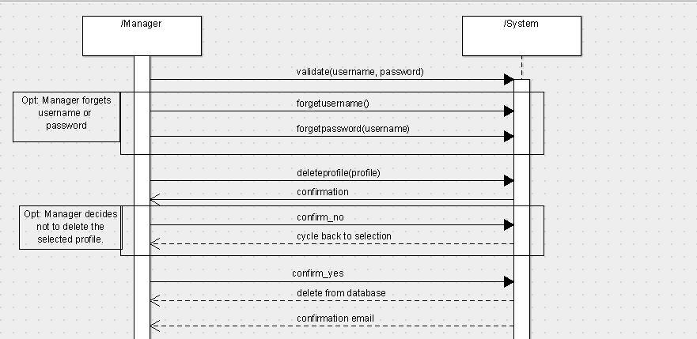

**Use case 2: Process firing an employee**

**------------------------------------------------------------------------------------------**

**Primary Actor:** Restaurant Manager

**Stakeholders and Interests**: All employees are affected. All employees could potentially be fired, or leave to pursue another career. This is an automated way to keep track of employee records.

**Preconditions:** The manager must be identified and authenticated in order to fire an employee. The employee profile must already exist in order to be edited or removed.

**Success guarantee:** The employee’s profile is deleted from the system.

**Main success scenario:**

1. Manager authenticates username and password.
2. Manager selects option to add, edit, or delete employee profile.
3. Manager selects employee profile to delete.
4. System asks manager for confirmation to delete profile.
5. Manager selects “yes”.
6. Employee profile is deleted from list of current employees.
7. System sends confirmation email to manager.

**Extensions:**

1a) Manager enters incorrect username or password

1. System notifies the manager that the username or password are incorrect.
2. System prompts the manager for the username or password again.
   1. Manager does not remember username/password
      1. Email is sent to the manager with a temporary username/password.
      2. Manager uses temporary login information, and resets password if needed.

5a) Manager chooses not to delete the selected profile

1. Manager clicks “No”
2. System keeps selected profile.
3. System goes back to asking which profile the manager wants to delete.

**Special Requirements**: System must be able to remove employee profile in less than 10 seconds.

**Technology and Data Variation List:**

1a) Manager must be given special permissions to add, edit, or delete an employee profile.

1b) Manager is using mouse, keyboard, or touchscreen to interact with system.

**Frequency of Occurrence:** On average, a few times a year

**Sequence Diagram: Edit Employee profile UC3**

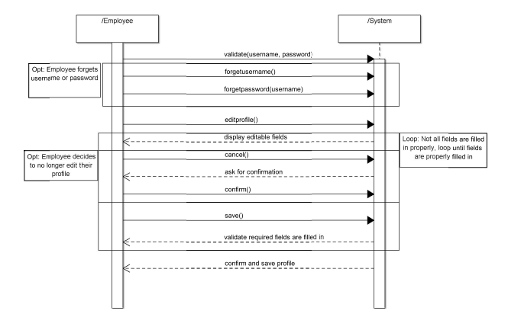

**Use case 3: Process editing employee profiles**

**------------------------------------------------------------------------------------------**

**Primary Actor:** Employee

**Stakeholders and Interests**: All employees are affected. All employees may need to eventually edit their profile. This is an automated way to keep track of employee records.

**Preconditions:** The employee must have an existing profile.

**Success guarantee:** The employee’s profile is deleted from the system.

**Main success scenario:**

1) Employee authenticates with a username and password.

2) Employee selects option to edit their profile.

3) Employee makes necessary changes.

4) Employee clicks the save option.

5) System ensures employee actually wants to overwrite existing profile

6) Employee confirms

7) System saves new employee profile

**Extensions:**

1a) Employee enters incorrect username and password

a. System re-prompts employee for username and password.

b. The “forgot username” and “forgot password” options will send email in case

employee forgot either username or password

i. employee given option to reset either username or password

4a) Not all required fields for employee profile are valid

a. System displays an error message to employee

b. System highlights fields that are missing, incomplete or invalid

c. Employee is able to re-edit fields, and attempt to save again

5a) Employee does not actually want to overwrite their previous profile.

a. System ignores any changes made before the last save and retains copy of

old profile.

**Special Requirements**: System must be able to process changes in less than 10 seconds.

**Technology and Data Variation List:**

1a) Employee using touchscreen, mouse, or keyboard to enter information

**Frequency of Occurrence:** On average, a few times a year

**System Sequence Diagram: Employee paycheck UC4**

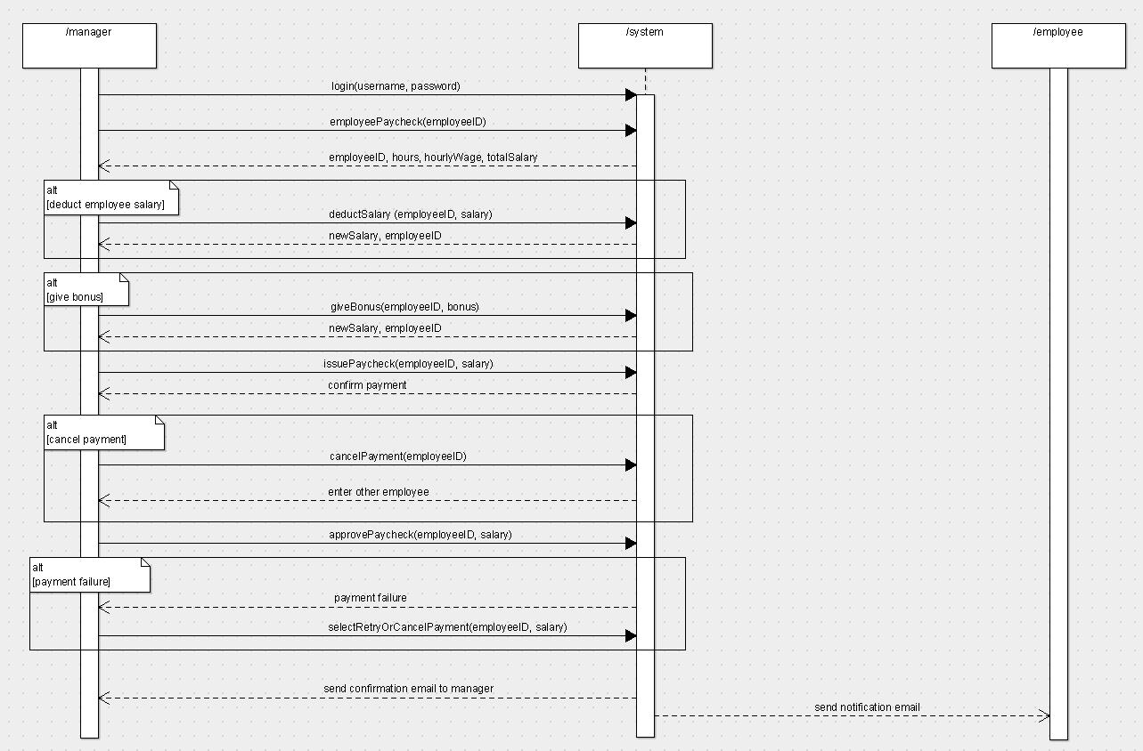

**System Sequence Diagram: Alternative Scenario 1 for UC4**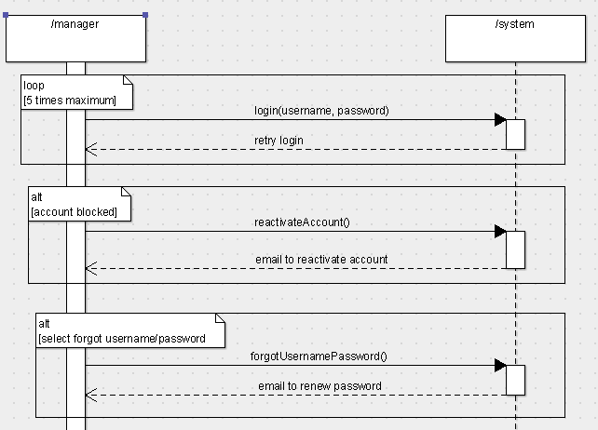

**Use Case 4: Employee paycheck**

**--------------------------------------------------------------------------------------**

**Primary Actor:** Restaurant Manager

**Stakeholders and Interests:** All employees are affected. Depending on the number of work hours, each employee will receive their monthly paycheck. The bank is also one of the stakeholders.

**Preconditions:** All employees must be registered in the system. Their work hours must be stored in the database. The manager should be authenticated in order to give monthly paychecks.

**Success guarantee:** All employees receive their monthly paycheck.

**Main Success Scenario:**

1.       Manager enters the username and password for successful authentication.

2.       Manager selects the issue employee paycheck option.

3.       The system returns the employee id, employee hours, hourly wage, and total salary.

4.       Manager issues a paycheck for the employee.

5.       System asks the manager for paycheck confirmation.

6.       Manager selects “yes.”

7.       A paycheck is issued on the employee’s name.

8.       A confirmation email is sent to the employee.

9.       A notification email is sent to the employee that his/her paycheck is ready.

**Extensions:**

1.       Manager enters wrong username and password.

                               i.            System alerts the manager with incorrect username or password.

                              ii.            System allows the manager to re-enter username and password.

a.       Manager successfully logs in to the system.

b.      Manager fails to login again.

·       After a certain amount of unsuccessful login (let’s say 5), the manager’s account gets blocked for security purposes.

·       A notification email is sent to the manager regarding the login attempts. A link is provided to reactivate the account and to change the password.

                            iii.            Manager selects the “forgot username or password.”

a.       An email is sent to the manager with a link to reset the password.

2.       Manager chooses to not issue the paycheck.

                               i.            Manager selects no during the issue paycheck confirmation.

                              ii.            System keeps the employee information.

                            iii.            System asks the manager to select the employee for the monthly paycheck.

3.       Manager decides to deduct the employee salary.

                               i.            Manager selects the modify salary option.

                              ii.            Manager enters the amount to be deducted along with reasoning.

                            iii.            Manager issues the paycheck.

                            iv.            System asks the manager for paycheck confirmation.

                              v.            Manager selects yes.

                            vi.            A confirmation email is sent to the manager.

                           vii.            A notification email is sent to the employee regarding the update in the paycheck.

4.       Manager decides to give bonus to the employee.

                               i.            Manager selects the modify salary option.

                              ii.            Manager enters the amount to be added along with reasoning.

                            iii.            Manager issues the paycheck.

                            iv.            System asks the manager for paycheck confirmation.

                              v.            Manager selects yes.

                            vi.            A confirmation email is sent to the manager.

                           vii.            A notification email is sent to the employee regarding the update in the paycheck.

5.       Failure to issue the paycheck.

                               i.            Manager is notified with the failure.

                              ii.            Manager can select the retry payment or cancel the payment.

**Special Requirements:** System must issue the paychecks as well as notify the customers within two minutes.

**Technology and Data Variation List:**

1. A database that would store the employee information, hours worked, and total salary.
2. An internet server to issue the paycheck.

**Frequency Occurrence:** Once a month for all the employees.

**System Sequence Diagram: Add inventory UC5**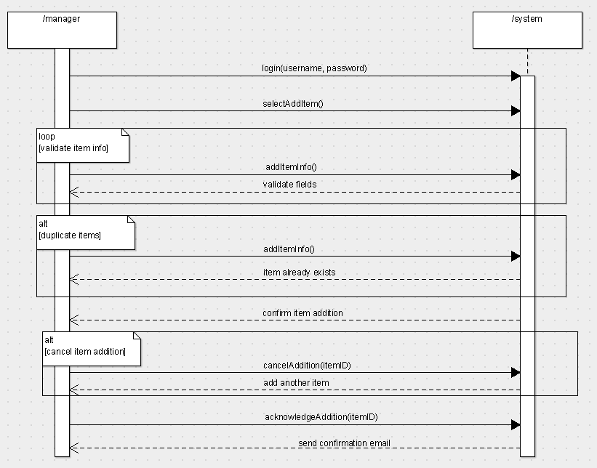

**System Sequence Diagram: Alternative Scenario 1 for UC5  
**

**Use Case 5: Add inventory**

**-------------------------------------------------------------------------------------------------**

**Primary Actor:** Manager

**Stakeholders and Interests:** The cook and the customers are affected.

**Preconditions:** The manager must be authenticated by the system. Each item must have a unique id.

**Success guarantee:** The item is added and the system is updated.

**Main Success Scenario:**

1.       Manager enters the username and password for successful authentication.

2.       Manager selects add new item to the inventory interface.

3.       Manager adds information of the new item.

4.       System validates the fields and checks for duplicates.

5.       On successful validation, the system asks the manager for confirmation to add the inventory.

6.       Manager selects yes.

7.       System adds the item to the database.

8.       System sends an email to the manager regarding the inventory addition.

**Extensions:**

1.       Manager enters wrong username and password.

                              i.            System alerts the manager with incorrect username or password.

                              ii.            System allows the manager to re-enter username and password.

a.       Manager successfully logs in to the system.

b.      Manager fails to login again.

·       After a certain amount of unsuccessful login (let’s say 5), the manager’s account gets blocked for security purposes.

·       A notification email is sent to the manager regarding the login attempts. A link is provided to reactivate the account and to change the password.

                            iii.            Manager selects the “forgot username or password.”

a.       An email is sent to the manager with a link to reset the password.

2.       Manager chooses to not add the inventory.

                               i.            Manager selects no during the confirmation of adding the inventory.

                              ii.            System asks the manager to add another inventory.

3.    The item already exists in the database

       i.       System notifies the manager regarding the duplication of item.

      ii.       System asks the manager to enter a new unique inventory.

4.    Validation error

       i.      System notifies the manager of any validation errors, such as missing fields.

      ii.      Manager reenters the information.

     iii.      System validates the information.

**Special Requirements:** The system must add the inventory to the database within five seconds.

**Technology and Data Variation List:**

1.       A database to store all the item information.

2.       The manager will use a PC, laptop, tablet, or smartphone to add the inventory.

**Frequency Occurrence:** Few times in a month.

**System Sequence Diagram: Update or delete inventory UC6**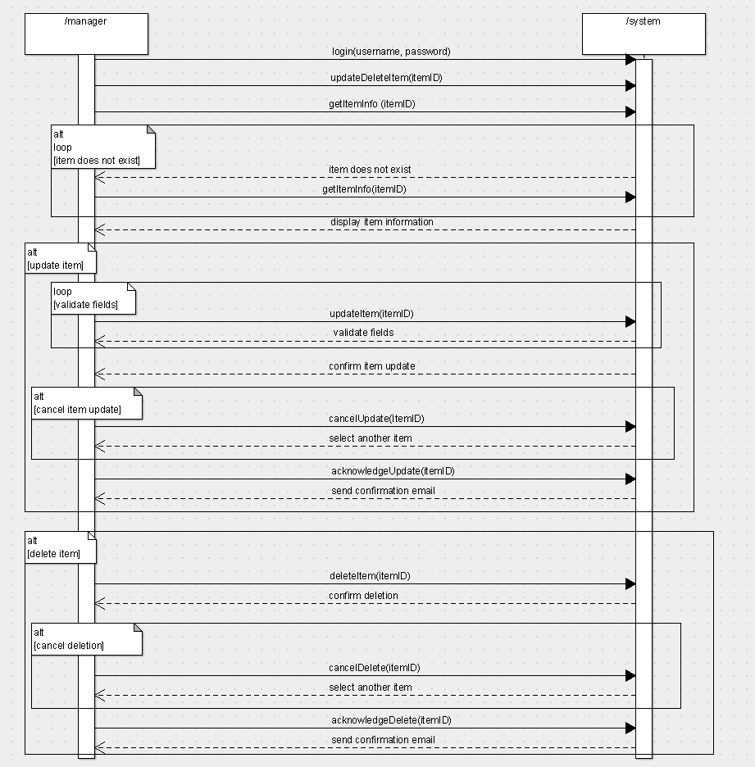

**System Sequence Diagram: Alternative Scenario 1 for UC6  
**

**Use Case 6: Update or delete inventory**

**-------------------------------------------------------------------------------------------------**

**Primary Actor:** Manager

**Stakeholders and Interests:** The cook and the customers are affected.

**Preconditions:** The manager must be authenticated by the system. Each item must have a unique id.

**Success guarantee:** The item is updated or removed from the system.

**Main Success Scenario:**

1.       Manager enters the username and password for successful authentication.

2.       Manager selects update or delete item from the inventory interface.

3.       Manager updates the information of the an item or selects an item for deletion.

4.       In the case of updating an item, the system validates all the fields.

5.       The system asks the manager for confirmation to update or delete an item from the inventory.

6.       Manager selects yes.

7.       System adds the item to the database.

8.       System sends an email to the manager regarding the inventory addition.

**Extensions:**

1.       Manager enters wrong username and password.

                              i.            System alerts the manager with incorrect username or password.

                              ii.            System allows the manager to re-enter username and password.

a.       Manager successfully logs in to the system.

b.      Manager fails to login again.

·       After a certain amount of unsuccessful login (let’s say 5), the manager’s account gets blocked for security purposes.

·       A notification email is sent to the manager regarding the login attempts. A link is provided to reactivate the account and to change the password.

                            iii.            Manager selects the “forgot username or password.”

a.       An email is sent to the manager with a link to reset the password.

2.       Manager chooses to not update or delete an item from the inventory.

                               i.            Manager selects no during the confirmation of adding the inventory.

                              ii.            System restores the original information of that item to the database.

3.    The item does not exist in the database

       i.       System notifies the manager that the item does not exist.

      ii.       System asks the manager to try again.

4.    Validation error during update

       i.      System notifies the manager of any validation errors, such as missing fields.

      ii.      Manager reenters the information.

     iii.      System validates the information.

**Special Requirements:** The system must update or delete the inventory in the database within five seconds.

**Technology and Data Variation List:**

1.       A database to store all the item information.

2.       The manager will use a PC, laptop, tablet, or smartphone to update or delete the inventory.

**Frequency Occurrence:** Few times in a month.

**System Sequence Diagram: Customer Seating UC7**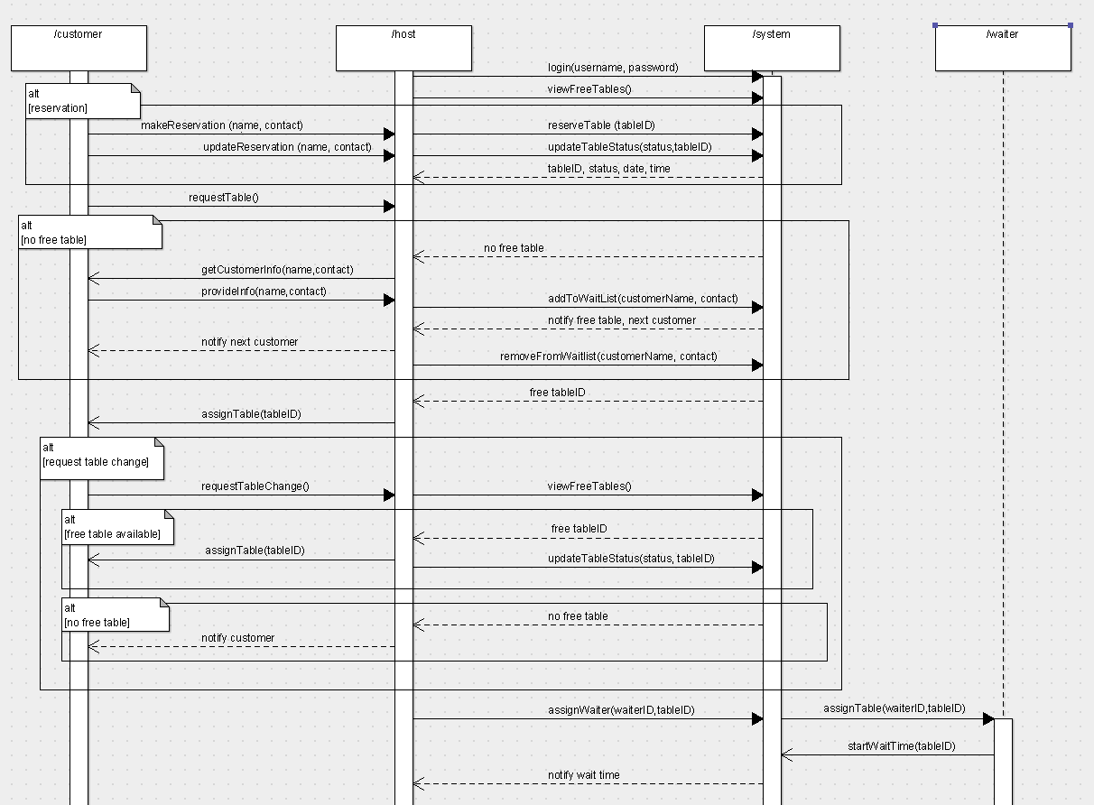

**System Sequence Diagram: Alternative Scenario 1 for UC7**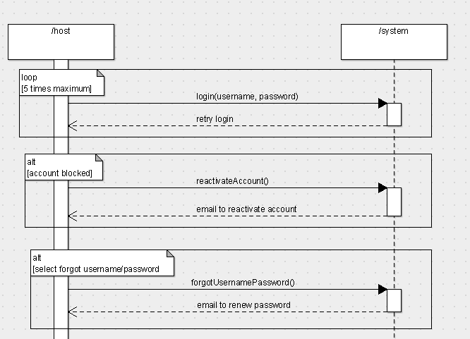

**Use Case 7: Customer Seating**

**----------------------------------------------------------------------------------------**

**Primary Actor:** Host

**Stakeholders and Interests:** The customers and restaurant employees, such as waiters, will be affected.

**Preconditions:** The host is authenticated by the system. There is a customer who hasn’t been seated, and there is a waiter who hasn’t been assigned to that table yet.

**Success guarantee:** Customer is seated and a waiter is assigned to that table.

**Main Success Scenario:**

1.       Host enters the username and password for successful authentication.

2.       Host selects the view table interface, and selects an unoccupied table for the customer.

3.       System asks for confirmation to reserve the table.

4.       Host selects yes.

5.    System changes the table status to occupied.

6.       Host assigns a waiter to the table.

7.      System starts the waiting time of that table.

**Extensions:**

1.       Host enters wrong username and password.

                               i.            System alerts the host with incorrect username or password.

                              ii.            System allows the host to re-enter username and password.

a.       Host successfully logs in to the system.

b.      Host fails to login again.

·       After a certain amount of unsuccessful login (let’s say 5), the host’s account gets blocked for security purposes.

·       A notification email is sent to the host regarding the login attempts. A link is provided to reactivate the account and to change the password.

                            iii.            Host selects the “forgot username or password.”

a.       An email is sent to the host with a link to reset the password.

2.       There are no free tables available.

                               i.            The host takes the customer information and adds them to the waiting list.

                              ii.            When the system changes tables status from occupied to free, the first customer in the     waiting list is notified.

                            iii.            The customer is removed from the waiting list after being seated at that free table.

3.       Customer wants to change the table.

                               i.            Customer requests the host to change the table.

                              ii.            Host checks for free tables.

a.       If there is a free table, the customer can switch their table. The system updates the table status accordingly, and it adds the waiting time from the first table to the second table.

b.      If there are no free tables, the customer continues to be seated at that same table.

4.       Customer wants to reserve the table beforehand.

                   i.            Customer requests a reservation online or by calling the restaurant.

                  ii.            If there is a free table during the customer’s requested date and time period, the system updates the status of that table to be reserved.

                iii.            Once the customer arrives on their reservation date and time, the system updates the table status from reserved to occupied.

                iv.            If the customer cancels the reservation, the system updates the table status from occupied to free.

**Special Requirements:**

       i.            The system must be able to update the table status within ten seconds.

      ii.            The system must notify the assigned waiter if the waiting time on that table has crossed a threshold value.

**Technology and Data Variation List:**

       i.            The host would use a computer, laptop, or tablet to assign tables and waiters.

**Frequency Occurrence:** Multiple times in a day.

**Sequence Diagram: Place Order UC8**

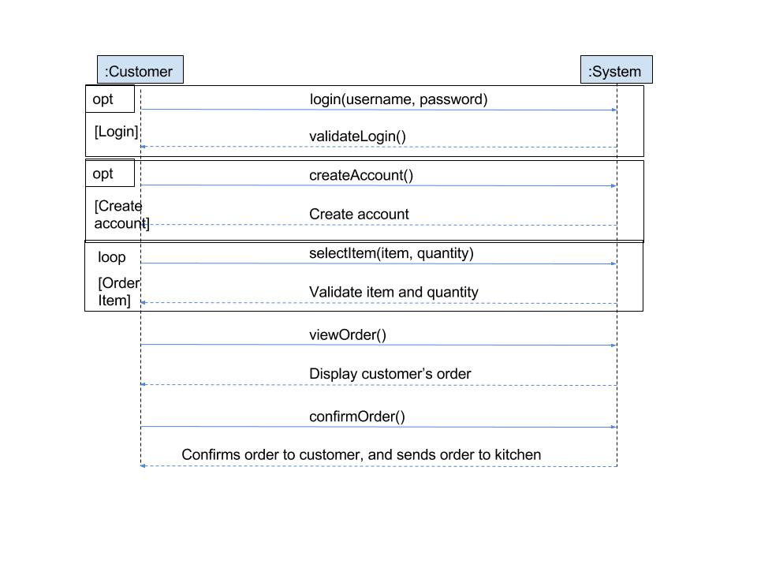

**Use case 8: Place order**

**------------------------------------------------------------------------------------------**

**Primary Actor:** Customers who place orders

**Stakeholders and Interests**: Managers and whoever takes care of inventory management.  All orders will be recorded so managers have a good idea of how much of what items are being ordered in order to properly order supplies.

**Preconditions:** The customer must log in as themselves or as a guest.

**Success guarantee:** The order is successfully received in the kitchen.

**Main success scenario:**

1.   Customer signs in, creates account, or continues as a guest.

2.   The customer selects items he or she wants to order

  3.   Customer adds item/quantity to cart.

  4.   Customer selects option to view and place order.

  5.   System asks customer to confirm order

  6.   Customer confirms.

  7.   System sends order to kitchen

                    a. The system updates order inventory for the kitchen

**Extensions:**

Note: Another option is to allow servers to take orders electronically for the customers, which would be implemented in essentially the same way

  1a) Customer does not remember account information

                    a. Customer selects “forgot username/password”

                    b. Email is sent with options to reset username and password

2a) The customer wants to remove/substitute ingredients from a menu item

                    a. Each item comes with a special notes section

                                i. allows user to enter any additional information or instructions for the item.

2b) Customers with a profile can view previously ordered items

4a) Customer wants to change the items ordered

                    a. System will have a “go back” feature that allows the customer to go back from

                    the checkout to the order menu

4b) Customer wishes to cancel order

                    a. System will have a cancel feature that will remove all items from cart.

                                i. Customer selects cancel order from cart menu

                                ii. System erases all items from cart

6a) Customer does not confirm order

                    a. System will bring customer back to cart menu.

**Special Requirements**: A server that can support holding a small database for food orders.

**Technology and Data Variation List:** User interacts via a touch screen on a tablet.

**Frequency of Occurrence:** Every time a customer orders.

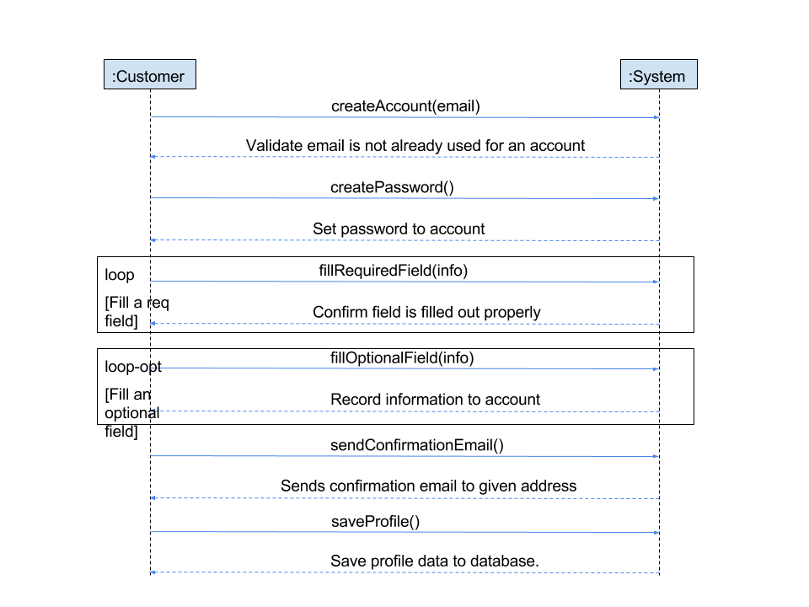**Sequence Diagram: Record Customer’s Information UC9**

**Use case 9: Record customer’s information**

**------------------------------------------------------------------------------------------**

**Primary Actor:** Customers who want to create accounts for the restaurant

**Stakeholders and Interests**: Customers who want to create user accounts in order to receive promotions or get order suggestions. The restaurant business could hold promotions and send coupons through user accounts.

**Preconditions:** The user must not already have a pre-existing account (confirmed by email). Customer must have a valid email address.

**Success guarantee:** The user account is successfully stored in the system.

**Main success scenario:**

        1. Customer selects to make a new account.

                    a. This happens when trying unlock the tablet

                    b. Unregistered customers can sign in as a guest.

        2. Customer enters mandatory fields.

        3. Customer selects username and password

        4. Customer saves profile

        5. Confirmation email is sent to the customer

                    a. Optional coupon is also sent for signing up

**Extensions:**

5a) Not all mandatory fields are filled out

                    a. Customer is brought back to editing page

                    b. Fields that are mandatory are highlighted in red

        5b) Customer information exists an existing profile

                    a. This is confirmed by matching email fields

                    b. The system fails to create a profile

                    c. Customer is notified

                    d. Customer is prompted to sign in to existing account

                                i. Customer has option to reset username and password via the “forgot username/password” option.

**Special Requirements**: A sufficient database is required for storage of profiles.

**Technology and Data Variation List:** Data entered via a touchscreen keyboard on tablet.

**Frequency of Occurrence:** Every time a customer create or updates an account.

**Sequence Diagram: Save customer’s order to their account UC10**

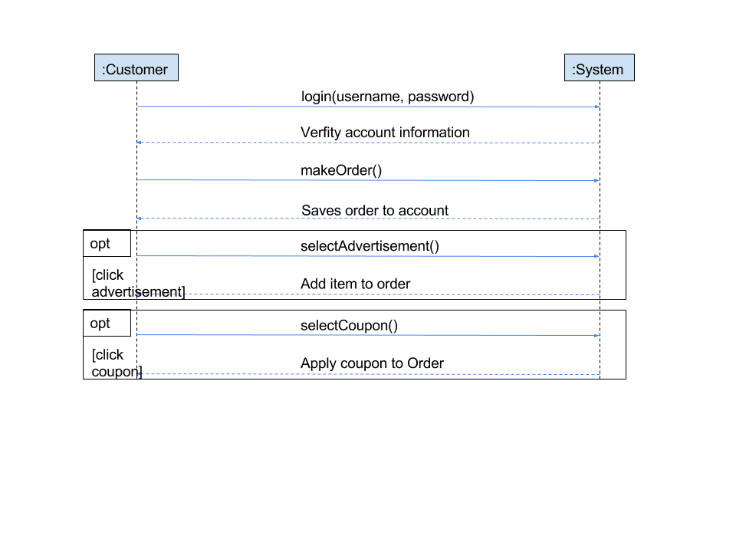

**Use case 10: Save customer’s order to their account**

**------------------------------------------------------------------------------------------**

**Primary Actor:** Customers who already have an account

**Stakeholders and Interests**: All customers with accounts are affected. Management is interested in saving customer’s orders so that the ease of ordering makes it more likely for them to return.

**Preconditions:** A customer has an account, has logged in, and has placed an order

**Success guarantee:** The customer’s order is successfully saved to their order history.

**Main success scenario:**

        1. The system saves order to order history for customer.

        2. The system records a time stamp of when the order was placed.

        3. The system may come up with advertisements / coupons for similar items

                    a. Displayed to customer as special offer when they continue

**Extensions:**

1a) If the order history is more than ~10 items long, oldest orders are removed

        1b) Order history contains link to actual menu items

                    a. hyper link for faster ordering

**Special Requirements**: A database large enough to store customer profiles.

**Technology and Data Variation List:** An internal clock must be able to process a time stamp.

**Frequency of Occurrence:** Every time a customer with an account orders an item.

**Sequence Diagram: Promotions UC11**

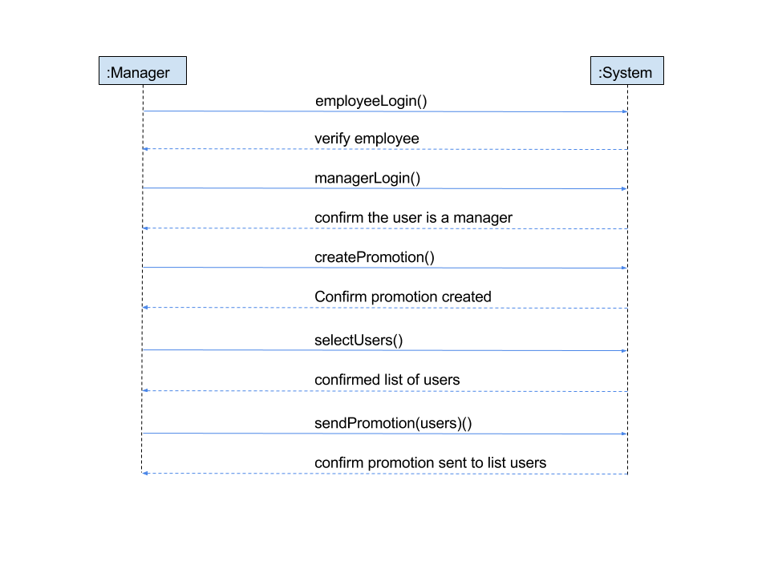

**Use case 11: Promotions**

**------------------------------------------------------------------------------------------**

**Primary Actor:** Customers who already have an account

**Stakeholders and Interests**: Customers with accounts because they will receive promotions via the email set up with their account.  Managers and restaurant owners are also stakeholders because promotions are a good way to increase business.

**Preconditions:** Manager is authenticated.

**Success guarantee:** The user is able to receive coupons and advertisements via email.

**Main success scenario:**

        1. Manager creates promotion material and uploads to distributor software.

        2. Manager elects to send promotion via email to registered customers

        3. System distributed emails to customers

**Extensions:**

        1a) Upload is unsuccessful.

                    a. File size limit to all uploads

                    b. System re-prompts manager for a file up to a given size.

**Special Requirements**: System must be able to send email in under 10 minutes. System must be able to upload file in less than 1 minute.

**Technology and Data Variation List:** All input is through a touchscreen keyboard.

**Frequency of Occurrence:** Every time a customer with an account orders an item or on special occasions for promotions

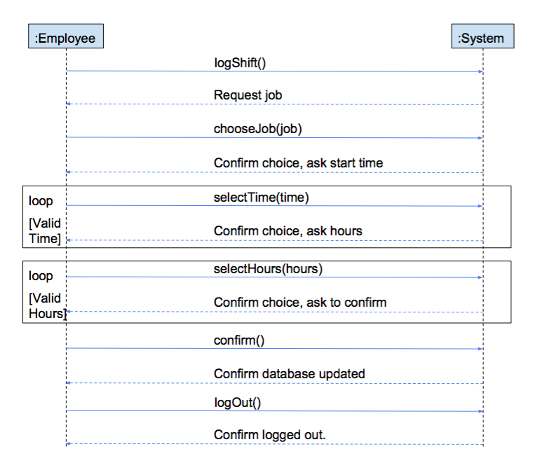**System Sequence Diagram: Record Employee Shift UC12**

**Use case 12: Record Employee Shift**

**------------------------------------------------------------------------------------------**

**Primary Actor:** Employee

**Stakeholders and Interests**:  All employees require payment. Managers and restaurant owners are also stakeholders because payroll is an important financial aspect to restaurant management.

**Preconditions:** Employee has an account, and has been authenticated

**Success guarantee:** Time spent working has been successfully recorded

**Main success scenario:**

           1. Employee selects “time sheet entry” option on internal management tablet

           2. Employee selects job

           3. Employee inputs start time

           4. Employee inputs number of hours worked

           5. Employee saves time sheet entry

           6. System records time sheet entry

           7. Employee logs out.

**Extensions:**

3a) Employee enters an invalid start time

                       a. System notifies the employee of invalid entry

                       b. Employee is brought back to edit page

                       c. Employee asked to enter a valid time

           4a) Employee enters an invalid number of hours worked

                       a. System notifies the employee of invalid entry

                       b. Employee is brought back to edit page

                       c. Employee asked to enter a valid number of hours

**Special Requirements**: Entry must be recorded in less than 10 seconds.

**Technology and Data Variation List:** All data is entered via touchscreen on a tablet

**Frequency of Occurrence:** Every time an employee works a shift

**System Sequence Diagram: Calculate customer tip UC13**

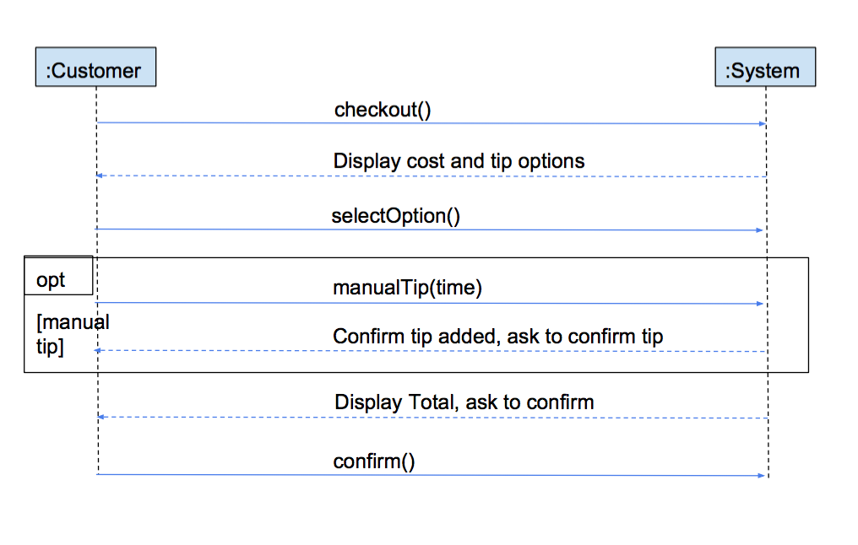

**Use case 13: Calculate customer tip**

**------------------------------------------------------------------------------------------**

**Primary Actor:** Customer

**Stakeholders and Interests**:  Employees who could benefit from a more generous suggested tip.

**Preconditions:** Customer is paying for meal.

**Success guarantee:** The tip has been successfully added to order total.

**Main success scenario:**

           1. Default tip of 15% is calculated based on order total

           2. Tip is added to order total

           3. Customer reviews order total, and confirms the correct total

**Extensions:**

3a) Customer chooses to adjust tip amount.

                       a. Customer can select option to adjust tip

                       b. Customer enters tip amount in dollars

                       c. New tip amount is added to order

**Special Requirements**: None.

**Technology and Data Variation List:** Customer views amount on a tablet and adjusts tip amount via a touchscreen.

**Frequency of Occurrence:** Every time a customer orders

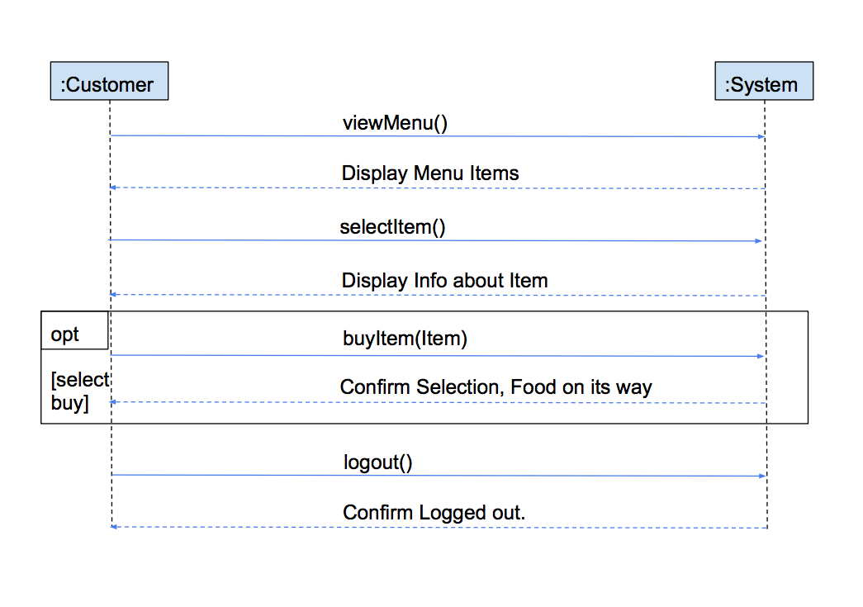**System Sequence Diagram: Show Menu Items UC14**

**Use case 14: Show Menu Items**

**------------------------------------------------------------------------------------------**

**Primary Actor:** Customer

**Stakeholders and Interests**:  Managers and employees because they want an accurate portrayal of what is on the menu. Customers also want a graphic display of different options in order to make a more informed decision.

**Preconditions:** Customer is signed in (potentially as a guest).

**Success guarantee:** The customer is able to view menu items

**Main success scenario:**

           1. The customer clicks through different tabs

                       a. Representative of different menu sections

           2. Customer is able to tap menu item

           3. Information about menu item appears

                       a. ingredients, health information, gluten-free available, house special, etc.

           4. Option to order item also appears

**Extensions:**

3a) Customer wants to go back to main menu

                       a. A back button will bring customers back to previous location

**Special Requirements**: Text must be large enough to view from 1ft away. Pictures require a resolution of 3.1 mega pixels. Touch response time and loading time combined must be less than 1 second.

**Technology and Data Variation List:** All user input through touchscreen.

**Frequency of Occurrence:** Every time a customer wants to view the menu

**System Sequence Diagram: Process Customer Payment UC15**

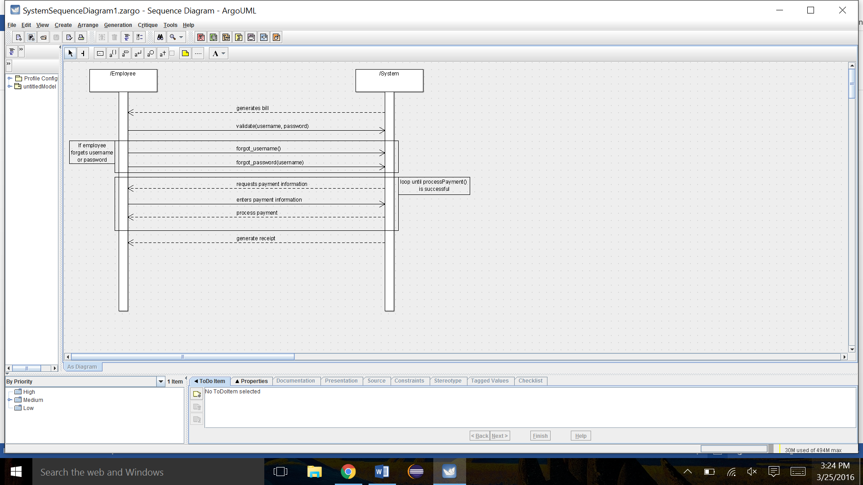

**Use Case 15: Process Customer Payment**

**------------------------------------------------------------------------------------**

**Primary Actor:** Waiter

**Stakeholders and Interests:** The customer and the cashier will be affected, as well as potentially waiters and management, if there is an error in the payment process.

**Preconditions:** The waiter is authenticated as able to handle payments. The customer has finished their meal, and the outstanding bill has been created within the system by the waiter. The bill has been delivered to the customer at their table, and they have returned the bill with either cash, debit, or credit card as payment.

**Success Guarantee:** The payment is approved by the system, and either an electronic or paper receipt is printed for both the restaurant and the customer’s record.

**Main success scenario:**

1. An outstanding bill is generated by the waiter and added to the system with some sort of flag to identify it as outstanding.
2. A paper copy of the bill is delivered to the customer at their table, and they return it to the waiter with their form of payment.
3. The waiter authenticates themselves to the system, and brings up the outstanding bill.
4. The system requests information on what type of payment is being used.
5. The system processes the payment.
6. The system generates a customer and restaurant copy of the receipt.
7. The system adds the transaction information to a database.
8. The customer’s copy of the receipt is delivered to their table.

**Extensions:**

1. The customer’s payment does not go through.

a. The system notifies the user of the failed payment, and offers a prompt to try a new form of payment, or try again with the current form.

     2.  The manager wants to comp the customer’s meal.

a. A special option should be available on every outstanding bill to comp the customer’s meal. The waiter selects this option, and the system asks for confirmation from a manager. The system authenticates the manager, and allows the bill to be marked as paid. The bill is added to a special list of manager comped meals to be kept track of by bookkeeping.

    3.   The waiter’s authentication to handle payment fails.

a. The system notifies the user of the failed authentication. It prompts the user to try again, or to have a different user authenticate themselves.

**Special Requirements:** The payment must process in 10 seconds or less (not counting the time it takes for the waiter to handle cash, if that is the form of payment being used).

**Technology and Data Variation List:**

1. A point of sale system, which consists of a cash drawer and some sort of screen on which you can complete payments.
2. A database to hold all the transaction information.

**Frequency of Occurrence:** Extremely often, could be hundreds of times per day.

**System Sequence Diagram: Food Delivery UC16**

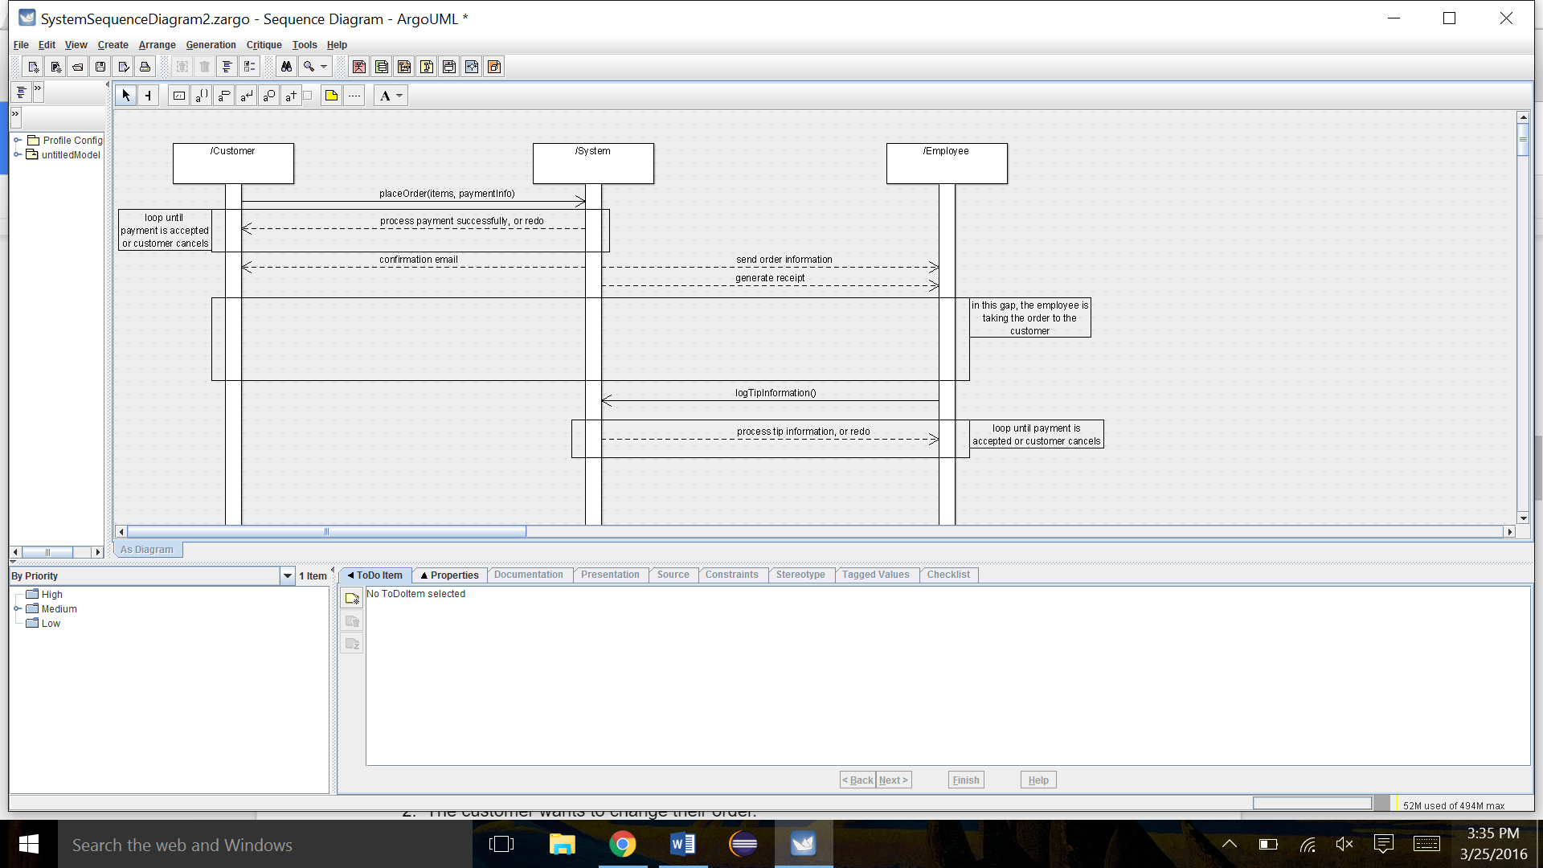

**Use Case 16: Food Delivery**

**--------------------------------------------------------------------------**

**Primary Actor:** The delivery person

**Stakeholders and Interests:** The customers at home, and the delivery person will be affected. Managers may also be affected if something goes wrong with payment.

**Preconditions:** An order has been logged by the system. If the payment type is credit or debit, then the payment has already been processed automatically by the system, and a paper receipt has been generated with a tip line included. If the payment type is marked as cash, the system generates a customer and restaurant copy of the receipt with the total, and no tip line. The delivery person has gone out, delivered the order, and returned with either the completed receipt, or the cash from the order and the restaurant copy of the receipt.

**Success Guarantee:** The delivery person logs the transaction as completed in the system, and the system charges the extra amount due to tip to the customer’s card (if applicable). If it was a cash transaction, the delivery person puts the cash into the drawer.

**Main Success Scenario:**

1. A customer enters a delivery order through the restaurant’s site, which is then sent to the system for processing.
2. If using credit or debit, the system processes the payment successfully.
3. The system generates an order to be sent to the kitchen, with a special flag to mark it as a delivery order.
4. The system generates either a debit/credit receipt with a tip line, or a cash receipt with no tip line.
5. The order is made and given to the delivery person to be taken to the customer.
6. The delivery person takes the order to the customer, and the customer completes the receipt as necessary.
7. The delivery person returns to the restaurant, and logs the tip information, allowing the system to charge the customer the extra amount for the tip.
8. The transaction is marked as completed, and added to the database for transactions.
9. If it’s a cash transaction, the delivery person puts the total amount back into the cash drawer.

**Extensions:**

1. The customer cancels their order.

a. The system should have an option to cancel an order and void the transaction. A notification is sent to the kitchen to waste whatever amount of food they’ve already made and prompts them to log the waste in the system.

     2.  The customer wants to change their order.

a. The system has an option to pull up the order and change it. The system has an option to pull up the order, and if selecting ‘Make Changes’, a prompt will appear asking the user to detail the changes. The changes will be sent to the kitchen as an alert.

     3.  The customer’s payment doesn’t go through.

a. The payment fails to go through in the system, and an alert is sent back to the site notifying the customer of failed payment. The order is not generated and sent to the kitchen.

**Special Requirements:** There must be something in place so the system can communicate with the restaurant’s site to send notifications of failed payment to the customer.

**Technology and Data Variation List:**

1. A point of sale system (Integrated through touch screen on tablet)
2. A database for holding transaction information

**Frequency of Occurrence:** Daily, could be anything from 10-50 orders a day (possibly more depending on the popularity of delivery for the specific restaurant)

**System Sequence Diagram: Add/Update/Remove Menu items UC17**

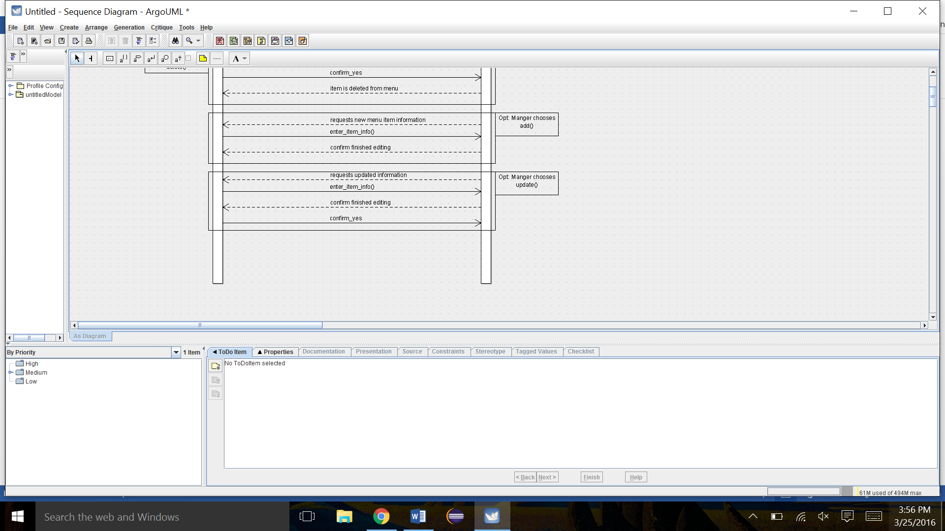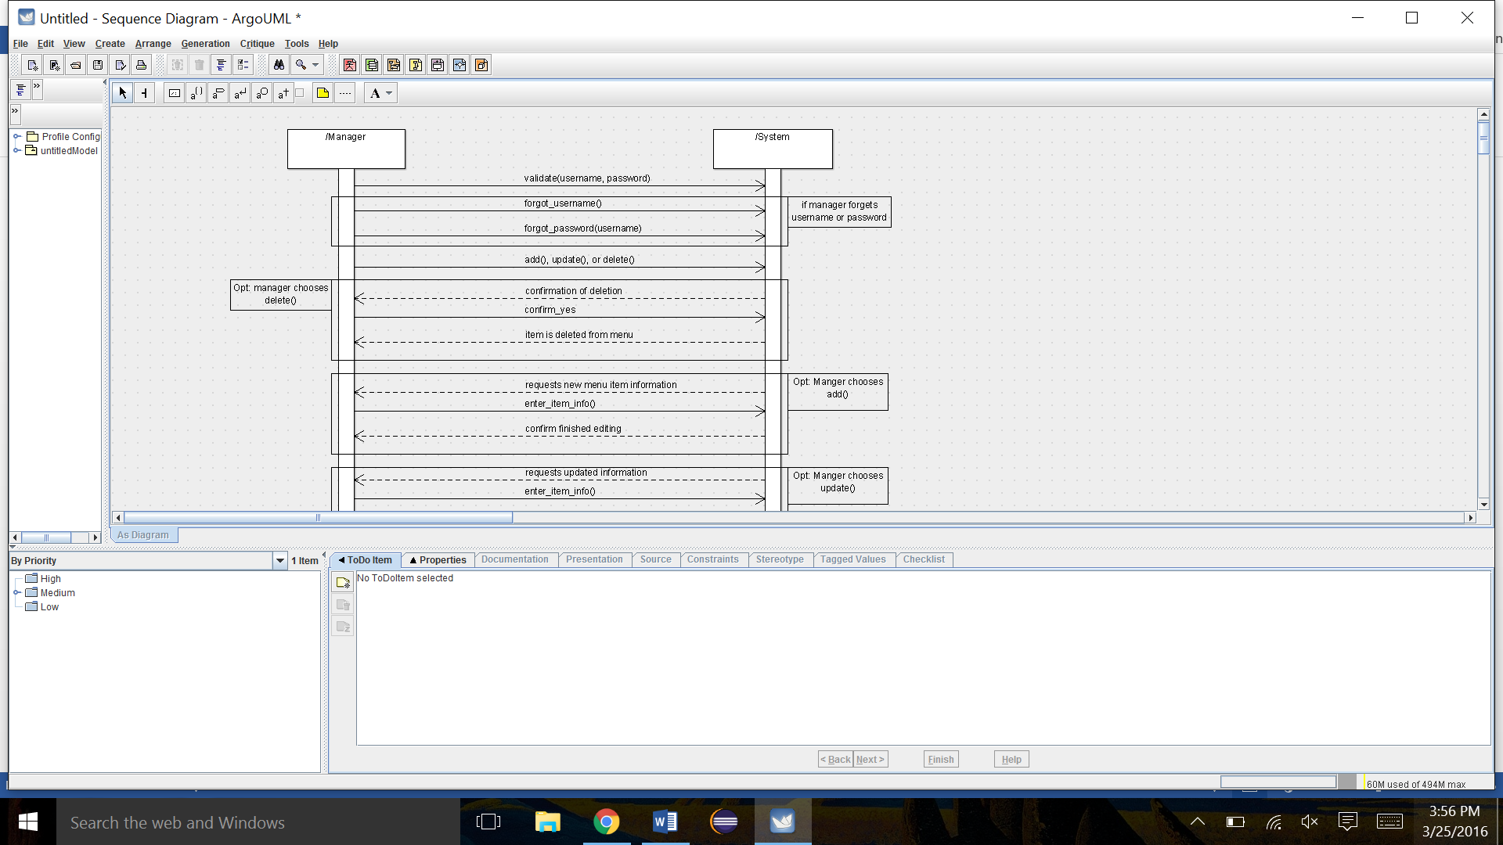

**Use Case 17: Add/Update/Remove Menu Items**

**-------------------------------------------------------------------------------------------**

**Primary Actor:** Manager

**Stakeholders and Interests:** All employees are affected by changes in menu items. Customers are also affected.

**Preconditions:** The manager must be authenticated to alter the menu.

**Success Guarantee:** Either a new item is added, an item is removed, or an item is successfully updated.

**Main Success Scenario:**

1. The system authenticates the manager as being able to alter the menu.
2. Manager selects between the option of add, update, or remove a menu item.
3. If deleting an item, the manager selects the item to delete.

* The system asks for confirmation on deletion of the item.
* Manager selects “Yes”.
* Item is deleted from current list of menu items.

    4.   If adding an item, a prompt will appear asking the manager for information on the item.

* The manager enters the new item’s information.
* The manager chooses an option to notify the system they are done entering information.
* The system asks for confirmation that the item is complete.
* Manager selects “Yes”.
* Item is added to current list of menu items.

    5.   If updating an item, the manager selects the item to update.

* The system pulls up the item to be updated, and opens a window allowing the manager to edit the current information.
* The manager alters the information as necessary.
* The manager chooses an option to notify the system they are done entering information.
* The system asks for confirmation that the item is complete.
* Manager selects “Yes”.
* Item is updated within the list of menu items.

**Extensions:**

1. The manager wants to cancel their add/update/remove request.

a. There should be an option during the process to cancel the request. The system will back out of the add/update/remove prompt and return to the menu.

**Special Requirements:** The system should update the menu/process the change within 10 seconds.

**Technology and Data Variation List:**

1. A database to store all the menu items.
2. A touchscreen tablet on which the manager makes the changes and follows the prompts.

**Frequency of Occurrence:** Not extremely often (at good restaurants, the menu does not change every day). About once or twice every month, possibly more in certain months with holiday promotion items.