**System Sequence Diagram: Process Hiring an employee**

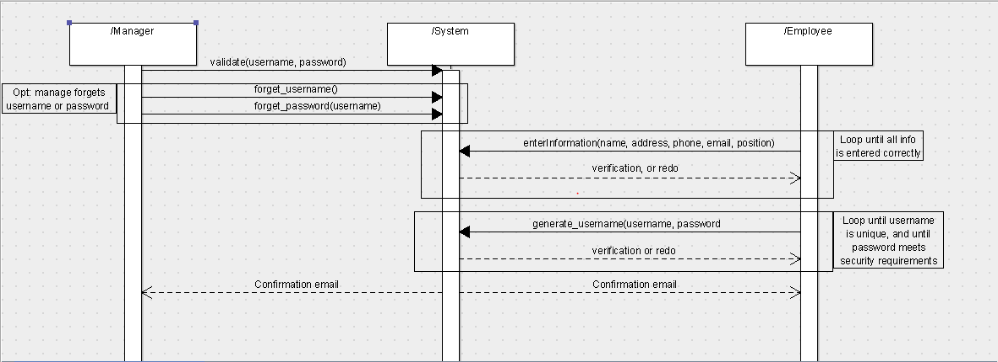

**Use case 1: Process hiring**

**------------------------------------------------------------------------------------------**

**Primary Actor:** Restaurant Manager

**Stakeholders and Interests**: All employees are affected. All employees have to be registered in order to have access to the system. This is an automated way to keep track of employee records.

**Preconditions:** The manager must be identified and authenticated in order to register a new employee.

**Success guarantee:** The employee is registered with the system. The employee is also given an employee ID. Confirmation is sent to the employee’s and managers email account.

**Main success scenario:**

1. Employee and manager are both present to register employee.
2. Manager authenticates, and is given permission by the system to add, edit, or remove employees.
3. Manager or employee enters standard employee information. Information could include name, address, phone number, email, job, relevant education/certifications, etc.
4. System adds employee to database.
5. System asks employee to generate username and password in order to use system.
6. Employee enters a valid username and password.
7. System generates a profile for the employee, and associates username and password with employee profile.
8. Confirmation emails are sent to both the employee and manager.

**Extensions:**

2a) Manager enters incorrect username and password

1. System notifies the manager that the username and password are incorrect.
2. System prompts the manager for the username and password again.
   1. Manager does not remember username/password
      1. Email is sent to the manager with a temporary username/password.
      2. Manager uses temporary login information, and resets password if needed.

3a) Missing fields for information

1. System notifies user that necessary fields are needed in order to register the employee.
2. System highlights fields with missing or incomplete information.
3. System is redirected to the “enter information” page.

3b) Employee with same information is entered twice

1. System identifies two employees with the same email address.
2. System notifies user that the employee could not be added
   1. Note: If existing profile contains a mistake, the manager must edit or delete existing profile separately.

6a) Employee username already exists

1. The system notifies the employee that the username already exists.
2. System then re-prompts user to select a username and password.

6b) Employee password is invalid

1. System notifies employee that the password entered is not valid.
2. System defines parameters for a password. (ie. must be x characters long, and contain y special characters)
3. System re-prompts employee to enter a password.

**Special Requirements**: System must be able to generate employee profile in less than 10 seconds.

**Technology and Data Variation List:**

2a) Manager must be given special permissions to add, edit, or delete an employee profile.

3a) Employee information is entered via a keyboard (touch or physical).

**Frequency of Occurrence:** On average, a few times a year.

**Sequence Diagram: Process Firing Employee**

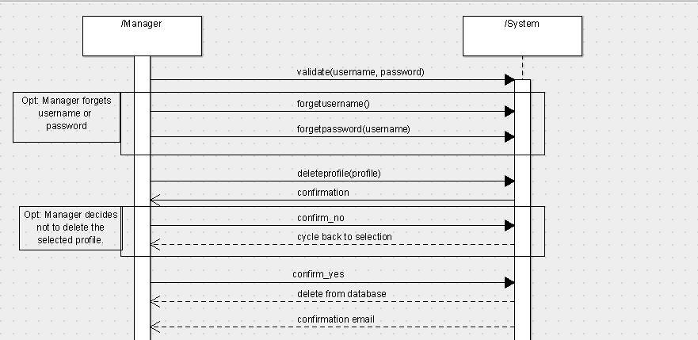

**Use case 2: Process firing an employee**

**------------------------------------------------------------------------------------------**

**Primary Actor:** Restaurant Manager

**Stakeholders and Interests**: All employees are affected. All employees could potentially be fired, or leave to pursue another career. This is an automated way to keep track of employee records.

**Preconditions:** The manager must be identified and authenticated in order to fire an employee. The employee profile must already exist in order to be edited or removed.

**Success guarantee:** The employee’s profile is deleted from the system.

**Main success scenario:**

1. Manager authenticates username and password.
2. Manager selects option to add, edit, or delete employee profile.
3. Manager selects employee profile to delete.
4. System asks manager for confirmation to delete profile.
5. Manager selects “yes”.
6. Employee profile is deleted from list of current employees.
7. System sends confirmation email to manager.

**Extensions:**

1a) Manager enters incorrect username or password

1. System notifies the manager that the username or password are incorrect.
2. System prompts the manager for the username or password again.
   1. Manager does not remember username/password
      1. Email is sent to the manager with a temporary username/password.
      2. Manager uses temporary login information, and resets password if needed.

5a) Manager chooses not to delete the selected profile

1. Manager clicks “No”
2. System keeps selected profile.
3. System goes back to asking which profile the manager wants to delete.

**Special Requirements**: System must be able to remove employee profile in less than 10 seconds.

**Technology and Data Variation List:**

1a) Manager must be given special permissions to add, edit, or delete an employee profile.

1b) Manager is using mouse, keyboard, or touchscreen to interact with system.

**Frequency of Occurrence:** On average, a few times a year

**Sequence Diagram: Edit Employee profile**

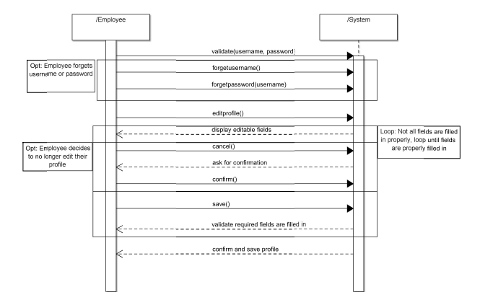

**Use case 3: Process editing employee profiles**

**------------------------------------------------------------------------------------------**

**Primary Actor:** Employee

**Stakeholders and Interests**: All employees are affected. All employees may need to eventually edit their profile. This is an automated way to keep track of employee records.

**Preconditions:** The employee must have an existing profile.

**Success guarantee:** The employee’s profile is deleted from the system.

**Main success scenario:**

1) Employee authenticates with a username and password.

2) Employee selects option to edit their profile.

3) Employee makes necessary changes.

4) Employee clicks the save option.

5) System ensures employee actually wants to overwrite existing profile

6) Employee confirms

7) System saves new employee profile

**Extensions:**

1a) Employee enters incorrect username and password

a. System re-prompts employee for username and password.

b. The “forgot username” and “forgot password” options will send email in case

employee forgot either username or password

i. employee given option to reset either username or password

4a) Not all required fields for employee profile are valid

a. System displays an error message to employee

b. System highlights fields that are missing, incomplete or invalid

c. Employee is able to re-edit fields, and attempt to save again

5a) Employee does not actually want to overwrite their previous profile.

a. System ignores any changes made before the last save and retains copy of

old profile.

**Special Requirements**: System must be able to process changes in less than 10 seconds.

**Technology and Data Variation List:**

1a) Employee using touchscreen, mouse, or keyboard to enter information

**Frequency of Occurrence:** On average, a few times a year