Targeted LTBI screening and health economics in the APY Lands
Updated planning and economic evaluation report for South Australia Public Health
Research question
Does targeted screening in the APY Lands improve efficiency, health gain, and value for money without compromising community-wide access?
Prepared for
South Australia Public Health
Important use note. This report is designed to support service planning and prioritisation, not to make decisions about any individual person. The model should inform sequencing and outreach effort. It should not be used to refuse screening or treatment.

PLACEHOLDER: Cover image
Insert approved APY Lands image, community-context image, or map. Add attribution and permission statement.

Draft status: this Word version incorporates the existing APY LTBI screening report and adds a health-economic module for DALYs, QALYs, ICERs, and Australian-system assumptions. Yellow highlighting marks items requiring replacement or final review.

Executive summary
This report updates the APY latent tuberculosis infection (LTBI) screening planning analysis and extends it with a health-economic component. The epidemiological component uses the current APY individual-level model to simulate a closed cohort of 1,500 people, screened over a 2-year window and followed for 20 years. The model generates exact ages from the APY age distribution, estimates LTBI risk through an age-based cumulative risk model, applies screening and preventive treatment pathways, and summarises infections cured or protected, active TB cases prevented, false-positive treatment, and efficiency metrics.
Across the illustrative IGRA plus 3HP scenarios, targeted sequencing remains more efficient than random sequencing when programme capacity is constrained. The gain is largest at lower treated proportions and narrows as coverage expands. Cure-targeted sequencing is most efficient for curing or protecting LTBI among those first reached, while prevention-targeted sequencing is most efficient for preventing future active TB cases.
The new health-economic extension estimates programme costs, DALYs averted, QALYs gained, and incremental cost-effectiveness ratios (ICERs) using Australian health-system assumptions informed by Dale et al. and the existing APY model output structure. Costs are expressed in 2019 Australian dollars, and the default health-economic framing uses an Australian health-care system perspective. The module estimates direct person-level health gains from active TB cases prevented; it does not include downstream transmission effects.
In the base-case health-economic outputs, all four IGRA plus 3HP strategies were cost-saving relative to baseline TB disease costs. The prevention-targeted strategy had the lowest cost per DALY averted (AUD $-8,484), the lowest cost per Dale-compatible mortality-adjusted QALY gained (AUD $-10,582), and the lowest cost per active TB case prevented (AUD $-13,969). These findings should be interpreted with two important caveats: programme setup/running costs are currently set to zero unless supplied, and TB mortality/YLL assumptions require final clinical and methods review.

Recommended policy position: a targeted strategy should be pursued as a sequencing and outreach-prioritisation tool, weighing efficiency and cost-effectiveness gains against operational simplicity and acceptability. Access should remain open to anyone who presents, is clinically indicated, or requests screening or treatment.

How this report should be used
- Use the model to compare screening and treatment sequencing strategies, not to decide whether any individual person should be offered care.
- Interpret targeting as a way to prioritise early outreach when staff time, travel, follow-up capacity, or treatment support capacity are constrained.
- Interpret the health-economic results as direct person-level programme results, not as a dynamic transmission economic model.
- Update the yellow-highlighted placeholders once the final DALY/QALY/ICER output tables and figures have been reviewed.

Research question and policy use
Primary question: does targeted LTBI screening in the APY Lands improve efficiency and value for money without compromising coverage?
In this report, efficiency means achieving greater benefit for the same programme effort: curing or protecting more LTBI, preventing more future active TB, reducing the number needed to screen or treat, or improving cost per health outcome gained. The practical use case is sequencing. If the programme cannot immediately offer the same intensity of outreach, follow-up, and treatment support to everyone, which people or communities should be approached first?
Equity guardrail. The model supports sequencing and prioritisation, not exclusion. Anyone who presents, is clinically indicated, or requests screening should remain able to access care.

The model is a planning model rather than an operational protocol. It is intended to answer comparative questions such as what is gained if the first rounds of outreach are targeted, rather than to set a rigid rule about who can or cannot be tested.

Epidemiological model overview
A closed cohort of 1,500 people is simulated and screened over the next 2 years, then followed for 20 years. Each simulated person is assigned an exact age from the APY age distribution. Other risk factors remain linked to existing broad age groups unless the user supplies different prevalence inputs.
LTBI risk is generated using a complementary log-log form, p(LTBI) = 1 - exp(-exp(eta)), so age behaves as a cumulative exposure process rather than a simple yes/no age-group multiplier.
Table 1. Epidemiological model workflow.
Step | What happens
Generate cohort | Sample 1,500 people, assign exact ages from the APY age distribution, and assign risk factors using local prevalence inputs.
Estimate LTBI risk | Use age as a cumulative exposure process and apply retained infection predictors for marijuana use, close contact, and renal disease.
Estimate untreated progression | Apply literature-based progression/reactivation risk multipliers and calibrate active TB hazard to the observed active TB prevalence target.
Apply screening | Spread screening across the first 2 years and apply the chosen test and targeting rule.
Apply preventive treatment | Move test-positive, non-active participants through treatment start, completion, adverse-reaction stop, and partial-treatment logic.
Summarise outcomes | Count false positives, treatment courses, infections protected or cured, active TB cases prevented, and efficiency metrics.

Interpretation note. The model is a person-level prevention model, not a full transmission model. Prevented TB cases are direct person-level cases prevented, not downstream transmission effects. Results are strongest for comparing strategies against each other rather than forecasting exact future case numbers.

Parameters and sources
The current analysis uses the default APY scenario as the base case. These settings can be replaced through the user-facing runner or Python APY backend without changing core model code.
Table 2. Current pathway and cascade assumptions used in the illustrative APY analysis.
Parameter | Base-case value | Source / note
Illustrative cohort size per run | 1,500 people | Model setting for each Monte Carlo replicate
Monte Carlo replicates | 2,000 | Illustrative planning default
Screening window | 2 years | Current APY planning assumption
Follow-up horizon | 20 years | Current APY planning assumption
Default test | IGRA | Stakeholder-selected default
Default preventive regimen | 3HP | 12 doses over 3 months
Treatment start probability | 0.85 | Current analytical default; user-editable
3HP completion probability | 0.80 | Current analytical default; user-editable
3HP treatment-limiting ADR stop | 0.05 | Current analytical default; user-editable
3HP full-course efficacy | 0.85 | Current analytical default; user-editable

Table 3. Calibration targets and key epidemiological inputs.
Parameter | Base-case value | Source / note
LTBI prevalence target | 7.53% | Barry et al. APY screening study / supplied preprint
Active TB prevalence target | 1.30% | Barry et al. APY screening study / supplied preprint
Crude age contrast for LTBI | OR 7.54 for >=25 vs <25 | Barry et al. APY screening study
Exact-age distribution | APY age profile with smoothed column | Supplied APY age-distribution input
LTBI predictors retained | Marijuana 3.65; close contact 2.53; renal disease 2.19 | Adjusted infection ORs from Barry et al.
Progression/reactivation multipliers | Contact 5; marijuana 3; renal 10; diabetes 3; smoking 2; chronic lung disease 3; alcohol/drugs 3 | Literature-review / planning inputs
Other risk-factor prevalences | Three broad age groups for most factors; overall values for sex and BCG | Current planning inputs; user-editable

What is new in the current build
- Exact-age population generation from APY age-distribution data.
- Age-based cumulative LTBI risk using the complementary log-log form.
- Editable user-facing inputs for prevalence targets, age distribution, risk-factor prevalence, test choice, treatment choice, and cascade parameters.
- Do-nothing summary that reports natural-history LTBI and active TB burden against the current strategy.
- Progression-only attributable-risk outputs for major reactivation factors.
- Python APY backend developed for offline analysis and experimental Streamlit use.

Health-economic model extension

Purpose and perspective
The health-economic extension estimates the costs and health outcomes associated with alternative LTBI screening and preventive treatment strategies in the APY model. The analysis is framed from an Australian health-care system perspective, using 2019 Australian dollars. It is designed to provide programme-relevant estimates of cost, net cost, DALYs averted, QALYs gained, and ICERs.
The health-economic framing is informed by Dale et al., who evaluated LTBI screening and treatment strategies in Australia from an Australian health-care system perspective, using 2019 Australian dollars, 3% discounting, and willingness-to-pay thresholds of AUD 45,000 to AUD 75,000 per QALY gained. Dale et al. focused on cost per QALY gained and TB cases averted; this APY extension also reports DALYs averted as a secondary health outcome.
Difference from Dale et al. Dale et al. modelled a lifetime migrant cohort with emigration, age-dependent mortality, and QALY outcomes. The APY extension uses the APY person-level prevention model and estimates direct health gains from active TB cases prevented. It does not yet include downstream transmission effects or a full lifetime Markov structure.

Economic and health-outcome assumptions
Table 4. Base-case health-economic assumptions.
Domain | Assumption | Base-case value / note
Perspective | Australian health-care system | Aligned with Dale et al.
Currency / year | 2019 Australian dollars | Aligned with KWAB150 costing frame
Discounting | 3% | Recorded in assumptions; the APY model does not yet reproduce a full lifetime Markov structure
WTP thresholds | AUD 45,000 and AUD 75,000 | Used for QALY and DALY net monetary benefit summaries
Active TB disability weight | 0.333 | GBD-style active TB disability weight used by Dale et al. sensitivity framing
Active TB duration | 0.5 years | Six-month active TB episode assumption
Healthy / LTBI utility | 0.8733 | Dale et al. utility table
Active TB utility | 0.8182 | Dale et al. utility table
SAE utility | 0.8685 | Dale et al. utility table
LTBI treatment utility decrement | 0 in base case; 0.0133 in sensitivity | Dale et al. found this assumption highly influential
TB case fatality risk | 0.074 | Placeholder assumption in current APY health-economics script
YLL per TB death | 20 years | Placeholder assumption in current APY health-economics script

PLACEHOLDER FOR CLINICAL REVIEW: TB case fatality risk and years of life lost assumptions require APY-specific review before final publication.

Cost inputs
Table 5. Base-case cost inputs.
Cost item | Value | Notes
IGRA test | AUD 113.48 | KWAB150-informed Australian costing preset
TST pathway | AUD 116.07 | KWAB150-informed Australian costing preset
3HP treatment course | AUD 165.5072 | Preventive regimen cost
4R treatment course | AUD 123.3172 | Preventive regimen cost
3HR treatment course | AUD 134.2272 | Preventive regimen cost
6H treatment course | AUD 187.7508 | Preventive regimen cost
9H treatment course | AUD 254.8544 | Preventive regimen cost
Active TB disease cost per case | AUD 19,079.60 | Australian health-system cost input
Programme setup cost | 0 in current script | Not supplied by KWAB150; set to zero pending local costing
Programme running cost | 0 in current script | Not supplied by KWAB150; set to zero pending local costing
False-positive incremental cost | 0 in current script | Not supplied by KWAB150; set to zero pending local costing

PLACEHOLDER FOR PROGRAMME COSTING: Insert APY-specific programme setup, travel, outreach, community engagement, staff time, and follow-up support costs if available.

Health-outcome equations
DALYs averted are calculated as years lived with disability averted plus years of life lost averted. In the base-case script, YLD averted is calculated as active TB cases prevented multiplied by the active TB disability weight and active TB duration. YLL averted is calculated as TB deaths prevented multiplied by years of life lost per TB death.
QALYs gained are now calculated with mortality benefits included in the primary QALY total. The Dale-compatible primary QALY output uses the Dale/Bauer active TB morbidity utility decrement, adds mortality QALYs based on TB deaths prevented and quality-adjusted life expectancy per TB death, and subtracts LTBI treatment and severe adverse event disutility. A GBD-aligned QALY sensitivity uses the active TB disability weight for morbidity plus the same mortality QALY component.
ICERs are calculated as incremental net cost divided by DALYs averted, Dale-compatible mortality-adjusted QALYs gained, GBD-aligned mortality-adjusted QALYs gained, or active TB cases prevented. Net monetary benefit is calculated using willingness-to-pay thresholds of AUD 45,000 and AUD 75,000.

Results: epidemiological outputs

LTBI cure / protection
Illustrative APY default scenario using IGRA plus 3HP. Targeted and random strategies are shown at the same treated proportion.
PLACEHOLDER: Figure - infections protected or cured
Insert chart of treated proportion versus infections protected or cured per cohort. Replace with current Python/MATLAB output figure.

- At the same treated proportion, cure-targeted sequencing is expected to yield more infections protected or cured than random sequencing across much of the curve.
- Once a person is known to have a positive IGRA, there may be less additional efficiency to gain from targeting from the perspective of infection elimination alone.
- The difference would be more marked if a test with more false positives, such as TST in BCG-vaccinated populations, were used.

Prevention of future active TB
The prevention-targeted strategy ranks people by predicted preventable active TB risk rather than LTBI risk alone.
PLACEHOLDER: Figure - active TB cases prevented
Insert chart of treated proportion versus active TB cases prevented per cohort. Replace with current model output.

- The prevention-targeted strategy is expected to prevent substantially more future active TB cases than random sequencing at the same treated proportion.
- The early separation between curves suggests that the model identifies people whose combination of LTBI risk and progression risk makes them especially important to reach first.
- As coverage expands, the curves are expected to move closer together.

NNS to prevent one active TB case
PLACEHOLDER: Figure - NNS to prevent active TB
Insert chart of treated proportion versus number needed to screen to prevent one active TB case.

This is often the most practical efficiency figure for programme planning because it translates future benefit into screening effort.

Results: health economics
The health-economic results compare random, LTBI-targeted, cure-targeted, and prevention-targeted sequencing under a common APY base-case scenario. The default scenario uses IGRA plus 3HP, a cohort size of 1,500, 2,000 Monte Carlo replicates, a 2-year screening window, a 20-year follow-up horizon, and 30% screening coverage.
Using 2019 AUD Australian health-care system costs and Dale et al.-informed health outcome assumptions, the prevention-targeted strategy prevented 12.0 active TB cases per 1,500 people screened, generated 19.758 DALYs averted and 15.840 Dale-compatible mortality-adjusted QALYs gained, and had net cost versus baseline of AUD $-167,628. Random screening prevented 4.0 active TB cases, while LTBI-targeted and cure-targeted screening each prevented 11.0 active TB cases in this run. All strategies were dominant in the base case because modelled programme costs were lower than TB disease costs averted.

Table 6. Health-economic strategy summary. Yellow placeholder values should be replaced with outputs from apy_daly_icer_strategy_summary.csv.
Strategy | TB cases prevented | Net cost vs baseline | DALYs averted | QALYs gained | Cost per DALY | Cost per QALY | Cost per TB case | NMB 45k QALY | NMB 75k QALY
Random | 4 | AUD $-19,956 | 6.586 | 0.110 | AUD $-3,030 | AUD $-181,242 | AUD $-4,989 | AUD $24,911 | AUD $28,214
LTBI-targeted | 11 | AUD $-147,721 | 18.111 | 0.303 | AUD $-8,156 | AUD $-487,891 | AUD $-13,429 | AUD $161,345 | AUD $170,429
Cure-targeted | 11 | AUD $-147,721 | 18.111 | 0.303 | AUD $-8,156 | AUD $-487,891 | AUD $-13,429 | AUD $161,345 | AUD $170,429
Prevention-targeted | 12 | AUD $-167,628 | 19.758 | 0.330 | AUD $-8,484 | AUD $-507,465 | AUD $-13,969 | AUD $182,492 | AUD $192,402

Figure. Cost per DALY averted by screening strategy.
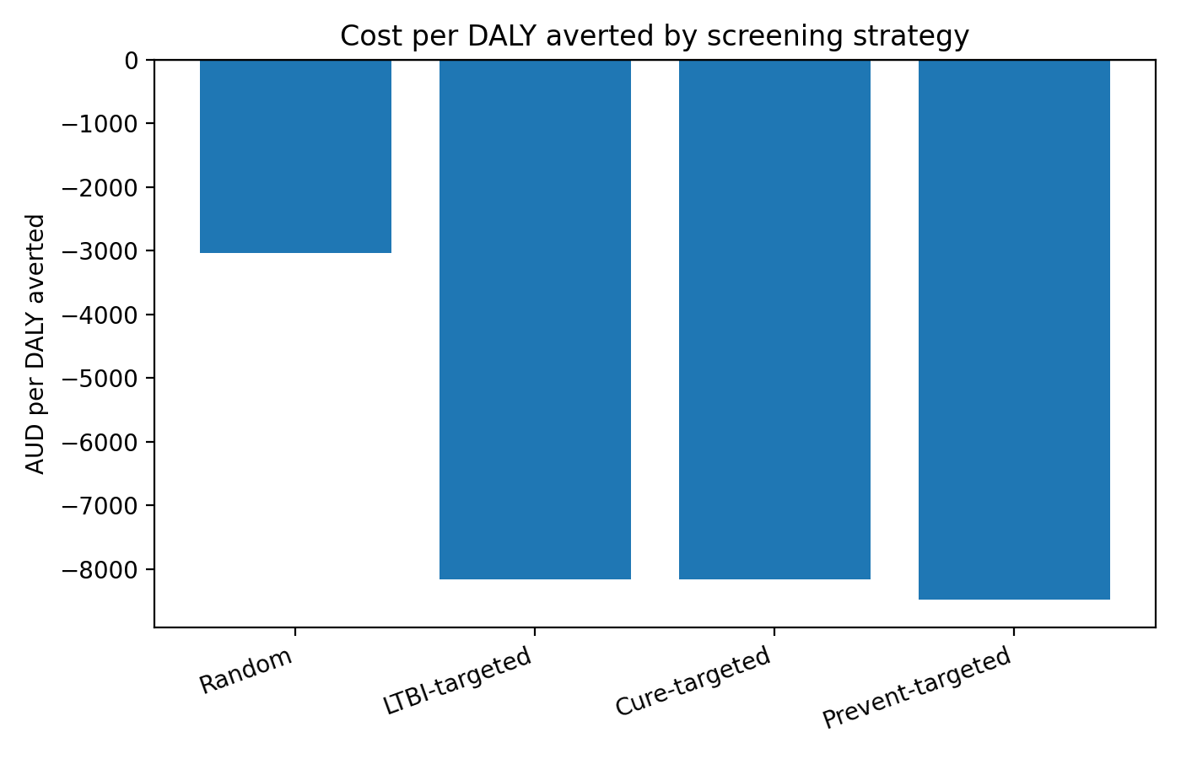

Figure. Cost per QALY gained by screening strategy.
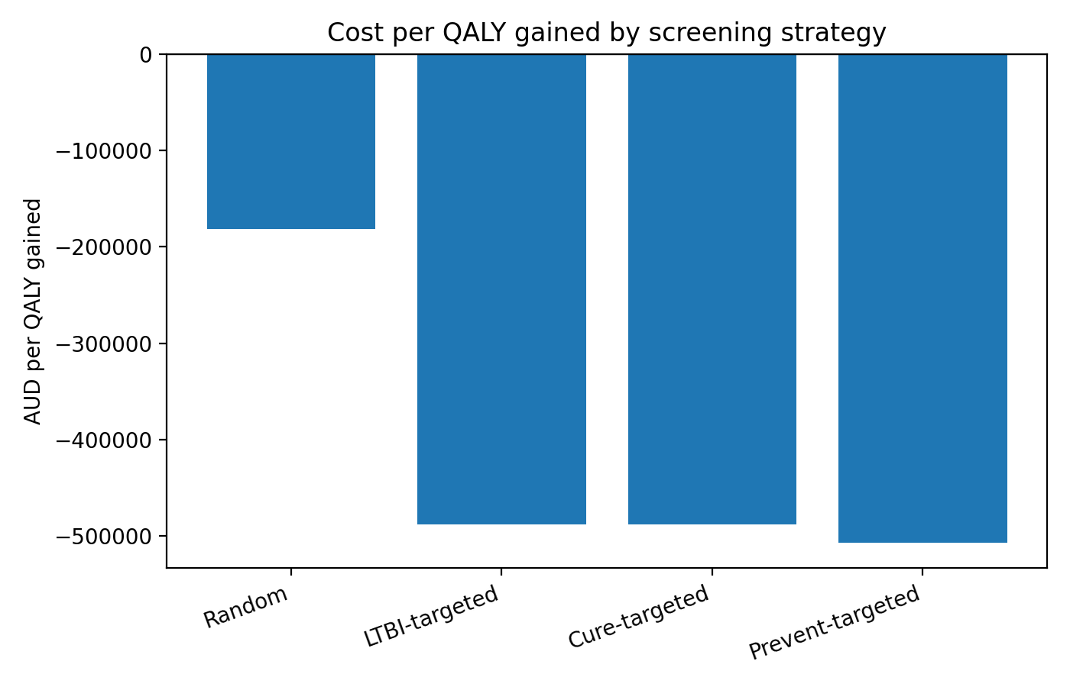

Figure. Net cost versus DALYs averted by screening strategy.
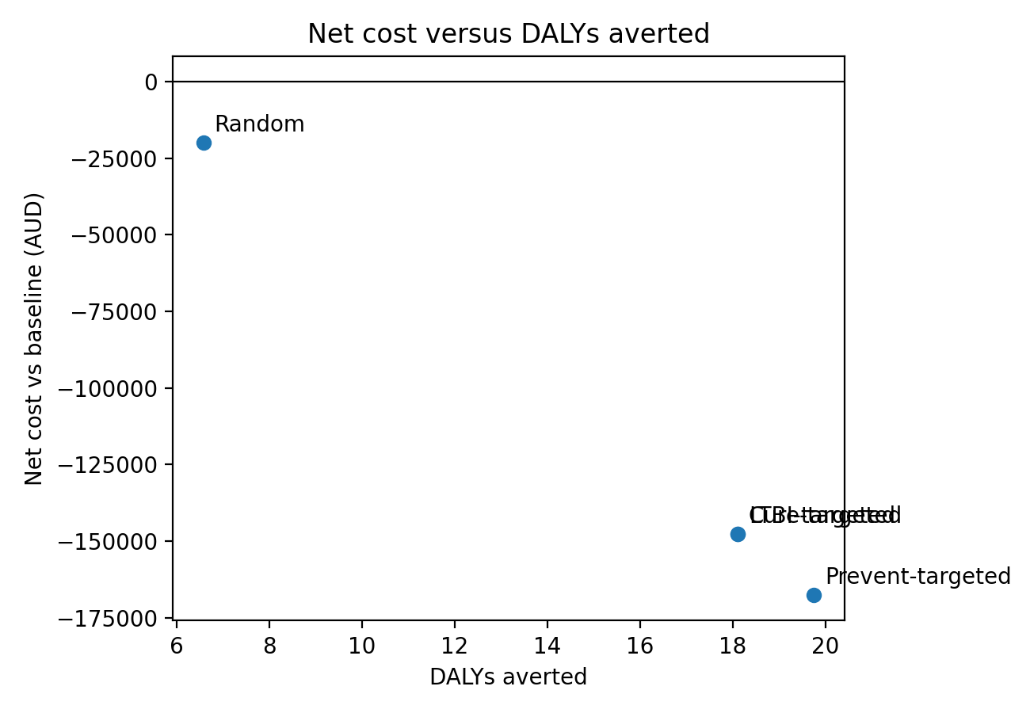

Sensitivity analysis
The health-economic model includes sensitivity analyses for LTBI treatment utility decrement, YLD-only DALY analysis, conservative and high YLL assumptions, and lower/higher TB case fatality risks. These sensitivity analyses are intended to show how much of the health-economic interpretation depends on uncertain assumptions.
Figure. DALY sensitivity results for the prevention-targeted strategy.
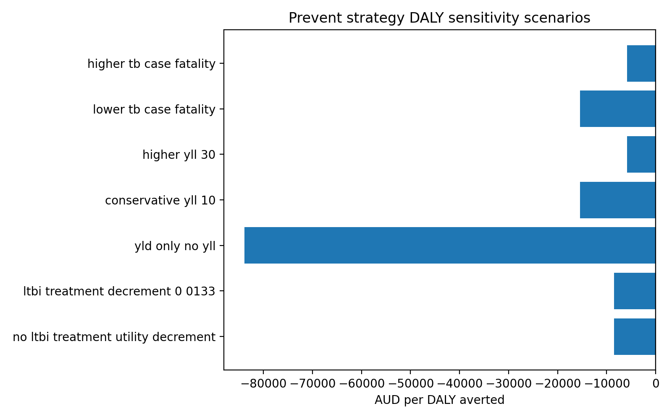

Sensitivity analyses changed the magnitude of health gains but not the overall base-case interpretation. Including the LTBI treatment utility decrement reduced QALYs gained, particularly for strategies with more treatment starts, while YLD-only DALY analysis substantially reduced DALYs averted compared with analyses including YLL. Conservative and higher YLL assumptions, and lower or higher TB case fatality risk, shifted the cost per DALY averted but did not change the preferred prevention-targeted strategy in the generated outputs. These sensitivity results should be treated as assumption-review outputs rather than final policy threshold decisions.

Interpretation for South Australia Public Health
The updated model continues to support targeted sequencing as a sensible planning strategy in the APY context when programmatic capacity is limited. The practical implication is not that some people should be excluded. Instead, it suggests that the first rounds of outreach, invitation, and follow-up should be weighted toward those with the highest predicted benefit, while maintaining open access for anyone who presents, is clinically indicated, or requests screening or treatment.
The health-economic extension adds an explicit value-for-money lens. If prevention-targeting is confirmed to have the lowest cost per DALY averted and QALY gained, this would reinforce the epidemiological interpretation that early outreach should prioritise people at highest preventable active TB risk. However, cost-saving or cost-effective findings must be interpreted cautiously where programme setup, travel, community engagement, implementation, and false-positive incremental costs are not yet supplied.
Results interpretation update: mortality-adjusted QALYs are substantially larger than the previous morbidity-only QALY component, so DALYs and QALYs are now more consistent in their treatment of mortality. DALYs remain a secondary burden-of-disease outcome. TB case fatality risk, YLL per TB death, and whether Dale/Bauer or GBD morbidity weights are preferred remain important sensitivity assumptions requiring review.
Operational interpretation. Targeting should be treated as a sequencing and support tool. It should not create a rigid eligibility threshold or reduce access for people outside a target group.

Health-economic caveats
- This is not a full dynamic transmission economic model; downstream transmission benefits are not included.
- This is not yet a full lifetime Markov model; APY outputs are direct person-level cases prevented over the model follow-up horizon.
- DALY estimates depend strongly on TB mortality and years-of-life-lost assumptions, which require review before final publication.
- QALY estimates depend strongly on whether LTBI diagnosis or treatment causes a utility decrement.
- Programme setup and implementation costs are currently set to zero unless supplied; including them may change cost-saving conclusions.
- Comparisons are most useful between strategies under the same model assumptions.

Conclusions and recommendations

Conclusion
In the current default APY scenario, targeted sequencing remains more efficient than random sequencing at the same treated proportion. The gain is greatest when treatment capacity is limited and the programme must decide who to approach first. As more of the reachable population is treated, the efficiency gap narrows.
The health-economic extension provides DALY, QALY, and ICER estimates for the same strategies. Draft model output suggests that prevention-targeted sequencing may have the strongest economic performance under current assumptions, but this conclusion should be updated after reviewing final outputs and local programme-cost inputs.
The offline APY health-economic outputs suggest that targeted LTBI screening and preventive treatment can be cost-saving under the current Australian-system assumptions, with the prevention-targeted strategy giving the strongest base-case cost per DALY, cost per QALY, and cost per active TB case prevented. These results support sequencing and prioritisation of outreach, not exclusion from care. Final interpretation should await review of TB mortality/YLL assumptions and inclusion of any APY-specific programme setup, outreach, travel, staffing, and follow-up costs.

Recommended policy position
A targeted strategy should be pursued, weighing efficiency and health-economic gains against the convenience and operational simplicity of targeting, while ensuring that no person is refused screening or treatment on the basis of this work.

Recommended actions
- Use targeted sequencing to plan the order of outreach and early treatment offer when capacity is limited.
- Keep access open: no person should be refused screening or treatment on the basis of modelling outputs.
- Use the health-economic module to compare value for money across strategies, tests, regimens, and programme-cost assumptions.
- Review TB mortality/YLL assumptions and programme implementation costs before final publication.
- Refresh results whenever APY-specific screening uptake, completion, adverse-event, cost, or outcome data are updated.
- Report sensitivity analyses clearly, especially around LTBI treatment utility decrement and YLL assumptions.

Selected references and source notes
[1] Barry SE, Brigham M, Gill C, Storken A, Kelly M, Mitnick CD. Tuberculosis Infection in a Remote Aboriginal Australian Community: Prevalence, Predictors, and Public Health Implications. Preprint supplied for this project, 2025.
[2] Dale KD, Abayawardana MJ, McBryde ES, Trauer JM, Carvalho N. Modeling the Cost-Effectiveness of Latent Tuberculosis Screening and Treatment Strategies in Recent Migrants to a Low-Incidence Setting. American Journal of Epidemiology. 2022;191(2):255-270.
[3] Internal APY model files supplied for this project, including the MATLAB v9 model, v9 add-on scripts, and Python APY backend outputs.
[4] Global Burden of Disease disability-weight framing as cited by Dale et al. for active TB disability weight of 0.333 over a 6-month episode.
[5] Bauer et al. utility values as used by Dale et al. for healthy/LTBI, LTBI treatment, SAE, and active TB states.

Appendix A. Base-case inputs reproduced from current model inputs
This appendix reproduces the current base-case input tables used by the model. In the current build, these values can be replaced through the user-facing runner or Python backend where appropriate.
Table A1. Infection-related inputs and retained infection ORs.
Input | 0-4 | 5-14 | >=15 | Disease OR | Infection OR
Marijuana use | 0 | 5% | 30% | 3.0 | 3.65
Close contact | 13% | 13% | 13% | 5.0 | 2.53
Renal disease | 0 | 1% | 15% | 10.0 | 2.19

Table A2. Age-specific baseline LTBI risk, progression factors, and population fractions.
Input | 0-4 | 5-14 | >=15 | Disease OR
Baseline LTBI risk by age | 1.5% | 2.5% | 8.0% | -
Diabetes | 0 | 0 | 30% | 3.0
Smoking | 0 | 10% | 60% | 2.0
Chronic lung disease | 0 | 10% | 50% | 3.0
Alcohol/drugs | 0 | 40% | 40% | 3.0
Population fraction | 9% | 17% | 74% | -

Table A3. Overall prevalence values.
Factor | Prevalence
Female sex | 56%
Close contact with infectious TB case | 13%
Current smoker | 52%
Ever smoker | 53%
Never smoker | 46%
Ever water-pipe marijuana use | 18%
Renal disease | 12%
Diabetes | 25%
Chronic lung disease | 19%
BCG vaccinated | 68%

Appendix B. APY age distribution used for exact-age sampling
The exact-age population in the current build is sampled from the APY age-distribution spreadsheet supplied for this project. The smoothed proportion column is used as the default sampling weight. Within each selected 5-year band, a single exact age is drawn uniformly.
Table B1. Age distribution used in the exact-age population generator.
Age group | ABS proportion | Smoothed proportion
0-4 | 10.7% | 10.7%
5-9 | 11.0% | 11.0%
10-14 | 11.0% | 11.0%
15-19 | 9.1% | 9.7%
20-24 | 9.1% | 8.6%
25-29 | 7.4% | 8.0%
30-34 | 7.4% | 6.7%
35-39 | 5.3% | 6.0%
40-44 | 5.3% | 5.2%
45-49 | 5.1% | 5.2%
50-54 | 5.1% | 4.7%
55-59 | 3.9% | 4.2%
60-64 | 3.9% | 2.9%
65-69 | 1.1% | 2.0%
70-74 | 1.1% | 1.1%
75-79 | 1.1% | 1.1%
80-84 | 1.1% | 1.1%
85+ | 1.1% | 0.6%

Appendix C. Health-economic formulas and update checklist

Core formulas
- TB deaths prevented = active TB cases prevented x TB case fatality risk.
- YLD averted = active TB cases prevented x active TB disability weight x active TB duration.
- YLL averted = TB deaths prevented x years of life lost per TB death.
- DALYs averted = YLD averted + YLL averted.
- QALY active TB loss averted = active TB cases prevented x (healthy utility - active TB utility) x active TB duration.
- QALYs gained = active TB QALY loss averted - LTBI treatment utility loss - SAE utility loss.
- ICER per DALY averted = incremental net cost / DALYs averted.
- ICER per QALY gained = incremental net cost / QALYs gained.
- Net monetary benefit = health gain x willingness-to-pay threshold - incremental net cost.
Primary DALY outputs include YLD plus YLL. Primary QALY outputs now include mortality benefits using the same TB mortality/YLL assumptions, while Dale/Bauer and GBD-aligned morbidity weights are presented separately. TB case fatality risk, YLL per TB death, and morbidity-weight choice remain subject to clinical and methods review.

Outputs to insert before finalising
- apy_daly_icer_strategy_summary.csv: use for health-economic strategy table.
- apy_daly_icer_health_outcomes.csv: use for DALYs, QALYs, and case/death outcomes.
- apy_daly_icer_costs.csv: use for total programme cost, disease costs averted, and net cost.
- apy_daly_icer_sensitivity.csv: use for sensitivity table and figure.
- apy_daly_icer_notes.md: use for interpretation paragraphs and caveats.

Appendix D. Figure and table placeholder register
All yellow-highlighted placeholders in this draft should be replaced, resolved, or removed before final circulation. Suggested outputs are listed below.
Table D1. Placeholder register for final editing.
Placeholder | Required output | Likely source
Cover image | Approved APY image or map | Manual insertion
Infections protected/cured figure | Treated proportion vs infections protected/cured | Existing model chart or generated figure
Active TB cases prevented figure | Treated proportion vs active TB cases prevented | Existing model chart or generated figure
NNS to prevent active TB figure | Treated proportion vs NNS to prevent active TB | Existing model chart or generated figure
Health-economic strategy table | DALY/QALY/ICER strategy table | apy_daly_icer_strategy_summary.csv
Cost per DALY figure | Bar chart by strategy | apy_daly_icer_strategy_summary.csv
Cost per QALY figure | Bar chart by strategy | apy_daly_icer_strategy_summary.csv
Cost-effectiveness plane | Incremental cost vs DALY/QALY | Generated by Codex from CSV outputs
Sensitivity plot | Tornado or grouped sensitivity chart | apy_daly_icer_sensitivity.csv

Final editing note. Yellow-highlighted statements should be checked against the final model outputs before circulation. The most important assumptions requiring review are programme implementation costs, TB case fatality risk, years of life lost, and the LTBI treatment utility decrement sensitivity.

Post-TB morbidity and mortality sensitivity analysis
Primary source: docs/source_material/Post TB Mortality & Standardised Follow up_Byrne June 2026.pptx.

Evidence summary
The Byrne June 2026 talk emphasises that successful microbiological treatment does not mark the end of TB burden. The slide deck reports 58 million DALYs due to post-TB sequelae, representing about 47% of the combined incident-TB plus post-TB burden, and 12.1 DALYs per incident TB case overall with 5.8 DALYs occurring after TB treatment.
The same talk summarises substantial long-term mortality after TB treatment, including Romanowski et al. with pooled SMR 2.91 and an Australian cohort analysis with overall cause-mortality ratio 1.16 and most deaths within 10 years of diagnosis.
Clinical sequelae highlighted in the talk include fibrosis, bronchiectasis, COPD/emphysema, pulmonary hypertension, chronic respiratory failure, lung cancer, and broader mental health, renal, visual, hearing, and musculoskeletal impairment.

Why the acute-only model may underestimate burden
The current APY health-economic model counts direct acute TB morbidity, TB mortality, and treatment-related losses, but it does not yet include a post-TB tail for survivors. That means acute-only DALYs and QALYs are likely conservative when post-treatment disability and excess mortality persist beyond microbiological cure.

Post-TB scenario results
For the prevention-targeted strategy, acute-only DALYs averted are 19.758. Adding the post-TB DALY tail raises this to 89.358. Acute-only QALYs gained are 15.84, and adding the post-TB QALY tail raises this to 27.
Under the default sensitivity settings, the model uses postTBDalysPerCase=5.8, postTBQalysLostPerCase=0.93, postTBDurationYears=10, and postTBExcessMortalityMultiplier=1.16.

Caveats
These post-TB results are sensitivity scenarios layered onto prevented incident TB cases. They do not alter APY epidemiological equations or rerun the underlying simulation. Excess mortality is recorded as an evidence anchor, but no APY-specific survivor hazard model has yet been added.
APY-specific PTLD prevalence, duration, annual care cost, and longer-horizon survivor outcomes are not yet available. These unresolved assumptions remain highlighted below and in the workbook.

Unresolved APY-specific assumptions
PTLD prevalence in APY TB survivors; post-TB annual care cost; numeric lifetime duration assumption; how to map excess mortality into APY-specific survivor follow-up
Statement: APY-specific PTLD data are not yet available, so these results should be interpreted as scenario bounds for planning rather than local estimates.

